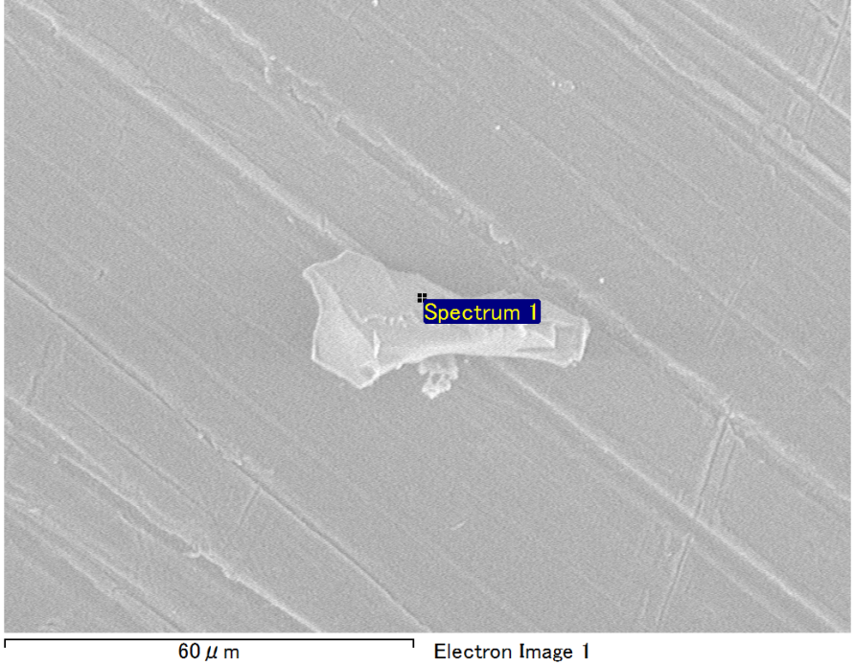

Spectrum Label: Spectrum 1

Livetime 90.0 s

Acquisition geometry ( degrees ):

Tilt = 0.0

Azimuth = 0.0

Elevation = 30.0

Accelerating voltage = 10.00 kV

Total spectrum counts = 66004

|  |  |  |  |
| --- | --- | --- | --- |
| Sample data : | Energy (eV) | Resn. (eV) | Area |
| Strobe : | 3.8 | 53.19 | 920322 |
|  |  |  |  |
| Optimization data : Manganese K series |  |  |  |
|  | Energy (eV) | Resn. (eV) | Area |
| Strobe : | .1 | 53.38 | 1150729 |
| Optimization element : | 5892.6 | 129.89 | 573533 |

Spectrum processing :

No peaks omitted

Processing option : Oxygen by stoichiometry (Normalised)

Number of iterations = 1

Standard :

Mg MgO 1-Jun-1999 12:00 AM

Al Al2O3 1-Jun-1999 12:00 AM

Si SiO2 1-Jun-1999 12:00 AM

|  |  |  |  |  |  |
| --- | --- | --- | --- | --- | --- |
| Element | Weight% | Atomic% | Compd% | Formula |  |
|  |  |  |  |  |  |
| Mg K | 5.17 | 4.32 | 8.57 | MgO |  |
| Al K | 42.84 | 32.29 | 80.95 | Al2O3 |  |
| Si K | 4.90 | 3.55 | 10.48 | SiO2 |  |
| O | 47.09 | 59.84 |  |  |  |
| Totals | 100.00 |  |  |  |  |

Project: Project 1

Owner: Operator

Site: Site of Interest 23

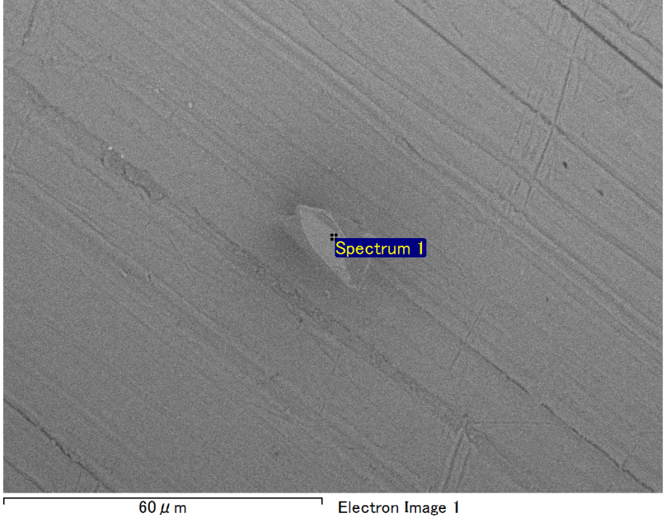

Spectrum Label: Spectrum 1

Livetime 90.0 s

Acquisition geometry ( degrees ):

Tilt = 0.0

Azimuth = 0.0

Elevation = 30.0

Accelerating voltage = 10.00 kV

Total spectrum counts = 63337

|  |  |  |  |
| --- | --- | --- | --- |
| Sample data : | Energy (eV) | Resn. (eV) | Area |
| Strobe : | 3.8 | 53.22 | 919780 |
|  |  |  |  |
| Optimization data : Manganese K series |  |  |  |
|  | Energy (eV) | Resn. (eV) | Area |
| Strobe : | .1 | 53.38 | 1150729 |
| Optimization element : | 5892.6 | 129.89 | 573533 |

Spectrum processing :

No peaks omitted

Processing option : Oxygen by stoichiometry (Normalised)

Number of iterations = 1

Standard :

Mg MgO 1-Jun-1999 12:00 AM

Al Al2O3 1-Jun-1999 12:00 AM

Si SiO2 1-Jun-1999 12:00 AM

|  |  |  |  |  |  |
| --- | --- | --- | --- | --- | --- |
| Element | Weight% | Atomic% | Compd% | Formula |  |
|  |  |  |  |  |  |
| Mg K | 1.27 | 1.06 | 2.10 | MgO |  |
| Al K | 49.67 | 37.50 | 93.84 | Al2O3 |  |
| Si K | 1.90 | 1.37 | 4.05 | SiO2 |  |
| O | 47.17 | 60.06 |  |  |  |
| Totals | 100.00 |  |  |  |  |

Project: Project 1

Owner: Operator

Site: Site of Interest 24

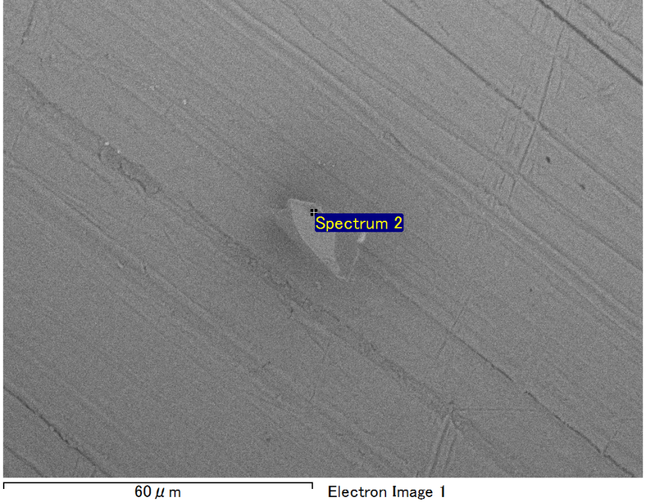

Spectrum Label: Spectrum 2

Livetime 90.0 s

Acquisition geometry ( degrees ):

Tilt = 0.0

Azimuth = 0.0

Elevation = 30.0

Accelerating voltage = 10.00 kV

Total spectrum counts = 63827

|  |  |  |  |
| --- | --- | --- | --- |
| Sample data : | Energy (eV) | Resn. (eV) | Area |
| Strobe : | 3.8 | 53.17 | 919924 |
|  |  |  |  |
| Optimization data : Manganese K series |  |  |  |
|  | Energy (eV) | Resn. (eV) | Area |
| Strobe : | .1 | 53.38 | 1150729 |
| Optimization element : | 5892.6 | 129.89 | 573533 |

Spectrum processing :

No peaks omitted

Processing option : Oxygen by stoichiometry (Normalised)

Number of iterations = 1

Standard :

Mg MgO 1-Jun-1999 12:00 AM

Al Al2O3 1-Jun-1999 12:00 AM

Si SiO2 1-Jun-1999 12:00 AM

|  |  |  |  |  |  |
| --- | --- | --- | --- | --- | --- |
| Element | Weight% | Atomic% | Compd% | Formula |  |
|  |  |  |  |  |  |
| Mg K | 1.52 | 1.27 | 2.52 | MgO |  |
| Al K | 49.45 | 37.33 | 93.43 | Al2O3 |  |
| Si K | 1.89 | 1.37 | 4.05 | SiO2 |  |
| O | 47.14 | 60.02 |  |  |  |
| Totals | 100.00 |  |  |  |  |

Project: Project 1

Owner: Operator

Site: Site of Interest 24

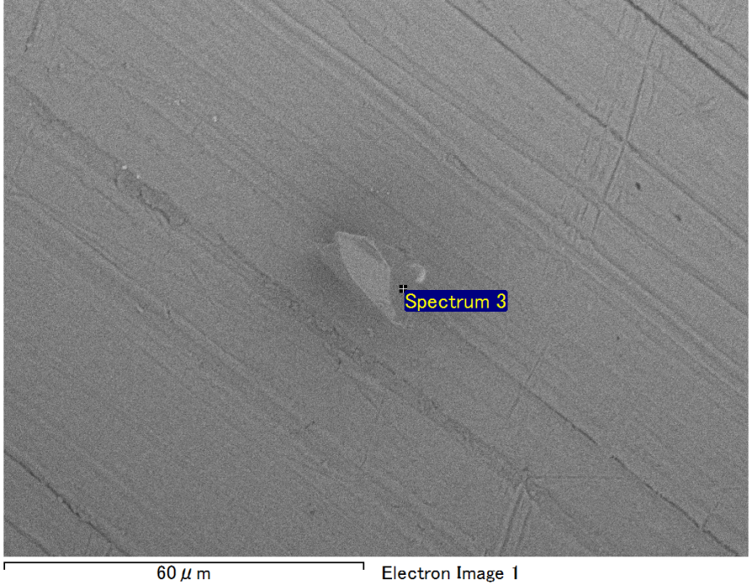

Spectrum Label: Spectrum 3

Livetime 90.0 s

Acquisition geometry ( degrees ):

Tilt = 0.0

Azimuth = 0.0

Elevation = 30.0

Accelerating voltage = 10.00 kV

Total spectrum counts = 64352

|  |  |  |  |
| --- | --- | --- | --- |
| Sample data : | Energy (eV) | Resn. (eV) | Area |
| Strobe : | 3.8 | 53.14 | 919404 |
|  |  |  |  |
| Optimization data : Manganese K series |  |  |  |
|  | Energy (eV) | Resn. (eV) | Area |
| Strobe : | .1 | 53.38 | 1150729 |
| Optimization element : | 5892.6 | 129.89 | 573533 |

Spectrum processing :

No peaks omitted

Processing option : Oxygen by stoichiometry (Normalised)

Number of iterations = 1

Standard :

Mg MgO 1-Jun-1999 12:00 AM

Al Al2O3 1-Jun-1999 12:00 AM

Si SiO2 1-Jun-1999 12:00 AM

|  |  |  |  |  |  |
| --- | --- | --- | --- | --- | --- |
| Element | Weight% | Atomic% | Compd% | Formula |  |
|  |  |  |  |  |  |
| Mg K | 2.77 | 2.32 | 4.59 | MgO |  |
| Al K | 47.04 | 35.49 | 88.88 | Al2O3 |  |
| Si K | 3.05 | 2.21 | 6.53 | SiO2 |  |
| O | 47.14 | 59.98 |  |  |  |
| Totals | 100.00 |  |  |  |  |

Project: Project 1

Owner: Operator

Site: Site of Interest 24

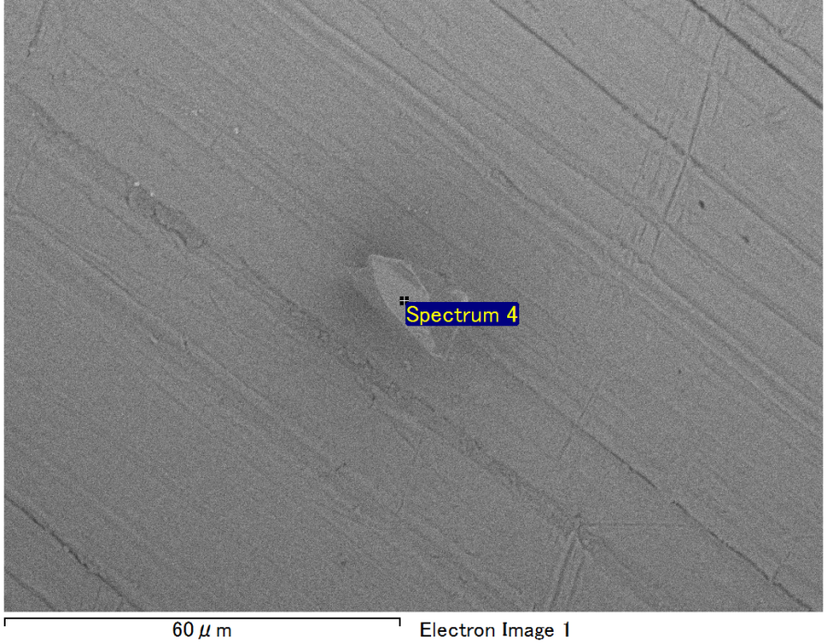

Spectrum Label: Spectrum 4

Livetime 90.0 s

Acquisition geometry ( degrees ):

Tilt = 0.0

Azimuth = 0.0

Elevation = 30.0

Accelerating voltage = 10.00 kV

Total spectrum counts = 64086

|  |  |  |  |
| --- | --- | --- | --- |
| Sample data : | Energy (eV) | Resn. (eV) | Area |
| Strobe : | 3.8 | 53.27 | 918346 |
|  |  |  |  |
| Optimization data : Manganese K series |  |  |  |
|  | Energy (eV) | Resn. (eV) | Area |
| Strobe : | .1 | 53.38 | 1150729 |
| Optimization element : | 5892.6 | 129.89 | 573533 |

Spectrum processing :

No peaks omitted

Processing option : Oxygen by stoichiometry (Normalised)

Number of iterations = 1

Standard :

Mg MgO 1-Jun-1999 12:00 AM

Al Al2O3 1-Jun-1999 12:00 AM

Si SiO2 1-Jun-1999 12:00 AM

|  |  |  |  |  |  |
| --- | --- | --- | --- | --- | --- |
| Element | Weight% | Atomic% | Compd% | Formula |  |
|  |  |  |  |  |  |
| Mg K | 2.77 | 2.32 | 4.60 | MgO |  |
| Al K | 47.31 | 35.69 | 89.38 | Al2O3 |  |
| Si K | 2.81 | 2.04 | 6.02 | SiO2 |  |
| O | 47.11 | 59.94 |  |  |  |
| Totals | 100.00 |  |  |  |  |

Project: Project 1

Owner: Operator

Site: Site of Interest 24