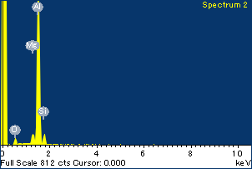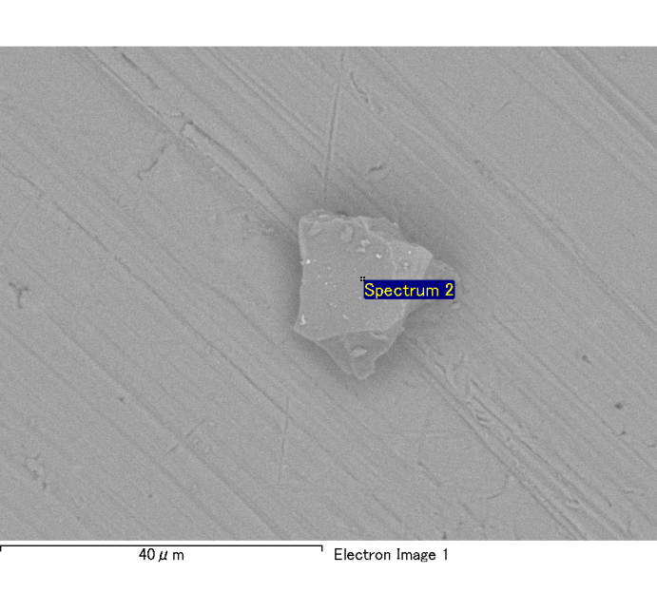

Spectrum Label: Spectrum 2

Livetime 120.0 s

Acquisition geometry ( degrees ):

Tilt = 0.0

Azimuth = 0.0

Elevation = 30.0

Accelerating voltage = 10.00 kV

Total spectrum counts = 115941

|  |  |  |  |
| --- | --- | --- | --- |
| Sample data : | Energy (eV) | Resn. (eV) | Area |
| Strobe : | 3.8 | 54.01 | 1209916 |
|  |  |  |  |
| Optimization data : Cobalt K series |  |  |  |
|  | Energy (eV) | Resn. (eV) | Area |
| Strobe : | .1 | 53.96 | 498142 |
| Optimization element : | 6926.7 | 142.17 | 16696 |

Spectrum processing :

No peaks omitted

Processing option : Oxygen by stoichiometry

Number of iterations = 2

Standard :

Na Albite 1-Jun-1999 12:00 AM

Mg MgO 1-Jun-1999 12:00 AM

Al Al2O3 1-Jun-1999 12:00 AM

Si SiO2 1-Jun-1999 12:00 AM

P GaP 1-Jun-1999 12:00 AM

S FeS2 1-Jun-1999 12:00 AM

K MAD-10 Feldspar 1-Jun-1999 12:00 AM

Ca Wollastonite 1-Jun-1999 12:00 AM

Cr Cr 1-Jun-1999 12:00 AM

Mn Mn 1-Jun-1999 12:00 AM

Fe Fe 1-Jun-1999 12:00 AM

Ni Ni 1-Jun-1999 12:00 AM

|  |  |  |  |  |  |
| --- | --- | --- | --- | --- | --- |
| Element | Weight% | Atomic% | Compd% | Formula |  |
|  |  |  |  |  |  |
| Na K | 0.00 | 0.02 | 0.00 | Na2O |  |
| Mg K | 0.05 | 2.02 | 0.08 | MgO |  |
| Al K | 0.86 | 33.70 | 1.62 | Al2O3 |  |
| Si K | 0.07 | 2.68 | 0.15 | SiO2 |  |
| P K | 0.00 | 0.03 | 0.00 | P2O5 |  |
| S K | 0.00 | 0.00 | 0.00 | SO3 |  |
| K K | 0.00 | -0.04 | 0.00 | K2O |  |
| Ca K | 0.00 | -0.04 | 0.00 | CaO |  |
| Cr K | -0.01 | -0.19 | -0.01 | Cr2O3 |  |
| Mn K | 0.01 | 0.13 | 0.01 | MnO |  |
| Fe K | 0.10 | 1.81 | 0.12 | FeO |  |
| Ni K | 0.01 | 0.11 | 0.01 | NiO |  |
| O | 0.90 | 59.75 |  |  |  |
| Totals | 1.97 |  |  |  |  |

Project: Project 1

Owner: Administrator

Site: Site of Interest 4

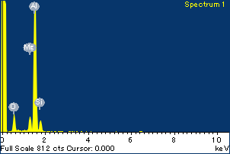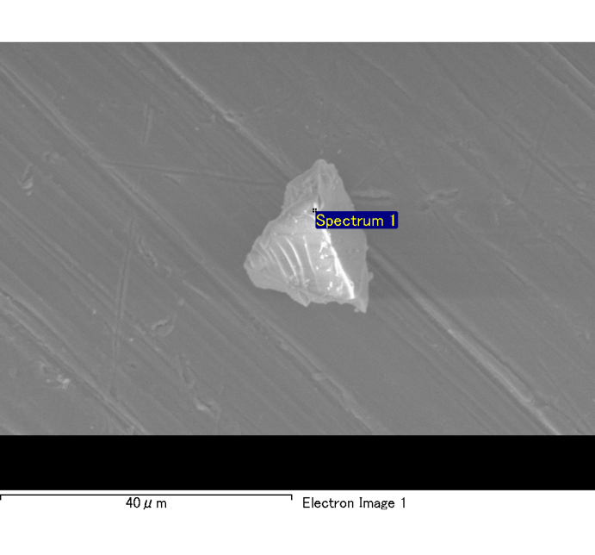

Spectrum Label: Spectrum 1

Livetime 105.5 s

Acquisition geometry ( degrees ):

Tilt = 0.0

Azimuth = 0.0

Elevation = 30.0

Accelerating voltage = 10.00 kV

Total spectrum counts = 103369

|  |  |  |  |
| --- | --- | --- | --- |
| Sample data : | Energy (eV) | Resn. (eV) | Area |
| Strobe : | 3.8 | 53.99 | 1062966 |
|  |  |  |  |
| Optimization data : Cobalt K series |  |  |  |
|  | Energy (eV) | Resn. (eV) | Area |
| Strobe : | .1 | 53.96 | 498142 |
| Optimization element : | 6926.7 | 142.17 | 16696 |

Spectrum processing :

No peaks omitted

Processing option : Oxygen by stoichiometry

Number of iterations = 2

Standard :

Na Albite 1-Jun-1999 12:00 AM

Mg MgO 1-Jun-1999 12:00 AM

Al Al2O3 1-Jun-1999 12:00 AM

Si SiO2 1-Jun-1999 12:00 AM

P GaP 1-Jun-1999 12:00 AM

S FeS2 1-Jun-1999 12:00 AM

K MAD-10 Feldspar 1-Jun-1999 12:00 AM

Ca Wollastonite 1-Jun-1999 12:00 AM

Cr Cr 1-Jun-1999 12:00 AM

Mn Mn 1-Jun-1999 12:00 AM

Fe Fe 1-Jun-1999 12:00 AM

Ni Ni 1-Jun-1999 12:00 AM

|  |  |  |  |  |  |
| --- | --- | --- | --- | --- | --- |
| Element | Weight% | Atomic% | Compd% | Formula |  |
|  |  |  |  |  |  |
| Na K | 0.00 | 0.10 | 0.00 | Na2O |  |
| Mg K | 0.09 | 3.25 | 0.14 | MgO |  |
| Al K | 0.91 | 31.19 | 1.72 | Al2O3 |  |
| Si K | 0.09 | 3.09 | 0.20 | SiO2 |  |
| P K | 0.00 | -0.07 | -0.01 | P2O5 |  |
| S K | 0.00 | -0.08 | -0.01 | SO3 |  |
| K K | 0.00 | 0.09 | 0.00 | K2O |  |
| Ca K | 0.00 | 0.10 | 0.01 | CaO |  |
| Cr K | 0.01 | 0.17 | 0.01 | Cr2O3 |  |
| Mn K | -0.01 | -0.17 | -0.01 | MnO |  |
| Fe K | 0.09 | 1.57 | 0.12 | FeO |  |
| Ni K | 0.10 | 1.57 | 0.13 | NiO |  |
| O | 1.02 | 59.20 |  |  |  |
| Totals | 2.31 |  |  |  |  |

Project: Project 1

Owner: Administrator

Site: Site of Interest 5

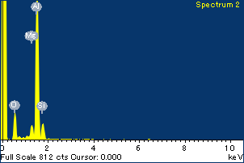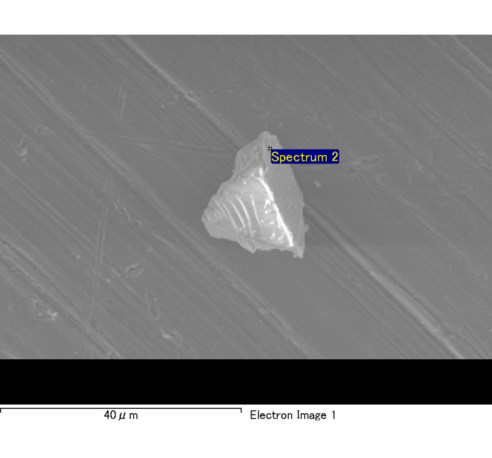

Spectrum Label: Spectrum 2

Livetime 120.0 s

Acquisition geometry ( degrees ):

Tilt = 0.0

Azimuth = 0.0

Elevation = 30.0

Accelerating voltage = 10.00 kV

Total spectrum counts = 119139

|  |  |  |  |
| --- | --- | --- | --- |
| Sample data : | Energy (eV) | Resn. (eV) | Area |
| Strobe : | 3.8 | 54.03 | 1207543 |
|  |  |  |  |
| Optimization data : Cobalt K series |  |  |  |
|  | Energy (eV) | Resn. (eV) | Area |
| Strobe : | .1 | 53.96 | 498142 |
| Optimization element : | 6926.7 | 142.17 | 16696 |

Spectrum processing :

No peaks omitted

Processing option : Oxygen by stoichiometry

Number of iterations = 2

Standard :

Na Albite 1-Jun-1999 12:00 AM

Mg MgO 1-Jun-1999 12:00 AM

Al Al2O3 1-Jun-1999 12:00 AM

Si SiO2 1-Jun-1999 12:00 AM

P GaP 1-Jun-1999 12:00 AM

S FeS2 1-Jun-1999 12:00 AM

K MAD-10 Feldspar 1-Jun-1999 12:00 AM

Ca Wollastonite 1-Jun-1999 12:00 AM

Cr Cr 1-Jun-1999 12:00 AM

Mn Mn 1-Jun-1999 12:00 AM

Fe Fe 1-Jun-1999 12:00 AM

Ni Ni 1-Jun-1999 12:00 AM

|  |  |  |  |  |  |
| --- | --- | --- | --- | --- | --- |
| Element | Weight% | Atomic% | Compd% | Formula |  |
|  |  |  |  |  |  |
| Na K | 0.01 | 0.38 | 0.01 | Na2O |  |
| Mg K | 0.06 | 2.35 | 0.11 | MgO |  |
| Al K | 0.96 | 31.56 | 1.81 | Al2O3 |  |
| Si K | 0.12 | 3.73 | 0.25 | SiO2 |  |
| P K | 0.01 | 0.21 | 0.02 | P2O5 |  |
| S K | 0.00 | 0.00 | 0.00 | SO3 |  |
| K K | 0.00 | -0.06 | 0.00 | K2O |  |
| Ca K | 0.00 | 0.05 | 0.00 | CaO |  |
| Cr K | -0.01 | -0.16 | -0.01 | Cr2O3 |  |
| Mn K | 0.02 | 0.31 | 0.02 | MnO |  |
| Fe K | 0.12 | 1.83 | 0.15 | FeO |  |
| Ni K | 0.00 | 0.01 | 0.00 | NiO |  |
| O | 1.08 | 59.79 |  |  |  |
| Totals | 2.36 |  |  |  |  |

Project: Project 1

Owner: Administrator

Site: Site of Interest 5

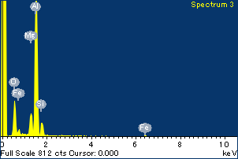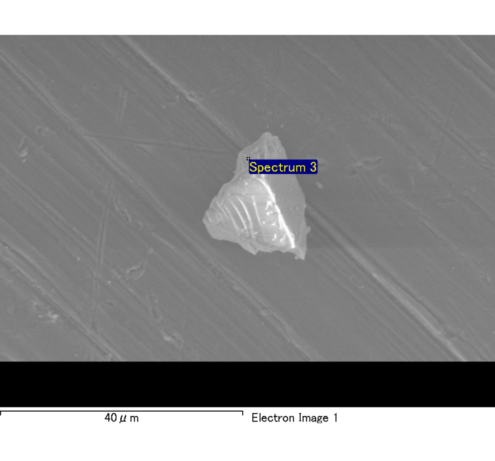

Spectrum Label: Spectrum 3

Livetime 120.0 s

Acquisition geometry ( degrees ):

Tilt = 0.0

Azimuth = 0.0

Elevation = 30.0

Accelerating voltage = 10.00 kV

Total spectrum counts = 120439

|  |  |  |  |
| --- | --- | --- | --- |
| Sample data : | Energy (eV) | Resn. (eV) | Area |
| Strobe : | 3.8 | 53.97 | 1206823 |
|  |  |  |  |
| Optimization data : Cobalt K series |  |  |  |
|  | Energy (eV) | Resn. (eV) | Area |
| Strobe : | .1 | 53.96 | 498142 |
| Optimization element : | 6926.7 | 142.17 | 16696 |

Spectrum processing :

No peaks omitted

Processing option : Oxygen by stoichiometry

Number of iterations = 2

Standard :

Na Albite 1-Jun-1999 12:00 AM

Mg MgO 1-Jun-1999 12:00 AM

Al Al2O3 1-Jun-1999 12:00 AM

Si SiO2 1-Jun-1999 12:00 AM

P GaP 1-Jun-1999 12:00 AM

S FeS2 1-Jun-1999 12:00 AM

K MAD-10 Feldspar 1-Jun-1999 12:00 AM

Ca Wollastonite 1-Jun-1999 12:00 AM

Cr Cr 1-Jun-1999 12:00 AM

Mn Mn 1-Jun-1999 12:00 AM

Fe Fe 1-Jun-1999 12:00 AM

Ni Ni 1-Jun-1999 12:00 AM

|  |  |  |  |  |  |
| --- | --- | --- | --- | --- | --- |
| Element | Weight% | Atomic% | Compd% | Formula |  |
|  |  |  |  |  |  |
| Na K | 0.00 | 0.02 | 0.00 | Na2O |  |
| Mg K | 0.12 | 4.26 | 0.20 | MgO |  |
| Al K | 0.96 | 30.58 | 1.82 | Al2O3 |  |
| Si K | 0.11 | 3.45 | 0.24 | SiO2 |  |
| P K | 0.00 | 0.03 | 0.00 | P2O5 |  |
| S K | 0.00 | 0.05 | 0.00 | SO3 |  |
| K K | 0.00 | 0.00 | 0.00 | K2O |  |
| Ca K | 0.01 | 0.12 | 0.01 | CaO |  |
| Cr K | -0.01 | -0.10 | -0.01 | Cr2O3 |  |
| Mn K | 0.00 | -0.03 | 0.00 | MnO |  |
| Fe K | 0.15 | 2.23 | 0.19 | FeO |  |
| Ni K | 0.00 | -0.02 | 0.00 | NiO |  |
| O | 1.11 | 59.41 |  |  |  |
| Totals | 2.45 |  |  |  |  |

Project: Project 1

Owner: Administrator

Site: Site of Interest 5

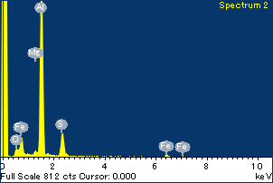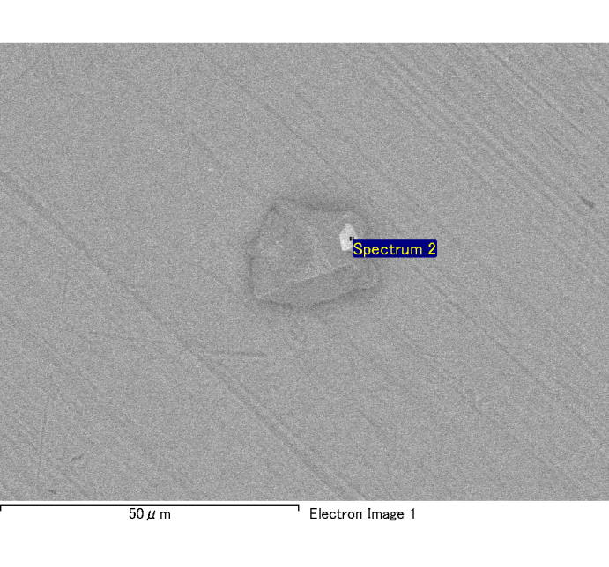

Spectrum Label: Spectrum 2

Livetime 120.0 s

Acquisition geometry ( degrees ):

Tilt = 0.0

Azimuth = 0.0

Elevation = 30.0

Accelerating voltage = 10.00 kV

Total spectrum counts = 119529

|  |  |  |  |
| --- | --- | --- | --- |
| Sample data : | Energy (eV) | Resn. (eV) | Area |
| Strobe : | 3.8 | 53.96 | 1207937 |
|  |  |  |  |
| Optimization data : Cobalt K series |  |  |  |
|  | Energy (eV) | Resn. (eV) | Area |
| Strobe : | .1 | 53.96 | 498142 |
| Optimization element : | 6926.7 | 142.17 | 16696 |

Spectrum processing :

No peaks omitted

Processing option : Oxygen by stoichiometry

Number of iterations = 2

Standard :

Na Albite 1-Jun-1999 12:00 AM

Mg MgO 1-Jun-1999 12:00 AM

Al Al2O3 1-Jun-1999 12:00 AM

Si SiO2 1-Jun-1999 12:00 AM

P GaP 1-Jun-1999 12:00 AM

S FeS2 1-Jun-1999 12:00 AM

K MAD-10 Feldspar 1-Jun-1999 12:00 AM

Ca Wollastonite 1-Jun-1999 12:00 AM

Cr Cr 1-Jun-1999 12:00 AM

Mn Mn 1-Jun-1999 12:00 AM

Fe Fe 1-Jun-1999 12:00 AM

Ni Ni 1-Jun-1999 12:00 AM

|  |  |  |  |  |  |
| --- | --- | --- | --- | --- | --- |
| Element | Weight% | Atomic% | Compd% | Formula |  |
|  |  |  |  |  |  |
| Na K | 0.00 | -0.01 | 0.00 | Na2O |  |
| Mg K | 0.02 | 0.51 | 0.03 | MgO |  |
| Al K | 0.92 | 27.01 | 1.74 | Al2O3 |  |
| Si K | 0.01 | 0.21 | 0.02 | SiO2 |  |
| P K | 0.00 | 0.06 | 0.01 | P2O5 |  |
| S K | 0.20 | 4.99 | 0.50 | SO3 |  |
| K K | -0.01 | -0.14 | -0.01 | K2O |  |
| Ca K | 0.00 | 0.07 | 0.00 | CaO |  |
| Cr K | 0.02 | 0.29 | 0.03 | Cr2O3 |  |
| Mn K | 0.01 | 0.13 | 0.01 | MnO |  |
| Fe K | 0.32 | 4.51 | 0.41 | FeO |  |
| Ni K | 0.03 | 0.37 | 0.04 | NiO |  |
| O | 1.25 | 62.00 |  |  |  |
| Totals | 2.77 |  |  |  |  |

Project: Project 1

Owner: Administrator

Site: Site of Interest 6

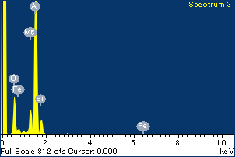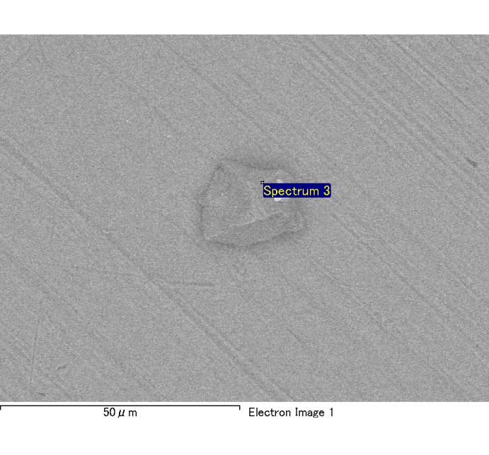

Spectrum Label: Spectrum 3

Livetime 120.0 s

Acquisition geometry ( degrees ):

Tilt = 0.0

Azimuth = 0.0

Elevation = 30.0

Accelerating voltage = 10.00 kV

Total spectrum counts = 120292

|  |  |  |  |
| --- | --- | --- | --- |
| Sample data : | Energy (eV) | Resn. (eV) | Area |
| Strobe : | 3.8 | 54.01 | 1208210 |
|  |  |  |  |
| Optimization data : Cobalt K series |  |  |  |
|  | Energy (eV) | Resn. (eV) | Area |
| Strobe : | .1 | 53.96 | 498142 |
| Optimization element : | 6926.7 | 142.17 | 16696 |

Spectrum processing :

No peaks omitted

Processing option : Oxygen by stoichiometry

Number of iterations = 2

Standard :

Na Albite 1-Jun-1999 12:00 AM

Mg MgO 1-Jun-1999 12:00 AM

Al Al2O3 1-Jun-1999 12:00 AM

Si SiO2 1-Jun-1999 12:00 AM

P GaP 1-Jun-1999 12:00 AM

S FeS2 1-Jun-1999 12:00 AM

K MAD-10 Feldspar 1-Jun-1999 12:00 AM

Ca Wollastonite 1-Jun-1999 12:00 AM

Cr Cr 1-Jun-1999 12:00 AM

Mn Mn 1-Jun-1999 12:00 AM

Fe Fe 1-Jun-1999 12:00 AM

Ni Ni 1-Jun-1999 12:00 AM

|  |  |  |  |  |  |
| --- | --- | --- | --- | --- | --- |
| Element | Weight% | Atomic% | Compd% | Formula |  |
|  |  |  |  |  |  |
| Na K | -0.01 | -0.33 | -0.01 | Na2O |  |
| Mg K | 0.12 | 4.32 | 0.20 | MgO |  |
| Al K | 0.97 | 31.28 | 1.84 | Al2O3 |  |
| Si K | 0.12 | 3.58 | 0.25 | SiO2 |  |
| P K | 0.00 | -0.08 | -0.01 | P2O5 |  |
| S K | 0.00 | 0.07 | 0.01 | SO3 |  |
| K K | 0.00 | -0.02 | 0.00 | K2O |  |
| Ca K | 0.00 | -0.07 | 0.00 | CaO |  |
| Cr K | 0.01 | 0.11 | 0.01 | Cr2O3 |  |
| Mn K | -0.01 | -0.17 | -0.01 | MnO |  |
| Fe K | 0.09 | 1.34 | 0.11 | FeO |  |
| Ni K | 0.02 | 0.25 | 0.02 | NiO |  |
| O | 1.10 | 59.73 |  |  |  |
| Totals | 2.40 |  |  |  |  |

Project: Project 1

Owner: Administrator

Site: Site of Interest 6

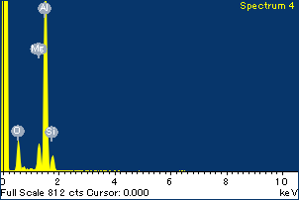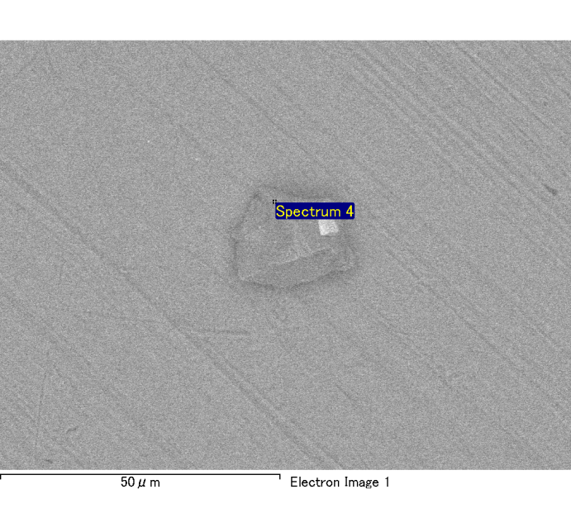

Spectrum Label: Spectrum 4

Livetime 120.0 s

Acquisition geometry ( degrees ):

Tilt = 0.0

Azimuth = 0.0

Elevation = 30.0

Accelerating voltage = 10.00 kV

Total spectrum counts = 119045

|  |  |  |  |
| --- | --- | --- | --- |
| Sample data : | Energy (eV) | Resn. (eV) | Area |
| Strobe : | 3.8 | 53.98 | 1208901 |
|  |  |  |  |
| Optimization data : Cobalt K series |  |  |  |
|  | Energy (eV) | Resn. (eV) | Area |
| Strobe : | .1 | 53.96 | 498142 |
| Optimization element : | 6926.7 | 142.17 | 16696 |

Spectrum processing :

No peaks omitted

Processing option : Oxygen by stoichiometry

Number of iterations = 2

Standard :

Na Albite 1-Jun-1999 12:00 AM

Mg MgO 1-Jun-1999 12:00 AM

Al Al2O3 1-Jun-1999 12:00 AM

Si SiO2 1-Jun-1999 12:00 AM

P GaP 1-Jun-1999 12:00 AM

S FeS2 1-Jun-1999 12:00 AM

K MAD-10 Feldspar 1-Jun-1999 12:00 AM

Ca Wollastonite 1-Jun-1999 12:00 AM

Cr Cr 1-Jun-1999 12:00 AM

Mn Mn 1-Jun-1999 12:00 AM

Fe Fe 1-Jun-1999 12:00 AM

Ni Ni 1-Jun-1999 12:00 AM

|  |  |  |  |  |  |
| --- | --- | --- | --- | --- | --- |
| Element | Weight% | Atomic% | Compd% | Formula |  |
|  |  |  |  |  |  |
| Na K | 0.00 | -0.14 | 0.00 | Na2O |  |
| Mg K | 0.11 | 4.05 | 0.18 | MgO |  |
| Al K | 0.92 | 31.36 | 1.74 | Al2O3 |  |
| Si K | 0.10 | 3.24 | 0.21 | SiO2 |  |
| P K | 0.00 | -0.04 | 0.00 | P2O5 |  |
| S K | 0.00 | -0.02 | 0.00 | SO3 |  |
| K K | 0.01 | 0.15 | 0.01 | K2O |  |
| Ca K | 0.00 | -0.06 | 0.00 | CaO |  |
| Cr K | 0.00 | -0.02 | 0.00 | Cr2O3 |  |
| Mn K | 0.00 | 0.03 | 0.00 | MnO |  |
| Fe K | 0.13 | 2.07 | 0.16 | FeO |  |
| Ni K | 0.00 | -0.01 | 0.00 | NiO |  |
| O | 1.04 | 59.40 |  |  |  |
| Totals | 2.29 |  |  |  |  |

Project: Project 1

Owner: Administrator

Site: Site of Interest 6

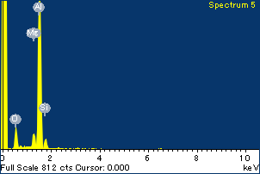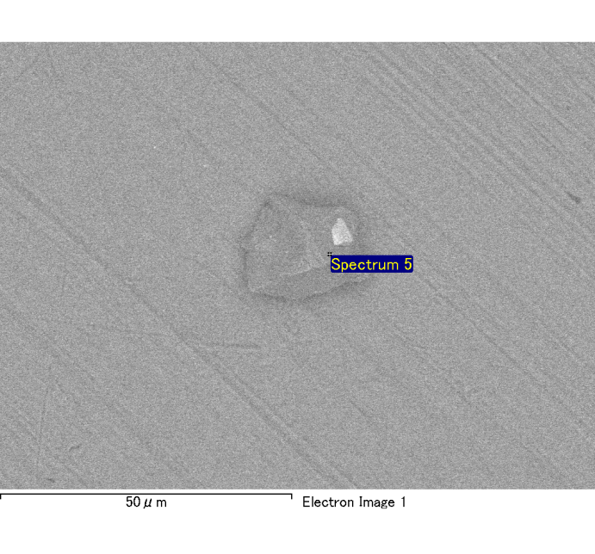

Spectrum Label: Spectrum 5

Livetime 120.0 s

Acquisition geometry ( degrees ):

Tilt = 0.0

Azimuth = 0.0

Elevation = 30.0

Accelerating voltage = 10.00 kV

Total spectrum counts = 119159

|  |  |  |  |
| --- | --- | --- | --- |
| Sample data : | Energy (eV) | Resn. (eV) | Area |
| Strobe : | 3.8 | 53.96 | 1208012 |
|  |  |  |  |
| Optimization data : Cobalt K series |  |  |  |
|  | Energy (eV) | Resn. (eV) | Area |
| Strobe : | .1 | 53.96 | 498142 |
| Optimization element : | 6926.7 | 142.17 | 16696 |

Spectrum processing :

No peaks omitted

Processing option : Oxygen by stoichiometry

Number of iterations = 2

Standard :

Na Albite 1-Jun-1999 12:00 AM

Mg MgO 1-Jun-1999 12:00 AM

Al Al2O3 1-Jun-1999 12:00 AM

Si SiO2 1-Jun-1999 12:00 AM

P GaP 1-Jun-1999 12:00 AM

S FeS2 1-Jun-1999 12:00 AM

K MAD-10 Feldspar 1-Jun-1999 12:00 AM

Ca Wollastonite 1-Jun-1999 12:00 AM

Cr Cr 1-Jun-1999 12:00 AM

Mn Mn 1-Jun-1999 12:00 AM

Fe Fe 1-Jun-1999 12:00 AM

Ni Ni 1-Jun-1999 12:00 AM

|  |  |  |  |  |  |
| --- | --- | --- | --- | --- | --- |
| Element | Weight% | Atomic% | Compd% | Formula |  |
|  |  |  |  |  |  |
| Na K | 0.00 | 0.11 | 0.00 | Na2O |  |
| Mg K | 0.07 | 2.47 | 0.11 | MgO |  |
| Al K | 1.00 | 33.78 | 1.88 | Al2O3 |  |
| Si K | 0.07 | 2.42 | 0.16 | SiO2 |  |
| P K | 0.01 | 0.16 | 0.01 | P2O5 |  |
| S K | 0.00 | 0.04 | 0.00 | SO3 |  |
| K K | 0.00 | 0.01 | 0.00 | K2O |  |
| Ca K | 0.01 | 0.13 | 0.01 | CaO |  |
| Cr K | 0.00 | -0.04 | 0.00 | Cr2O3 |  |
| Mn K | -0.01 | -0.24 | -0.02 | MnO |  |
| Fe K | 0.12 | 1.99 | 0.16 | FeO |  |
| Ni K | -0.04 | -0.60 | -0.05 | NiO |  |
| O | 1.05 | 59.78 |  |  |  |
| Totals | 2.26 |  |  |  |  |

Project: Project 1

Owner: Administrator

Site: Site of Interest 6