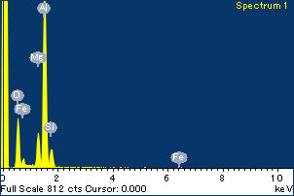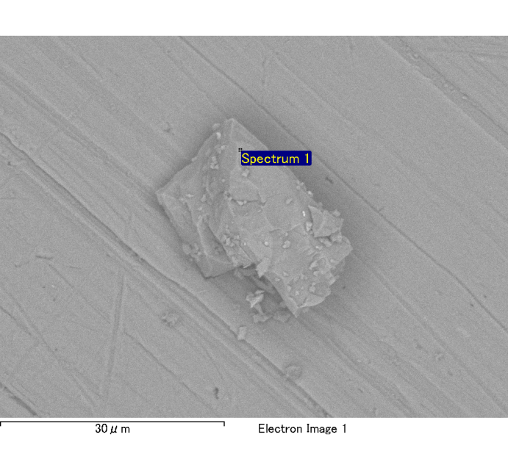

Spectrum Label: Spectrum 1

Livetime 120.0 s

Acquisition geometry ( degrees ):

Tilt = 0.0

Azimuth = 0.0

Elevation = 30.0

Accelerating voltage = 10.00 kV

Total spectrum counts = 120039

|  |  |  |  |
| --- | --- | --- | --- |
| Sample data : | Energy (eV) | Resn. (eV) | Area |
| Strobe : | 3.8 | 54.06 | 1207952 |
|  |  |  |  |
| Optimization data : Cobalt K series |  |  |  |
|  | Energy (eV) | Resn. (eV) | Area |
| Strobe : | .1 | 53.96 | 498142 |
| Optimization element : | 6926.7 | 142.17 | 16696 |

Spectrum processing :

No peaks omitted

Processing option : Oxygen by stoichiometry

Number of iterations = 2

Standard :

Na Albite 1-Jun-1999 12:00 AM

Mg MgO 1-Jun-1999 12:00 AM

Al Al2O3 1-Jun-1999 12:00 AM

Si SiO2 1-Jun-1999 12:00 AM

P GaP 1-Jun-1999 12:00 AM

S FeS2 1-Jun-1999 12:00 AM

K MAD-10 Feldspar 1-Jun-1999 12:00 AM

Ca Wollastonite 1-Jun-1999 12:00 AM

Cr Cr 1-Jun-1999 12:00 AM

Mn Mn 1-Jun-1999 12:00 AM

Fe Fe 1-Jun-1999 12:00 AM

Ni Ni 1-Jun-1999 12:00 AM

|  |  |  |  |  |  |
| --- | --- | --- | --- | --- | --- |
| Element | Weight% | Atomic% | Compd% | Formula |  |
|  |  |  |  |  |  |
| Na K | 0.00 | -0.11 | 0.00 | Na2O |  |
| Mg K | 0.13 | 5.03 | 0.22 | MgO |  |
| Al K | 0.90 | 30.29 | 1.70 | Al2O3 |  |
| Si K | 0.12 | 3.81 | 0.25 | SiO2 |  |
| P K | 0.00 | 0.11 | 0.01 | P2O5 |  |
| S K | 0.00 | 0.01 | 0.00 | SO3 |  |
| K K | 0.00 | -0.07 | 0.00 | K2O |  |
| Ca K | 0.00 | 0.08 | 0.01 | CaO |  |
| Cr K | 0.01 | 0.22 | 0.02 | Cr2O3 |  |
| Mn K | 0.00 | -0.03 | 0.00 | MnO |  |
| Fe K | 0.08 | 1.33 | 0.10 | FeO |  |
| Ni K | -0.02 | -0.34 | -0.03 | NiO |  |
| O | 1.05 | 59.67 |  |  |  |
| Totals | 2.27 |  |  |  |  |

Project: Project 1

Owner: Administrator

Site: Site of Interest 7

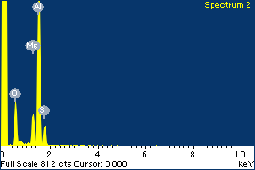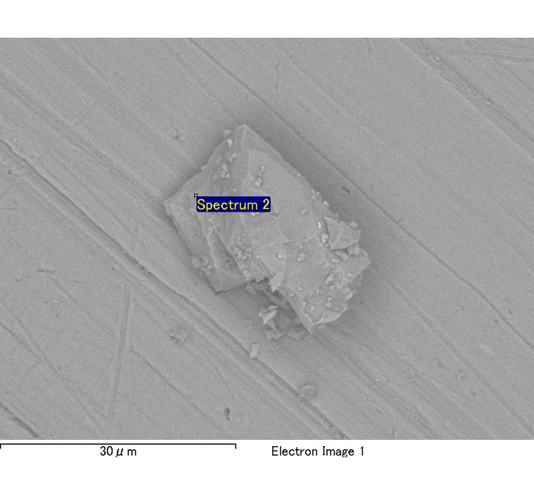

Spectrum Label: Spectrum 2

Livetime 120.0 s

Acquisition geometry ( degrees ):

Tilt = 0.0

Azimuth = 0.0

Elevation = 30.0

Accelerating voltage = 10.00 kV

Total spectrum counts = 120317

|  |  |  |  |
| --- | --- | --- | --- |
| Sample data : | Energy (eV) | Resn. (eV) | Area |
| Strobe : | 3.8 | 54.06 | 1207902 |
|  |  |  |  |
| Optimization data : Cobalt K series |  |  |  |
|  | Energy (eV) | Resn. (eV) | Area |
| Strobe : | .1 | 53.96 | 498142 |
| Optimization element : | 6926.7 | 142.17 | 16696 |

Spectrum processing :

No peaks omitted

Processing option : Oxygen by stoichiometry

Number of iterations = 2

Standard :

Na Albite 1-Jun-1999 12:00 AM

Mg MgO 1-Jun-1999 12:00 AM

Al Al2O3 1-Jun-1999 12:00 AM

Si SiO2 1-Jun-1999 12:00 AM

P GaP 1-Jun-1999 12:00 AM

S FeS2 1-Jun-1999 12:00 AM

K MAD-10 Feldspar 1-Jun-1999 12:00 AM

Ca Wollastonite 1-Jun-1999 12:00 AM

Cr Cr 1-Jun-1999 12:00 AM

Mn Mn 1-Jun-1999 12:00 AM

Fe Fe 1-Jun-1999 12:00 AM

Ni Ni 1-Jun-1999 12:00 AM

|  |  |  |  |  |  |
| --- | --- | --- | --- | --- | --- |
| Element | Weight% | Atomic% | Compd% | Formula |  |
|  |  |  |  |  |  |
| Na K | 0.01 | 0.20 | 0.01 | Na2O |  |
| Mg K | 0.15 | 5.21 | 0.25 | MgO |  |
| Al K | 0.91 | 28.62 | 1.72 | Al2O3 |  |
| Si K | 0.14 | 4.32 | 0.31 | SiO2 |  |
| P K | 0.00 | -0.04 | 0.00 | P2O5 |  |
| S K | 0.00 | -0.03 | 0.00 | SO3 |  |
| K K | 0.01 | 0.12 | 0.01 | K2O |  |
| Ca K | 0.00 | -0.04 | 0.00 | CaO |  |
| Cr K | 0.02 | 0.26 | 0.02 | Cr2O3 |  |
| Mn K | -0.01 | -0.13 | -0.01 | MnO |  |
| Fe K | 0.10 | 1.50 | 0.13 | FeO |  |
| Ni K | 0.05 | 0.76 | 0.07 | NiO |  |
| O | 1.12 | 59.24 |  |  |  |
| Totals | 2.49 |  |  |  |  |

Project: Project 1

Owner: Administrator

Site: Site of Interest 7

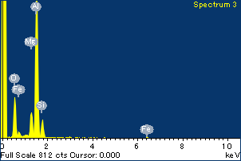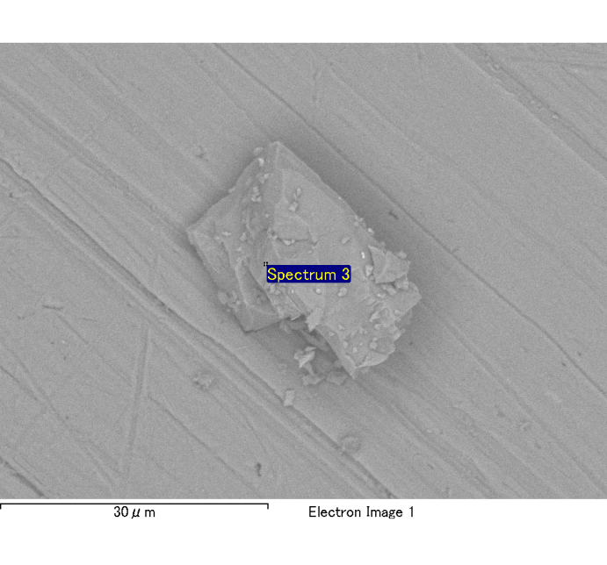

Spectrum Label: Spectrum 3

Livetime 120.0 s

Acquisition geometry ( degrees ):

Tilt = 0.0

Azimuth = 0.0

Elevation = 30.0

Accelerating voltage = 10.00 kV

Total spectrum counts = 119595

|  |  |  |  |
| --- | --- | --- | --- |
| Sample data : | Energy (eV) | Resn. (eV) | Area |
| Strobe : | 3.8 | 54.03 | 1208577 |
|  |  |  |  |
| Optimization data : Cobalt K series |  |  |  |
|  | Energy (eV) | Resn. (eV) | Area |
| Strobe : | .1 | 53.96 | 498142 |
| Optimization element : | 6926.7 | 142.17 | 16696 |

Spectrum processing :

No peaks omitted

Processing option : Oxygen by stoichiometry

Number of iterations = 2

Standard :

Na Albite 1-Jun-1999 12:00 AM

Mg MgO 1-Jun-1999 12:00 AM

Al Al2O3 1-Jun-1999 12:00 AM

Si SiO2 1-Jun-1999 12:00 AM

P GaP 1-Jun-1999 12:00 AM

S FeS2 1-Jun-1999 12:00 AM

K MAD-10 Feldspar 1-Jun-1999 12:00 AM

Ca Wollastonite 1-Jun-1999 12:00 AM

Cr Cr 1-Jun-1999 12:00 AM

Mn Mn 1-Jun-1999 12:00 AM

Fe Fe 1-Jun-1999 12:00 AM

Ni Ni 1-Jun-1999 12:00 AM

|  |  |  |  |  |  |
| --- | --- | --- | --- | --- | --- |
| Element | Weight% | Atomic% | Compd% | Formula |  |
|  |  |  |  |  |  |
| Na K | 0.00 | 0.09 | 0.00 | Na2O |  |
| Mg K | 0.13 | 4.99 | 0.22 | MgO |  |
| Al K | 0.88 | 29.79 | 1.66 | Al2O3 |  |
| Si K | 0.13 | 4.16 | 0.27 | SiO2 |  |
| P K | 0.00 | 0.07 | 0.01 | P2O5 |  |
| S K | 0.00 | 0.06 | 0.01 | SO3 |  |
| K K | 0.00 | 0.07 | 0.00 | K2O |  |
| Ca K | 0.00 | -0.06 | 0.00 | CaO |  |
| Cr K | 0.00 | 0.03 | 0.00 | Cr2O3 |  |
| Mn K | 0.01 | 0.19 | 0.01 | MnO |  |
| Fe K | 0.13 | 2.19 | 0.17 | FeO |  |
| Ni K | -0.08 | -1.18 | -0.10 | NiO |  |
| O | 1.04 | 59.60 |  |  |  |
| Totals | 2.26 |  |  |  |  |

Project: Project 1

Owner: Administrator

Site: Site of Interest 7

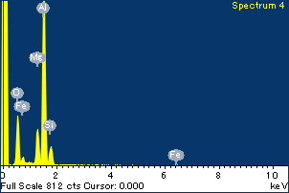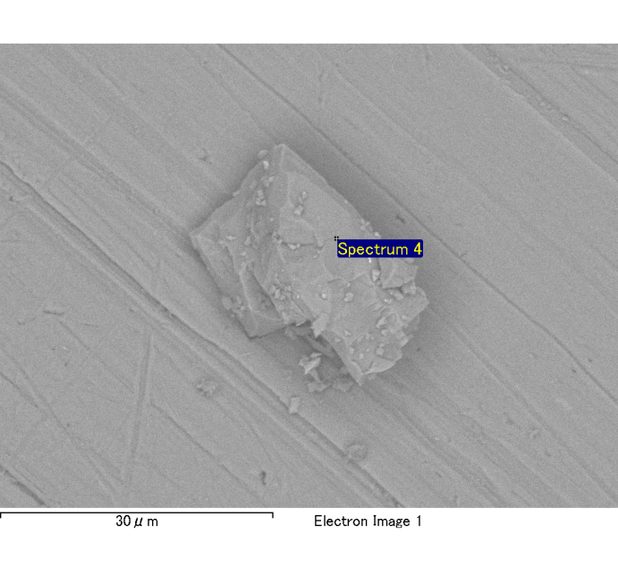

Spectrum Label: Spectrum 4

Livetime 120.0 s

Acquisition geometry ( degrees ):

Tilt = 0.0

Azimuth = 0.0

Elevation = 30.0

Accelerating voltage = 10.00 kV

Total spectrum counts = 120175

|  |  |  |  |
| --- | --- | --- | --- |
| Sample data : | Energy (eV) | Resn. (eV) | Area |
| Strobe : | 3.8 | 54.02 | 1209040 |
|  |  |  |  |
| Optimization data : Cobalt K series |  |  |  |
|  | Energy (eV) | Resn. (eV) | Area |
| Strobe : | .1 | 53.96 | 498142 |
| Optimization element : | 6926.7 | 142.17 | 16696 |

Spectrum processing :

No peaks omitted

Processing option : Oxygen by stoichiometry

Number of iterations = 2

Standard :

Na Albite 1-Jun-1999 12:00 AM

Mg MgO 1-Jun-1999 12:00 AM

Al Al2O3 1-Jun-1999 12:00 AM

Si SiO2 1-Jun-1999 12:00 AM

P GaP 1-Jun-1999 12:00 AM

S FeS2 1-Jun-1999 12:00 AM

K MAD-10 Feldspar 1-Jun-1999 12:00 AM

Ca Wollastonite 1-Jun-1999 12:00 AM

Cr Cr 1-Jun-1999 12:00 AM

Mn Mn 1-Jun-1999 12:00 AM

Fe Fe 1-Jun-1999 12:00 AM

Ni Ni 1-Jun-1999 12:00 AM

|  |  |  |  |  |  |
| --- | --- | --- | --- | --- | --- |
| Element | Weight% | Atomic% | Compd% | Formula |  |
|  |  |  |  |  |  |
| Na K | -0.01 | -0.20 | -0.01 | Na2O |  |
| Mg K | 0.15 | 5.63 | 0.25 | MgO |  |
| Al K | 0.88 | 29.78 | 1.67 | Al2O3 |  |
| Si K | 0.12 | 3.97 | 0.26 | SiO2 |  |
| P K | 0.00 | -0.10 | -0.01 | P2O5 |  |
| S K | 0.00 | -0.10 | -0.01 | SO3 |  |
| K K | 0.00 | -0.06 | 0.00 | K2O |  |
| Ca K | 0.00 | 0.02 | 0.00 | CaO |  |
| Cr K | -0.01 | -0.17 | -0.01 | Cr2O3 |  |
| Mn K | 0.00 | -0.02 | 0.00 | MnO |  |
| Fe K | 0.11 | 1.81 | 0.14 | FeO |  |
| Ni K | 0.01 | 0.15 | 0.01 | NiO |  |
| O | 1.04 | 59.28 |  |  |  |
| Totals | 2.29 |  |  |  |  |

Project: Project 1

Owner: Administrator

Site: Site of Interest 7

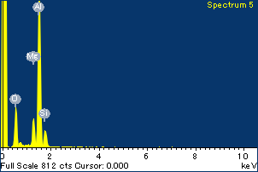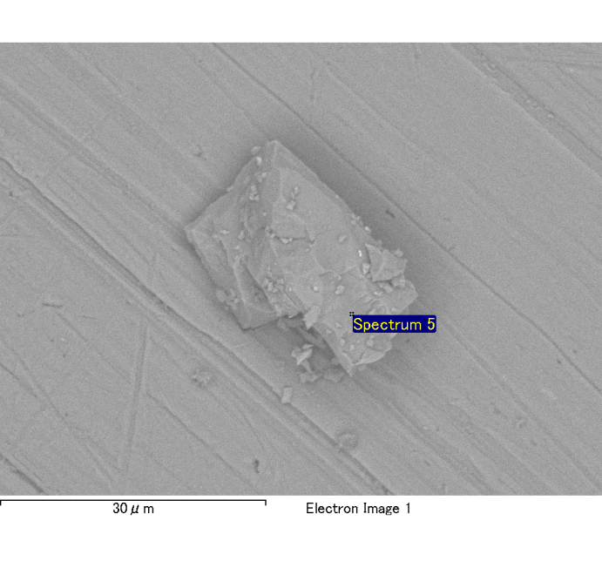

Spectrum Label: Spectrum 5

Livetime 120.0 s

Acquisition geometry ( degrees ):

Tilt = 0.0

Azimuth = 0.0

Elevation = 30.0

Accelerating voltage = 10.00 kV

Total spectrum counts = 119551

|  |  |  |  |
| --- | --- | --- | --- |
| Sample data : | Energy (eV) | Resn. (eV) | Area |
| Strobe : | 3.8 | 54.05 | 1208914 |
|  |  |  |  |
| Optimization data : Cobalt K series |  |  |  |
|  | Energy (eV) | Resn. (eV) | Area |
| Strobe : | .1 | 53.96 | 498142 |
| Optimization element : | 6926.7 | 142.17 | 16696 |

Spectrum processing :

No peaks omitted

Processing option : Oxygen by stoichiometry

Number of iterations = 2

Standard :

Na Albite 1-Jun-1999 12:00 AM

Mg MgO 1-Jun-1999 12:00 AM

Al Al2O3 1-Jun-1999 12:00 AM

Si SiO2 1-Jun-1999 12:00 AM

P GaP 1-Jun-1999 12:00 AM

S FeS2 1-Jun-1999 12:00 AM

K MAD-10 Feldspar 1-Jun-1999 12:00 AM

Ca Wollastonite 1-Jun-1999 12:00 AM

Cr Cr 1-Jun-1999 12:00 AM

Mn Mn 1-Jun-1999 12:00 AM

Fe Fe 1-Jun-1999 12:00 AM

Ni Ni 1-Jun-1999 12:00 AM

|  |  |  |  |  |  |
| --- | --- | --- | --- | --- | --- |
| Element | Weight% | Atomic% | Compd% | Formula |  |
|  |  |  |  |  |  |
| Na K | 0.00 | -0.02 | 0.00 | Na2O |  |
| Mg K | 0.13 | 4.94 | 0.21 | MgO |  |
| Al K | 0.88 | 31.14 | 1.66 | Al2O3 |  |
| Si K | 0.12 | 4.23 | 0.27 | SiO2 |  |
| P K | 0.00 | -0.11 | -0.01 | P2O5 |  |
| S K | 0.01 | 0.16 | 0.01 | SO3 |  |
| K K | 0.00 | -0.12 | -0.01 | K2O |  |
| Ca K | 0.00 | 0.03 | 0.00 | CaO |  |
| Cr K | 0.01 | 0.16 | 0.01 | Cr2O3 |  |
| Mn K | -0.03 | -0.53 | -0.04 | MnO |  |
| Fe K | 0.05 | 0.88 | 0.07 | FeO |  |
| Ni K | -0.05 | -0.84 | -0.07 | NiO |  |
| O | 1.01 | 60.06 |  |  |  |
| Totals | 2.11 |  |  |  |  |

Project: Project 1

Owner: Administrator

Site: Site of Interest 7

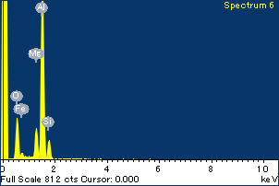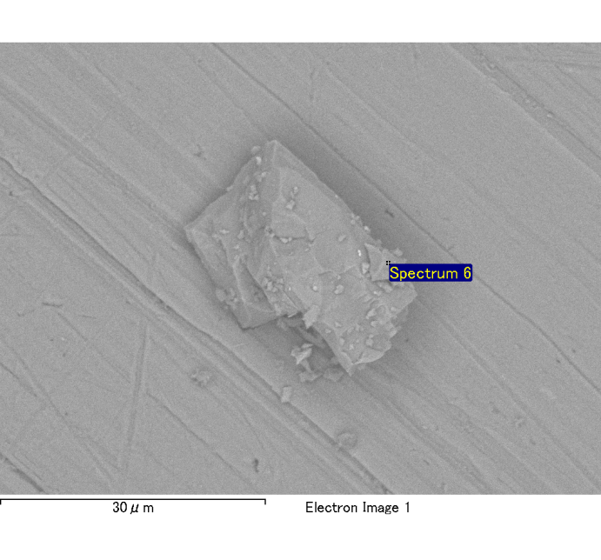

Spectrum Label: Spectrum 6

Livetime 120.0 s

Acquisition geometry ( degrees ):

Tilt = 0.0

Azimuth = 0.0

Elevation = 30.0

Accelerating voltage = 10.00 kV

Total spectrum counts = 119307

|  |  |  |  |
| --- | --- | --- | --- |
| Sample data : | Energy (eV) | Resn. (eV) | Area |
| Strobe : | 3.8 | 53.99 | 1208506 |
|  |  |  |  |
| Optimization data : Cobalt K series |  |  |  |
|  | Energy (eV) | Resn. (eV) | Area |
| Strobe : | .1 | 53.96 | 498142 |
| Optimization element : | 6926.7 | 142.17 | 16696 |

Spectrum processing :

No peaks omitted

Processing option : Oxygen by stoichiometry

Number of iterations = 2

Standard :

Na Albite 1-Jun-1999 12:00 AM

Mg MgO 1-Jun-1999 12:00 AM

Al Al2O3 1-Jun-1999 12:00 AM

Si SiO2 1-Jun-1999 12:00 AM

P GaP 1-Jun-1999 12:00 AM

S FeS2 1-Jun-1999 12:00 AM

K MAD-10 Feldspar 1-Jun-1999 12:00 AM

Ca Wollastonite 1-Jun-1999 12:00 AM

Cr Cr 1-Jun-1999 12:00 AM

Mn Mn 1-Jun-1999 12:00 AM

Fe Fe 1-Jun-1999 12:00 AM

Ni Ni 1-Jun-1999 12:00 AM

|  |  |  |  |  |  |
| --- | --- | --- | --- | --- | --- |
| Element | Weight% | Atomic% | Compd% | Formula |  |
|  |  |  |  |  |  |
| Na K | 0.00 | -0.07 | 0.00 | Na2O |  |
| Mg K | 0.13 | 4.93 | 0.21 | MgO |  |
| Al K | 0.87 | 30.00 | 1.63 | Al2O3 |  |
| Si K | 0.12 | 4.13 | 0.27 | SiO2 |  |
| P K | 0.00 | 0.11 | 0.01 | P2O5 |  |
| S K | 0.00 | -0.03 | 0.00 | SO3 |  |
| K K | 0.00 | 0.05 | 0.00 | K2O |  |
| Ca K | 0.00 | 0.09 | 0.01 | CaO |  |
| Cr K | 0.00 | -0.06 | 0.00 | Cr2O3 |  |
| Mn K | 0.02 | 0.30 | 0.02 | MnO |  |
| Fe K | 0.07 | 1.20 | 0.09 | FeO |  |
| Ni K | -0.02 | -0.25 | -0.02 | NiO |  |
| O | 1.02 | 59.61 |  |  |  |
| Totals | 2.21 |  |  |  |  |

Project: Project 1

Owner: Administrator

Site: Site of Interest 7

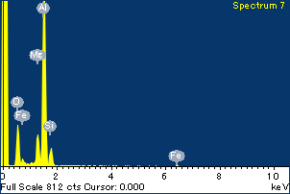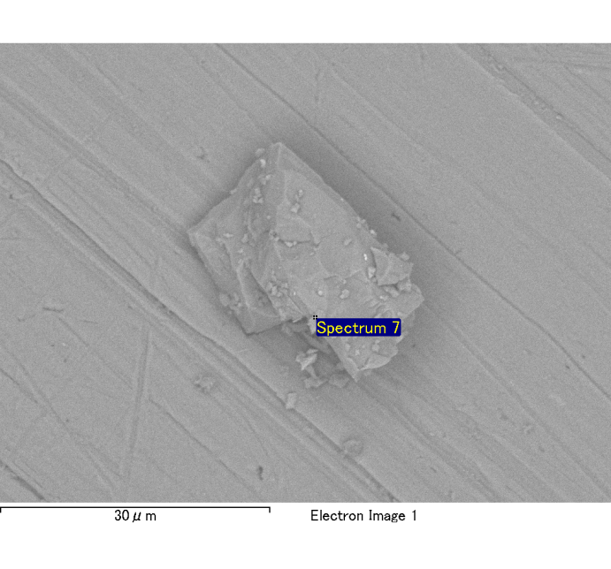

Spectrum Label: Spectrum 7

Livetime 120.0 s

Acquisition geometry ( degrees ):

Tilt = 0.0

Azimuth = 0.0

Elevation = 30.0

Accelerating voltage = 10.00 kV

Total spectrum counts = 119538

|  |  |  |  |
| --- | --- | --- | --- |
| Sample data : | Energy (eV) | Resn. (eV) | Area |
| Strobe : | 3.8 | 54.00 | 1207883 |
|  |  |  |  |
| Optimization data : Cobalt K series |  |  |  |
|  | Energy (eV) | Resn. (eV) | Area |
| Strobe : | .1 | 53.96 | 498142 |
| Optimization element : | 6926.7 | 142.17 | 16696 |

Spectrum processing :

No peaks omitted

Processing option : Oxygen by stoichiometry

Number of iterations = 2

Standard :

Na Albite 1-Jun-1999 12:00 AM

Mg MgO 1-Jun-1999 12:00 AM

Al Al2O3 1-Jun-1999 12:00 AM

Si SiO2 1-Jun-1999 12:00 AM

P GaP 1-Jun-1999 12:00 AM

S FeS2 1-Jun-1999 12:00 AM

K MAD-10 Feldspar 1-Jun-1999 12:00 AM

Ca Wollastonite 1-Jun-1999 12:00 AM

Cr Cr 1-Jun-1999 12:00 AM

Mn Mn 1-Jun-1999 12:00 AM

Fe Fe 1-Jun-1999 12:00 AM

Ni Ni 1-Jun-1999 12:00 AM

|  |  |  |  |  |  |
| --- | --- | --- | --- | --- | --- |
| Element | Weight% | Atomic% | Compd% | Formula |  |
|  |  |  |  |  |  |
| Na K | 0.00 | 0.05 | 0.00 | Na2O |  |
| Mg K | 0.13 | 4.84 | 0.21 | MgO |  |
| Al K | 0.87 | 29.48 | 1.65 | Al2O3 |  |
| Si K | 0.11 | 3.55 | 0.23 | SiO2 |  |
| P K | 0.00 | -0.02 | 0.00 | P2O5 |  |
| S K | 0.00 | -0.10 | -0.01 | SO3 |  |
| K K | 0.01 | 0.16 | 0.01 | K2O |  |
| Ca K | 0.00 | 0.06 | 0.00 | CaO |  |
| Cr K | 0.00 | 0.03 | 0.00 | Cr2O3 |  |
| Mn K | 0.01 | 0.19 | 0.01 | MnO |  |
| Fe K | 0.17 | 2.76 | 0.22 | FeO |  |
| Ni K | 0.00 | 0.03 | 0.00 | NiO |  |
| O | 1.04 | 58.99 |  |  |  |
| Totals | 2.34 |  |  |  |  |

Project: Project 1

Owner: Administrator

Site: Site of Interest 7