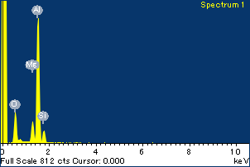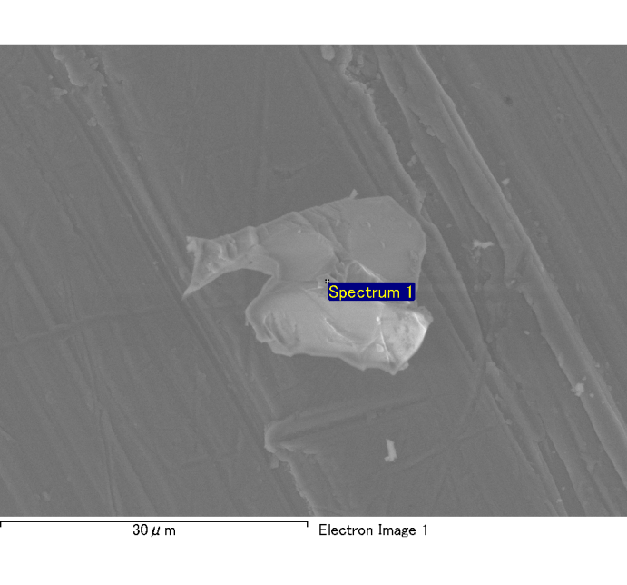

Spectrum Label: Spectrum 1

Livetime 120.0 s

Acquisition geometry ( degrees ):

Tilt = 0.0

Azimuth = 0.0

Elevation = 30.0

Accelerating voltage = 10.00 kV

Total spectrum counts = 116673

|  |  |  |  |
| --- | --- | --- | --- |
| Sample data : | Energy (eV) | Resn. (eV) | Area |
| Strobe : | 3.8 | 54.03 | 1208636 |
|  |  |  |  |
| Optimization data : Cobalt K series |  |  |  |
|  | Energy (eV) | Resn. (eV) | Area |
| Strobe : | .1 | 53.96 | 498142 |
| Optimization element : | 6926.7 | 142.17 | 16696 |

Spectrum processing :

No peaks omitted

Processing option : Oxygen by stoichiometry

Number of iterations = 2

Standard :

Na Albite 1-Jun-1999 12:00 AM

Mg MgO 1-Jun-1999 12:00 AM

Al Al2O3 1-Jun-1999 12:00 AM

Si SiO2 1-Jun-1999 12:00 AM

P GaP 1-Jun-1999 12:00 AM

S FeS2 1-Jun-1999 12:00 AM

K MAD-10 Feldspar 1-Jun-1999 12:00 AM

Ca Wollastonite 1-Jun-1999 12:00 AM

Cr Cr 1-Jun-1999 12:00 AM

Mn Mn 1-Jun-1999 12:00 AM

Fe Fe 1-Jun-1999 12:00 AM

Ni Ni 1-Jun-1999 12:00 AM

|  |  |  |  |  |  |
| --- | --- | --- | --- | --- | --- |
| Element | Weight% | Atomic% | Compd% | Formula |  |
|  |  |  |  |  |  |
| Na K | 0.00 | -0.10 | 0.00 | Na2O |  |
| Mg K | 0.09 | 4.61 | 0.16 | MgO |  |
| Al K | 0.68 | 29.87 | 1.29 | Al2O3 |  |
| Si K | 0.09 | 3.95 | 0.20 | SiO2 |  |
| P K | 0.00 | -0.13 | -0.01 | P2O5 |  |
| S K | 0.00 | -0.08 | -0.01 | SO3 |  |
| K K | 0.00 | 0.11 | 0.00 | K2O |  |
| Ca K | 0.00 | 0.00 | 0.00 | CaO |  |
| Cr K | 0.00 | 0.05 | 0.00 | Cr2O3 |  |
| Mn K | 0.01 | 0.14 | 0.01 | MnO |  |
| Fe K | 0.10 | 2.03 | 0.12 | FeO |  |
| Ni K | 0.01 | 0.29 | 0.02 | NiO |  |
| O | 0.80 | 59.27 |  |  |  |
| Totals | 1.79 |  |  |  |  |

Project: Project 1

Owner: Administrator

Site: Site of Interest 16

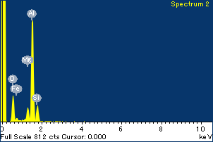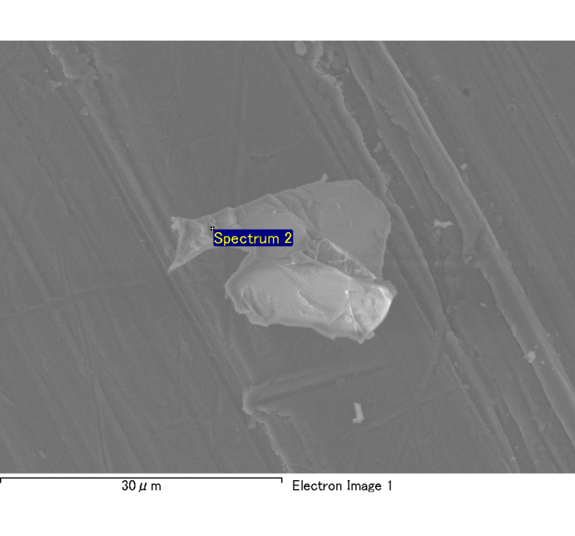

Spectrum Label: Spectrum 2

Livetime 120.0 s

Acquisition geometry ( degrees ):

Tilt = 0.0

Azimuth = 0.0

Elevation = 30.0

Accelerating voltage = 10.00 kV

Total spectrum counts = 116586

|  |  |  |  |
| --- | --- | --- | --- |
| Sample data : | Energy (eV) | Resn. (eV) | Area |
| Strobe : | 3.8 | 54.06 | 1209554 |
|  |  |  |  |
| Optimization data : Cobalt K series |  |  |  |
|  | Energy (eV) | Resn. (eV) | Area |
| Strobe : | .1 | 53.96 | 498142 |
| Optimization element : | 6926.7 | 142.17 | 16696 |

Spectrum processing :

No peaks omitted

Processing option : Oxygen by stoichiometry

Number of iterations = 2

Standard :

Na Albite 1-Jun-1999 12:00 AM

Mg MgO 1-Jun-1999 12:00 AM

Al Al2O3 1-Jun-1999 12:00 AM

Si SiO2 1-Jun-1999 12:00 AM

P GaP 1-Jun-1999 12:00 AM

S FeS2 1-Jun-1999 12:00 AM

K MAD-10 Feldspar 1-Jun-1999 12:00 AM

Ca Wollastonite 1-Jun-1999 12:00 AM

Cr Cr 1-Jun-1999 12:00 AM

Mn Mn 1-Jun-1999 12:00 AM

Fe Fe 1-Jun-1999 12:00 AM

Ni Ni 1-Jun-1999 12:00 AM

|  |  |  |  |  |  |
| --- | --- | --- | --- | --- | --- |
| Element | Weight% | Atomic% | Compd% | Formula |  |
|  |  |  |  |  |  |
| Na K | 0.00 | -0.08 | 0.00 | Na2O |  |
| Mg K | 0.07 | 3.42 | 0.12 | MgO |  |
| Al K | 0.67 | 29.39 | 1.26 | Al2O3 |  |
| Si K | 0.13 | 5.69 | 0.29 | SiO2 |  |
| P K | 0.00 | 0.00 | 0.00 | P2O5 |  |
| S K | 0.00 | 0.12 | 0.01 | SO3 |  |
| K K | 0.00 | -0.03 | 0.00 | K2O |  |
| Ca K | 0.00 | 0.00 | 0.00 | CaO |  |
| Cr K | -0.01 | -0.23 | -0.01 | Cr2O3 |  |
| Mn K | 0.02 | 0.34 | 0.02 | MnO |  |
| Fe K | 0.06 | 1.32 | 0.08 | FeO |  |
| Ni K | -0.01 | -0.22 | -0.01 | NiO |  |
| O | 0.81 | 60.29 |  |  |  |
| Totals | 1.74 |  |  |  |  |

Project: Project 1

Owner: Administrator

Site: Site of Interest 16

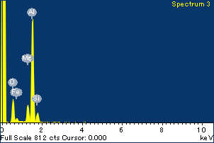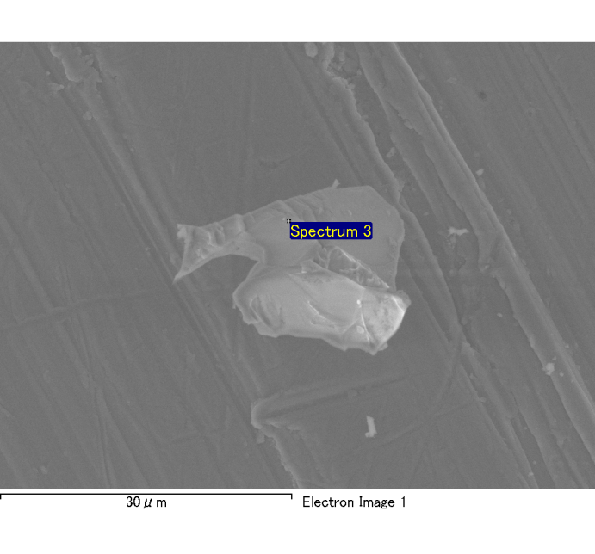

Spectrum Label: Spectrum 3

Livetime 120.0 s

Acquisition geometry ( degrees ):

Tilt = 0.0

Azimuth = 0.0

Elevation = 30.0

Accelerating voltage = 10.00 kV

Total spectrum counts = 116556

|  |  |  |  |
| --- | --- | --- | --- |
| Sample data : | Energy (eV) | Resn. (eV) | Area |
| Strobe : | 3.8 | 53.98 | 1209236 |
|  |  |  |  |
| Optimization data : Cobalt K series |  |  |  |
|  | Energy (eV) | Resn. (eV) | Area |
| Strobe : | .1 | 53.96 | 498142 |
| Optimization element : | 6926.7 | 142.17 | 16696 |

Spectrum processing :

No peaks omitted

Processing option : Oxygen by stoichiometry

Number of iterations = 2

Standard :

Na Albite 1-Jun-1999 12:00 AM

Mg MgO 1-Jun-1999 12:00 AM

Al Al2O3 1-Jun-1999 12:00 AM

Si SiO2 1-Jun-1999 12:00 AM

P GaP 1-Jun-1999 12:00 AM

S FeS2 1-Jun-1999 12:00 AM

K MAD-10 Feldspar 1-Jun-1999 12:00 AM

Ca Wollastonite 1-Jun-1999 12:00 AM

Cr Cr 1-Jun-1999 12:00 AM

Mn Mn 1-Jun-1999 12:00 AM

Fe Fe 1-Jun-1999 12:00 AM

Ni Ni 1-Jun-1999 12:00 AM

|  |  |  |  |  |  |
| --- | --- | --- | --- | --- | --- |
| Element | Weight% | Atomic% | Compd% | Formula |  |
|  |  |  |  |  |  |
| Na K | 0.00 | -0.19 | 0.00 | Na2O |  |
| Mg K | 0.09 | 4.91 | 0.16 | MgO |  |
| Al K | 0.66 | 31.10 | 1.25 | Al2O3 |  |
| Si K | 0.08 | 3.68 | 0.17 | SiO2 |  |
| P K | 0.00 | 0.01 | 0.00 | P2O5 |  |
| S K | 0.00 | 0.00 | 0.00 | SO3 |  |
| K K | 0.00 | 0.09 | 0.00 | K2O |  |
| Ca K | 0.00 | -0.05 | 0.00 | CaO |  |
| Cr K | 0.00 | 0.08 | 0.00 | Cr2O3 |  |
| Mn K | -0.01 | -0.31 | -0.02 | MnO |  |
| Fe K | 0.03 | 0.60 | 0.03 | FeO |  |
| Ni K | 0.02 | 0.42 | 0.02 | NiO |  |
| O | 0.75 | 59.66 |  |  |  |
| Totals | 1.62 |  |  |  |  |

Project: Project 1

Owner: Administrator

Site: Site of Interest 16

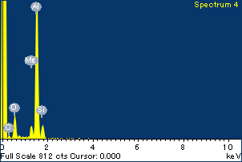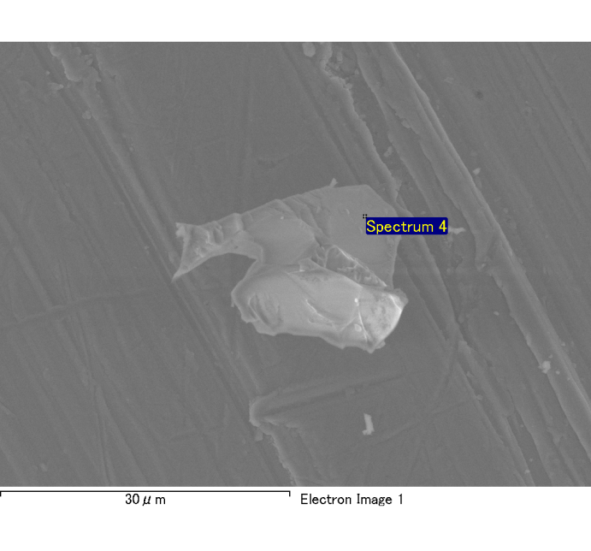

Spectrum Label: Spectrum 4

Livetime 120.0 s

Acquisition geometry ( degrees ):

Tilt = 0.0

Azimuth = 0.0

Elevation = 30.0

Accelerating voltage = 10.00 kV

Total spectrum counts = 116649

|  |  |  |  |
| --- | --- | --- | --- |
| Sample data : | Energy (eV) | Resn. (eV) | Area |
| Strobe : | 3.8 | 54.09 | 1208491 |
|  |  |  |  |
| Optimization data : Cobalt K series |  |  |  |
|  | Energy (eV) | Resn. (eV) | Area |
| Strobe : | .1 | 53.96 | 498142 |
| Optimization element : | 6926.7 | 142.17 | 16696 |

Spectrum processing :

No peaks omitted

Processing option : Oxygen by stoichiometry

Number of iterations = 2

Standard :

Na Albite 1-Jun-1999 12:00 AM

Mg MgO 1-Jun-1999 12:00 AM

Al Al2O3 1-Jun-1999 12:00 AM

Si SiO2 1-Jun-1999 12:00 AM

P GaP 1-Jun-1999 12:00 AM

S FeS2 1-Jun-1999 12:00 AM

K MAD-10 Feldspar 1-Jun-1999 12:00 AM

Ca Wollastonite 1-Jun-1999 12:00 AM

Cr Cr 1-Jun-1999 12:00 AM

Mn Mn 1-Jun-1999 12:00 AM

Fe Fe 1-Jun-1999 12:00 AM

Ni Ni 1-Jun-1999 12:00 AM

|  |  |  |  |  |  |
| --- | --- | --- | --- | --- | --- |
| Element | Weight% | Atomic% | Compd% | Formula |  |
|  |  |  |  |  |  |
| Na K | -0.01 | -0.28 | -0.01 | Na2O |  |
| Mg K | 0.06 | 2.68 | 0.09 | MgO |  |
| Al K | 0.76 | 32.72 | 1.43 | Al2O3 |  |
| Si K | 0.09 | 3.87 | 0.20 | SiO2 |  |
| P K | 0.00 | 0.08 | 0.00 | P2O5 |  |
| S K | 0.00 | 0.05 | 0.00 | SO3 |  |
| K K | 0.00 | 0.03 | 0.00 | K2O |  |
| Ca K | 0.00 | 0.02 | 0.00 | CaO |  |
| Cr K | -0.02 | -0.42 | -0.03 | Cr2O3 |  |
| Mn K | 0.02 | 0.41 | 0.03 | MnO |  |
| Fe K | 0.01 | 0.15 | 0.01 | FeO |  |
| Ni K | 0.03 | 0.50 | 0.03 | NiO |  |
| O | 0.83 | 60.19 |  |  |  |
| Totals | 1.77 |  |  |  |  |

Project: Project 1

Owner: Administrator

Site: Site of Interest 16

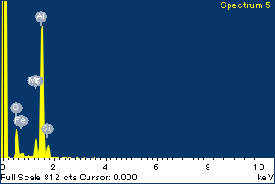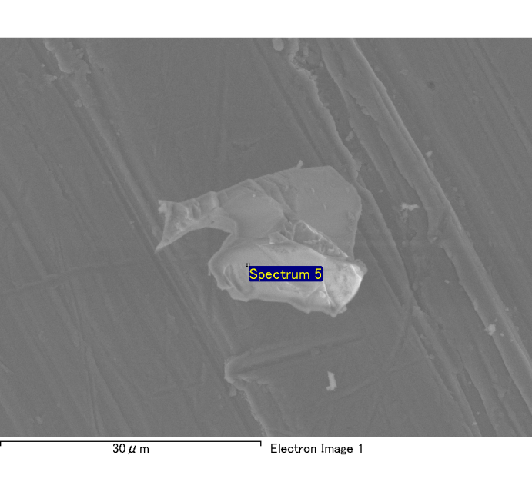

Spectrum Label: Spectrum 5

Livetime 120.0 s

Acquisition geometry ( degrees ):

Tilt = 0.0

Azimuth = 0.0

Elevation = 30.0

Accelerating voltage = 10.00 kV

Total spectrum counts = 115347

|  |  |  |  |
| --- | --- | --- | --- |
| Sample data : | Energy (eV) | Resn. (eV) | Area |
| Strobe : | 3.8 | 53.99 | 1208874 |
|  |  |  |  |
| Optimization data : Cobalt K series |  |  |  |
|  | Energy (eV) | Resn. (eV) | Area |
| Strobe : | .1 | 53.96 | 498142 |
| Optimization element : | 6926.7 | 142.17 | 16696 |

Spectrum processing :

No peaks omitted

Processing option : Oxygen by stoichiometry

Number of iterations = 2

Standard :

Na Albite 1-Jun-1999 12:00 AM

Mg MgO 1-Jun-1999 12:00 AM

Al Al2O3 1-Jun-1999 12:00 AM

Si SiO2 1-Jun-1999 12:00 AM

P GaP 1-Jun-1999 12:00 AM

S FeS2 1-Jun-1999 12:00 AM

K MAD-10 Feldspar 1-Jun-1999 12:00 AM

Ca Wollastonite 1-Jun-1999 12:00 AM

Cr Cr 1-Jun-1999 12:00 AM

Mn Mn 1-Jun-1999 12:00 AM

Fe Fe 1-Jun-1999 12:00 AM

Ni Ni 1-Jun-1999 12:00 AM

|  |  |  |  |  |  |
| --- | --- | --- | --- | --- | --- |
| Element | Weight% | Atomic% | Compd% | Formula |  |
|  |  |  |  |  |  |
| Na K | 0.00 | -0.11 | 0.00 | Na2O |  |
| Mg K | 0.08 | 4.15 | 0.13 | MgO |  |
| Al K | 0.66 | 31.35 | 1.24 | Al2O3 |  |
| Si K | 0.09 | 3.92 | 0.18 | SiO2 |  |
| P K | 0.00 | -0.04 | 0.00 | P2O5 |  |
| S K | 0.00 | 0.02 | 0.00 | SO3 |  |
| K K | 0.00 | 0.01 | 0.00 | K2O |  |
| Ca K | 0.00 | 0.03 | 0.00 | CaO |  |
| Cr K | 0.02 | 0.46 | 0.03 | Cr2O3 |  |
| Mn K | -0.01 | -0.33 | -0.02 | MnO |  |
| Fe K | 0.07 | 1.70 | 0.10 | FeO |  |
| Ni K | -0.05 | -1.11 | -0.06 | NiO |  |
| O | 0.75 | 59.94 |  |  |  |
| Totals | 1.59 |  |  |  |  |

Project: Project 1

Owner: Administrator

Site: Site of Interest 16

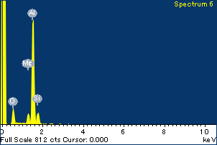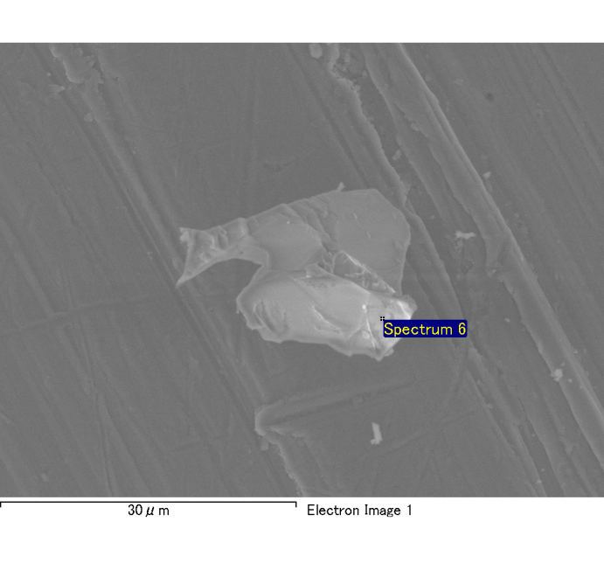

Spectrum Label: Spectrum 6

Livetime 120.0 s

Acquisition geometry ( degrees ):

Tilt = 0.0

Azimuth = 0.0

Elevation = 30.0

Accelerating voltage = 10.00 kV

Total spectrum counts = 114541

|  |  |  |  |
| --- | --- | --- | --- |
| Sample data : | Energy (eV) | Resn. (eV) | Area |
| Strobe : | 3.8 | 54.06 | 1209377 |
|  |  |  |  |
| Optimization data : Cobalt K series |  |  |  |
|  | Energy (eV) | Resn. (eV) | Area |
| Strobe : | .1 | 53.96 | 498142 |
| Optimization element : | 6926.7 | 142.17 | 16696 |

Spectrum processing :

No peaks omitted

Processing option : Oxygen by stoichiometry

Number of iterations = 2

Standard :

Na Albite 1-Jun-1999 12:00 AM

Mg MgO 1-Jun-1999 12:00 AM

Al Al2O3 1-Jun-1999 12:00 AM

Si SiO2 1-Jun-1999 12:00 AM

P GaP 1-Jun-1999 12:00 AM

S FeS2 1-Jun-1999 12:00 AM

K MAD-10 Feldspar 1-Jun-1999 12:00 AM

Ca Wollastonite 1-Jun-1999 12:00 AM

Cr Cr 1-Jun-1999 12:00 AM

Mn Mn 1-Jun-1999 12:00 AM

Fe Fe 1-Jun-1999 12:00 AM

Ni Ni 1-Jun-1999 12:00 AM

|  |  |  |  |  |  |
| --- | --- | --- | --- | --- | --- |
| Element | Weight% | Atomic% | Compd% | Formula |  |
|  |  |  |  |  |  |
| Na K | 0.00 | -0.06 | 0.00 | Na2O |  |
| Mg K | 0.06 | 2.98 | 0.09 | MgO |  |
| Al K | 0.65 | 31.11 | 1.22 | Al2O3 |  |
| Si K | 0.10 | 4.54 | 0.21 | SiO2 |  |
| P K | 0.00 | -0.02 | 0.00 | P2O5 |  |
| S K | 0.00 | -0.09 | -0.01 | SO3 |  |
| K K | 0.00 | 0.06 | 0.00 | K2O |  |
| Ca K | 0.00 | 0.09 | 0.00 | CaO |  |
| Cr K | -0.01 | -0.32 | -0.02 | Cr2O3 |  |
| Mn K | 0.00 | 0.07 | 0.00 | MnO |  |
| Fe K | 0.03 | 0.80 | 0.04 | FeO |  |
| Ni K | 0.04 | 0.96 | 0.06 | NiO |  |
| O | 0.74 | 59.87 |  |  |  |
| Totals | 1.61 |  |  |  |  |

Project: Project 1

Owner: Administrator

Site: Site of Interest 16

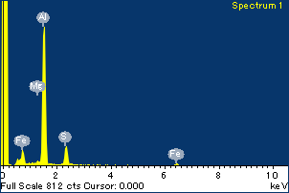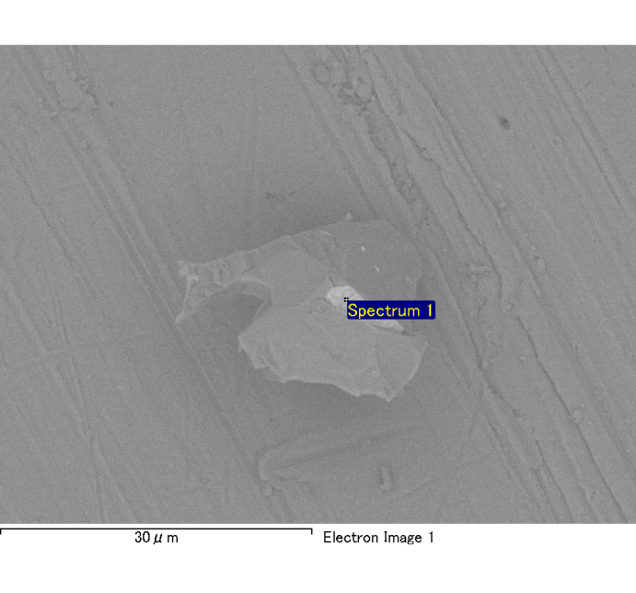

Spectrum Label: Spectrum 1

Livetime 120.0 s

Acquisition geometry ( degrees ):

Tilt = 0.0

Azimuth = 0.0

Elevation = 30.0

Accelerating voltage = 10.00 kV

Total spectrum counts = 115697

|  |  |  |  |
| --- | --- | --- | --- |
| Sample data : | Energy (eV) | Resn. (eV) | Area |
| Strobe : | 3.8 | 54.08 | 1208644 |
|  |  |  |  |
| Optimization data : Cobalt K series |  |  |  |
|  | Energy (eV) | Resn. (eV) | Area |
| Strobe : | .1 | 53.96 | 498142 |
| Optimization element : | 6926.7 | 142.17 | 16696 |

Spectrum processing :

No peaks omitted

Processing option : Oxygen by stoichiometry

Number of iterations = 2

Standard :

Na Albite 1-Jun-1999 12:00 AM

Mg MgO 1-Jun-1999 12:00 AM

Al Al2O3 1-Jun-1999 12:00 AM

Si SiO2 1-Jun-1999 12:00 AM

P GaP 1-Jun-1999 12:00 AM

S FeS2 1-Jun-1999 12:00 AM

K MAD-10 Feldspar 1-Jun-1999 12:00 AM

Ca Wollastonite 1-Jun-1999 12:00 AM

Cr Cr 1-Jun-1999 12:00 AM

Mn Mn 1-Jun-1999 12:00 AM

Fe Fe 1-Jun-1999 12:00 AM

Ni Ni 1-Jun-1999 12:00 AM

|  |  |  |  |  |  |
| --- | --- | --- | --- | --- | --- |
| Element | Weight% | Atomic% | Compd% | Formula |  |
|  |  |  |  |  |  |
| Na K | 0.00 | -0.07 | 0.00 | Na2O |  |
| Mg K | 0.01 | 0.58 | 0.02 | MgO |  |
| Al K | 0.65 | 25.90 | 1.22 | Al2O3 |  |
| Si K | 0.01 | 0.25 | 0.01 | SiO2 |  |
| P K | 0.00 | -0.01 | 0.00 | P2O5 |  |
| S K | 0.17 | 5.68 | 0.42 | SO3 |  |
| K K | 0.00 | 0.06 | 0.00 | K2O |  |
| Ca K | 0.00 | 0.09 | 0.00 | CaO |  |
| Cr K | 0.00 | 0.03 | 0.00 | Cr2O3 |  |
| Mn K | 0.00 | 0.05 | 0.00 | MnO |  |
| Fe K | 0.29 | 5.55 | 0.37 | FeO |  |
| Ni K | -0.02 | -0.41 | -0.03 | NiO |  |
| O | 0.92 | 62.29 |  |  |  |
| Totals | 2.03 |  |  |  |  |

Project: Project 1

Owner: Administrator

Site: Site of Interest 1