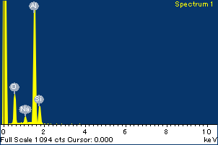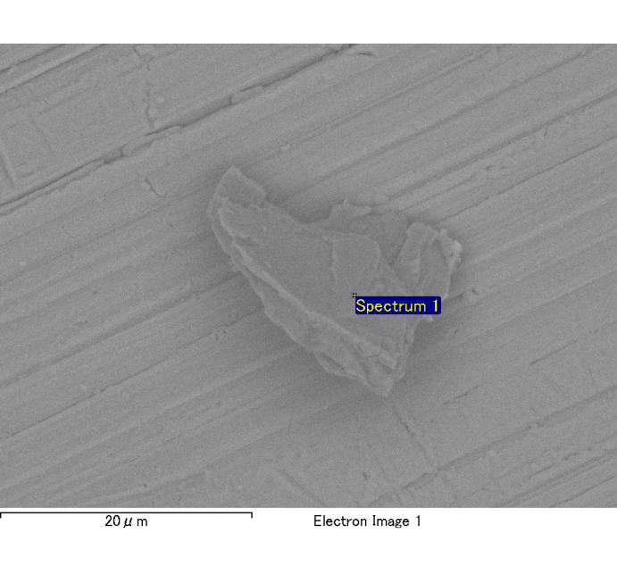

Spectrum Label: Spectrum 1

Livetime 120.0 s

Acquisition geometry ( degrees ):

Tilt = 0.0

Azimuth = 0.0

Elevation = 30.0

Accelerating voltage = 10.00 kV

Total spectrum counts = 121489

|  |  |  |  |
| --- | --- | --- | --- |
| Sample data : | Energy (eV) | Resn. (eV) | Area |
| Strobe : | 3.8 | 54.12 | 1207859 |
|  |  |  |  |
| Optimization data : Cobalt K series |  |  |  |
|  | Energy (eV) | Resn. (eV) | Area |
| Strobe : | .1 | 53.96 | 498142 |
| Optimization element : | 6926.7 | 142.17 | 16696 |

Spectrum processing :

No peaks omitted

Processing option : Oxygen by stoichiometry

Number of iterations = 2

Standard :

Na Albite 1-Jun-1999 12:00 AM

Mg MgO 1-Jun-1999 12:00 AM

Al Al2O3 1-Jun-1999 12:00 AM

Si SiO2 1-Jun-1999 12:00 AM

P GaP 1-Jun-1999 12:00 AM

S FeS2 1-Jun-1999 12:00 AM

K MAD-10 Feldspar 1-Jun-1999 12:00 AM

Ca Wollastonite 1-Jun-1999 12:00 AM

Cr Cr 1-Jun-1999 12:00 AM

Mn Mn 1-Jun-1999 12:00 AM

Fe Fe 1-Jun-1999 12:00 AM

Ni Ni 1-Jun-1999 12:00 AM

|  |  |  |  |  |  |
| --- | --- | --- | --- | --- | --- |
| Element | Weight% | Atomic% | Compd% | Formula |  |
|  |  |  |  |  |  |
| Na K | 0.05 | 1.86 | 0.07 | Na2O |  |
| Mg K | 0.00 | 0.09 | 0.00 | MgO |  |
| Al K | 1.01 | 30.70 | 1.91 | Al2O3 |  |
| Si K | 0.23 | 6.65 | 0.49 | SiO2 |  |
| P K | 0.00 | 0.00 | 0.00 | P2O5 |  |
| S K | 0.00 | -0.04 | 0.00 | SO3 |  |
| K K | 0.01 | 0.12 | 0.01 | K2O |  |
| Ca K | 0.01 | 0.21 | 0.01 | CaO |  |
| Cr K | -0.01 | -0.09 | -0.01 | Cr2O3 |  |
| Mn K | 0.00 | 0.00 | 0.00 | MnO |  |
| Fe K | -0.02 | -0.30 | -0.03 | FeO |  |
| Ni K | 0.03 | 0.36 | 0.03 | NiO |  |
| O | 1.18 | 60.44 |  |  |  |
| Totals | 2.49 |  |  |  |  |

Project: Project 1

Owner: Administrator

Site: Site of Interest 4

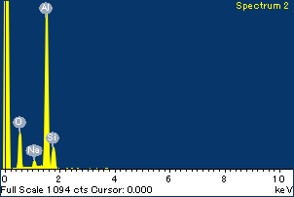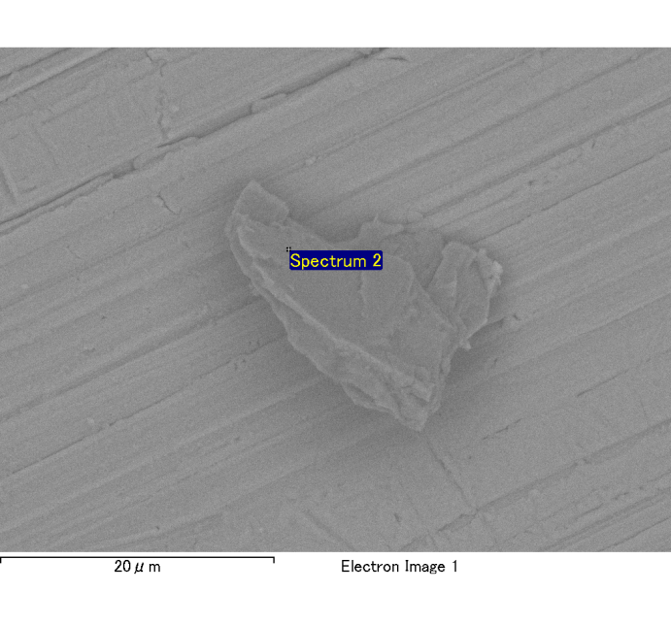

Spectrum Label: Spectrum 2

Livetime 120.0 s

Acquisition geometry ( degrees ):

Tilt = 0.0

Azimuth = 0.0

Elevation = 30.0

Accelerating voltage = 10.00 kV

Total spectrum counts = 121381

|  |  |  |  |
| --- | --- | --- | --- |
| Sample data : | Energy (eV) | Resn. (eV) | Area |
| Strobe : | 3.8 | 54.05 | 1207785 |
|  |  |  |  |
| Optimization data : Cobalt K series |  |  |  |
|  | Energy (eV) | Resn. (eV) | Area |
| Strobe : | .1 | 53.96 | 498142 |
| Optimization element : | 6926.7 | 142.17 | 16696 |

Spectrum processing :

No peaks omitted

Processing option : Oxygen by stoichiometry

Number of iterations = 2

Standard :

Na Albite 1-Jun-1999 12:00 AM

Mg MgO 1-Jun-1999 12:00 AM

Al Al2O3 1-Jun-1999 12:00 AM

Si SiO2 1-Jun-1999 12:00 AM

P GaP 1-Jun-1999 12:00 AM

S FeS2 1-Jun-1999 12:00 AM

K MAD-10 Feldspar 1-Jun-1999 12:00 AM

Ca Wollastonite 1-Jun-1999 12:00 AM

Cr Cr 1-Jun-1999 12:00 AM

Mn Mn 1-Jun-1999 12:00 AM

Fe Fe 1-Jun-1999 12:00 AM

Ni Ni 1-Jun-1999 12:00 AM

|  |  |  |  |  |  |
| --- | --- | --- | --- | --- | --- |
| Element | Weight% | Atomic% | Compd% | Formula |  |
|  |  |  |  |  |  |
| Na K | 0.04 | 1.45 | 0.05 | Na2O |  |
| Mg K | 0.00 | 0.14 | 0.01 | MgO |  |
| Al K | 1.03 | 31.96 | 1.95 | Al2O3 |  |
| Si K | 0.20 | 5.82 | 0.42 | SiO2 |  |
| P K | 0.00 | 0.01 | 0.00 | P2O5 |  |
| S K | 0.00 | -0.09 | -0.01 | SO3 |  |
| K K | 0.01 | 0.11 | 0.01 | K2O |  |
| Ca K | 0.01 | 0.15 | 0.01 | CaO |  |
| Cr K | -0.02 | -0.28 | -0.03 | Cr2O3 |  |
| Mn K | 0.00 | 0.03 | 0.00 | MnO |  |
| Fe K | 0.00 | 0.03 | 0.00 | FeO |  |
| Ni K | 0.02 | 0.31 | 0.03 | NiO |  |
| O | 1.16 | 60.36 |  |  |  |
| Totals | 2.45 |  |  |  |  |

Project: Project 1

Owner: Administrator

Site: Site of Interest 4

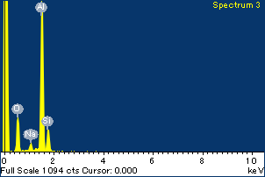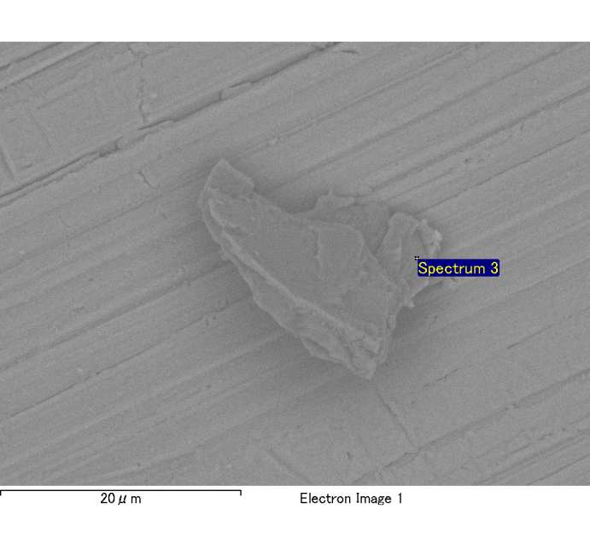

Spectrum Label: Spectrum 3

Livetime 120.0 s

Acquisition geometry ( degrees ):

Tilt = 0.0

Azimuth = 0.0

Elevation = 30.0

Accelerating voltage = 10.00 kV

Total spectrum counts = 120621

|  |  |  |  |
| --- | --- | --- | --- |
| Sample data : | Energy (eV) | Resn. (eV) | Area |
| Strobe : | 3.8 | 53.99 | 1209105 |
|  |  |  |  |
| Optimization data : Cobalt K series |  |  |  |
|  | Energy (eV) | Resn. (eV) | Area |
| Strobe : | .1 | 53.96 | 498142 |
| Optimization element : | 6926.7 | 142.17 | 16696 |

Spectrum processing :

No peaks omitted

Processing option : Oxygen by stoichiometry

Number of iterations = 2

Standard :

Na Albite 1-Jun-1999 12:00 AM

Mg MgO 1-Jun-1999 12:00 AM

Al Al2O3 1-Jun-1999 12:00 AM

Si SiO2 1-Jun-1999 12:00 AM

P GaP 1-Jun-1999 12:00 AM

S FeS2 1-Jun-1999 12:00 AM

K MAD-10 Feldspar 1-Jun-1999 12:00 AM

Ca Wollastonite 1-Jun-1999 12:00 AM

Cr Cr 1-Jun-1999 12:00 AM

Mn Mn 1-Jun-1999 12:00 AM

Fe Fe 1-Jun-1999 12:00 AM

Ni Ni 1-Jun-1999 12:00 AM

|  |  |  |  |  |  |
| --- | --- | --- | --- | --- | --- |
| Element | Weight% | Atomic% | Compd% | Formula |  |
|  |  |  |  |  |  |
| Na K | 0.04 | 1.59 | 0.06 | Na2O |  |
| Mg K | 0.01 | 0.18 | 0.01 | MgO |  |
| Al K | 1.00 | 31.59 | 1.90 | Al2O3 |  |
| Si K | 0.21 | 6.26 | 0.44 | SiO2 |  |
| P K | 0.00 | -0.04 | 0.00 | P2O5 |  |
| S K | 0.00 | 0.09 | 0.01 | SO3 |  |
| K K | 0.00 | 0.08 | 0.00 | K2O |  |
| Ca K | 0.01 | 0.28 | 0.02 | CaO |  |
| Cr K | 0.00 | 0.02 | 0.00 | Cr2O3 |  |
| Mn K | 0.00 | 0.06 | 0.00 | MnO |  |
| Fe K | -0.01 | -0.17 | -0.01 | FeO |  |
| Ni K | -0.04 | -0.63 | -0.06 | NiO |  |
| O | 1.14 | 60.68 |  |  |  |
| Totals | 2.37 |  |  |  |  |

Project: Project 1

Owner: Administrator

Site: Site of Interest 4

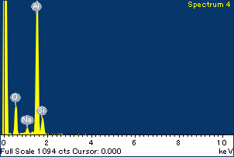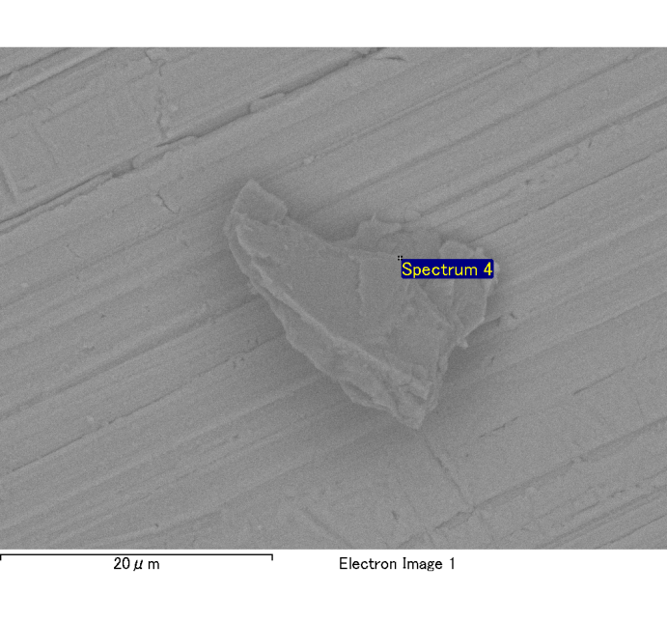

Spectrum Label: Spectrum 4

Livetime 120.0 s

Acquisition geometry ( degrees ):

Tilt = 0.0

Azimuth = 0.0

Elevation = 30.0

Accelerating voltage = 10.00 kV

Total spectrum counts = 121953

|  |  |  |  |
| --- | --- | --- | --- |
| Sample data : | Energy (eV) | Resn. (eV) | Area |
| Strobe : | 3.8 | 54.05 | 1209262 |
|  |  |  |  |
| Optimization data : Cobalt K series |  |  |  |
|  | Energy (eV) | Resn. (eV) | Area |
| Strobe : | .1 | 53.96 | 498142 |
| Optimization element : | 6926.7 | 142.17 | 16696 |

Spectrum processing :

No peaks omitted

Processing option : Oxygen by stoichiometry

Number of iterations = 2

Standard :

Na Albite 1-Jun-1999 12:00 AM

Mg MgO 1-Jun-1999 12:00 AM

Al Al2O3 1-Jun-1999 12:00 AM

Si SiO2 1-Jun-1999 12:00 AM

P GaP 1-Jun-1999 12:00 AM

S FeS2 1-Jun-1999 12:00 AM

K MAD-10 Feldspar 1-Jun-1999 12:00 AM

Ca Wollastonite 1-Jun-1999 12:00 AM

Cr Cr 1-Jun-1999 12:00 AM

Mn Mn 1-Jun-1999 12:00 AM

Fe Fe 1-Jun-1999 12:00 AM

Ni Ni 1-Jun-1999 12:00 AM

|  |  |  |  |  |  |
| --- | --- | --- | --- | --- | --- |
| Element | Weight% | Atomic% | Compd% | Formula |  |
|  |  |  |  |  |  |
| Na K | 0.04 | 1.63 | 0.06 | Na2O |  |
| Mg K | 0.01 | 0.21 | 0.01 | MgO |  |
| Al K | 1.06 | 33.11 | 2.01 | Al2O3 |  |
| Si K | 0.18 | 5.43 | 0.39 | SiO2 |  |
| P K | 0.00 | 0.07 | 0.01 | P2O5 |  |
| S K | 0.00 | 0.12 | 0.01 | SO3 |  |
| K K | -0.01 | -0.15 | -0.01 | K2O |  |
| Ca K | 0.01 | 0.23 | 0.02 | CaO |  |
| Cr K | 0.00 | -0.06 | -0.01 | Cr2O3 |  |
| Mn K | 0.00 | 0.04 | 0.00 | MnO |  |
| Fe K | 0.00 | -0.03 | 0.00 | FeO |  |
| Ni K | -0.10 | -1.38 | -0.12 | NiO |  |
| O | 1.16 | 60.78 |  |  |  |
| Totals | 2.36 |  |  |  |  |

Project: Project 1

Owner: Administrator

Site: Site of Interest 4