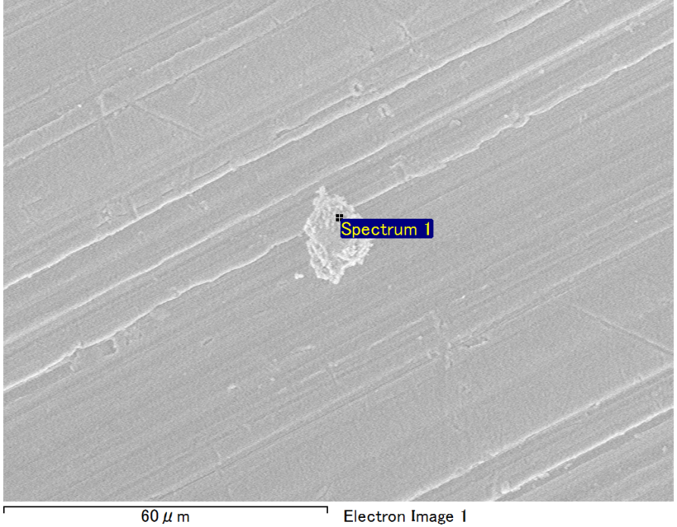

Spectrum Label: Spectrum 1

Livetime 90.0 s

Acquisition geometry ( degrees ):

Tilt = 0.0

Azimuth = 0.0

Elevation = 30.0

Accelerating voltage = 10.00 kV

Total spectrum counts = 66202

|  |  |  |  |
| --- | --- | --- | --- |
| Sample data : | Energy (eV) | Resn. (eV) | Area |
| Strobe : | 3.8 | 53.26 | 918807 |
|  |  |  |  |
| Optimization data : Manganese K series |  |  |  |
|  | Energy (eV) | Resn. (eV) | Area |
| Strobe : | .1 | 53.38 | 1150729 |
| Optimization element : | 5892.6 | 129.89 | 573533 |

Spectrum processing :

Peak possibly omitted : 0.720 keV

Processing option : Oxygen by stoichiometry (Normalised)

Number of iterations = 1

Standard :

Mg MgO 1-Jun-1999 12:00 AM

Al Al2O3 1-Jun-1999 12:00 AM

Si SiO2 1-Jun-1999 12:00 AM

|  |  |  |  |  |  |
| --- | --- | --- | --- | --- | --- |
| Element | Weight% | Atomic% | Compd% | Formula |  |
|  |  |  |  |  |  |
| Mg K | 4.69 | 3.92 | 7.77 | MgO |  |
| Al K | 43.04 | 32.43 | 81.32 | Al2O3 |  |
| Si K | 5.10 | 3.69 | 10.90 | SiO2 |  |
| O | 47.17 | 59.95 |  |  |  |
| Totals | 100.00 |  |  |  |  |

Project: Project 1

Owner: Operator

Site: Site of Interest 15

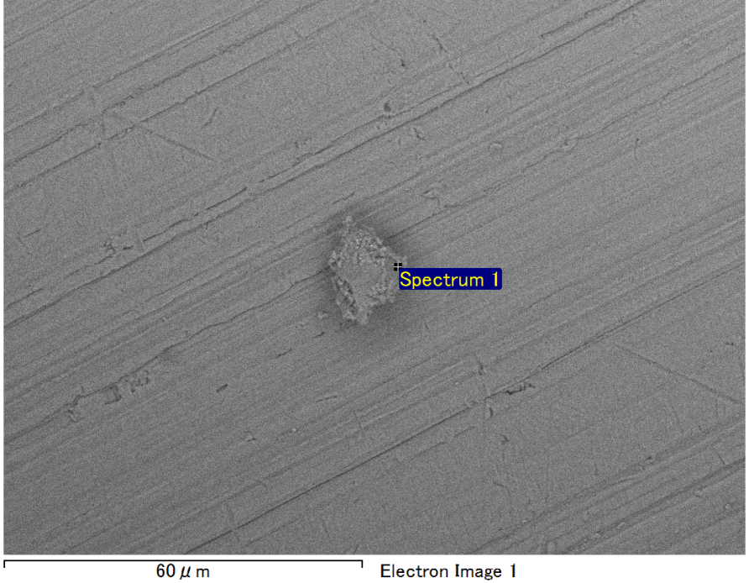

Spectrum Label: Spectrum 1

Livetime 90.0 s

Acquisition geometry ( degrees ):

Tilt = 0.0

Azimuth = 0.0

Elevation = 30.0

Accelerating voltage = 10.00 kV

Total spectrum counts = 66820

|  |  |  |  |
| --- | --- | --- | --- |
| Sample data : | Energy (eV) | Resn. (eV) | Area |
| Strobe : | 3.8 | 53.24 | 917655 |
|  |  |  |  |
| Optimization data : Manganese K series |  |  |  |
|  | Energy (eV) | Resn. (eV) | Area |
| Strobe : | .1 | 53.38 | 1150729 |
| Optimization element : | 5892.6 | 129.89 | 573533 |

Spectrum processing :

No peaks omitted

Processing option : Oxygen by stoichiometry (Normalised)

Number of iterations = 1

Standard :

Mg MgO 1-Jun-1999 12:00 AM

Al Al2O3 1-Jun-1999 12:00 AM

Si SiO2 1-Jun-1999 12:00 AM

|  |  |  |  |  |  |
| --- | --- | --- | --- | --- | --- |
| Element | Weight% | Atomic% | Compd% | Formula |  |
|  |  |  |  |  |  |
| Mg K | 4.45 | 3.72 | 7.37 | MgO |  |
| Al K | 44.09 | 33.24 | 83.30 | Al2O3 |  |
| Si K | 4.36 | 3.16 | 9.33 | SiO2 |  |
| O | 47.11 | 59.89 |  |  |  |
| Totals | 100.00 |  |  |  |  |

Project: Project 1

Owner: Operator

Site: Site of Interest 16

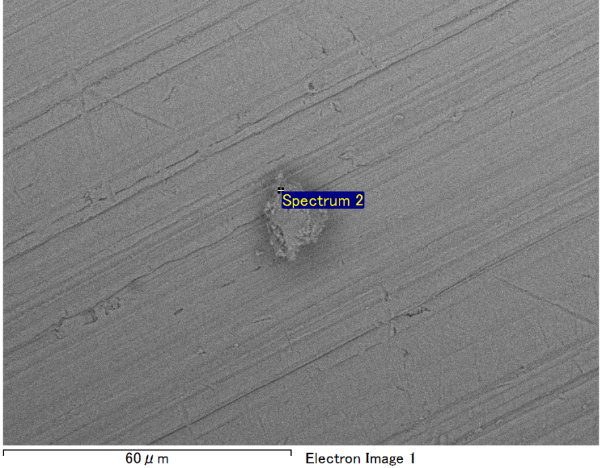

Spectrum Label: Spectrum 2

Livetime 90.0 s

Acquisition geometry ( degrees ):

Tilt = 0.0

Azimuth = 0.0

Elevation = 30.0

Accelerating voltage = 10.00 kV

Total spectrum counts = 67232

|  |  |  |  |
| --- | --- | --- | --- |
| Sample data : | Energy (eV) | Resn. (eV) | Area |
| Strobe : | 3.8 | 53.29 | 918859 |
|  |  |  |  |
| Optimization data : Manganese K series |  |  |  |
|  | Energy (eV) | Resn. (eV) | Area |
| Strobe : | .1 | 53.38 | 1150729 |
| Optimization element : | 5892.6 | 129.89 | 573533 |

Spectrum processing :

No peaks omitted

Processing option : Oxygen by stoichiometry (Normalised)

Number of iterations = 1

Standard :

Mg MgO 1-Jun-1999 12:00 AM

Al Al2O3 1-Jun-1999 12:00 AM

Si SiO2 1-Jun-1999 12:00 AM

Fe Fe 1-Jun-1999 12:00 AM

|  |  |  |  |  |  |
| --- | --- | --- | --- | --- | --- |
| Element | Weight% | Atomic% | Compd% | Formula |  |
|  |  |  |  |  |  |
| Mg K | 4.24 | 3.72 | 7.03 | MgO |  |
| Al K | 39.26 | 31.08 | 74.18 | Al2O3 |  |
| Si K | 3.64 | 2.77 | 7.79 | SiO2 |  |
| Fe L | 8.55 | 3.27 | 11.00 | FeO |  |
| O | 44.31 | 59.15 |  |  |  |
| Totals | 100.00 |  |  |  |  |

Project: Project 1

Owner: Operator

Site: Site of Interest 16

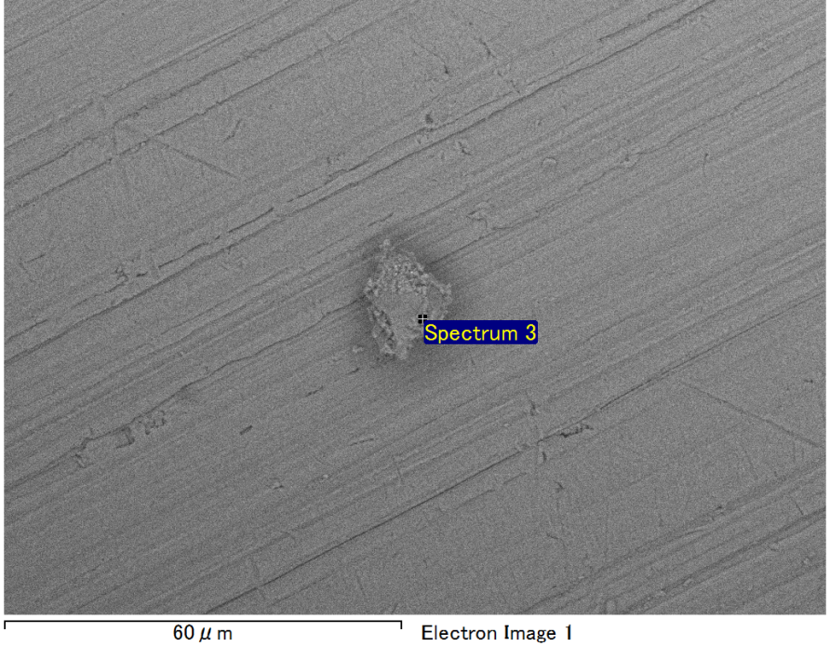

Spectrum Label: Spectrum 3

Livetime 90.0 s

Acquisition geometry ( degrees ):

Tilt = 0.0

Azimuth = 0.0

Elevation = 30.0

Accelerating voltage = 10.00 kV

Total spectrum counts = 66928

|  |  |  |  |
| --- | --- | --- | --- |
| Sample data : | Energy (eV) | Resn. (eV) | Area |
| Strobe : | 3.8 | 53.20 | 918363 |
|  |  |  |  |
| Optimization data : Manganese K series |  |  |  |
|  | Energy (eV) | Resn. (eV) | Area |
| Strobe : | .1 | 53.38 | 1150729 |
| Optimization element : | 5892.6 | 129.89 | 573533 |

Spectrum processing :

No peaks omitted

Processing option : Oxygen by stoichiometry (Normalised)

Number of iterations = 1

Standard :

Mg MgO 1-Jun-1999 12:00 AM

Al Al2O3 1-Jun-1999 12:00 AM

Si SiO2 1-Jun-1999 12:00 AM

Fe Fe 1-Jun-1999 12:00 AM

|  |  |  |  |  |  |
| --- | --- | --- | --- | --- | --- |
| Element | Weight% | Atomic% | Compd% | Formula |  |
|  |  |  |  |  |  |
| Mg K | 4.51 | 4.00 | 7.47 | MgO |  |
| Al K | 37.61 | 30.07 | 71.06 | Al2O3 |  |
| Si K | 3.87 | 2.97 | 8.28 | SiO2 |  |
| Fe L | 10.26 | 3.96 | 13.20 | FeO |  |
| O | 43.76 | 59.00 |  |  |  |
| Totals | 100.00 |  |  |  |  |

Project: Project 1

Owner: Operator

Site: Site of Interest 16

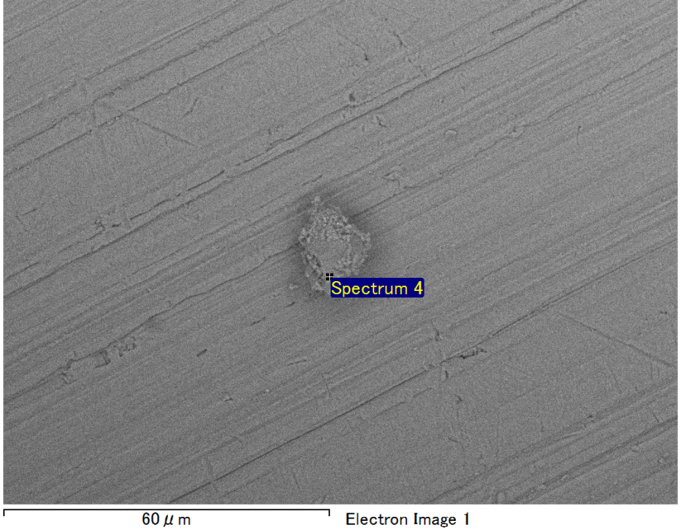

Spectrum Label: Spectrum 4

Livetime 90.0 s

Acquisition geometry ( degrees ):

Tilt = 0.0

Azimuth = 0.0

Elevation = 30.0

Accelerating voltage = 10.00 kV

Total spectrum counts = 66071

|  |  |  |  |
| --- | --- | --- | --- |
| Sample data : | Energy (eV) | Resn. (eV) | Area |
| Strobe : | 3.8 | 53.21 | 918751 |
|  |  |  |  |
| Optimization data : Manganese K series |  |  |  |
|  | Energy (eV) | Resn. (eV) | Area |
| Strobe : | .1 | 53.38 | 1150729 |
| Optimization element : | 5892.6 | 129.89 | 573533 |

Spectrum processing :

No peaks omitted

Processing option : Oxygen by stoichiometry (Normalised)

Number of iterations = 1

Standard :

Mg MgO 1-Jun-1999 12:00 AM

Al Al2O3 1-Jun-1999 12:00 AM

Si SiO2 1-Jun-1999 12:00 AM

|  |  |  |  |  |  |
| --- | --- | --- | --- | --- | --- |
| Element | Weight% | Atomic% | Compd% | Formula |  |
|  |  |  |  |  |  |
| Mg K | 4.42 | 3.70 | 7.32 | MgO |  |
| Al K | 44.58 | 33.61 | 84.22 | Al2O3 |  |
| Si K | 3.95 | 2.86 | 8.45 | SiO2 |  |
| O | 47.06 | 59.83 |  |  |  |
| Totals | 100.00 |  |  |  |  |

Project: Project 1

Owner: Operator

Site: Site of Interest 16