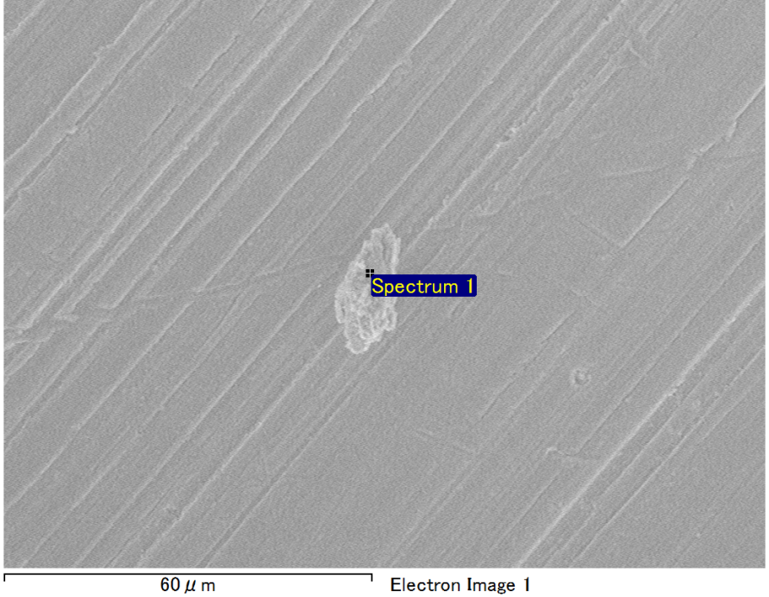

Spectrum Label: Spectrum 1

Livetime 90.0 s

Acquisition geometry ( degrees ):

Tilt = 0.0

Azimuth = 0.0

Elevation = 30.0

Accelerating voltage = 10.00 kV

Total spectrum counts = 64684

|  |  |  |  |
| --- | --- | --- | --- |
| Sample data : | Energy (eV) | Resn. (eV) | Area |
| Strobe : | 3.8 | 53.15 | 921128 |
|  |  |  |  |
| Optimization data : Manganese K series |  |  |  |
|  | Energy (eV) | Resn. (eV) | Area |
| Strobe : | .1 | 53.38 | 1150729 |
| Optimization element : | 5892.6 | 129.89 | 573533 |

Spectrum processing :

No peaks omitted

Processing option : Oxygen by stoichiometry (Normalised)

Number of iterations = 1

Standard :

Mg MgO 1-Jun-1999 12:00 AM

Al Al2O3 1-Jun-1999 12:00 AM

Si SiO2 1-Jun-1999 12:00 AM

Ca Wollastonite 1-Jun-1999 12:00 AM

|  |  |  |  |  |  |
| --- | --- | --- | --- | --- | --- |
| Element | Weight% | Atomic% | Compd% | Formula |  |
|  |  |  |  |  |  |
| Mg K | 2.53 | 2.13 | 4.19 | MgO |  |
| Al K | 41.33 | 31.43 | 78.10 | Al2O3 |  |
| Si K | 6.73 | 4.91 | 14.39 | SiO2 |  |
| Ca K | 2.37 | 1.21 | 3.31 | CaO |  |
| O | 47.04 | 60.31 |  |  |  |
| Totals | 100.00 |  |  |  |  |

Project: Project 1

Owner: Operator

Site: Site of Interest 28

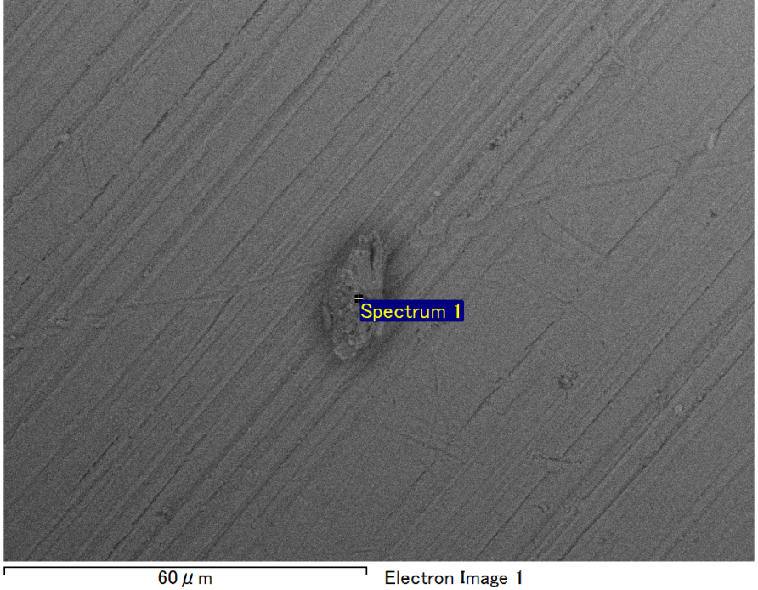

Spectrum Label: Spectrum 1

Livetime 90.0 s

Acquisition geometry ( degrees ):

Tilt = 0.0

Azimuth = 0.0

Elevation = 30.0

Accelerating voltage = 10.00 kV

Total spectrum counts = 64595

|  |  |  |  |
| --- | --- | --- | --- |
| Sample data : | Energy (eV) | Resn. (eV) | Area |
| Strobe : | 3.8 | 53.15 | 919637 |
|  |  |  |  |
| Optimization data : Manganese K series |  |  |  |
|  | Energy (eV) | Resn. (eV) | Area |
| Strobe : | .1 | 53.38 | 1150729 |
| Optimization element : | 5892.6 | 129.89 | 573533 |

Spectrum processing :

No peaks omitted

Processing option : Oxygen by stoichiometry (Normalised)

Number of iterations = 1

Standard :

Na Albite 1-Jun-1999 12:00 AM

Al Al2O3 1-Jun-1999 12:00 AM

Si SiO2 1-Jun-1999 12:00 AM

|  |  |  |  |  |  |
| --- | --- | --- | --- | --- | --- |
| Element | Weight% | Atomic% | Compd% | Formula |  |
|  |  |  |  |  |  |
| Na K | 1.55 | 1.37 | 2.09 | Na2O |  |
| Al K | 42.88 | 32.32 | 81.02 | Al2O3 |  |
| Si K | 7.90 | 5.72 | 16.89 | SiO2 |  |
| O | 47.67 | 60.60 |  |  |  |
| Totals | 100.00 |  |  |  |  |

Project: Project 1

Owner: Operator

Site: Site of Interest 29

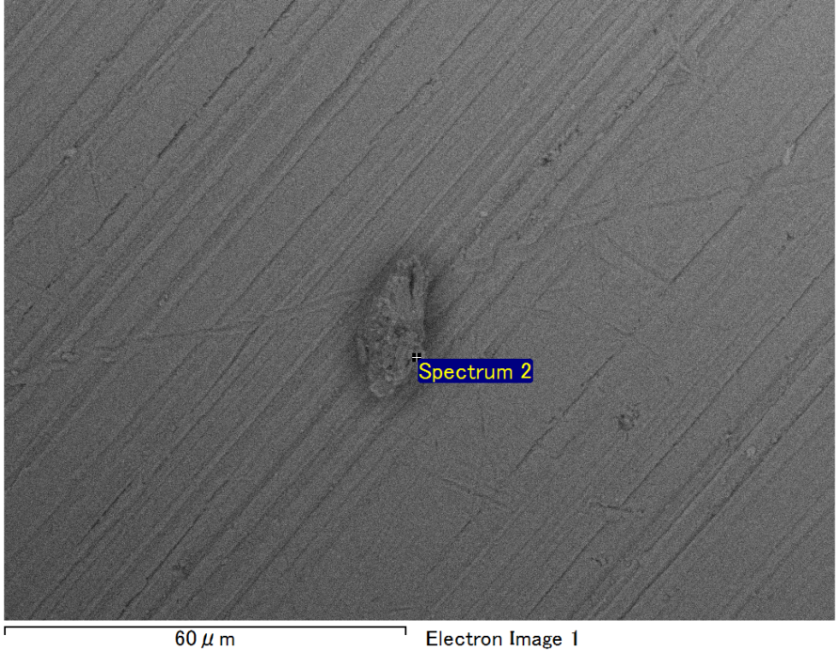

Spectrum Label: Spectrum 2

Livetime 90.0 s

Acquisition geometry ( degrees ):

Tilt = 0.0

Azimuth = 0.0

Elevation = 30.0

Accelerating voltage = 10.00 kV

Total spectrum counts = 63813

|  |  |  |  |
| --- | --- | --- | --- |
| Sample data : | Energy (eV) | Resn. (eV) | Area |
| Strobe : | 3.8 | 53.08 | 918925 |
|  |  |  |  |
| Optimization data : Manganese K series |  |  |  |
|  | Energy (eV) | Resn. (eV) | Area |
| Strobe : | .1 | 53.38 | 1150729 |
| Optimization element : | 5892.6 | 129.89 | 573533 |

Spectrum processing :

No peaks omitted

Processing option : Oxygen by stoichiometry (Normalised)

Number of iterations = 1

Standard :

Mg MgO 1-Jun-1999 12:00 AM

Al Al2O3 1-Jun-1999 12:00 AM

Si SiO2 1-Jun-1999 12:00 AM

Ca Wollastonite 1-Jun-1999 12:00 AM

|  |  |  |  |  |  |
| --- | --- | --- | --- | --- | --- |
| Element | Weight% | Atomic% | Compd% | Formula |  |
|  |  |  |  |  |  |
| Mg K | 1.91 | 1.62 | 3.16 | MgO |  |
| Al K | 43.25 | 33.01 | 81.72 | Al2O3 |  |
| Si K | 4.98 | 3.65 | 10.66 | SiO2 |  |
| Ca K | 3.18 | 1.64 | 4.46 | CaO |  |
| O | 46.67 | 60.08 |  |  |  |
| Totals | 100.00 |  |  |  |  |

Project: Project 1

Owner: Operator

Site: Site of Interest 29

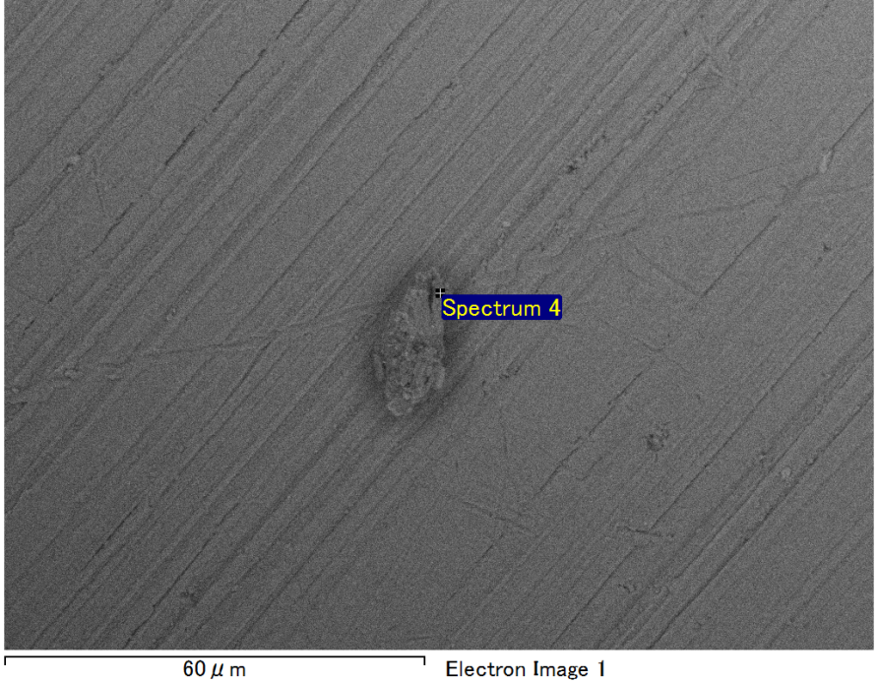

Spectrum Label: Spectrum 4

Livetime 90.0 s

Acquisition geometry ( degrees ):

Tilt = 0.0

Azimuth = 0.0

Elevation = 30.0

Accelerating voltage = 10.00 kV

Total spectrum counts = 64750

|  |  |  |  |
| --- | --- | --- | --- |
| Sample data : | Energy (eV) | Resn. (eV) | Area |
| Strobe : | 3.8 | 53.17 | 919412 |
|  |  |  |  |
| Optimization data : Manganese K series |  |  |  |
|  | Energy (eV) | Resn. (eV) | Area |
| Strobe : | .1 | 53.38 | 1150729 |
| Optimization element : | 5892.6 | 129.89 | 573533 |

Spectrum processing :

No peaks omitted

Processing option : Oxygen by stoichiometry (Normalised)

Number of iterations = 1

Standard :

Na Albite 1-Jun-1999 12:00 AM

Al Al2O3 1-Jun-1999 12:00 AM

Si SiO2 1-Jun-1999 12:00 AM

|  |  |  |  |  |  |
| --- | --- | --- | --- | --- | --- |
| Element | Weight% | Atomic% | Compd% | Formula |  |
|  |  |  |  |  |  |
| Na K | 1.59 | 1.41 | 2.14 | Na2O |  |
| Al K | 43.66 | 32.91 | 82.48 | Al2O3 |  |
| Si K | 7.19 | 5.21 | 15.38 | SiO2 |  |
| O | 47.57 | 60.48 |  |  |  |
| Totals | 100.00 |  |  |  |  |

Project: Project 1

Owner: Operator

Site: Site of Interest 29

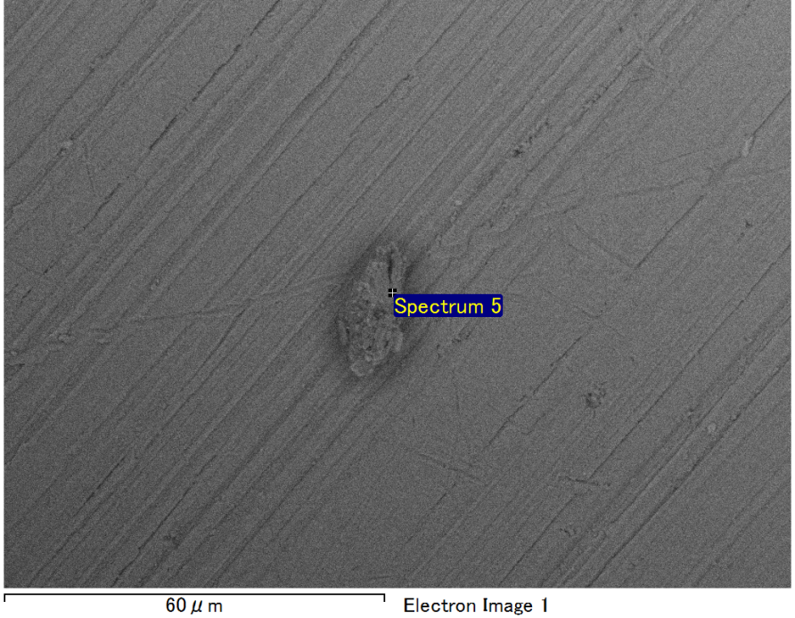

Spectrum Label: Spectrum 5

Livetime 90.0 s

Acquisition geometry ( degrees ):

Tilt = 0.0

Azimuth = 0.0

Elevation = 30.0

Accelerating voltage = 10.00 kV

Total spectrum counts = 64806

|  |  |  |  |
| --- | --- | --- | --- |
| Sample data : | Energy (eV) | Resn. (eV) | Area |
| Strobe : | 3.8 | 53.14 | 919352 |
|  |  |  |  |
| Optimization data : Manganese K series |  |  |  |
|  | Energy (eV) | Resn. (eV) | Area |
| Strobe : | .1 | 53.38 | 1150729 |
| Optimization element : | 5892.6 | 129.89 | 573533 |

Spectrum processing :

No peaks omitted

Processing option : Oxygen by stoichiometry (Normalised)

Number of iterations = 1

Standard :

Mg MgO 1-Jun-1999 12:00 AM

Al Al2O3 1-Jun-1999 12:00 AM

Si SiO2 1-Jun-1999 12:00 AM

Ca Wollastonite 1-Jun-1999 12:00 AM

|  |  |  |  |  |  |
| --- | --- | --- | --- | --- | --- |
| Element | Weight% | Atomic% | Compd% | Formula |  |
|  |  |  |  |  |  |
| Mg K | 2.59 | 2.19 | 4.29 | MgO |  |
| Al K | 40.45 | 30.84 | 76.42 | Al2O3 |  |
| Si K | 6.97 | 5.10 | 14.90 | SiO2 |  |
| Ca K | 3.13 | 1.61 | 4.39 | CaO |  |
| O | 46.87 | 60.26 |  |  |  |
| Totals | 100.00 |  |  |  |  |

Project: Project 1

Owner: Operator

Site: Site of Interest 29