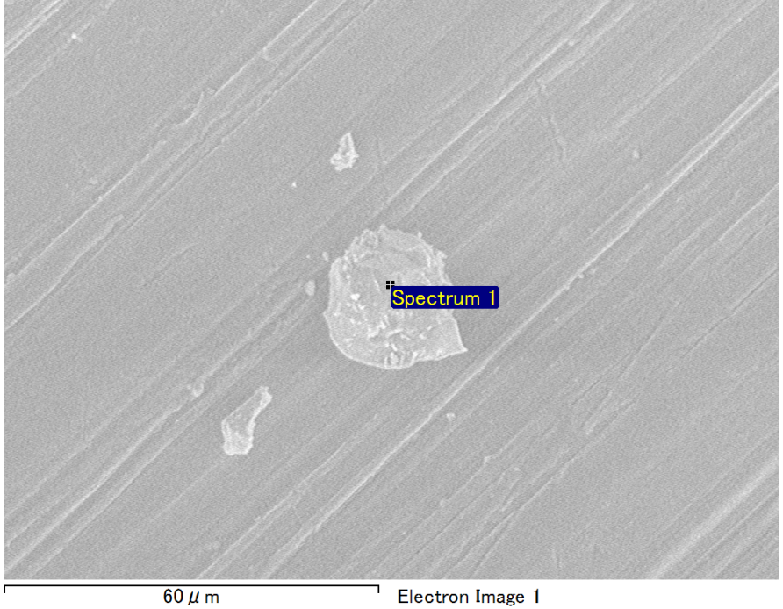

Spectrum Label: Spectrum 1

Livetime 90.0 s

Acquisition geometry ( degrees ):

Tilt = 0.0

Azimuth = 0.0

Elevation = 30.0

Accelerating voltage = 10.00 kV

Total spectrum counts = 64454

|  |  |  |  |
| --- | --- | --- | --- |
| Sample data : | Energy (eV) | Resn. (eV) | Area |
| Strobe : | 3.8 | 53.10 | 919510 |
|  |  |  |  |
| Optimization data : Manganese K series |  |  |  |
|  | Energy (eV) | Resn. (eV) | Area |
| Strobe : | .1 | 53.38 | 1150729 |
| Optimization element : | 5892.6 | 129.89 | 573533 |

Spectrum processing :

No peaks omitted

Processing option : Oxygen by stoichiometry (Normalised)

Number of iterations = 1

Standard :

Mg MgO 1-Jun-1999 12:00 AM

Al Al2O3 1-Jun-1999 12:00 AM

Si SiO2 1-Jun-1999 12:00 AM

|  |  |  |  |  |  |
| --- | --- | --- | --- | --- | --- |
| Element | Weight% | Atomic% | Compd% | Formula |  |
|  |  |  |  |  |  |
| Mg K | 4.14 | 3.46 | 6.87 | MgO |  |
| Al K | 44.41 | 33.48 | 83.92 | Al2O3 |  |
| Si K | 4.31 | 3.12 | 9.22 | SiO2 |  |
| O | 47.14 | 59.93 |  |  |  |
| Totals | 100.00 |  |  |  |  |

Project: Project 1

Owner: Operator

Site: Site of Interest 41

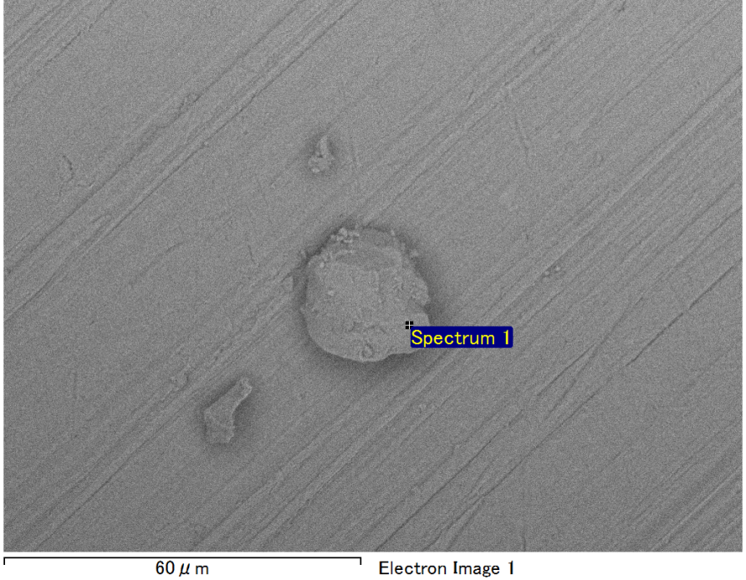

Spectrum Label: Spectrum 1

Livetime 90.0 s

Acquisition geometry ( degrees ):

Tilt = 0.0

Azimuth = 0.0

Elevation = 30.0

Accelerating voltage = 10.00 kV

Total spectrum counts = 65293

|  |  |  |  |
| --- | --- | --- | --- |
| Sample data : | Energy (eV) | Resn. (eV) | Area |
| Strobe : | 3.8 | 53.19 | 919051 |
|  |  |  |  |
| Optimization data : Manganese K series |  |  |  |
|  | Energy (eV) | Resn. (eV) | Area |
| Strobe : | .1 | 53.38 | 1150729 |
| Optimization element : | 5892.6 | 129.89 | 573533 |

Spectrum processing :

No peaks omitted

Processing option : Oxygen by stoichiometry (Normalised)

Number of iterations = 1

Standard :

Mg MgO 1-Jun-1999 12:00 AM

Al Al2O3 1-Jun-1999 12:00 AM

Si SiO2 1-Jun-1999 12:00 AM

Fe Fe 1-Jun-1999 12:00 AM

|  |  |  |  |  |  |
| --- | --- | --- | --- | --- | --- |
| Element | Weight% | Atomic% | Compd% | Formula |  |
|  |  |  |  |  |  |
| Mg K | 4.80 | 4.22 | 7.95 | MgO |  |
| Al K | 38.06 | 30.16 | 71.92 | Al2O3 |  |
| Si K | 4.12 | 3.14 | 8.82 | SiO2 |  |
| Fe L | 8.79 | 3.37 | 11.31 | FeO |  |
| O | 44.23 | 59.11 |  |  |  |
| Totals | 100.00 |  |  |  |  |

Project: Project 1

Owner: Operator

Site: Site of Interest 42

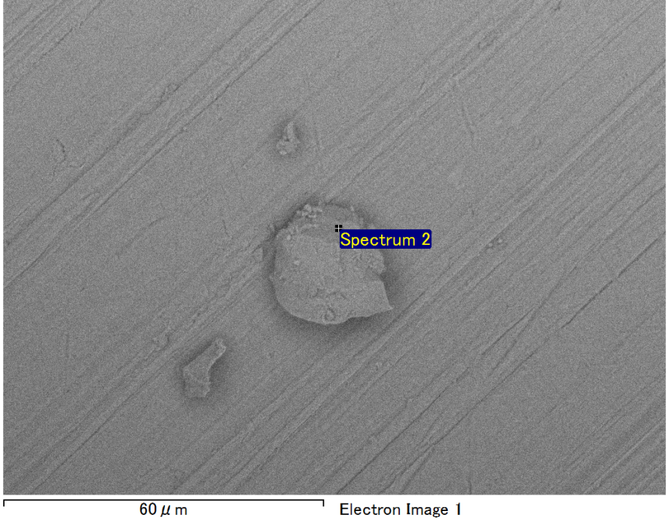

Spectrum Label: Spectrum 2

Livetime 90.0 s

Acquisition geometry ( degrees ):

Tilt = 0.0

Azimuth = 0.0

Elevation = 30.0

Accelerating voltage = 10.00 kV

Total spectrum counts = 65993

|  |  |  |  |
| --- | --- | --- | --- |
| Sample data : | Energy (eV) | Resn. (eV) | Area |
| Strobe : | 3.8 | 53.11 | 919044 |
|  |  |  |  |
| Optimization data : Manganese K series |  |  |  |
|  | Energy (eV) | Resn. (eV) | Area |
| Strobe : | .1 | 53.38 | 1150729 |
| Optimization element : | 5892.6 | 129.89 | 573533 |

Spectrum processing :

No peaks omitted

Processing option : Oxygen by stoichiometry (Normalised)

Number of iterations = 1

Standard :

Mg MgO 1-Jun-1999 12:00 AM

Al Al2O3 1-Jun-1999 12:00 AM

Si SiO2 1-Jun-1999 12:00 AM

Fe Fe 1-Jun-1999 12:00 AM

|  |  |  |  |  |  |
| --- | --- | --- | --- | --- | --- |
| Element | Weight% | Atomic% | Compd% | Formula |  |
|  |  |  |  |  |  |
| Mg K | 5.02 | 4.44 | 8.32 | MgO |  |
| Al K | 36.92 | 29.44 | 69.75 | Al2O3 |  |
| Si K | 4.30 | 3.29 | 9.19 | SiO2 |  |
| Fe L | 9.90 | 3.81 | 12.73 | FeO |  |
| O | 43.87 | 59.01 |  |  |  |
| Totals | 100.00 |  |  |  |  |

Project: Project 1

Owner: Operator

Site: Site of Interest 42

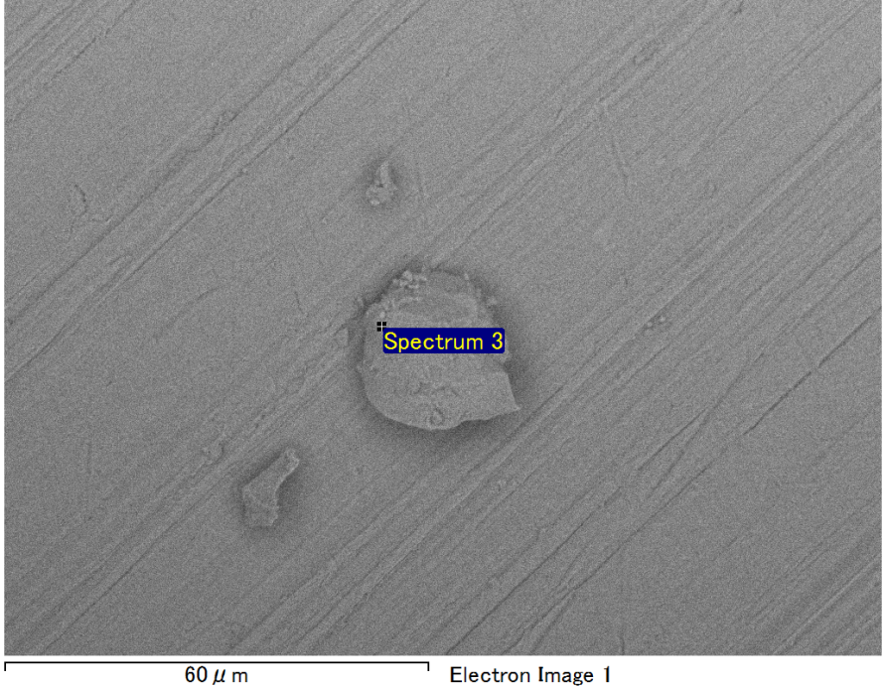

Spectrum Label: Spectrum 3

Livetime 90.0 s

Acquisition geometry ( degrees ):

Tilt = 0.0

Azimuth = 0.0

Elevation = 30.0

Accelerating voltage = 10.00 kV

Total spectrum counts = 64291

|  |  |  |  |
| --- | --- | --- | --- |
| Sample data : | Energy (eV) | Resn. (eV) | Area |
| Strobe : | 3.8 | 53.13 | 920964 |
|  |  |  |  |
| Optimization data : Manganese K series |  |  |  |
|  | Energy (eV) | Resn. (eV) | Area |
| Strobe : | .1 | 53.38 | 1150729 |
| Optimization element : | 5892.6 | 129.89 | 573533 |

Spectrum processing :

No peaks omitted

Processing option : Oxygen by stoichiometry (Normalised)

Number of iterations = 1

Standard :

Mg MgO 1-Jun-1999 12:00 AM

Al Al2O3 1-Jun-1999 12:00 AM

Si SiO2 1-Jun-1999 12:00 AM

|  |  |  |  |  |  |
| --- | --- | --- | --- | --- | --- |
| Element | Weight% | Atomic% | Compd% | Formula |  |
|  |  |  |  |  |  |
| Mg K | 2.94 | 2.46 | 4.88 | MgO |  |
| Al K | 46.09 | 34.76 | 87.08 | Al2O3 |  |
| Si K | 3.76 | 2.72 | 8.03 | SiO2 |  |
| O | 47.21 | 60.05 |  |  |  |
| Totals | 100.00 |  |  |  |  |

Project: Project 1

Owner: Operator

Site: Site of Interest 42

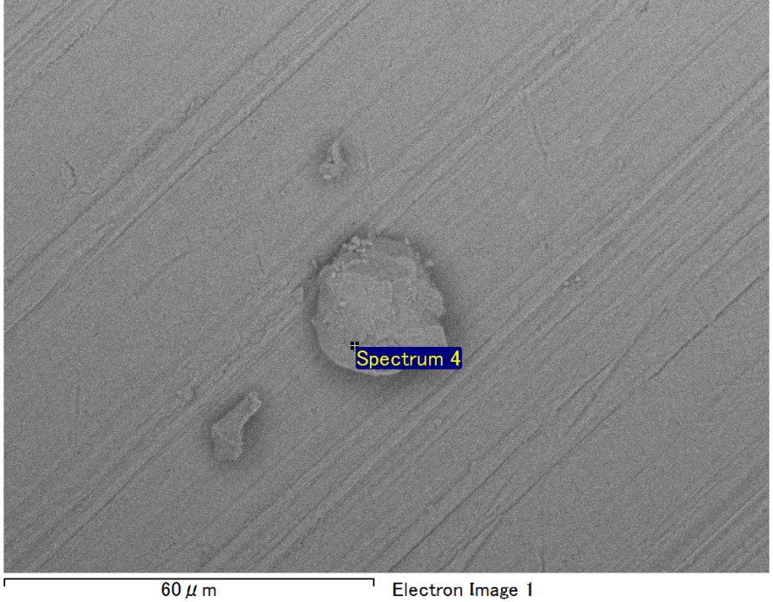

Spectrum Label: Spectrum 4

Livetime 90.0 s

Acquisition geometry ( degrees ):

Tilt = 0.0

Azimuth = 0.0

Elevation = 30.0

Accelerating voltage = 10.00 kV

Total spectrum counts = 63772

|  |  |  |  |
| --- | --- | --- | --- |
| Sample data : | Energy (eV) | Resn. (eV) | Area |
| Strobe : | 3.8 | 53.07 | 921049 |
|  |  |  |  |
| Optimization data : Manganese K series |  |  |  |
|  | Energy (eV) | Resn. (eV) | Area |
| Strobe : | .1 | 53.38 | 1150729 |
| Optimization element : | 5892.6 | 129.89 | 573533 |

Spectrum processing :

No peaks omitted

Processing option : Oxygen by stoichiometry (Normalised)

Number of iterations = 1

Standard :

Mg MgO 1-Jun-1999 12:00 AM

Al Al2O3 1-Jun-1999 12:00 AM

Si SiO2 1-Jun-1999 12:00 AM

|  |  |  |  |  |  |
| --- | --- | --- | --- | --- | --- |
| Element | Weight% | Atomic% | Compd% | Formula |  |
|  |  |  |  |  |  |
| Mg K | 3.19 | 2.67 | 5.29 | MgO |  |
| Al K | 45.29 | 34.15 | 85.56 | Al2O3 |  |
| Si K | 4.28 | 3.10 | 9.15 | SiO2 |  |
| O | 47.25 | 60.09 |  |  |  |
| Totals | 100.00 |  |  |  |  |

Project: Project 1

Owner: Operator

Site: Site of Interest 42