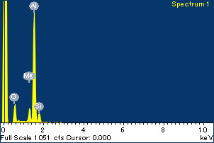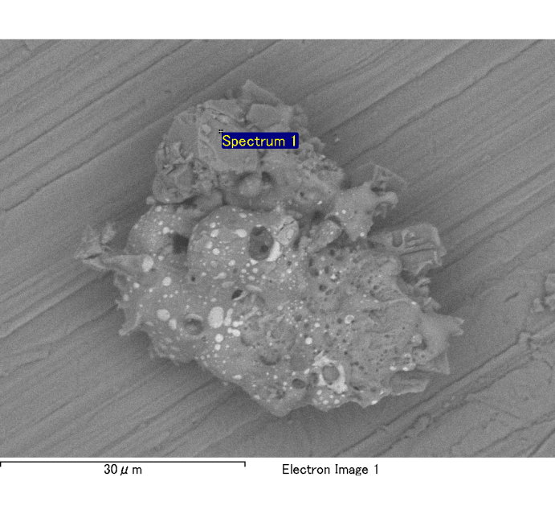

Spectrum Label: Spectrum 1

Livetime 120.0 s

Acquisition geometry ( degrees ):

Tilt = 0.0

Azimuth = 0.0

Elevation = 30.0

Accelerating voltage = 10.00 kV

Total spectrum counts = 118433

|  |  |  |  |
| --- | --- | --- | --- |
| Sample data : | Energy (eV) | Resn. (eV) | Area |
| Strobe : | 3.8 | 54.00 | 1208527 |
|  |  |  |  |
| Optimization data : Cobalt K series |  |  |  |
|  | Energy (eV) | Resn. (eV) | Area |
| Strobe : | .1 | 53.96 | 498142 |
| Optimization element : | 6926.7 | 142.17 | 16696 |

Spectrum processing :

No peaks omitted

Processing option : Oxygen by stoichiometry

Number of iterations = 2

Standard :

Na Albite 1-Jun-1999 12:00 AM

Mg MgO 1-Jun-1999 12:00 AM

Al Al2O3 1-Jun-1999 12:00 AM

Si SiO2 1-Jun-1999 12:00 AM

P GaP 1-Jun-1999 12:00 AM

S FeS2 1-Jun-1999 12:00 AM

K MAD-10 Feldspar 1-Jun-1999 12:00 AM

Ca Wollastonite 1-Jun-1999 12:00 AM

Cr Cr 1-Jun-1999 12:00 AM

Mn Mn 1-Jun-1999 12:00 AM

Fe Fe 1-Jun-1999 12:00 AM

Ni Ni 1-Jun-1999 12:00 AM

|  |  |  |  |  |  |
| --- | --- | --- | --- | --- | --- |
| Element | Weight% | Atomic% | Compd% | Formula |  |
|  |  |  |  |  |  |
| Na K | 0.00 | -0.04 | 0.00 | Na2O |  |
| Mg K | 0.09 | 3.55 | 0.15 | MgO |  |
| Al K | 0.92 | 31.53 | 1.73 | Al2O3 |  |
| Si K | 0.11 | 3.58 | 0.23 | SiO2 |  |
| P K | 0.00 | 0.04 | 0.00 | P2O5 |  |
| S K | 0.00 | 0.12 | 0.01 | SO3 |  |
| K K | 0.00 | 0.00 | 0.00 | K2O |  |
| Ca K | 0.00 | 0.01 | 0.00 | CaO |  |
| Cr K | -0.01 | -0.17 | -0.01 | Cr2O3 |  |
| Mn K | 0.01 | 0.10 | 0.01 | MnO |  |
| Fe K | 0.15 | 2.46 | 0.19 | FeO |  |
| Ni K | -0.06 | -0.97 | -0.08 | NiO |  |
| O | 1.03 | 59.79 |  |  |  |
| Totals | 2.24 |  |  |  |  |

Project: Project 1

Owner: Administrator

Site: Site of Interest 2

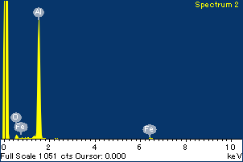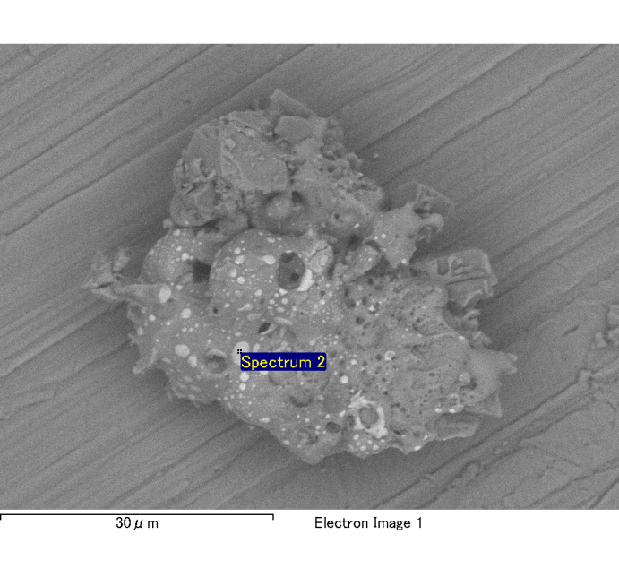

Spectrum Label: Spectrum 2

Livetime 120.0 s

Acquisition geometry ( degrees ):

Tilt = 0.0

Azimuth = 0.0

Elevation = 30.0

Accelerating voltage = 10.00 kV

Total spectrum counts = 114674

|  |  |  |  |
| --- | --- | --- | --- |
| Sample data : | Energy (eV) | Resn. (eV) | Area |
| Strobe : | 3.8 | 54.07 | 1209412 |
|  |  |  |  |
| Optimization data : Cobalt K series |  |  |  |
|  | Energy (eV) | Resn. (eV) | Area |
| Strobe : | .1 | 53.96 | 498142 |
| Optimization element : | 6926.7 | 142.17 | 16696 |

Spectrum processing :

No peaks omitted

Processing option : Oxygen by stoichiometry

Number of iterations = 2

Standard :

Na Albite 1-Jun-1999 12:00 AM

Mg MgO 1-Jun-1999 12:00 AM

Al Al2O3 1-Jun-1999 12:00 AM

Si SiO2 1-Jun-1999 12:00 AM

P GaP 1-Jun-1999 12:00 AM

S FeS2 1-Jun-1999 12:00 AM

K MAD-10 Feldspar 1-Jun-1999 12:00 AM

Ca Wollastonite 1-Jun-1999 12:00 AM

Cr Cr 1-Jun-1999 12:00 AM

Mn Mn 1-Jun-1999 12:00 AM

Fe Fe 1-Jun-1999 12:00 AM

Ni Ni 1-Jun-1999 12:00 AM

|  |  |  |  |  |  |
| --- | --- | --- | --- | --- | --- |
| Element | Weight% | Atomic% | Compd% | Formula |  |
|  |  |  |  |  |  |
| Na K | 0.00 | 0.21 | 0.01 | Na2O |  |
| Mg K | 0.01 | 0.38 | 0.02 | MgO |  |
| Al K | 0.88 | 32.96 | 1.67 | Al2O3 |  |
| Si K | 0.00 | 0.10 | 0.01 | SiO2 |  |
| P K | 0.00 | 0.08 | 0.01 | P2O5 |  |
| S K | 0.01 | 0.25 | 0.02 | SO3 |  |
| K K | 0.01 | 0.14 | 0.01 | K2O |  |
| Ca K | 0.00 | -0.04 | 0.00 | CaO |  |
| Cr K | 0.00 | 0.02 | 0.00 | Cr2O3 |  |
| Mn K | 0.01 | 0.13 | 0.01 | MnO |  |
| Fe K | 0.36 | 6.43 | 0.46 | FeO |  |
| Ni K | 0.05 | 0.82 | 0.06 | NiO |  |
| O | 0.93 | 58.52 |  |  |  |
| Totals | 2.26 |  |  |  |  |

Project: Project 1

Owner: Administrator

Site: Site of Interest 2

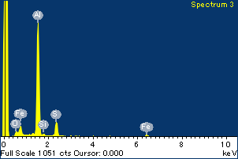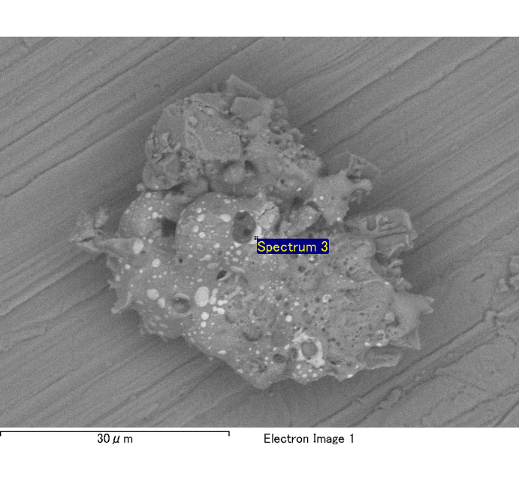

Spectrum Label: Spectrum 3

Livetime 120.0 s

Acquisition geometry ( degrees ):

Tilt = 0.0

Azimuth = 0.0

Elevation = 30.0

Accelerating voltage = 10.00 kV

Total spectrum counts = 118552

|  |  |  |  |
| --- | --- | --- | --- |
| Sample data : | Energy (eV) | Resn. (eV) | Area |
| Strobe : | 3.8 | 53.96 | 1206971 |
|  |  |  |  |
| Optimization data : Cobalt K series |  |  |  |
|  | Energy (eV) | Resn. (eV) | Area |
| Strobe : | .1 | 53.96 | 498142 |
| Optimization element : | 6926.7 | 142.17 | 16696 |

Spectrum processing :

No peaks omitted

Processing option : Oxygen by stoichiometry

Number of iterations = 2

Standard :

Na Albite 1-Jun-1999 12:00 AM

Mg MgO 1-Jun-1999 12:00 AM

Al Al2O3 1-Jun-1999 12:00 AM

Si SiO2 1-Jun-1999 12:00 AM

P GaP 1-Jun-1999 12:00 AM

S FeS2 1-Jun-1999 12:00 AM

K MAD-10 Feldspar 1-Jun-1999 12:00 AM

Ca Wollastonite 1-Jun-1999 12:00 AM

Cr Cr 1-Jun-1999 12:00 AM

Mn Mn 1-Jun-1999 12:00 AM

Fe Fe 1-Jun-1999 12:00 AM

Ni Ni 1-Jun-1999 12:00 AM

|  |  |  |  |  |  |
| --- | --- | --- | --- | --- | --- |
| Element | Weight% | Atomic% | Compd% | Formula |  |
|  |  |  |  |  |  |
| Na K | 0.00 | -0.07 | 0.00 | Na2O |  |
| Mg K | 0.01 | 0.39 | 0.02 | MgO |  |
| Al K | 0.85 | 26.87 | 1.60 | Al2O3 |  |
| Si K | 0.02 | 0.52 | 0.04 | SiO2 |  |
| P K | 0.00 | 0.01 | 0.00 | P2O5 |  |
| S K | 0.19 | 4.94 | 0.46 | SO3 |  |
| K K | 0.00 | -0.05 | 0.00 | K2O |  |
| Ca K | 0.00 | 0.09 | 0.01 | CaO |  |
| Cr K | 0.00 | 0.00 | 0.00 | Cr2O3 |  |
| Mn K | 0.01 | 0.19 | 0.02 | MnO |  |
| Fe K | 0.31 | 4.81 | 0.40 | FeO |  |
| Ni K | 0.02 | 0.34 | 0.03 | NiO |  |
| O | 1.16 | 61.95 |  |  |  |
| Totals | 2.57 |  |  |  |  |

Project: Project 1

Owner: Administrator

Site: Site of Interest 2

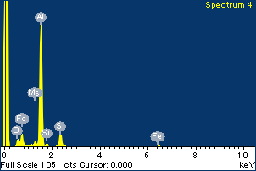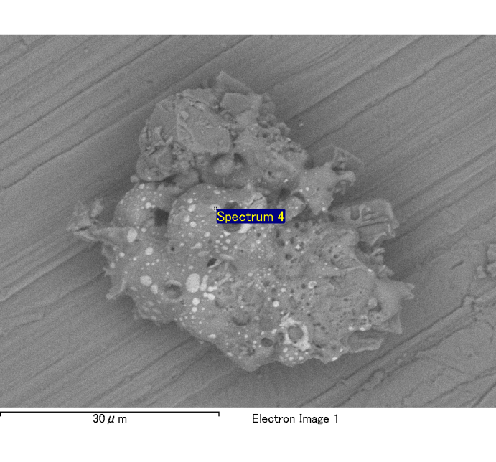

Spectrum Label: Spectrum 4

Livetime 120.0 s

Acquisition geometry ( degrees ):

Tilt = 0.0

Azimuth = 0.0

Elevation = 30.0

Accelerating voltage = 10.00 kV

Total spectrum counts = 118444

|  |  |  |  |
| --- | --- | --- | --- |
| Sample data : | Energy (eV) | Resn. (eV) | Area |
| Strobe : | 3.8 | 54.13 | 1208661 |
|  |  |  |  |
| Optimization data : Cobalt K series |  |  |  |
|  | Energy (eV) | Resn. (eV) | Area |
| Strobe : | .1 | 53.96 | 498142 |
| Optimization element : | 6926.7 | 142.17 | 16696 |

Spectrum processing :

No peaks omitted

Processing option : Oxygen by stoichiometry

Number of iterations = 2

Standard :

Na Albite 1-Jun-1999 12:00 AM

Mg MgO 1-Jun-1999 12:00 AM

Al Al2O3 1-Jun-1999 12:00 AM

Si SiO2 1-Jun-1999 12:00 AM

P GaP 1-Jun-1999 12:00 AM

S FeS2 1-Jun-1999 12:00 AM

K MAD-10 Feldspar 1-Jun-1999 12:00 AM

Ca Wollastonite 1-Jun-1999 12:00 AM

Cr Cr 1-Jun-1999 12:00 AM

Mn Mn 1-Jun-1999 12:00 AM

Fe Fe 1-Jun-1999 12:00 AM

Ni Ni 1-Jun-1999 12:00 AM

|  |  |  |  |  |  |
| --- | --- | --- | --- | --- | --- |
| Element | Weight% | Atomic% | Compd% | Formula |  |
|  |  |  |  |  |  |
| Na K | 0.00 | 0.08 | 0.00 | Na2O |  |
| Mg K | 0.02 | 0.84 | 0.04 | MgO |  |
| Al K | 0.85 | 28.14 | 1.61 | Al2O3 |  |
| Si K | 0.02 | 0.62 | 0.04 | SiO2 |  |
| P K | 0.00 | -0.04 | 0.00 | P2O5 |  |
| S K | 0.15 | 4.04 | 0.36 | SO3 |  |
| K K | 0.00 | -0.09 | 0.00 | K2O |  |
| Ca K | 0.00 | -0.01 | 0.00 | CaO |  |
| Cr K | 0.01 | 0.11 | 0.01 | Cr2O3 |  |
| Mn K | -0.01 | -0.23 | -0.02 | MnO |  |
| Fe K | 0.38 | 6.06 | 0.49 | FeO |  |
| Ni K | -0.06 | -0.91 | -0.08 | NiO |  |
| O | 1.10 | 61.38 |  |  |  |
| Totals | 2.45 |  |  |  |  |

Project: Project 1

Owner: Administrator

Site: Site of Interest 2

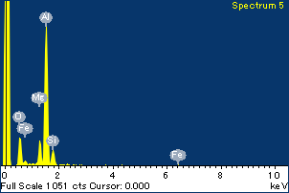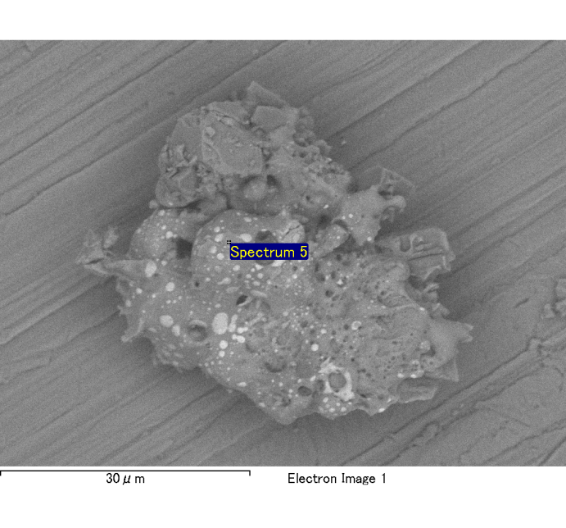

Spectrum Label: Spectrum 5

Livetime 120.0 s

Acquisition geometry ( degrees ):

Tilt = 0.0

Azimuth = 0.0

Elevation = 30.0

Accelerating voltage = 10.00 kV

Total spectrum counts = 119434

|  |  |  |  |
| --- | --- | --- | --- |
| Sample data : | Energy (eV) | Resn. (eV) | Area |
| Strobe : | 3.8 | 53.96 | 1208681 |
|  |  |  |  |
| Optimization data : Cobalt K series |  |  |  |
|  | Energy (eV) | Resn. (eV) | Area |
| Strobe : | .1 | 53.96 | 498142 |
| Optimization element : | 6926.7 | 142.17 | 16696 |

Spectrum processing :

No peaks omitted

Processing option : Oxygen by stoichiometry

Number of iterations = 2

Standard :

Na Albite 1-Jun-1999 12:00 AM

Mg MgO 1-Jun-1999 12:00 AM

Al Al2O3 1-Jun-1999 12:00 AM

Si SiO2 1-Jun-1999 12:00 AM

P GaP 1-Jun-1999 12:00 AM

S FeS2 1-Jun-1999 12:00 AM

K MAD-10 Feldspar 1-Jun-1999 12:00 AM

Ca Wollastonite 1-Jun-1999 12:00 AM

Cr Cr 1-Jun-1999 12:00 AM

Mn Mn 1-Jun-1999 12:00 AM

Fe Fe 1-Jun-1999 12:00 AM

Ni Ni 1-Jun-1999 12:00 AM

|  |  |  |  |  |  |
| --- | --- | --- | --- | --- | --- |
| Element | Weight% | Atomic% | Compd% | Formula |  |
|  |  |  |  |  |  |
| Na K | 0.00 | -0.08 | 0.00 | Na2O |  |
| Mg K | 0.12 | 4.77 | 0.20 | MgO |  |
| Al K | 0.84 | 29.40 | 1.59 | Al2O3 |  |
| Si K | 0.12 | 4.09 | 0.26 | SiO2 |  |
| P K | 0.00 | 0.11 | 0.01 | P2O5 |  |
| S K | 0.01 | 0.21 | 0.02 | SO3 |  |
| K K | 0.00 | -0.10 | -0.01 | K2O |  |
| Ca K | 0.00 | 0.08 | 0.00 | CaO |  |
| Cr K | 0.00 | 0.01 | 0.00 | Cr2O3 |  |
| Mn K | 0.00 | 0.08 | 0.01 | MnO |  |
| Fe K | 0.13 | 2.28 | 0.17 | FeO |  |
| Ni K | -0.04 | -0.57 | -0.05 | NiO |  |
| O | 1.01 | 59.73 |  |  |  |
| Totals | 2.21 |  |  |  |  |

Project: Project 1

Owner: Administrator

Site: Site of Interest 2

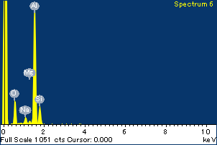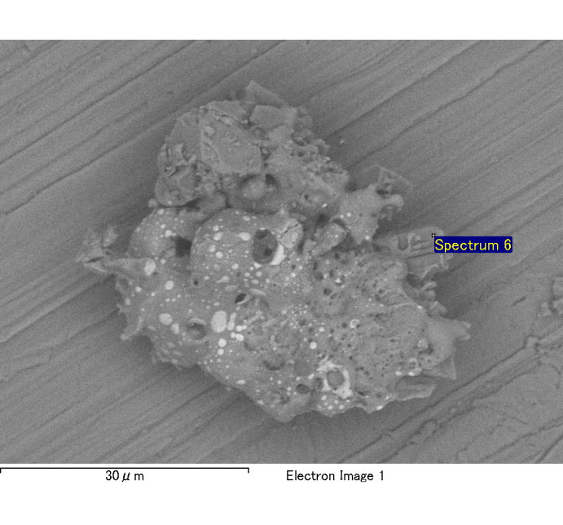

Spectrum Label: Spectrum 6

Livetime 120.0 s

Acquisition geometry ( degrees ):

Tilt = 0.0

Azimuth = 0.0

Elevation = 30.0

Accelerating voltage = 10.00 kV

Total spectrum counts = 118877

|  |  |  |  |
| --- | --- | --- | --- |
| Sample data : | Energy (eV) | Resn. (eV) | Area |
| Strobe : | 3.8 | 54.00 | 1208485 |
|  |  |  |  |
| Optimization data : Cobalt K series |  |  |  |
|  | Energy (eV) | Resn. (eV) | Area |
| Strobe : | .1 | 53.96 | 498142 |
| Optimization element : | 6926.7 | 142.17 | 16696 |

Spectrum processing :

No peaks omitted

Processing option : Oxygen by stoichiometry

Number of iterations = 2

Standard :

Na Albite 1-Jun-1999 12:00 AM

Mg MgO 1-Jun-1999 12:00 AM

Al Al2O3 1-Jun-1999 12:00 AM

Si SiO2 1-Jun-1999 12:00 AM

P GaP 1-Jun-1999 12:00 AM

S FeS2 1-Jun-1999 12:00 AM

K MAD-10 Feldspar 1-Jun-1999 12:00 AM

Ca Wollastonite 1-Jun-1999 12:00 AM

Cr Cr 1-Jun-1999 12:00 AM

Mn Mn 1-Jun-1999 12:00 AM

Fe Fe 1-Jun-1999 12:00 AM

Ni Ni 1-Jun-1999 12:00 AM

|  |  |  |  |  |  |
| --- | --- | --- | --- | --- | --- |
| Element | Weight% | Atomic% | Compd% | Formula |  |
|  |  |  |  |  |  |
| Na K | 0.04 | 1.55 | 0.05 | Na2O |  |
| Mg K | 0.02 | 0.71 | 0.03 | MgO |  |
| Al K | 0.95 | 30.84 | 1.79 | Al2O3 |  |
| Si K | 0.20 | 6.34 | 0.43 | SiO2 |  |
| P K | 0.00 | -0.10 | -0.01 | P2O5 |  |
| S K | 0.00 | 0.03 | 0.00 | SO3 |  |
| K K | 0.00 | 0.07 | 0.00 | K2O |  |
| Ca K | 0.01 | 0.19 | 0.01 | CaO |  |
| Cr K | 0.00 | 0.07 | 0.01 | Cr2O3 |  |
| Mn K | 0.01 | 0.20 | 0.02 | MnO |  |
| Fe K | -0.01 | -0.12 | -0.01 | FeO |  |
| Ni K | -0.02 | -0.23 | -0.02 | NiO |  |
| O | 1.10 | 60.45 |  |  |  |
| Totals | 2.32 |  |  |  |  |

Project: Project 1

Owner: Administrator

Site: Site of Interest 2

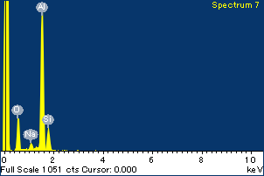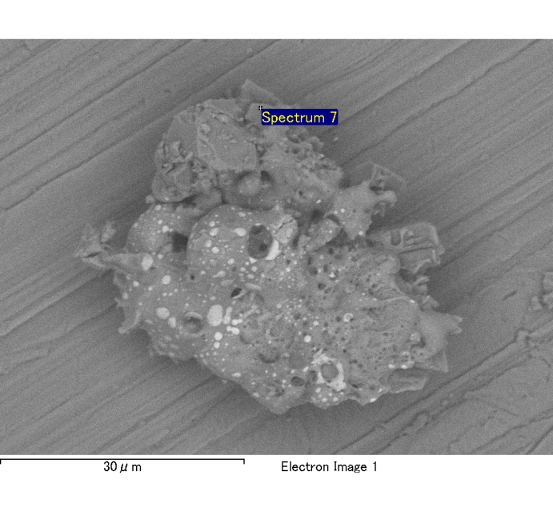

Spectrum Label: Spectrum 7

Livetime 120.0 s

Acquisition geometry ( degrees ):

Tilt = 0.0

Azimuth = 0.0

Elevation = 30.0

Accelerating voltage = 10.00 kV

Total spectrum counts = 119808

|  |  |  |  |
| --- | --- | --- | --- |
| Sample data : | Energy (eV) | Resn. (eV) | Area |
| Strobe : | 3.8 | 54.05 | 1209789 |
|  |  |  |  |
| Optimization data : Cobalt K series |  |  |  |
|  | Energy (eV) | Resn. (eV) | Area |
| Strobe : | .1 | 53.96 | 498142 |
| Optimization element : | 6926.7 | 142.17 | 16696 |

Spectrum processing :

No peaks omitted

Processing option : Oxygen by stoichiometry

Number of iterations = 2

Standard :

Na Albite 1-Jun-1999 12:00 AM

Mg MgO 1-Jun-1999 12:00 AM

Al Al2O3 1-Jun-1999 12:00 AM

Si SiO2 1-Jun-1999 12:00 AM

P GaP 1-Jun-1999 12:00 AM

S FeS2 1-Jun-1999 12:00 AM

K MAD-10 Feldspar 1-Jun-1999 12:00 AM

Ca Wollastonite 1-Jun-1999 12:00 AM

Cr Cr 1-Jun-1999 12:00 AM

Mn Mn 1-Jun-1999 12:00 AM

Fe Fe 1-Jun-1999 12:00 AM

Ni Ni 1-Jun-1999 12:00 AM

|  |  |  |  |  |  |
| --- | --- | --- | --- | --- | --- |
| Element | Weight% | Atomic% | Compd% | Formula |  |
|  |  |  |  |  |  |
| Na K | 0.05 | 1.82 | 0.07 | Na2O |  |
| Mg K | 0.01 | 0.28 | 0.01 | MgO |  |
| Al K | 0.96 | 30.26 | 1.81 | Al2O3 |  |
| Si K | 0.20 | 6.03 | 0.43 | SiO2 |  |
| P K | 0.00 | 0.00 | 0.00 | P2O5 |  |
| S K | 0.00 | 0.07 | 0.01 | SO3 |  |
| K K | 0.01 | 0.20 | 0.01 | K2O |  |
| Ca K | 0.01 | 0.14 | 0.01 | CaO |  |
| Cr K | 0.01 | 0.14 | 0.01 | Cr2O3 |  |
| Mn K | -0.02 | -0.26 | -0.02 | MnO |  |
| Fe K | 0.03 | 0.49 | 0.04 | FeO |  |
| Ni K | 0.04 | 0.62 | 0.05 | NiO |  |
| O | 1.13 | 60.19 |  |  |  |
| Totals | 2.43 |  |  |  |  |

Project: Project 1

Owner: Administrator

Site: Site of Interest 2

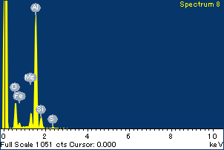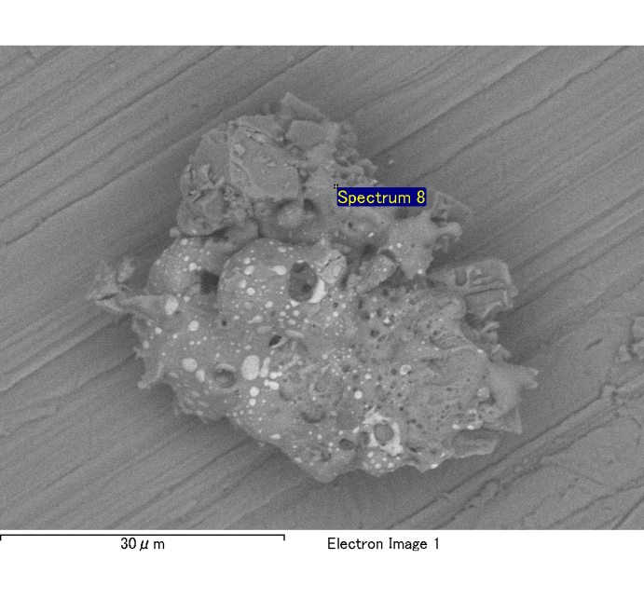

Spectrum Label: Spectrum 8

Livetime 120.0 s

Acquisition geometry ( degrees ):

Tilt = 0.0

Azimuth = 0.0

Elevation = 30.0

Accelerating voltage = 10.00 kV

Total spectrum counts = 120355

|  |  |  |  |
| --- | --- | --- | --- |
| Sample data : | Energy (eV) | Resn. (eV) | Area |
| Strobe : | 3.8 | 54.09 | 1209054 |
|  |  |  |  |
| Optimization data : Cobalt K series |  |  |  |
|  | Energy (eV) | Resn. (eV) | Area |
| Strobe : | .1 | 53.96 | 498142 |
| Optimization element : | 6926.7 | 142.17 | 16696 |

Spectrum processing :

No peaks omitted

Processing option : Oxygen by stoichiometry

Number of iterations = 2

Standard :

Na Albite 1-Jun-1999 12:00 AM

Mg MgO 1-Jun-1999 12:00 AM

Al Al2O3 1-Jun-1999 12:00 AM

Si SiO2 1-Jun-1999 12:00 AM

P GaP 1-Jun-1999 12:00 AM

S FeS2 1-Jun-1999 12:00 AM

K MAD-10 Feldspar 1-Jun-1999 12:00 AM

Ca Wollastonite 1-Jun-1999 12:00 AM

Cr Cr 1-Jun-1999 12:00 AM

Mn Mn 1-Jun-1999 12:00 AM

Fe Fe 1-Jun-1999 12:00 AM

Ni Ni 1-Jun-1999 12:00 AM

|  |  |  |  |  |  |
| --- | --- | --- | --- | --- | --- |
| Element | Weight% | Atomic% | Compd% | Formula |  |
|  |  |  |  |  |  |
| Na K | 0.01 | 0.28 | 0.01 | Na2O |  |
| Mg K | 0.11 | 4.01 | 0.18 | MgO |  |
| Al K | 0.89 | 29.67 | 1.69 | Al2O3 |  |
| Si K | 0.12 | 3.71 | 0.25 | SiO2 |  |
| P K | 0.00 | 0.09 | 0.01 | P2O5 |  |
| S K | 0.02 | 0.61 | 0.05 | SO3 |  |
| K K | 0.00 | 0.05 | 0.00 | K2O |  |
| Ca K | 0.00 | 0.00 | 0.00 | CaO |  |
| Cr K | 0.02 | 0.32 | 0.03 | Cr2O3 |  |
| Mn K | 0.00 | -0.06 | 0.00 | MnO |  |
| Fe K | 0.09 | 1.44 | 0.12 | FeO |  |
| Ni K | 0.00 | -0.07 | -0.01 | NiO |  |
| O | 1.07 | 59.95 |  |  |  |
| Totals | 2.32 |  |  |  |  |

Project: Project 1

Owner: Administrator

Site: Site of Interest 2

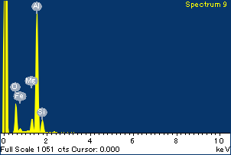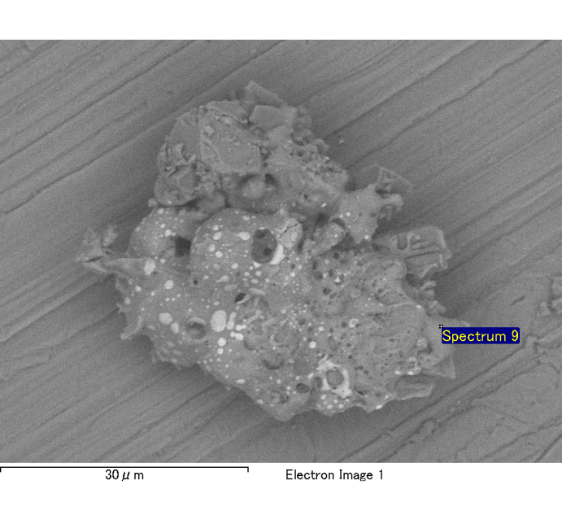

Spectrum Label: Spectrum 9

Livetime 120.0 s

Acquisition geometry ( degrees ):

Tilt = 0.0

Azimuth = 0.0

Elevation = 30.0

Accelerating voltage = 10.00 kV

Total spectrum counts = 119838

|  |  |  |  |
| --- | --- | --- | --- |
| Sample data : | Energy (eV) | Resn. (eV) | Area |
| Strobe : | 3.8 | 54.05 | 1207395 |
|  |  |  |  |
| Optimization data : Cobalt K series |  |  |  |
|  | Energy (eV) | Resn. (eV) | Area |
| Strobe : | .1 | 53.96 | 498142 |
| Optimization element : | 6926.7 | 142.17 | 16696 |

Spectrum processing :

No peaks omitted

Processing option : Oxygen by stoichiometry

Number of iterations = 2

Standard :

Na Albite 1-Jun-1999 12:00 AM

Mg MgO 1-Jun-1999 12:00 AM

Al Al2O3 1-Jun-1999 12:00 AM

Si SiO2 1-Jun-1999 12:00 AM

P GaP 1-Jun-1999 12:00 AM

S FeS2 1-Jun-1999 12:00 AM

K MAD-10 Feldspar 1-Jun-1999 12:00 AM

Ca Wollastonite 1-Jun-1999 12:00 AM

Cr Cr 1-Jun-1999 12:00 AM

Mn Mn 1-Jun-1999 12:00 AM

Fe Fe 1-Jun-1999 12:00 AM

Ni Ni 1-Jun-1999 12:00 AM

|  |  |  |  |  |  |
| --- | --- | --- | --- | --- | --- |
| Element | Weight% | Atomic% | Compd% | Formula |  |
|  |  |  |  |  |  |
| Na K | 0.00 | 0.10 | 0.00 | Na2O |  |
| Mg K | 0.10 | 3.59 | 0.16 | MgO |  |
| Al K | 0.91 | 30.25 | 1.73 | Al2O3 |  |
| Si K | 0.13 | 4.16 | 0.28 | SiO2 |  |
| P K | 0.00 | -0.08 | -0.01 | P2O5 |  |
| S K | 0.01 | 0.32 | 0.03 | SO3 |  |
| K K | 0.00 | -0.05 | 0.00 | K2O |  |
| Ca K | 0.00 | 0.01 | 0.00 | CaO |  |
| Cr K | 0.01 | 0.24 | 0.02 | Cr2O3 |  |
| Mn K | 0.01 | 0.17 | 0.01 | MnO |  |
| Fe K | 0.07 | 1.11 | 0.09 | FeO |  |
| Ni K | 0.02 | 0.23 | 0.02 | NiO |  |
| O | 1.07 | 59.94 |  |  |  |
| Totals | 2.33 |  |  |  |  |

Project: Project 1

Owner: Administrator

Site: Site of Interest 2

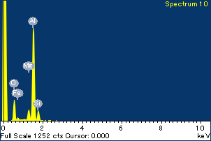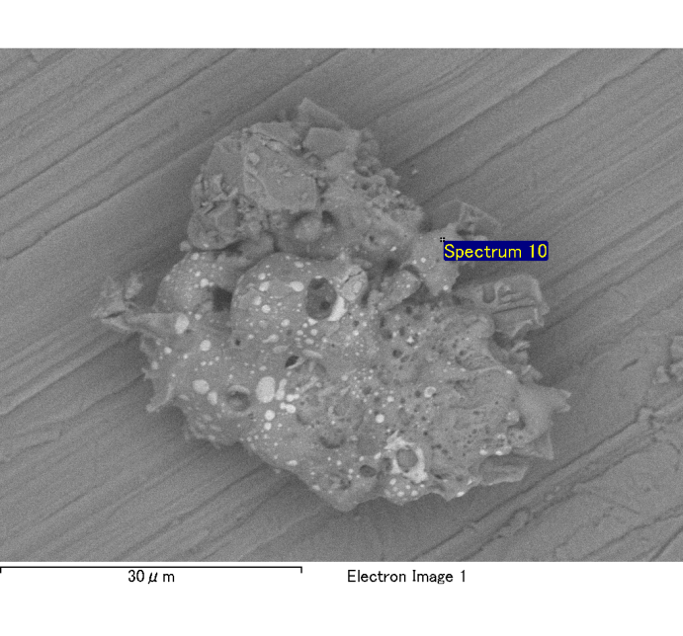

Spectrum Label: Spectrum 10

Livetime 120.0 s

Acquisition geometry ( degrees ):

Tilt = 0.0

Azimuth = 0.0

Elevation = 30.0

Accelerating voltage = 10.00 kV

Total spectrum counts = 119263

|  |  |  |  |
| --- | --- | --- | --- |
| Sample data : | Energy (eV) | Resn. (eV) | Area |
| Strobe : | 3.8 | 54.05 | 1208828 |
|  |  |  |  |
| Optimization data : Cobalt K series |  |  |  |
|  | Energy (eV) | Resn. (eV) | Area |
| Strobe : | .1 | 53.96 | 498142 |
| Optimization element : | 6926.7 | 142.17 | 16696 |

Spectrum processing :

No peaks omitted

Processing option : Oxygen by stoichiometry

Number of iterations = 2

Standard :

Na Albite 1-Jun-1999 12:00 AM

Mg MgO 1-Jun-1999 12:00 AM

Al Al2O3 1-Jun-1999 12:00 AM

Si SiO2 1-Jun-1999 12:00 AM

P GaP 1-Jun-1999 12:00 AM

S FeS2 1-Jun-1999 12:00 AM

K MAD-10 Feldspar 1-Jun-1999 12:00 AM

Ca Wollastonite 1-Jun-1999 12:00 AM

Cr Cr 1-Jun-1999 12:00 AM

Mn Mn 1-Jun-1999 12:00 AM

Fe Fe 1-Jun-1999 12:00 AM

Ni Ni 1-Jun-1999 12:00 AM

|  |  |  |  |  |  |
| --- | --- | --- | --- | --- | --- |
| Element | Weight% | Atomic% | Compd% | Formula |  |
|  |  |  |  |  |  |
| Na K | 0.00 | 0.12 | 0.00 | Na2O |  |
| Mg K | 0.10 | 3.72 | 0.16 | MgO |  |
| Al K | 0.91 | 31.17 | 1.71 | Al2O3 |  |
| Si K | 0.12 | 4.08 | 0.26 | SiO2 |  |
| P K | 0.00 | -0.05 | 0.00 | P2O5 |  |
| S K | 0.01 | 0.43 | 0.04 | SO3 |  |
| K K | 0.00 | 0.04 | 0.00 | K2O |  |
| Ca K | 0.00 | 0.11 | 0.01 | CaO |  |
| Cr K | 0.01 | 0.19 | 0.02 | Cr2O3 |  |
| Mn K | 0.01 | 0.16 | 0.01 | MnO |  |
| Fe K | 0.09 | 1.52 | 0.12 | FeO |  |
| Ni K | -0.11 | -1.72 | -0.14 | NiO |  |
| O | 1.04 | 60.23 |  |  |  |
| Totals | 2.19 |  |  |  |  |

Project: Project 1

Owner: Administrator

Site: Site of Interest 2

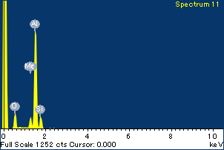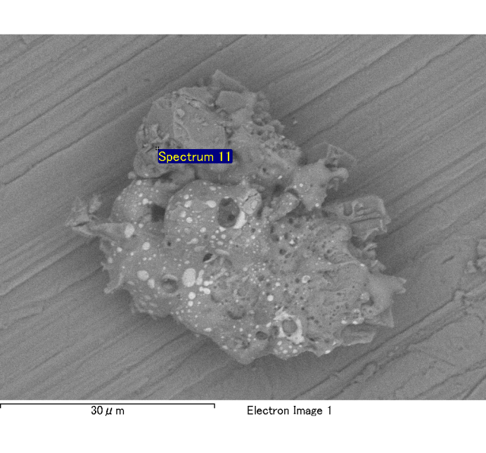

Spectrum Label: Spectrum 11

Livetime 120.0 s

Acquisition geometry ( degrees ):

Tilt = 0.0

Azimuth = 0.0

Elevation = 30.0

Accelerating voltage = 10.00 kV

Total spectrum counts = 118679

|  |  |  |  |
| --- | --- | --- | --- |
| Sample data : | Energy (eV) | Resn. (eV) | Area |
| Strobe : | 3.8 | 54.04 | 1207850 |
|  |  |  |  |
| Optimization data : Cobalt K series |  |  |  |
|  | Energy (eV) | Resn. (eV) | Area |
| Strobe : | .1 | 53.96 | 498142 |
| Optimization element : | 6926.7 | 142.17 | 16696 |

Spectrum processing :

No peaks omitted

Processing option : Oxygen by stoichiometry

Number of iterations = 2

Standard :

Na Albite 1-Jun-1999 12:00 AM

Mg MgO 1-Jun-1999 12:00 AM

Al Al2O3 1-Jun-1999 12:00 AM

Si SiO2 1-Jun-1999 12:00 AM

P GaP 1-Jun-1999 12:00 AM

S FeS2 1-Jun-1999 12:00 AM

K MAD-10 Feldspar 1-Jun-1999 12:00 AM

Ca Wollastonite 1-Jun-1999 12:00 AM

Cr Cr 1-Jun-1999 12:00 AM

Mn Mn 1-Jun-1999 12:00 AM

Fe Fe 1-Jun-1999 12:00 AM

Ni Ni 1-Jun-1999 12:00 AM

|  |  |  |  |  |  |
| --- | --- | --- | --- | --- | --- |
| Element | Weight% | Atomic% | Compd% | Formula |  |
|  |  |  |  |  |  |
| Na K | 0.00 | 0.05 | 0.00 | Na2O |  |
| Mg K | 0.08 | 3.10 | 0.13 | MgO |  |
| Al K | 0.89 | 31.06 | 1.67 | Al2O3 |  |
| Si K | 0.15 | 4.90 | 0.31 | SiO2 |  |
| P K | 0.00 | -0.01 | 0.00 | P2O5 |  |
| S K | 0.00 | 0.05 | 0.00 | SO3 |  |
| K K | 0.00 | -0.05 | 0.00 | K2O |  |
| Ca K | 0.00 | -0.11 | -0.01 | CaO |  |
| Cr K | -0.01 | -0.14 | -0.01 | Cr2O3 |  |
| Mn K | 0.01 | 0.10 | 0.01 | MnO |  |
| Fe K | 0.07 | 1.12 | 0.08 | FeO |  |
| Ni K | -0.02 | -0.30 | -0.02 | NiO |  |
| O | 1.02 | 60.23 |  |  |  |
| Totals | 2.17 |  |  |  |  |

Project: Project 1

Owner: Administrator

Site: Site of Interest 2