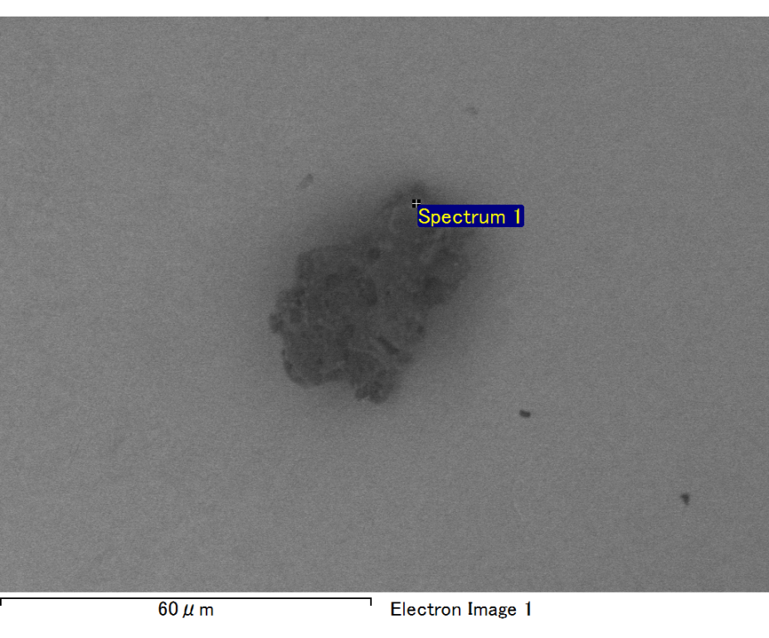

Spectrum processing :

No peaks omitted

Processing option : All elements analyzed (Normalised)

Number of iterations = 2

Standard :

C CaCO3 1-Jun-1999 12:00 AM

O SiO2 1-Jun-1999 12:00 AM

Mg MgO 1-Jun-1999 12:00 AM

Si SiO2 1-Jun-1999 12:00 AM

Fe Fe 1-Jun-1999 12:00 AM

Au Au 1-Jun-1999 12:00 AM

|  |  |  |  |
| --- | --- | --- | --- |
| Element | Weight% | Atomic% |  |
|  |  |  |  |
| C K | 2.91 | 10.64 |  |
| O K | 17.61 | 48.27 |  |
| Mg K | 4.15 | 7.48 |  |
| Si K | 4.07 | 6.35 |  |
| Fe L | 20.27 | 15.92 |  |
| Au M | 50.98 | 11.35 |  |
|  |  |  |  |
| Totals | 100.00 |  |  |

Spectrum Label: Spectrum 1

Livetime 60.0 s

Acquisition geometry ( degrees ):

Tilt = 15.0

Azimuth = 0.0

Elevation = 30.0

Accelerating voltage = 10.00 kV

Total spectrum counts = 39604

|  |  |  |  |
| --- | --- | --- | --- |
| Sample data : | Energy (eV) | Resn. (eV) | Area |
| Strobe : | 3.8 | 47.35 | 1000372 |
|  |  |  |  |

No quant optimization performed

Sample: Sample 1

Type: Default

ID:

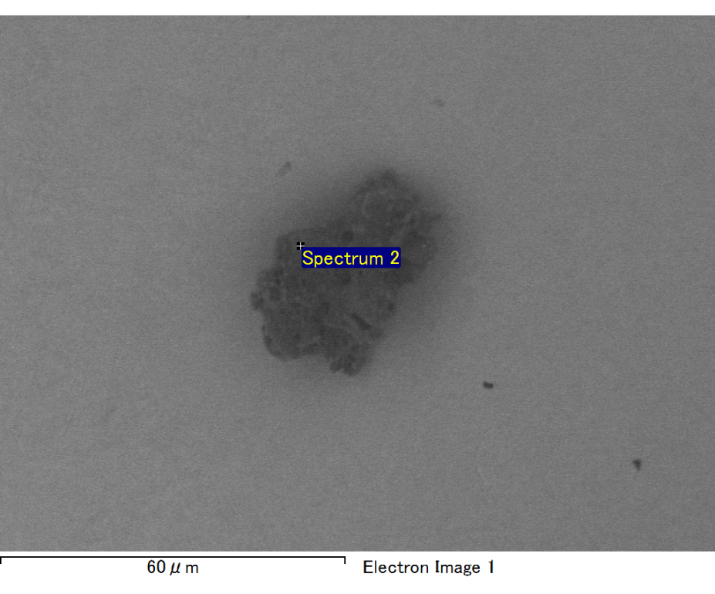

Spectrum processing :

No peaks omitted

Processing option : All elements analyzed (Normalised)

Number of iterations = 2

Standard :

C CaCO3 1-Jun-1999 12:00 AM

O SiO2 1-Jun-1999 12:00 AM

Na Albite 1-Jun-1999 12:00 AM

Mg MgO 1-Jun-1999 12:00 AM

Al Al2O3 1-Jun-1999 12:00 AM

Si SiO2 1-Jun-1999 12:00 AM

Au Au 1-Jun-1999 12:00 AM

|  |  |  |  |
| --- | --- | --- | --- |
| Element | Weight% | Atomic% |  |
|  |  |  |  |
| C K | 3.12 | 11.10 |  |
| O K | 20.51 | 54.76 |  |
| Na K | 1.05 | 1.95 |  |
| Mg K | 2.31 | 4.07 |  |
| Al K | 1.69 | 2.68 |  |
| Si K | 7.66 | 11.64 |  |
| Au M | 63.66 | 13.81 |  |
|  |  |  |  |
| Totals | 100.00 |  |  |

Spectrum Label: Spectrum 2

Livetime 60.0 s

Acquisition geometry ( degrees ):

Tilt = 15.0

Azimuth = 0.0

Elevation = 30.0

Accelerating voltage = 10.00 kV

Total spectrum counts = 38010

|  |  |  |  |
| --- | --- | --- | --- |
| Sample data : | Energy (eV) | Resn. (eV) | Area |
| Strobe : | 3.8 | 47.37 | 999637 |
|  |  |  |  |

No quant optimization performed

Sample: Sample 1

Type: Default

ID:

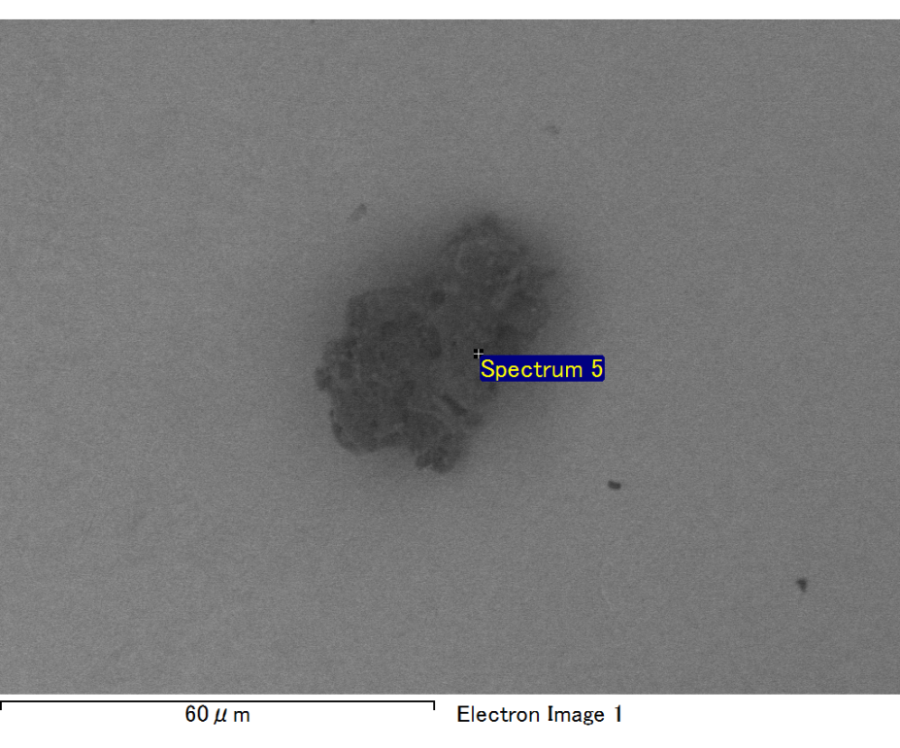

Spectrum processing :

Peak possibly omitted : 0.720 keV

Processing option : All elements analyzed (Normalised)

Number of iterations = 2

Standard :

C CaCO3 1-Jun-1999 12:00 AM

O SiO2 1-Jun-1999 12:00 AM

Mg MgO 1-Jun-1999 12:00 AM

Si SiO2 1-Jun-1999 12:00 AM

Au Au 1-Jun-1999 12:00 AM

|  |  |  |  |
| --- | --- | --- | --- |
| Element | Weight% | Atomic% |  |
|  |  |  |  |
| C K | 2.99 | 17.03 |  |
| O K | 8.67 | 37.06 |  |
| Mg K | 3.02 | 8.48 |  |
| Si K | 3.75 | 9.13 |  |
| Au M | 81.57 | 28.30 |  |
|  |  |  |  |
| Totals | 100.00 |  |  |

Spectrum Label: Spectrum 5

Livetime 60.0 s

Acquisition geometry ( degrees ):

Tilt = 15.0

Azimuth = 0.0

Elevation = 30.0

Accelerating voltage = 10.00 kV

Total spectrum counts = 35365

|  |  |  |  |
| --- | --- | --- | --- |
| Sample data : | Energy (eV) | Resn. (eV) | Area |
| Strobe : | 3.8 | 47.35 | 1000765 |
|  |  |  |  |

No quant optimization performed

Sample: Sample 1

Type: Default

ID:

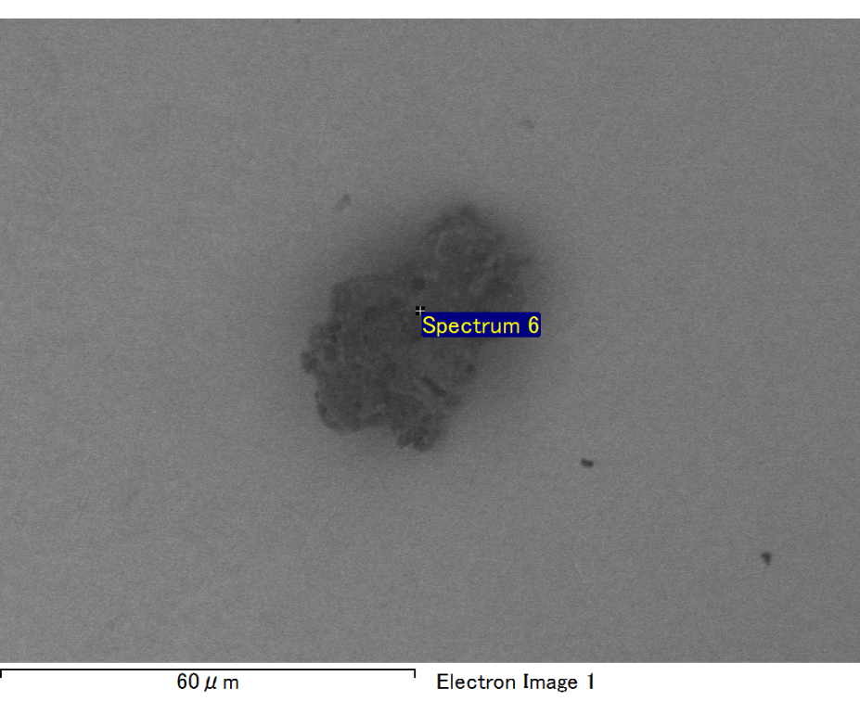

Spectrum processing :

No peaks omitted

Processing option : All elements analyzed (Normalised)

Number of iterations = 2

Standard :

C CaCO3 1-Jun-1999 12:00 AM

O SiO2 1-Jun-1999 12:00 AM

Mg MgO 1-Jun-1999 12:00 AM

Si SiO2 1-Jun-1999 12:00 AM

Fe Fe 1-Jun-1999 12:00 AM

Au Au 1-Jun-1999 12:00 AM

|  |  |  |  |
| --- | --- | --- | --- |
| Element | Weight% | Atomic% |  |
|  |  |  |  |
| C K | 2.93 | 9.39 |  |
| O K | 22.13 | 53.30 |  |
| Mg K | 6.28 | 9.96 |  |
| Si K | 5.28 | 7.25 |  |
| Fe L | 15.55 | 10.73 |  |
| Au M | 47.82 | 9.36 |  |
|  |  |  |  |
| Totals | 100.00 |  |  |

Spectrum Label: Spectrum 6

Livetime 60.0 s

Acquisition geometry ( degrees ):

Tilt = 15.0

Azimuth = 0.0

Elevation = 30.0

Accelerating voltage = 10.00 kV

Total spectrum counts = 38807

|  |  |  |  |
| --- | --- | --- | --- |
| Sample data : | Energy (eV) | Resn. (eV) | Area |
| Strobe : | 3.8 | 47.38 | 1000059 |
|  |  |  |  |

No quant optimization performed

Sample: Sample 1

Type: Default

ID:

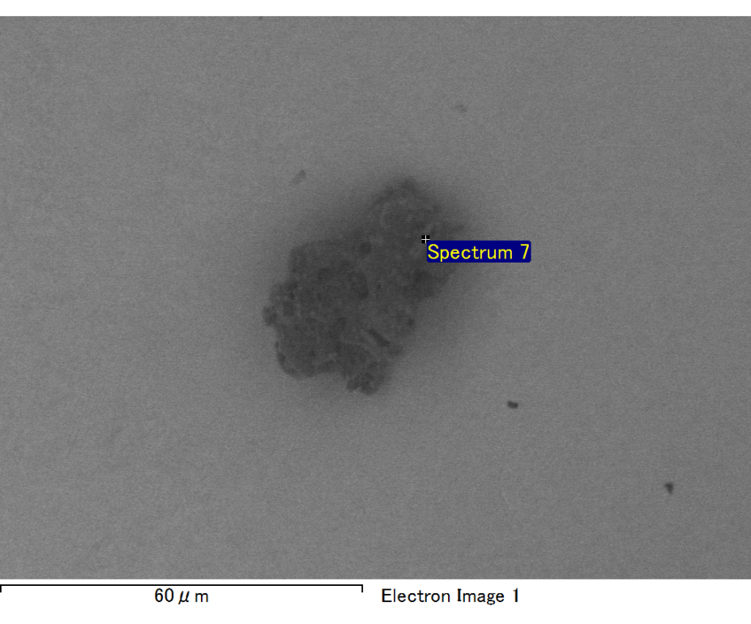

Spectrum processing :

Peak possibly omitted : 1.266 keV

Processing option : All elements analyzed (Normalised)

Number of iterations = 2

Standard :

O SiO2 1-Jun-1999 12:00 AM

Ca Wollastonite 1-Jun-1999 12:00 AM

Au Au 1-Jun-1999 12:00 AM

|  |  |  |  |
| --- | --- | --- | --- |
| Element | Weight% | Atomic% |  |
|  |  |  |  |
| O K | 4.40 | 30.70 |  |
| Ca K | 6.84 | 19.03 |  |
| Au M | 88.76 | 50.27 |  |
|  |  |  |  |
| Totals | 100.00 |  |  |

Spectrum Label: Spectrum 7

Livetime 60.0 s

Acquisition geometry ( degrees ):

Tilt = 15.0

Azimuth = 0.0

Elevation = 30.0

Accelerating voltage = 10.00 kV

Total spectrum counts = 35588

|  |  |  |  |
| --- | --- | --- | --- |
| Sample data : | Energy (eV) | Resn. (eV) | Area |
| Strobe : | 3.8 | 47.36 | 1000715 |
|  |  |  |  |

No quant optimization performed

Sample: Sample 1

Type: Default

ID: