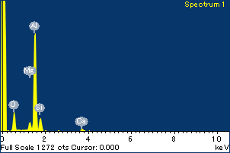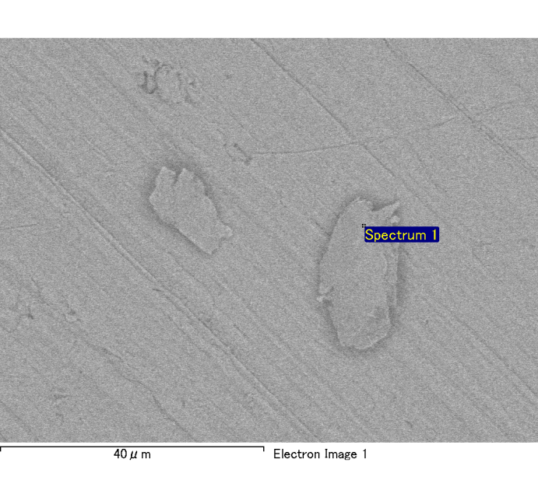

Spectrum Label: Spectrum 1

Livetime 120.0 s

Acquisition geometry ( degrees ):

Tilt = 0.0

Azimuth = 0.0

Elevation = 30.0

Accelerating voltage = 10.00 kV

Total spectrum counts = 119797

|  |  |  |  |
| --- | --- | --- | --- |
| Sample data : | Energy (eV) | Resn. (eV) | Area |
| Strobe : | 3.8 | 54.02 | 1207272 |
|  |  |  |  |
| Optimization data : Cobalt K series |  |  |  |
|  | Energy (eV) | Resn. (eV) | Area |
| Strobe : | .1 | 53.96 | 498142 |
| Optimization element : | 6926.7 | 142.17 | 16696 |

Spectrum processing :

No peaks omitted

Processing option : Oxygen by stoichiometry

Number of iterations = 2

Standard :

Na Albite 1-Jun-1999 12:00 AM

Mg MgO 1-Jun-1999 12:00 AM

Al Al2O3 1-Jun-1999 12:00 AM

Si SiO2 1-Jun-1999 12:00 AM

P GaP 1-Jun-1999 12:00 AM

S FeS2 1-Jun-1999 12:00 AM

K MAD-10 Feldspar 1-Jun-1999 12:00 AM

Ca Wollastonite 1-Jun-1999 12:00 AM

Cr Cr 1-Jun-1999 12:00 AM

Mn Mn 1-Jun-1999 12:00 AM

Fe Fe 1-Jun-1999 12:00 AM

Ni Ni 1-Jun-1999 12:00 AM

|  |  |  |  |  |  |
| --- | --- | --- | --- | --- | --- |
| Element | Weight% | Atomic% | Compd% | Formula |  |
|  |  |  |  |  |  |
| Na K | 0.00 | 0.15 | 0.01 | Na2O |  |
| Mg K | 0.06 | 2.06 | 0.09 | MgO |  |
| Al K | 0.90 | 29.51 | 1.70 | Al2O3 |  |
| Si K | 0.17 | 5.28 | 0.36 | SiO2 |  |
| P K | 0.00 | 0.08 | 0.01 | P2O5 |  |
| S K | 0.00 | -0.09 | -0.01 | SO3 |  |
| K K | 0.00 | -0.04 | 0.00 | K2O |  |
| Ca K | 0.08 | 1.67 | 0.11 | CaO |  |
| Cr K | 0.00 | -0.08 | -0.01 | Cr2O3 |  |
| Mn K | -0.01 | -0.15 | -0.01 | MnO |  |
| Fe K | 0.01 | 0.21 | 0.02 | FeO |  |
| Ni K | 0.10 | 1.47 | 0.12 | NiO |  |
| O | 1.08 | 59.94 |  |  |  |
| Totals | 2.38 |  |  |  |  |

Project: Project 1

Owner: Administrator

Site: Site of Interest 4

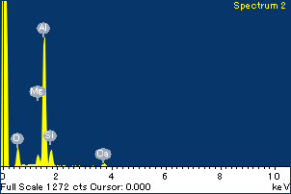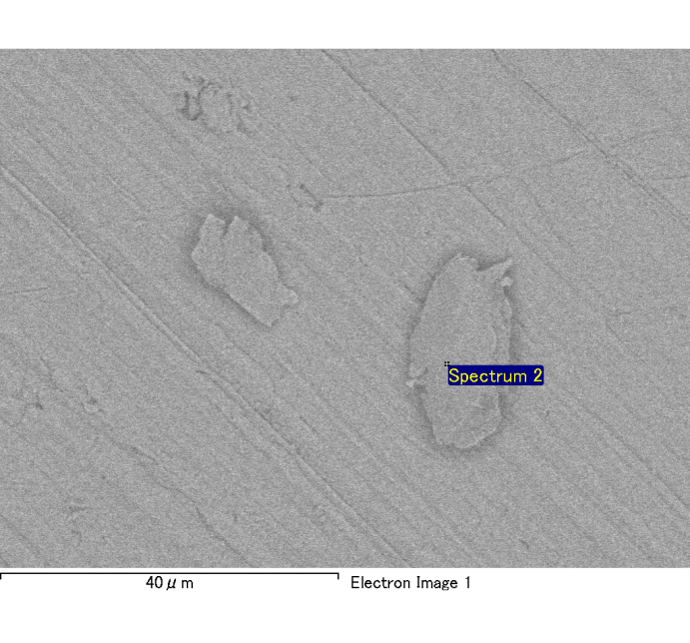

Spectrum Label: Spectrum 2

Livetime 120.0 s

Acquisition geometry ( degrees ):

Tilt = 0.0

Azimuth = 0.0

Elevation = 30.0

Accelerating voltage = 10.00 kV

Total spectrum counts = 119263

|  |  |  |  |
| --- | --- | --- | --- |
| Sample data : | Energy (eV) | Resn. (eV) | Area |
| Strobe : | 3.8 | 54.07 | 1209099 |
|  |  |  |  |
| Optimization data : Cobalt K series |  |  |  |
|  | Energy (eV) | Resn. (eV) | Area |
| Strobe : | .1 | 53.96 | 498142 |
| Optimization element : | 6926.7 | 142.17 | 16696 |

Spectrum processing :

No peaks omitted

Processing option : Oxygen by stoichiometry

Number of iterations = 2

Standard :

Na Albite 1-Jun-1999 12:00 AM

Mg MgO 1-Jun-1999 12:00 AM

Al Al2O3 1-Jun-1999 12:00 AM

Si SiO2 1-Jun-1999 12:00 AM

P GaP 1-Jun-1999 12:00 AM

S FeS2 1-Jun-1999 12:00 AM

K MAD-10 Feldspar 1-Jun-1999 12:00 AM

Ca Wollastonite 1-Jun-1999 12:00 AM

Cr Cr 1-Jun-1999 12:00 AM

Mn Mn 1-Jun-1999 12:00 AM

Fe Fe 1-Jun-1999 12:00 AM

Ni Ni 1-Jun-1999 12:00 AM

|  |  |  |  |  |  |
| --- | --- | --- | --- | --- | --- |
| Element | Weight% | Atomic% | Compd% | Formula |  |
|  |  |  |  |  |  |
| Na K | 0.00 | 0.00 | 0.00 | Na2O |  |
| Mg K | 0.06 | 2.40 | 0.10 | MgO |  |
| Al K | 0.88 | 30.53 | 1.65 | Al2O3 |  |
| Si K | 0.17 | 5.68 | 0.36 | SiO2 |  |
| P K | 0.00 | 0.00 | 0.00 | P2O5 |  |
| S K | -0.01 | -0.15 | -0.01 | SO3 |  |
| K K | 0.00 | 0.04 | 0.00 | K2O |  |
| Ca K | 0.07 | 1.74 | 0.10 | CaO |  |
| Cr K | 0.01 | 0.19 | 0.01 | Cr2O3 |  |
| Mn K | -0.02 | -0.26 | -0.02 | MnO |  |
| Fe K | 0.01 | 0.15 | 0.01 | FeO |  |
| Ni K | -0.04 | -0.68 | -0.05 | NiO |  |
| O | 1.03 | 60.36 |  |  |  |
| Totals | 2.17 |  |  |  |  |

Project: Project 1

Owner: Administrator

Site: Site of Interest 4

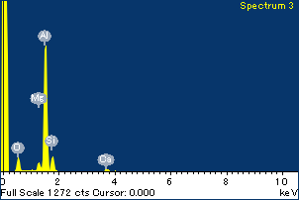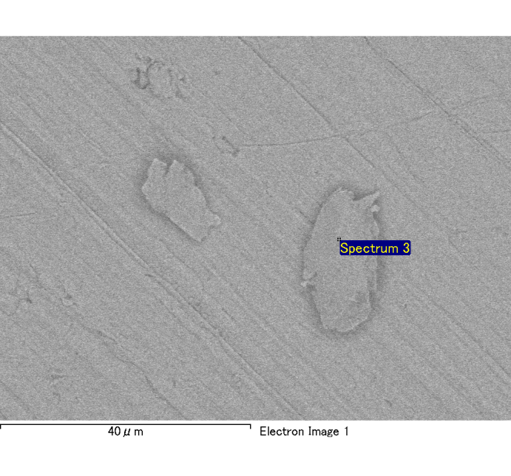

Spectrum Label: Spectrum 3

Livetime 120.0 s

Acquisition geometry ( degrees ):

Tilt = 0.0

Azimuth = 0.0

Elevation = 30.0

Accelerating voltage = 10.00 kV

Total spectrum counts = 118115

|  |  |  |  |
| --- | --- | --- | --- |
| Sample data : | Energy (eV) | Resn. (eV) | Area |
| Strobe : | 3.8 | 54.01 | 1206834 |
|  |  |  |  |
| Optimization data : Cobalt K series |  |  |  |
|  | Energy (eV) | Resn. (eV) | Area |
| Strobe : | .1 | 53.96 | 498142 |
| Optimization element : | 6926.7 | 142.17 | 16696 |

Spectrum processing :

No peaks omitted

Processing option : Oxygen by stoichiometry

Number of iterations = 2

Standard :

Na Albite 1-Jun-1999 12:00 AM

Mg MgO 1-Jun-1999 12:00 AM

Al Al2O3 1-Jun-1999 12:00 AM

Si SiO2 1-Jun-1999 12:00 AM

P GaP 1-Jun-1999 12:00 AM

S FeS2 1-Jun-1999 12:00 AM

K MAD-10 Feldspar 1-Jun-1999 12:00 AM

Ca Wollastonite 1-Jun-1999 12:00 AM

Cr Cr 1-Jun-1999 12:00 AM

Mn Mn 1-Jun-1999 12:00 AM

Fe Fe 1-Jun-1999 12:00 AM

Ni Ni 1-Jun-1999 12:00 AM

|  |  |  |  |  |  |
| --- | --- | --- | --- | --- | --- |
| Element | Weight% | Atomic% | Compd% | Formula |  |
|  |  |  |  |  |  |
| Na K | 0.00 | 0.18 | 0.01 | Na2O |  |
| Mg K | 0.05 | 1.90 | 0.08 | MgO |  |
| Al K | 0.86 | 30.77 | 1.62 | Al2O3 |  |
| Si K | 0.15 | 5.09 | 0.32 | SiO2 |  |
| P K | 0.00 | 0.01 | 0.00 | P2O5 |  |
| S K | 0.00 | 0.04 | 0.00 | SO3 |  |
| K K | 0.01 | 0.14 | 0.01 | K2O |  |
| Ca K | 0.07 | 1.65 | 0.10 | CaO |  |
| Cr K | 0.00 | 0.09 | 0.01 | Cr2O3 |  |
| Mn K | -0.01 | -0.18 | -0.01 | MnO |  |
| Fe K | 0.03 | 0.59 | 0.04 | FeO |  |
| Ni K | -0.03 | -0.51 | -0.04 | NiO |  |
| O | 0.99 | 60.23 |  |  |  |
| Totals | 2.12 |  |  |  |  |

Project: Project 1

Owner: Administrator

Site: Site of Interest 4

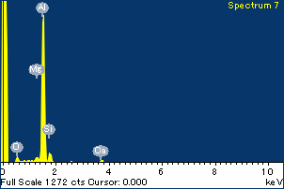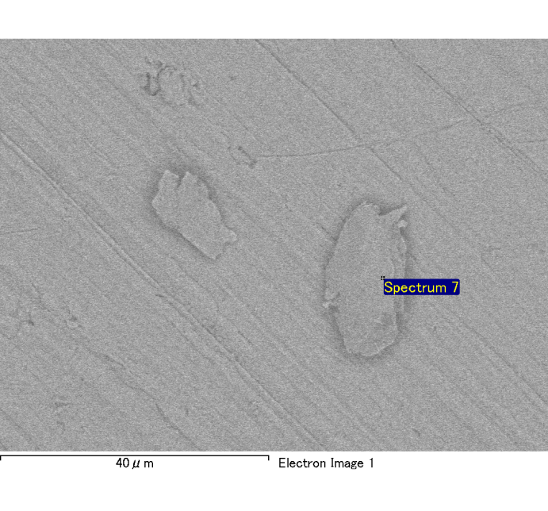

Spectrum Label: Spectrum 7

Livetime 120.0 s

Acquisition geometry ( degrees ):

Tilt = 0.0

Azimuth = 0.0

Elevation = 30.0

Accelerating voltage = 10.00 kV

Total spectrum counts = 118521

|  |  |  |  |
| --- | --- | --- | --- |
| Sample data : | Energy (eV) | Resn. (eV) | Area |
| Strobe : | 3.8 | 54.02 | 1207465 |
|  |  |  |  |
| Optimization data : Cobalt K series |  |  |  |
|  | Energy (eV) | Resn. (eV) | Area |
| Strobe : | .1 | 53.96 | 498142 |
| Optimization element : | 6926.7 | 142.17 | 16696 |

Spectrum processing :

No peaks omitted

Processing option : Oxygen by stoichiometry

Number of iterations = 2

Standard :

Na Albite 1-Jun-1999 12:00 AM

Mg MgO 1-Jun-1999 12:00 AM

Al Al2O3 1-Jun-1999 12:00 AM

Si SiO2 1-Jun-1999 12:00 AM

P GaP 1-Jun-1999 12:00 AM

S FeS2 1-Jun-1999 12:00 AM

K MAD-10 Feldspar 1-Jun-1999 12:00 AM

Ca Wollastonite 1-Jun-1999 12:00 AM

Cr Cr 1-Jun-1999 12:00 AM

Mn Mn 1-Jun-1999 12:00 AM

Fe Fe 1-Jun-1999 12:00 AM

Ni Ni 1-Jun-1999 12:00 AM

|  |  |  |  |  |  |
| --- | --- | --- | --- | --- | --- |
| Element | Weight% | Atomic% | Compd% | Formula |  |
|  |  |  |  |  |  |
| Na K | 0.00 | 0.09 | 0.00 | Na2O |  |
| Mg K | 0.02 | 0.71 | 0.03 | MgO |  |
| Al K | 1.09 | 34.05 | 2.06 | Al2O3 |  |
| Si K | 0.09 | 2.75 | 0.20 | SiO2 |  |
| P K | 0.00 | 0.12 | 0.01 | P2O5 |  |
| S K | 0.00 | 0.09 | 0.01 | SO3 |  |
| K K | 0.00 | 0.03 | 0.00 | K2O |  |
| Ca K | 0.05 | 1.08 | 0.07 | CaO |  |
| Cr K | 0.00 | 0.08 | 0.01 | Cr2O3 |  |
| Mn K | 0.00 | 0.00 | 0.00 | MnO |  |
| Fe K | 0.04 | 0.54 | 0.05 | FeO |  |
| Ni K | 0.03 | 0.41 | 0.04 | NiO |  |
| O | 1.14 | 60.06 |  |  |  |
| Totals | 2.47 |  |  |  |  |

Project: Project 1

Owner: Administrator

Site: Site of Interest 4

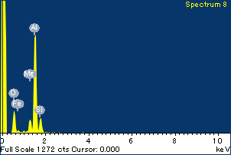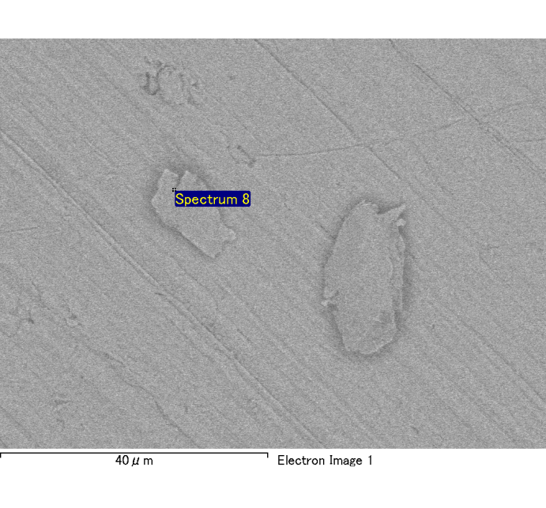

Spectrum Label: Spectrum 8

Livetime 120.0 s

Acquisition geometry ( degrees ):

Tilt = 0.0

Azimuth = 0.0

Elevation = 30.0

Accelerating voltage = 10.00 kV

Total spectrum counts = 120343

|  |  |  |  |
| --- | --- | --- | --- |
| Sample data : | Energy (eV) | Resn. (eV) | Area |
| Strobe : | 3.8 | 54.03 | 1207839 |
|  |  |  |  |
| Optimization data : Cobalt K series |  |  |  |
|  | Energy (eV) | Resn. (eV) | Area |
| Strobe : | .1 | 53.96 | 498142 |
| Optimization element : | 6926.7 | 142.17 | 16696 |

Spectrum processing :

No peaks omitted

Processing option : Oxygen by stoichiometry

Number of iterations = 2

Standard :

Na Albite 1-Jun-1999 12:00 AM

Mg MgO 1-Jun-1999 12:00 AM

Al Al2O3 1-Jun-1999 12:00 AM

Si SiO2 1-Jun-1999 12:00 AM

P GaP 1-Jun-1999 12:00 AM

S FeS2 1-Jun-1999 12:00 AM

K MAD-10 Feldspar 1-Jun-1999 12:00 AM

Ca Wollastonite 1-Jun-1999 12:00 AM

Cr Cr 1-Jun-1999 12:00 AM

Mn Mn 1-Jun-1999 12:00 AM

Fe Fe 1-Jun-1999 12:00 AM

Ni Ni 1-Jun-1999 12:00 AM

|  |  |  |  |  |  |
| --- | --- | --- | --- | --- | --- |
| Element | Weight% | Atomic% | Compd% | Formula |  |
|  |  |  |  |  |  |
| Na K | -0.01 | -0.25 | -0.01 | Na2O |  |
| Mg K | 0.10 | 3.70 | 0.17 | MgO |  |
| Al K | 0.91 | 29.96 | 1.71 | Al2O3 |  |
| Si K | 0.17 | 5.55 | 0.37 | SiO2 |  |
| P K | 0.00 | 0.03 | 0.00 | P2O5 |  |
| S K | 0.00 | 0.11 | 0.01 | SO3 |  |
| K K | 0.00 | -0.04 | 0.00 | K2O |  |
| Ca K | 0.00 | 0.00 | 0.00 | CaO |  |
| Cr K | 0.02 | 0.30 | 0.03 | Cr2O3 |  |
| Mn K | 0.00 | 0.07 | 0.01 | MnO |  |
| Fe K | 0.05 | 0.87 | 0.07 | FeO |  |
| Ni K | -0.06 | -0.85 | -0.07 | NiO |  |
| O | 1.09 | 60.54 |  |  |  |
| Totals | 2.29 |  |  |  |  |

Project: Project 1

Owner: Administrator

Site: Site of Interest 4

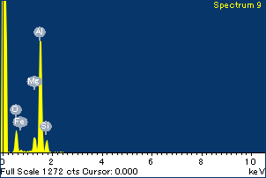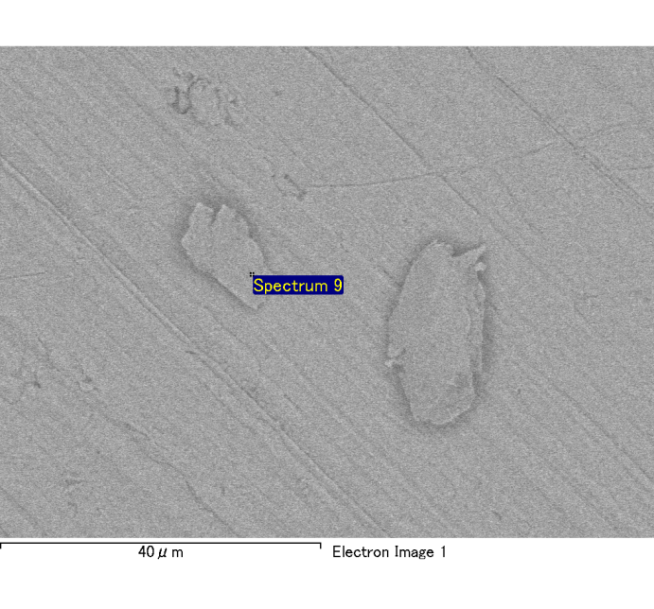

Spectrum Label: Spectrum 9

Livetime 120.0 s

Acquisition geometry ( degrees ):

Tilt = 0.0

Azimuth = 0.0

Elevation = 30.0

Accelerating voltage = 10.00 kV

Total spectrum counts = 120359

|  |  |  |  |
| --- | --- | --- | --- |
| Sample data : | Energy (eV) | Resn. (eV) | Area |
| Strobe : | 3.8 | 54.03 | 1208371 |
|  |  |  |  |
| Optimization data : Cobalt K series |  |  |  |
|  | Energy (eV) | Resn. (eV) | Area |
| Strobe : | .1 | 53.96 | 498142 |
| Optimization element : | 6926.7 | 142.17 | 16696 |

Spectrum processing :

No peaks omitted

Processing option : Oxygen by stoichiometry

Number of iterations = 2

Standard :

Na Albite 1-Jun-1999 12:00 AM

Mg MgO 1-Jun-1999 12:00 AM

Al Al2O3 1-Jun-1999 12:00 AM

Si SiO2 1-Jun-1999 12:00 AM

P GaP 1-Jun-1999 12:00 AM

S FeS2 1-Jun-1999 12:00 AM

K MAD-10 Feldspar 1-Jun-1999 12:00 AM

Ca Wollastonite 1-Jun-1999 12:00 AM

Cr Cr 1-Jun-1999 12:00 AM

Mn Mn 1-Jun-1999 12:00 AM

Fe Fe 1-Jun-1999 12:00 AM

Ni Ni 1-Jun-1999 12:00 AM

|  |  |  |  |  |  |
| --- | --- | --- | --- | --- | --- |
| Element | Weight% | Atomic% | Compd% | Formula |  |
|  |  |  |  |  |  |
| Na K | 0.00 | -0.16 | -0.01 | Na2O |  |
| Mg K | 0.11 | 4.02 | 0.18 | MgO |  |
| Al K | 0.92 | 30.10 | 1.74 | Al2O3 |  |
| Si K | 0.13 | 3.99 | 0.27 | SiO2 |  |
| P K | 0.00 | 0.07 | 0.01 | P2O5 |  |
| S K | 0.00 | 0.03 | 0.00 | SO3 |  |
| K K | 0.00 | -0.02 | 0.00 | K2O |  |
| Ca K | 0.00 | 0.02 | 0.00 | CaO |  |
| Cr K | 0.01 | 0.24 | 0.02 | Cr2O3 |  |
| Mn K | 0.00 | -0.01 | 0.00 | MnO |  |
| Fe K | 0.06 | 0.93 | 0.08 | FeO |  |
| Ni K | 0.07 | 1.09 | 0.09 | NiO |  |
| O | 1.09 | 59.70 |  |  |  |
| Totals | 2.39 |  |  |  |  |

Project: Project 1

Owner: Administrator

Site: Site of Interest 4

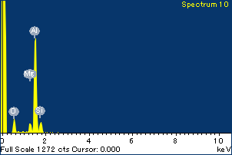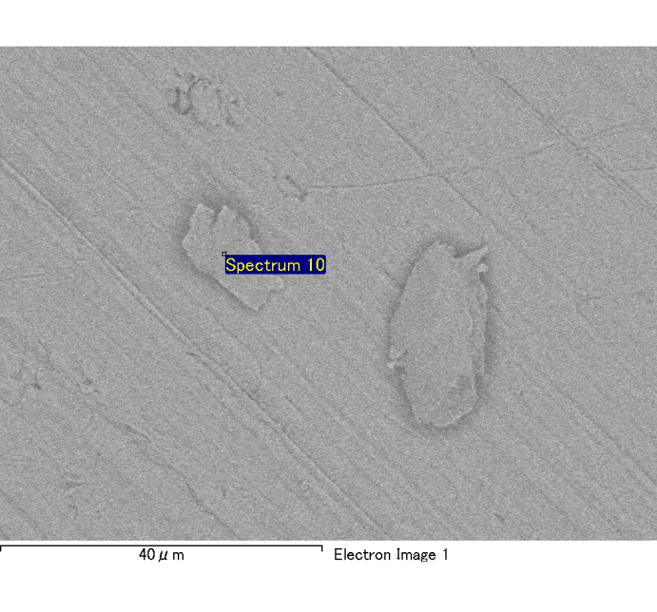

Spectrum Label: Spectrum 10

Livetime 120.0 s

Acquisition geometry ( degrees ):

Tilt = 0.0

Azimuth = 0.0

Elevation = 30.0

Accelerating voltage = 10.00 kV

Total spectrum counts = 118856

|  |  |  |  |
| --- | --- | --- | --- |
| Sample data : | Energy (eV) | Resn. (eV) | Area |
| Strobe : | 3.8 | 54.12 | 1208745 |
|  |  |  |  |
| Optimization data : Cobalt K series |  |  |  |
|  | Energy (eV) | Resn. (eV) | Area |
| Strobe : | .1 | 53.96 | 498142 |
| Optimization element : | 6926.7 | 142.17 | 16696 |

Spectrum processing :

No peaks omitted

Processing option : Oxygen by stoichiometry

Number of iterations = 2

Standard :

Na Albite 1-Jun-1999 12:00 AM

Mg MgO 1-Jun-1999 12:00 AM

Al Al2O3 1-Jun-1999 12:00 AM

Si SiO2 1-Jun-1999 12:00 AM

P GaP 1-Jun-1999 12:00 AM

S FeS2 1-Jun-1999 12:00 AM

K MAD-10 Feldspar 1-Jun-1999 12:00 AM

Ca Wollastonite 1-Jun-1999 12:00 AM

Cr Cr 1-Jun-1999 12:00 AM

Mn Mn 1-Jun-1999 12:00 AM

Fe Fe 1-Jun-1999 12:00 AM

Ni Ni 1-Jun-1999 12:00 AM

|  |  |  |  |  |  |
| --- | --- | --- | --- | --- | --- |
| Element | Weight% | Atomic% | Compd% | Formula |  |
|  |  |  |  |  |  |
| Na K | 0.00 | -0.04 | 0.00 | Na2O |  |
| Mg K | 0.08 | 3.12 | 0.13 | MgO |  |
| Al K | 0.87 | 32.40 | 1.65 | Al2O3 |  |
| Si K | 0.14 | 4.94 | 0.30 | SiO2 |  |
| P K | 0.00 | 0.08 | 0.01 | P2O5 |  |
| S K | 0.00 | 0.04 | 0.00 | SO3 |  |
| K K | 0.00 | -0.04 | 0.00 | K2O |  |
| Ca K | 0.00 | 0.06 | 0.00 | CaO |  |
| Cr K | 0.00 | 0.08 | 0.01 | Cr2O3 |  |
| Mn K | 0.00 | 0.02 | 0.00 | MnO |  |
| Fe K | 0.02 | 0.30 | 0.02 | FeO |  |
| Ni K | -0.10 | -1.66 | -0.12 | NiO |  |
| O | 0.97 | 60.70 |  |  |  |
| Totals | 1.98 |  |  |  |  |

Project: Project 1

Owner: Administrator

Site: Site of Interest 4