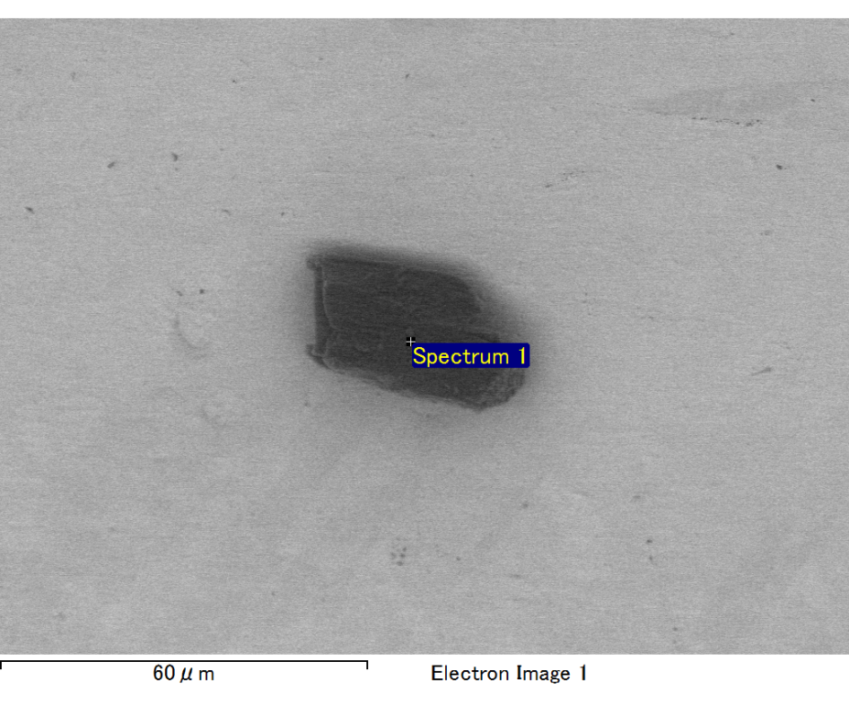

Spectrum processing :

No peaks omitted

Processing option : All elements analyzed (Normalised)

Number of iterations = 2

Standard :

O SiO2 1-Jun-1999 12:00 AM

Al Al2O3 1-Jun-1999 12:00 AM

Au Au 1-Jun-1999 12:00 AM

|  |  |  |  |
| --- | --- | --- | --- |
| Element | Weight% | Atomic% |  |
|  |  |  |  |
| O K | 36.84 | 66.80 |  |
| Al K | 25.75 | 27.69 |  |
| Au M | 37.40 | 5.51 |  |
|  |  |  |  |
| Totals | 100.00 |  |  |

Spectrum Label: Spectrum 1

Livetime 60.0 s

Acquisition geometry ( degrees ):

Tilt = 15.0

Azimuth = 0.0

Elevation = 30.0

Accelerating voltage = 10.00 kV

Total spectrum counts = 35898

|  |  |  |  |
| --- | --- | --- | --- |
| Sample data : | Energy (eV) | Resn. (eV) | Area |
| Strobe : | 3.8 | 47.20 | 1000129 |
|  |  |  |  |

No quant optimization performed

Sample: Sample 1

Type: Default

ID:

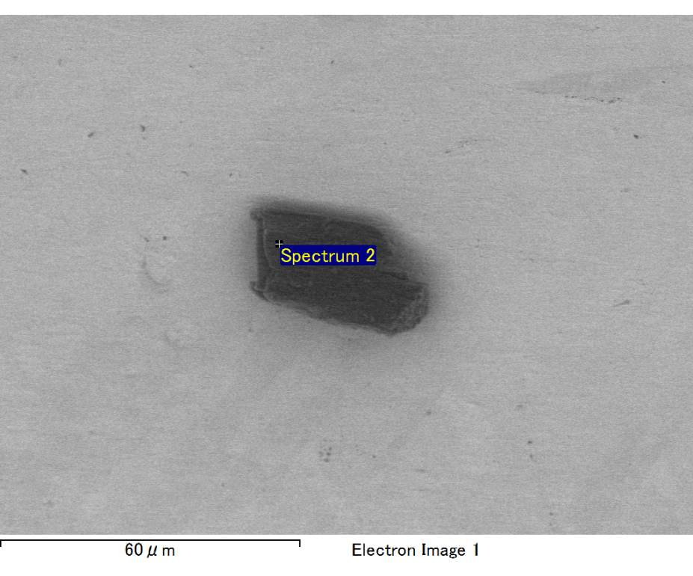

Spectrum processing :

No peaks omitted

Processing option : All elements analyzed (Normalised)

Number of iterations = 2

Standard :

C CaCO3 1-Jun-1999 12:00 AM

O SiO2 1-Jun-1999 12:00 AM

Al Al2O3 1-Jun-1999 12:00 AM

Au Au 1-Jun-1999 12:00 AM

|  |  |  |  |
| --- | --- | --- | --- |
| Element | Weight% | Atomic% |  |
|  |  |  |  |
| C K | 2.55 | 6.44 |  |
| O K | 32.78 | 62.15 |  |
| Al K | 22.10 | 24.85 |  |
| Au M | 42.57 | 6.56 |  |
|  |  |  |  |
| Totals | 100.00 |  |  |

Spectrum Label: Spectrum 2

Livetime 60.0 s

Acquisition geometry ( degrees ):

Tilt = 15.0

Azimuth = 0.0

Elevation = 30.0

Accelerating voltage = 10.00 kV

Total spectrum counts = 35172

|  |  |  |  |
| --- | --- | --- | --- |
| Sample data : | Energy (eV) | Resn. (eV) | Area |
| Strobe : | 3.8 | 47.24 | 999836 |
|  |  |  |  |

No quant optimization performed

Sample: Sample 1

Type: Default

ID:

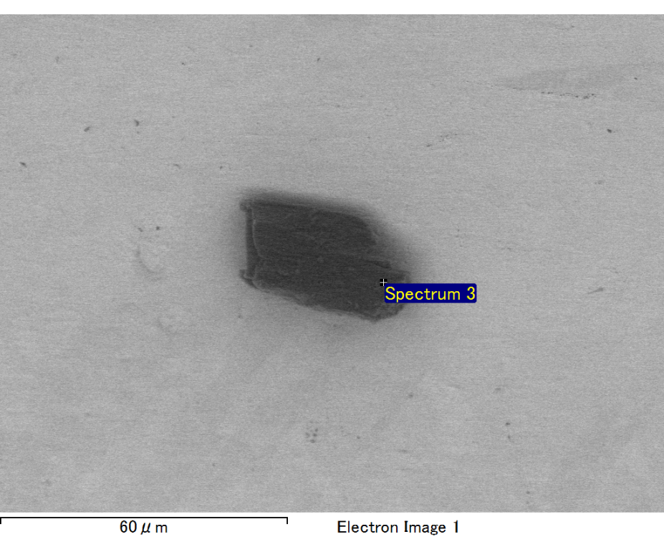

Spectrum processing :

Peak possibly omitted : 0.270 keV

Processing option : All elements analyzed (Normalised)

Number of iterations = 2

Standard :

O SiO2 1-Jun-1999 12:00 AM

Al Al2O3 1-Jun-1999 12:00 AM

Au Au 1-Jun-1999 12:00 AM

|  |  |  |  |
| --- | --- | --- | --- |
| Element | Weight% | Atomic% |  |
|  |  |  |  |
| O K | 31.11 | 63.21 |  |
| Al K | 24.45 | 29.46 |  |
| Au M | 44.44 | 7.33 |  |
|  |  |  |  |
| Totals | 100.00 |  |  |

Spectrum Label: Spectrum 3

Livetime 60.0 s

Acquisition geometry ( degrees ):

Tilt = 15.0

Azimuth = 0.0

Elevation = 30.0

Accelerating voltage = 10.00 kV

Total spectrum counts = 35177

|  |  |  |  |
| --- | --- | --- | --- |
| Sample data : | Energy (eV) | Resn. (eV) | Area |
| Strobe : | 3.8 | 47.25 | 1000232 |
|  |  |  |  |

No quant optimization performed

Sample: Sample 1

Type: Default

ID: