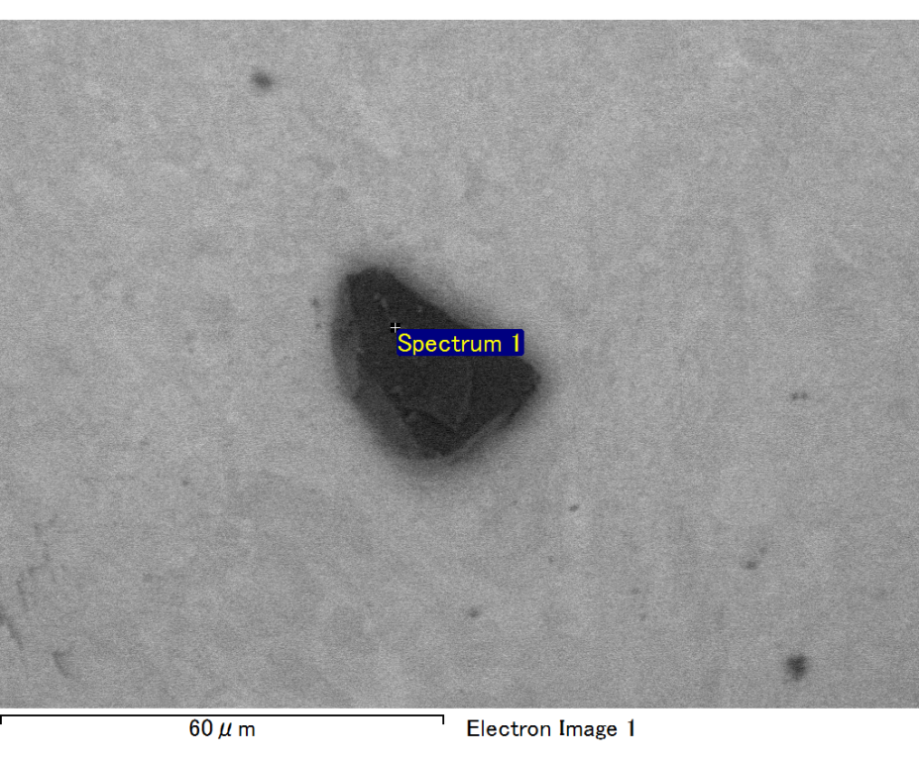

Spectrum processing :

No peaks omitted

Processing option : All elements analyzed (Normalised)

Number of iterations = 2

Standard :

C CaCO3 1-Jun-1999 12:00 AM

O SiO2 1-Jun-1999 12:00 AM

Mg MgO 1-Jun-1999 12:00 AM

Si SiO2 1-Jun-1999 12:00 AM

Fe Fe 1-Jun-1999 12:00 AM

Au Au 1-Jun-1999 12:00 AM

|  |  |  |  |
| --- | --- | --- | --- |
| Element | Weight% | Atomic% |  |
|  |  |  |  |
| C K | 2.53 | 8.33 |  |
| O K | 22.02 | 54.44 |  |
| Mg K | 6.81 | 11.08 |  |
| Si K | 4.80 | 6.76 |  |
| Fe L | 12.94 | 9.16 |  |
| Au M | 50.91 | 10.23 |  |
|  |  |  |  |
| Totals | 100.00 |  |  |

Spectrum Label: Spectrum 1

Livetime 60.0 s

Acquisition geometry ( degrees ):

Tilt = 15.0

Azimuth = 0.0

Elevation = 30.0

Accelerating voltage = 10.00 kV

Total spectrum counts = 43923

|  |  |  |  |
| --- | --- | --- | --- |
| Sample data : | Energy (eV) | Resn. (eV) | Area |
| Strobe : | 3.8 | 47.19 | 1000679 |
|  |  |  |  |

No quant optimization performed

Sample: Sample 1

Type: Default

ID:

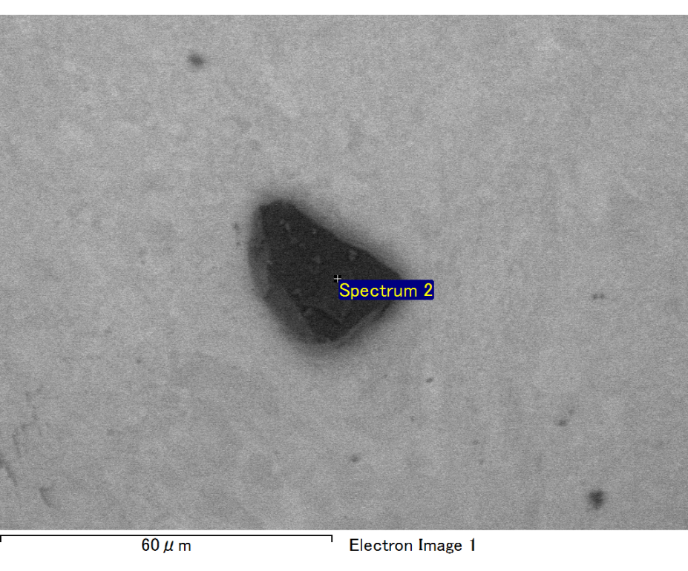

Spectrum processing :

No peaks omitted

Processing option : All elements analyzed (Normalised)

Number of iterations = 2

Standard :

C CaCO3 1-Jun-1999 12:00 AM

O SiO2 1-Jun-1999 12:00 AM

Mg MgO 1-Jun-1999 12:00 AM

Si SiO2 1-Jun-1999 12:00 AM

Fe Fe 1-Jun-1999 12:00 AM

Au Au 1-Jun-1999 12:00 AM

|  |  |  |  |
| --- | --- | --- | --- |
| Element | Weight% | Atomic% |  |
|  |  |  |  |
| C K | 2.37 | 7.91 |  |
| O K | 21.78 | 54.54 |  |
| Mg K | 6.69 | 11.02 |  |
| Si K | 4.98 | 7.10 |  |
| Fe L | 12.39 | 8.89 |  |
| Au M | 51.79 | 10.53 |  |
|  |  |  |  |
| Totals | 100.00 |  |  |

Spectrum Label: Spectrum 2

Livetime 60.0 s

Acquisition geometry ( degrees ):

Tilt = 15.0

Azimuth = 0.0

Elevation = 30.0

Accelerating voltage = 10.00 kV

Total spectrum counts = 44163

|  |  |  |  |
| --- | --- | --- | --- |
| Sample data : | Energy (eV) | Resn. (eV) | Area |
| Strobe : | 3.8 | 47.21 | 1000295 |
|  |  |  |  |

No quant optimization performed

Sample: Sample 1

Type: Default

ID:

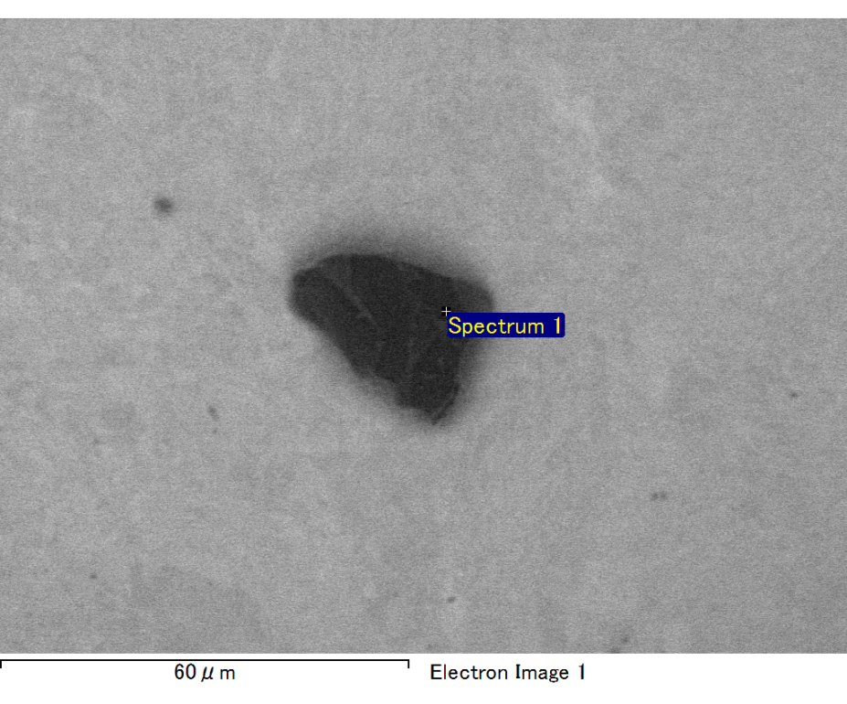

Spectrum processing :

No peaks omitted

Processing option : All elements analyzed (Normalised)

Number of iterations = 2

Standard :

C CaCO3 1-Jun-1999 12:00 AM

O SiO2 1-Jun-1999 12:00 AM

Mg MgO 1-Jun-1999 12:00 AM

Si SiO2 1-Jun-1999 12:00 AM

Fe Fe 1-Jun-1999 12:00 AM

Au Au 1-Jun-1999 12:00 AM

|  |  |  |  |
| --- | --- | --- | --- |
| Element | Weight% | Atomic% |  |
|  |  |  |  |
| C K | 2.65 | 9.56 |  |
| O K | 19.59 | 53.09 |  |
| Mg K | 6.44 | 11.49 |  |
| Si K | 4.23 | 6.53 |  |
| Fe L | 8.17 | 6.35 |  |
| Au M | 58.92 | 12.97 |  |
|  |  |  |  |
| Totals | 100.00 |  |  |

Spectrum Label: Spectrum 1

Livetime 60.0 s

Acquisition geometry ( degrees ):

Tilt = 15.0

Azimuth = 0.0

Elevation = 30.0

Accelerating voltage = 10.00 kV

Total spectrum counts = 41674

|  |  |  |  |
| --- | --- | --- | --- |
| Sample data : | Energy (eV) | Resn. (eV) | Area |
| Strobe : | 3.8 | 47.26 | 1000220 |
|  |  |  |  |

No quant optimization performed

Sample: Sample 1

Type: Default

ID:

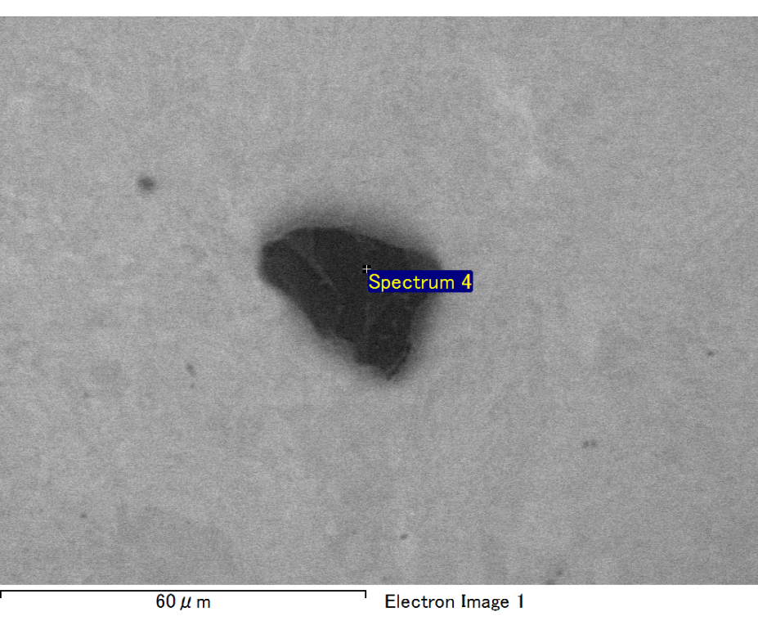

Spectrum processing :

No peaks omitted

Processing option : All elements analyzed (Normalised)

Number of iterations = 2

Standard :

C CaCO3 1-Jun-1999 12:00 AM

O SiO2 1-Jun-1999 12:00 AM

Mg MgO 1-Jun-1999 12:00 AM

Si SiO2 1-Jun-1999 12:00 AM

Fe Fe 1-Jun-1999 12:00 AM

Au Au 1-Jun-1999 12:00 AM

|  |  |  |  |
| --- | --- | --- | --- |
| Element | Weight% | Atomic% |  |
|  |  |  |  |
| C K | 2.85 | 9.87 |  |
| O K | 20.48 | 53.29 |  |
| Mg K | 5.82 | 9.98 |  |
| Si K | 4.45 | 6.60 |  |
| Fe L | 11.64 | 8.68 |  |
| Au M | 54.76 | 11.58 |  |
|  |  |  |  |
| Totals | 100.00 |  |  |

Spectrum Label: Spectrum 4

Livetime 60.0 s

Acquisition geometry ( degrees ):

Tilt = 15.0

Azimuth = 0.0

Elevation = 30.0

Accelerating voltage = 10.00 kV

Total spectrum counts = 42016

|  |  |  |  |
| --- | --- | --- | --- |
| Sample data : | Energy (eV) | Resn. (eV) | Area |
| Strobe : | 3.8 | 47.22 | 1000418 |
|  |  |  |  |

No quant optimization performed

Sample: Sample 1

Type: Default

ID:

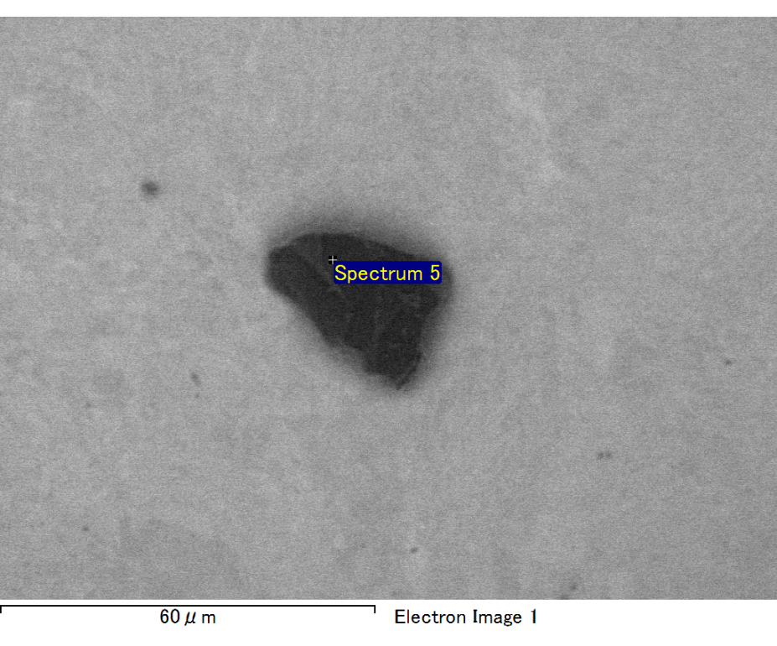

Spectrum processing :

No peaks omitted

Processing option : All elements analyzed (Normalised)

Number of iterations = 2

Standard :

C CaCO3 1-Jun-1999 12:00 AM

O SiO2 1-Jun-1999 12:00 AM

Mg MgO 1-Jun-1999 12:00 AM

Si SiO2 1-Jun-1999 12:00 AM

Fe Fe 1-Jun-1999 12:00 AM

Au Au 1-Jun-1999 12:00 AM

|  |  |  |  |
| --- | --- | --- | --- |
| Element | Weight% | Atomic% |  |
|  |  |  |  |
| C K | 3.24 | 11.31 |  |
| O K | 20.36 | 53.31 |  |
| Mg K | 5.96 | 10.27 |  |
| Si K | 4.02 | 6.00 |  |
| Fe L | 9.31 | 6.98 |  |
| Au M | 57.11 | 12.14 |  |
|  |  |  |  |
| Totals | 100.00 |  |  |

Spectrum Label: Spectrum 5

Livetime 60.0 s

Acquisition geometry ( degrees ):

Tilt = 15.0

Azimuth = 0.0

Elevation = 30.0

Accelerating voltage = 10.00 kV

Total spectrum counts = 41308

|  |  |  |  |
| --- | --- | --- | --- |
| Sample data : | Energy (eV) | Resn. (eV) | Area |
| Strobe : | 3.8 | 47.22 | 1000226 |
|  |  |  |  |

No quant optimization performed

Sample: Sample 1

Type: Default

ID: