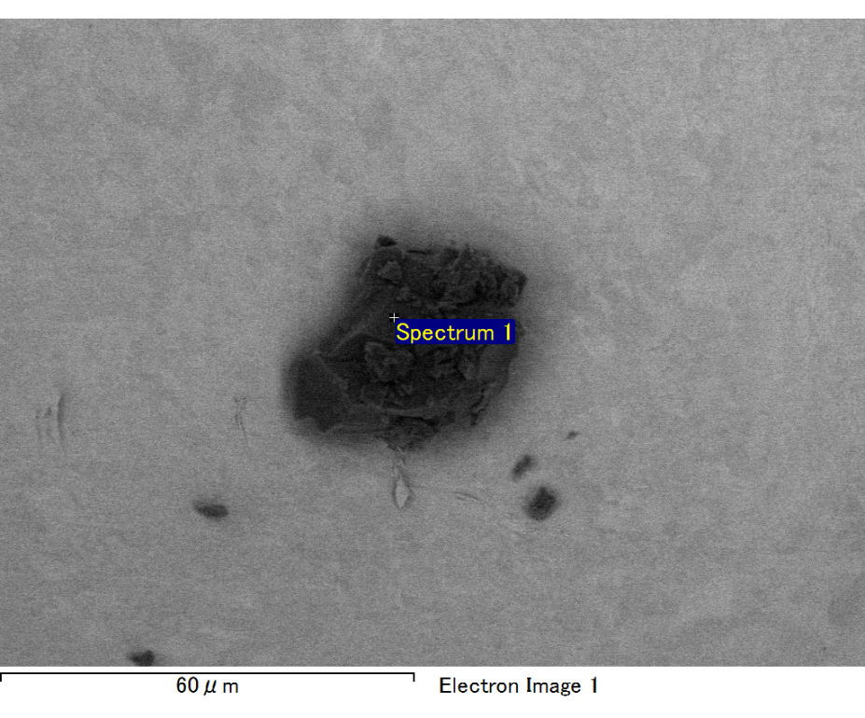

Spectrum processing :

No peaks omitted

Processing option : All elements analyzed (Normalised)

Number of iterations = 2

Standard :

C CaCO3 1-Jun-1999 12:00 AM

O SiO2 1-Jun-1999 12:00 AM

Mg MgO 1-Jun-1999 12:00 AM

Si SiO2 1-Jun-1999 12:00 AM

Fe Fe 1-Jun-1999 12:00 AM

Au Au 1-Jun-1999 12:00 AM

|  |  |  |  |
| --- | --- | --- | --- |
| Element | Weight% | Atomic% |  |
|  |  |  |  |
| C K | 3.26 | 10.88 |  |
| O K | 20.78 | 52.09 |  |
| Mg K | 6.16 | 10.16 |  |
| Si K | 4.77 | 6.82 |  |
| Fe L | 13.23 | 9.50 |  |
| Au M | 51.80 | 10.55 |  |
|  |  |  |  |
| Totals | 100.00 |  |  |

Spectrum Label: Spectrum 1

Livetime 60.0 s

Acquisition geometry ( degrees ):

Tilt = 15.0

Azimuth = 0.0

Elevation = 30.0

Accelerating voltage = 10.00 kV

Total spectrum counts = 44035

|  |  |  |  |
| --- | --- | --- | --- |
| Sample data : | Energy (eV) | Resn. (eV) | Area |
| Strobe : | 3.8 | 47.30 | 1000791 |
|  |  |  |  |

No quant optimization performed

Sample: Sample 1

Type: Default

ID:

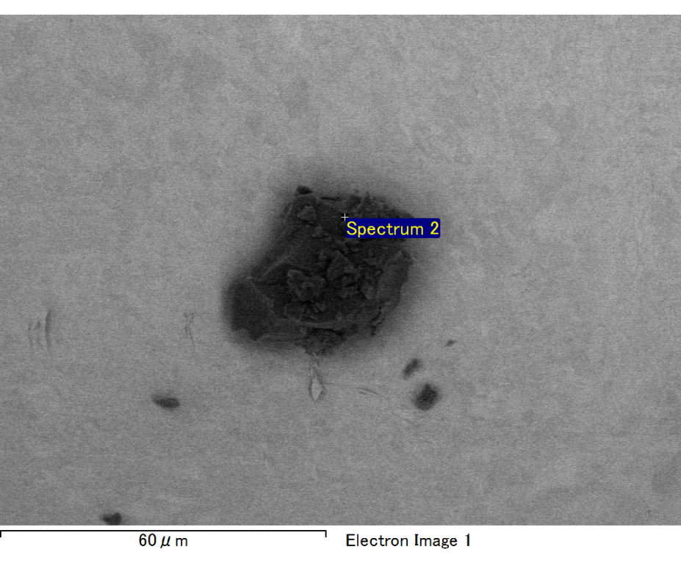

Spectrum processing :

No peaks omitted

Processing option : All elements analyzed (Normalised)

Number of iterations = 2

Standard :

C CaCO3 1-Jun-1999 12:00 AM

O SiO2 1-Jun-1999 12:00 AM

Mg MgO 1-Jun-1999 12:00 AM

Si SiO2 1-Jun-1999 12:00 AM

Fe Fe 1-Jun-1999 12:00 AM

Au Au 1-Jun-1999 12:00 AM

|  |  |  |  |
| --- | --- | --- | --- |
| Element | Weight% | Atomic% |  |
|  |  |  |  |
| C K | 2.88 | 10.38 |  |
| O K | 18.75 | 50.80 |  |
| Mg K | 5.69 | 10.15 |  |
| Si K | 3.99 | 6.15 |  |
| Fe L | 13.31 | 10.33 |  |
| Au M | 55.38 | 12.18 |  |
|  |  |  |  |
| Totals | 100.00 |  |  |

Spectrum Label: Spectrum 2

Livetime 60.0 s

Acquisition geometry ( degrees ):

Tilt = 15.0

Azimuth = 0.0

Elevation = 30.0

Accelerating voltage = 10.00 kV

Total spectrum counts = 43004

|  |  |  |  |
| --- | --- | --- | --- |
| Sample data : | Energy (eV) | Resn. (eV) | Area |
| Strobe : | 3.8 | 47.20 | 1000481 |
|  |  |  |  |

No quant optimization performed

Sample: Sample 1

Type: Default

ID:

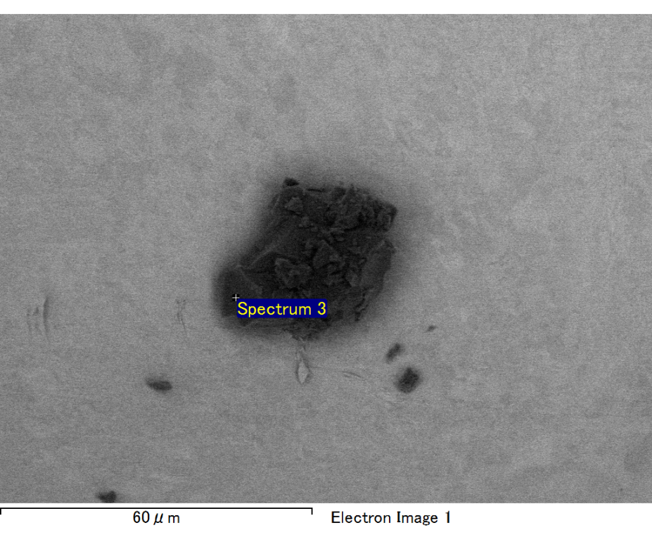

Spectrum processing :

No peaks omitted

Processing option : All elements analyzed (Normalised)

Number of iterations = 2

Standard :

C CaCO3 1-Jun-1999 12:00 AM

O SiO2 1-Jun-1999 12:00 AM

Mg MgO 1-Jun-1999 12:00 AM

Si SiO2 1-Jun-1999 12:00 AM

Au Au 1-Jun-1999 12:00 AM

|  |  |  |  |
| --- | --- | --- | --- |
| Element | Weight% | Atomic% |  |
|  |  |  |  |
| C K | 5.39 | 33.30 |  |
| O K | 5.10 | 23.66 |  |
| Mg K | 1.70 | 5.19 |  |
| Si K | 2.11 | 5.58 |  |
| Au M | 85.69 | 32.27 |  |
|  |  |  |  |
| Totals | 100.00 |  |  |

Spectrum Label: Spectrum 3

Livetime 60.0 s

Acquisition geometry ( degrees ):

Tilt = 15.0

Azimuth = 0.0

Elevation = 30.0

Accelerating voltage = 10.00 kV

Total spectrum counts = 38806

|  |  |  |  |
| --- | --- | --- | --- |
| Sample data : | Energy (eV) | Resn. (eV) | Area |
| Strobe : | 3.8 | 47.22 | 1000783 |
|  |  |  |  |

No quant optimization performed

Sample: Sample 1

Type: Default

ID:

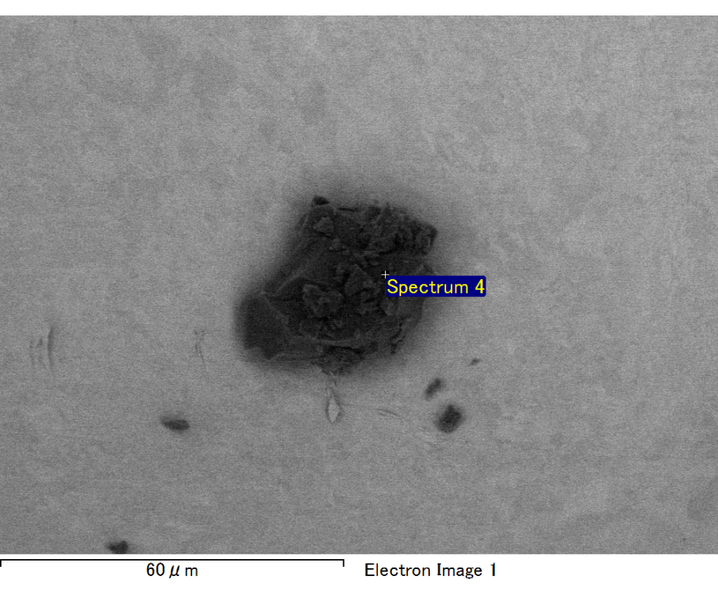

Spectrum processing :

No peaks omitted

Processing option : All elements analyzed (Normalised)

Number of iterations = 2

Standard :

C CaCO3 1-Jun-1999 12:00 AM

O SiO2 1-Jun-1999 12:00 AM

Mg MgO 1-Jun-1999 12:00 AM

Si SiO2 1-Jun-1999 12:00 AM

Fe Fe 1-Jun-1999 12:00 AM

Au Au 1-Jun-1999 12:00 AM

|  |  |  |  |
| --- | --- | --- | --- |
| Element | Weight% | Atomic% |  |
|  |  |  |  |
| C K | 3.47 | 22.65 |  |
| O K | 5.60 | 27.42 |  |
| Mg K | 1.71 | 5.52 |  |
| Si K | 1.59 | 4.45 |  |
| Fe L | 5.11 | 7.16 |  |
| Au M | 82.51 | 32.80 |  |
|  |  |  |  |
| Totals | 100.00 |  |  |

Spectrum Label: Spectrum 4

Livetime 60.0 s

Acquisition geometry ( degrees ):

Tilt = 15.0

Azimuth = 0.0

Elevation = 30.0

Accelerating voltage = 10.00 kV

Total spectrum counts = 37460

|  |  |  |  |
| --- | --- | --- | --- |
| Sample data : | Energy (eV) | Resn. (eV) | Area |
| Strobe : | 3.8 | 47.31 | 1000341 |
|  |  |  |  |

No quant optimization performed

Sample: Sample 1

Type: Default

ID:

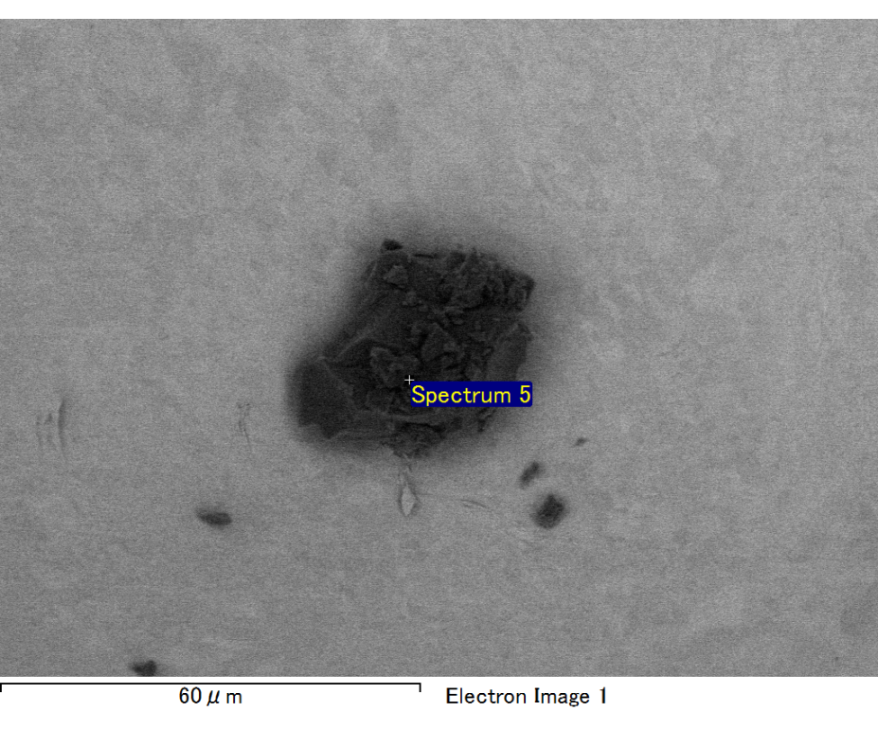

Spectrum processing :

No peaks omitted

Processing option : All elements analyzed (Normalised)

Number of iterations = 2

Standard :

C CaCO3 1-Jun-1999 12:00 AM

O SiO2 1-Jun-1999 12:00 AM

Mg MgO 1-Jun-1999 12:00 AM

Si SiO2 1-Jun-1999 12:00 AM

Fe Fe 1-Jun-1999 12:00 AM

Au Au 1-Jun-1999 12:00 AM

|  |  |  |  |
| --- | --- | --- | --- |
| Element | Weight% | Atomic% |  |
|  |  |  |  |
| C K | 2.98 | 10.06 |  |
| O K | 21.38 | 54.19 |  |
| Mg K | 6.56 | 10.95 |  |
| Si K | 4.08 | 5.89 |  |
| Fe L | 10.61 | 7.70 |  |
| Au M | 54.38 | 11.20 |  |
|  |  |  |  |
| Totals | 100.00 |  |  |

Spectrum Label: Spectrum 5

Livetime 60.0 s

Acquisition geometry ( degrees ):

Tilt = 15.0

Azimuth = 0.0

Elevation = 30.0

Accelerating voltage = 10.00 kV

Total spectrum counts = 42849

|  |  |  |  |
| --- | --- | --- | --- |
| Sample data : | Energy (eV) | Resn. (eV) | Area |
| Strobe : | 3.8 | 47.26 | 1000466 |
|  |  |  |  |

No quant optimization performed

Sample: Sample 1

Type: Default

ID: