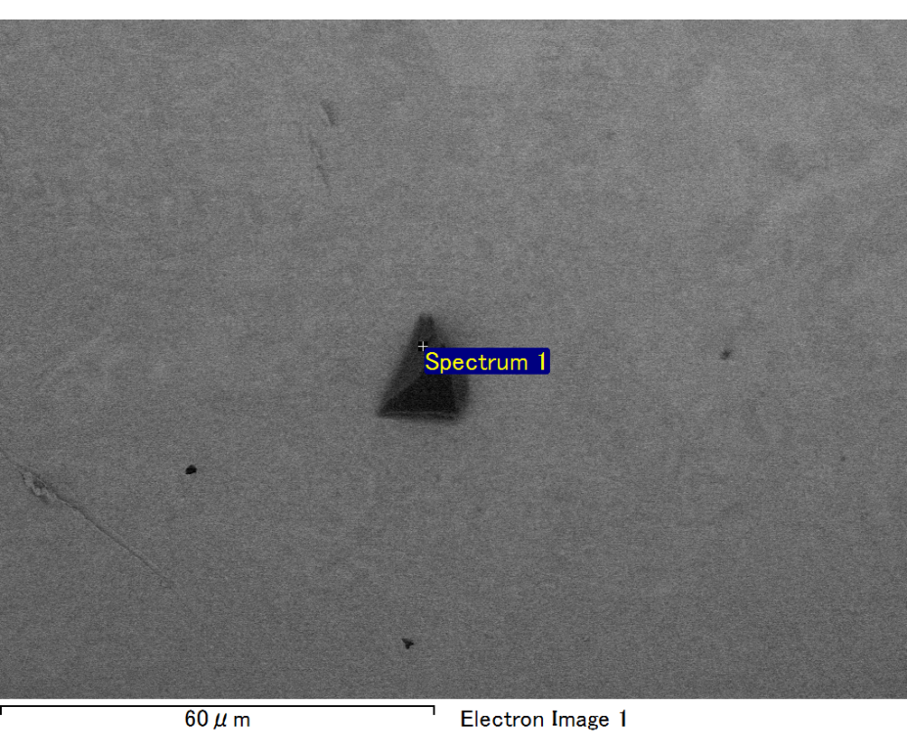

Spectrum processing :

No peaks omitted

Processing option : All elements analyzed (Normalised)

Number of iterations = 2

Standard :

C CaCO3 1-Jun-1999 12:00 AM

O SiO2 1-Jun-1999 12:00 AM

Mg MgO 1-Jun-1999 12:00 AM

Si SiO2 1-Jun-1999 12:00 AM

Fe Fe 1-Jun-1999 12:00 AM

Au Au 1-Jun-1999 12:00 AM

|  |  |  |  |
| --- | --- | --- | --- |
| Element | Weight% | Atomic% |  |
|  |  |  |  |
| C K | 2.94 | 11.57 |  |
| O K | 16.81 | 49.66 |  |
| Mg K | 4.84 | 9.41 |  |
| Si K | 3.91 | 6.57 |  |
| Fe L | 9.29 | 7.86 |  |
| Au M | 62.21 | 14.93 |  |
|  |  |  |  |
| Totals | 100.00 |  |  |

Spectrum Label: Spectrum 1

Livetime 60.0 s

Acquisition geometry ( degrees ):

Tilt = 15.0

Azimuth = 0.0

Elevation = 30.0

Accelerating voltage = 10.00 kV

Total spectrum counts = 43419

|  |  |  |  |
| --- | --- | --- | --- |
| Sample data : | Energy (eV) | Resn. (eV) | Area |
| Strobe : | 3.8 | 47.25 | 1000604 |
|  |  |  |  |

No quant optimization performed

Sample: Sample 1

Type: Default

ID:

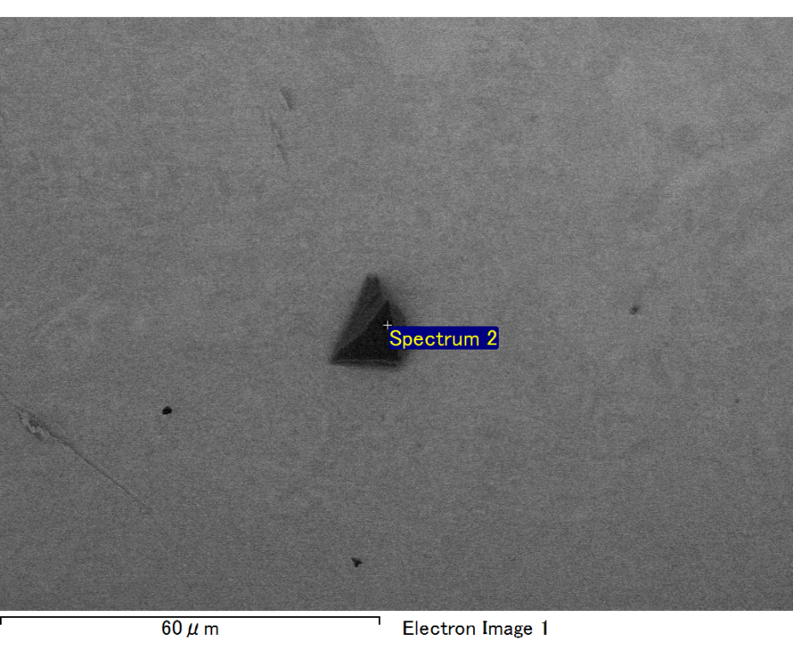

Spectrum processing :

Peak possibly omitted : 0.260 keV

Processing option : All elements analyzed (Normalised)

Number of iterations = 2

Standard :

O SiO2 1-Jun-1999 12:00 AM

Mg MgO 1-Jun-1999 12:00 AM

Si SiO2 1-Jun-1999 12:00 AM

Fe Fe 1-Jun-1999 12:00 AM

Au Au 1-Jun-1999 12:00 AM

|  |  |  |  |
| --- | --- | --- | --- |
| Element | Weight% | Atomic% |  |
|  |  |  |  |
| O K | 20.23 | 60.68 |  |
| Mg K | 5.03 | 9.92 |  |
| Si K | 4.11 | 7.02 |  |
| Fe L | 8.38 | 7.20 |  |
| Au M | 62.25 | 15.17 |  |
|  |  |  |  |
| Totals | 100.00 |  |  |

Spectrum Label: Spectrum 2

Livetime 60.0 s

Acquisition geometry ( degrees ):

Tilt = 15.0

Azimuth = 0.0

Elevation = 30.0

Accelerating voltage = 10.00 kV

Total spectrum counts = 42468

|  |  |  |  |
| --- | --- | --- | --- |
| Sample data : | Energy (eV) | Resn. (eV) | Area |
| Strobe : | 3.8 | 47.23 | 1000398 |
|  |  |  |  |

No quant optimization performed

Sample: Sample 1

Type: Default

ID:

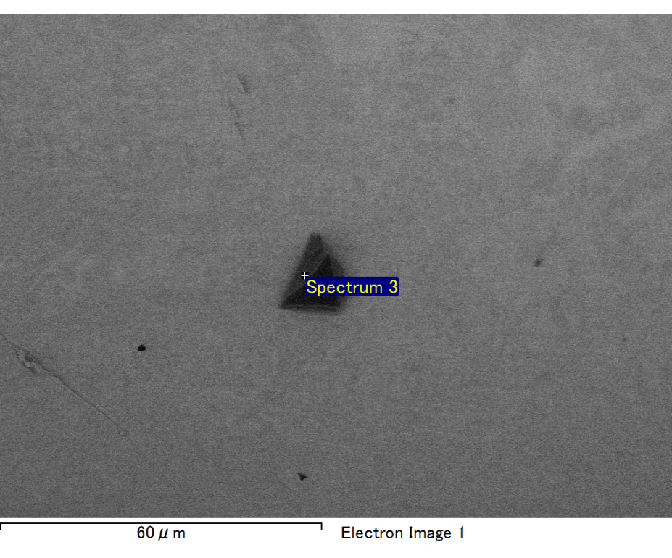

Spectrum processing :

No peaks omitted

Processing option : All elements analyzed (Normalised)

Number of iterations = 2

Standard :

C CaCO3 1-Jun-1999 12:00 AM

O SiO2 1-Jun-1999 12:00 AM

Mg MgO 1-Jun-1999 12:00 AM

Si SiO2 1-Jun-1999 12:00 AM

Fe Fe 1-Jun-1999 12:00 AM

Au Au 1-Jun-1999 12:00 AM

|  |  |  |  |
| --- | --- | --- | --- |
| Element | Weight% | Atomic% |  |
|  |  |  |  |
| C K | 3.22 | 12.13 |  |
| O K | 18.46 | 52.20 |  |
| Mg K | 4.82 | 8.97 |  |
| Si K | 3.27 | 5.26 |  |
| Fe L | 9.16 | 7.42 |  |
| Au M | 61.07 | 14.03 |  |
|  |  |  |  |
| Totals | 100.00 |  |  |

Spectrum Label: Spectrum 3

Livetime 60.0 s

Acquisition geometry ( degrees ):

Tilt = 15.0

Azimuth = 0.0

Elevation = 30.0

Accelerating voltage = 10.00 kV

Total spectrum counts = 44260

|  |  |  |  |
| --- | --- | --- | --- |
| Sample data : | Energy (eV) | Resn. (eV) | Area |
| Strobe : | 3.8 | 47.22 | 1000959 |
|  |  |  |  |

No quant optimization performed

Sample: Sample 1

Type: Default

ID:

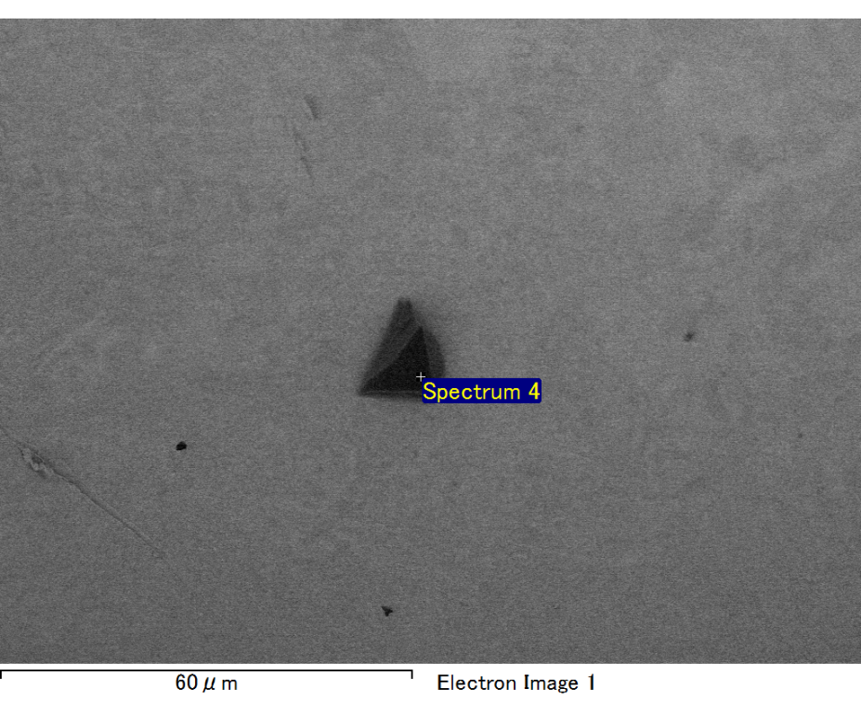

Spectrum processing :

No peaks omitted

Processing option : All elements analyzed (Normalised)

Number of iterations = 2

Standard :

C CaCO3 1-Jun-1999 12:00 AM

O SiO2 1-Jun-1999 12:00 AM

Mg MgO 1-Jun-1999 12:00 AM

Si SiO2 1-Jun-1999 12:00 AM

Au Au 1-Jun-1999 12:00 AM

|  |  |  |  |
| --- | --- | --- | --- |
| Element | Weight% | Atomic% |  |
|  |  |  |  |
| C K | 2.99 | 14.58 |  |
| O K | 12.63 | 46.30 |  |
| Mg K | 3.71 | 8.96 |  |
| Si K | 3.42 | 7.15 |  |
| Au M | 77.25 | 23.01 |  |
|  |  |  |  |
| Totals | 100.00 |  |  |

Spectrum Label: Spectrum 4

Livetime 60.0 s

Acquisition geometry ( degrees ):

Tilt = 15.0

Azimuth = 0.0

Elevation = 30.0

Accelerating voltage = 10.00 kV

Total spectrum counts = 39823

|  |  |  |  |
| --- | --- | --- | --- |
| Sample data : | Energy (eV) | Resn. (eV) | Area |
| Strobe : | 3.8 | 47.24 | 999930 |
|  |  |  |  |

No quant optimization performed

Sample: Sample 1

Type: Default

ID:

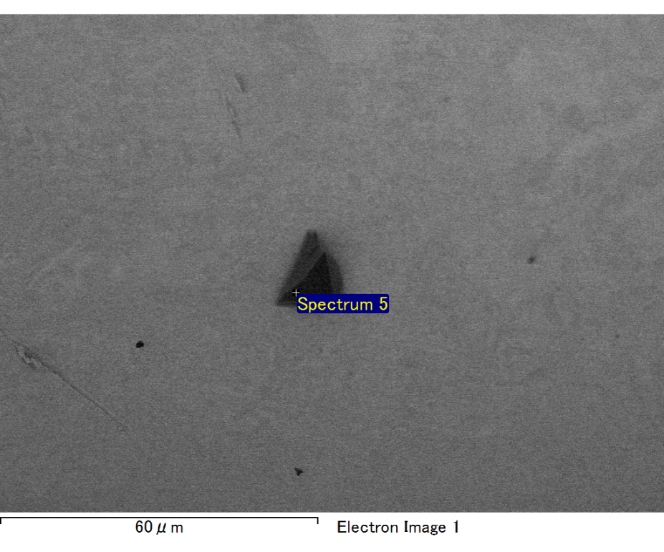

Spectrum processing :

No peaks omitted

Processing option : All elements analyzed (Normalised)

Number of iterations = 2

Standard :

C CaCO3 1-Jun-1999 12:00 AM

O SiO2 1-Jun-1999 12:00 AM

Mg MgO 1-Jun-1999 12:00 AM

Si SiO2 1-Jun-1999 12:00 AM

Fe Fe 1-Jun-1999 12:00 AM

Au Au 1-Jun-1999 12:00 AM

|  |  |  |  |
| --- | --- | --- | --- |
| Element | Weight% | Atomic% |  |
|  |  |  |  |
| C K | 3.18 | 11.42 |  |
| O K | 18.77 | 50.64 |  |
| Mg K | 5.13 | 9.11 |  |
| Si K | 3.95 | 6.07 |  |
| Fe L | 13.82 | 10.68 |  |
| Au M | 55.14 | 12.08 |  |
|  |  |  |  |
| Totals | 100.00 |  |  |

Spectrum Label: Spectrum 5

Livetime 60.0 s

Acquisition geometry ( degrees ):

Tilt = 15.0

Azimuth = 0.0

Elevation = 30.0

Accelerating voltage = 10.00 kV

Total spectrum counts = 43627

|  |  |  |  |
| --- | --- | --- | --- |
| Sample data : | Energy (eV) | Resn. (eV) | Area |
| Strobe : | 3.8 | 47.24 | 999821 |
|  |  |  |  |

No quant optimization performed

Sample: Sample 1

Type: Default

ID: