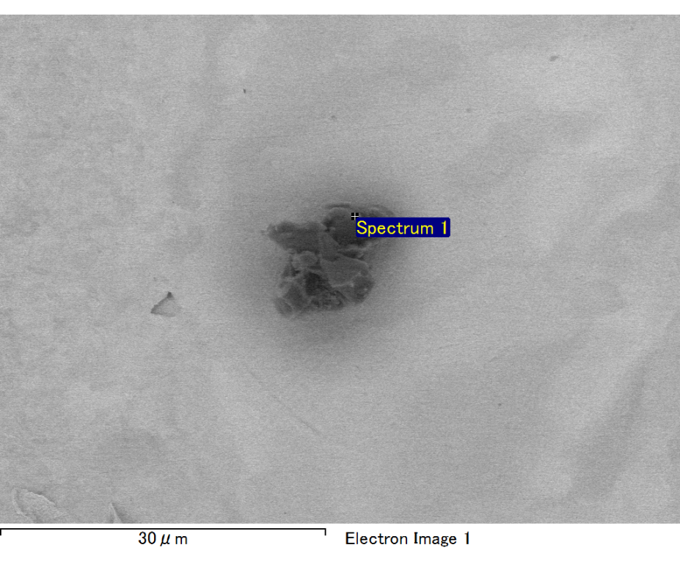

Spectrum processing :

No peaks omitted

Processing option : All elements analyzed (Normalised)

Number of iterations = 2

Standard :

C CaCO3 1-Jun-1999 12:00 AM

O SiO2 1-Jun-1999 12:00 AM

Mg MgO 1-Jun-1999 12:00 AM

Si SiO2 1-Jun-1999 12:00 AM

Fe Fe 1-Jun-1999 12:00 AM

Au Au 1-Jun-1999 12:00 AM

|  |  |  |  |
| --- | --- | --- | --- |
| Element | Weight% | Atomic% |  |
|  |  |  |  |
| C K | 2.68 | 9.26 |  |
| O K | 21.00 | 54.45 |  |
| Mg K | 5.67 | 9.68 |  |
| Si K | 4.27 | 6.31 |  |
| Fe L | 11.86 | 8.81 |  |
| Au M | 54.51 | 11.48 |  |
|  |  |  |  |
| Totals | 100.00 |  |  |

Spectrum Label: Spectrum 1

Livetime 60.0 s

Acquisition geometry ( degrees ):

Tilt = 10.0

Azimuth = 0.0

Elevation = 30.0

Accelerating voltage = 10.00 kV

Total spectrum counts = 46007

|  |  |  |  |
| --- | --- | --- | --- |
| Sample data : | Energy (eV) | Resn. (eV) | Area |
| Strobe : | 3.8 | 47.20 | 1000108 |
|  |  |  |  |

No quant optimization performed

Sample: Sample 1

Type: Default

ID:

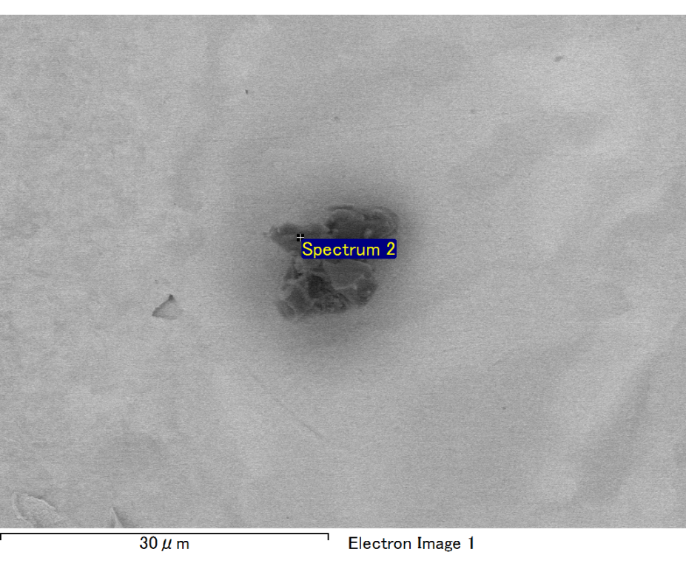

Spectrum processing :

Peaks possibly omitted : 0.700, 3.320 keV

Processing option : All elements analyzed (Normalised)

Number of iterations = 2

Standard :

C CaCO3 1-Jun-1999 12:00 AM

O SiO2 1-Jun-1999 12:00 AM

Mg MgO 1-Jun-1999 12:00 AM

Al Al2O3 1-Jun-1999 12:00 AM

Si SiO2 1-Jun-1999 12:00 AM

Au Au 1-Jun-1999 12:00 AM

|  |  |  |  |
| --- | --- | --- | --- |
| Element | Weight% | Atomic% |  |
|  |  |  |  |
| C K | 3.37 | 13.01 |  |
| O K | 20.05 | 58.19 |  |
| Mg K | 1.71 | 3.27 |  |
| Al K | 1.26 | 2.16 |  |
| Si K | 4.25 | 7.03 |  |
| Au M | 69.36 | 16.35 |  |
|  |  |  |  |
| Totals | 100.00 |  |  |

Spectrum Label: Spectrum 2

Livetime 60.0 s

Acquisition geometry ( degrees ):

Tilt = 10.0

Azimuth = 0.0

Elevation = 30.0

Accelerating voltage = 10.00 kV

Total spectrum counts = 47258

|  |  |  |  |
| --- | --- | --- | --- |
| Sample data : | Energy (eV) | Resn. (eV) | Area |
| Strobe : | 3.8 | 47.19 | 1000887 |
|  |  |  |  |

No quant optimization performed

Sample: Sample 1

Type: Default

ID:

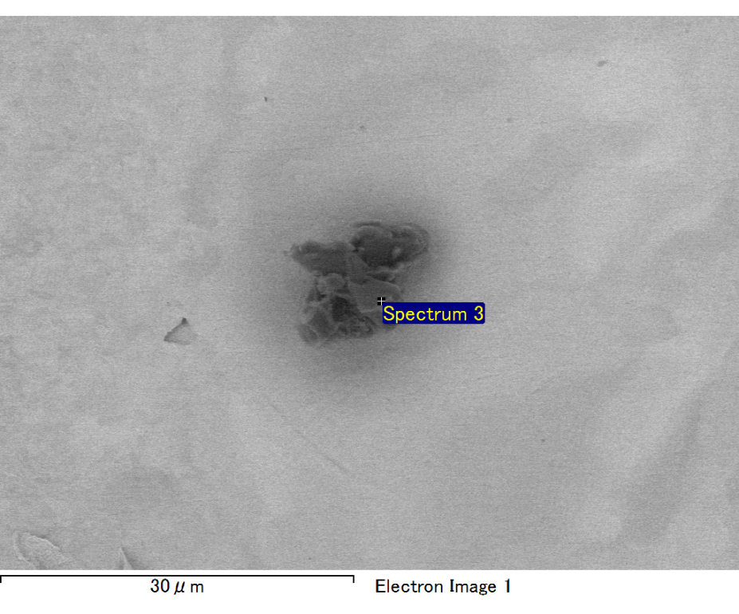

Spectrum processing :

No peaks omitted

Processing option : All elements analyzed (Normalised)

Number of iterations = 2

Standard :

C CaCO3 1-Jun-1999 12:00 AM

O SiO2 1-Jun-1999 12:00 AM

Mg MgO 1-Jun-1999 12:00 AM

Si SiO2 1-Jun-1999 12:00 AM

Fe Fe 1-Jun-1999 12:00 AM

Au Au 1-Jun-1999 12:00 AM

|  |  |  |  |
| --- | --- | --- | --- |
| Element | Weight% | Atomic% |  |
|  |  |  |  |
| C K | 2.48 | 8.46 |  |
| O K | 21.56 | 55.22 |  |
| Mg K | 5.82 | 9.81 |  |
| Si K | 3.69 | 5.38 |  |
| Fe L | 13.89 | 10.19 |  |
| Au M | 52.58 | 10.94 |  |
|  |  |  |  |
| Totals | 100.00 |  |  |

Spectrum Label: Spectrum 3

Livetime 60.0 s

Acquisition geometry ( degrees ):

Tilt = 10.0

Azimuth = 0.0

Elevation = 30.0

Accelerating voltage = 10.00 kV

Total spectrum counts = 46339

|  |  |  |  |
| --- | --- | --- | --- |
| Sample data : | Energy (eV) | Resn. (eV) | Area |
| Strobe : | 3.8 | 47.29 | 1000303 |
|  |  |  |  |

No quant optimization performed

Sample: Sample 1

Type: Default

ID:

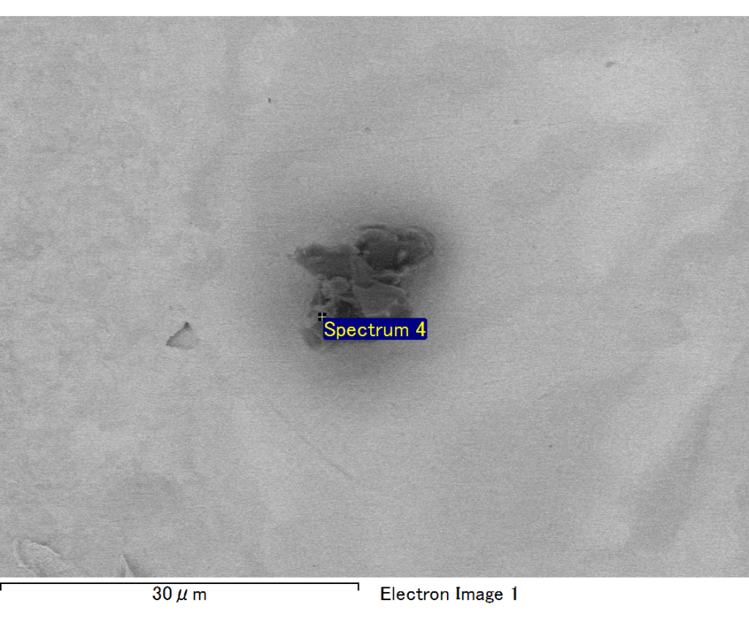

Spectrum processing :

No peaks omitted

Processing option : All elements analyzed (Normalised)

Number of iterations = 2

Standard :

C CaCO3 1-Jun-1999 12:00 AM

O SiO2 1-Jun-1999 12:00 AM

Mg MgO 1-Jun-1999 12:00 AM

Si SiO2 1-Jun-1999 12:00 AM

Fe Fe 1-Jun-1999 12:00 AM

Au Au 1-Jun-1999 12:00 AM

|  |  |  |  |
| --- | --- | --- | --- |
| Element | Weight% | Atomic% |  |
|  |  |  |  |
| C K | 2.96 | 13.41 |  |
| O K | 14.25 | 48.44 |  |
| Mg K | 2.63 | 5.88 |  |
| Si K | 2.92 | 5.66 |  |
| Fe L | 7.57 | 7.37 |  |
| Au M | 69.67 | 19.23 |  |
|  |  |  |  |
| Totals | 100.00 |  |  |

Spectrum Label: Spectrum 4

Livetime 60.0 s

Acquisition geometry ( degrees ):

Tilt = 10.0

Azimuth = 0.0

Elevation = 30.0

Accelerating voltage = 10.00 kV

Total spectrum counts = 45282

|  |  |  |  |
| --- | --- | --- | --- |
| Sample data : | Energy (eV) | Resn. (eV) | Area |
| Strobe : | 3.8 | 47.18 | 1000891 |
|  |  |  |  |

No quant optimization performed

Sample: Sample 1

Type: Default

ID:

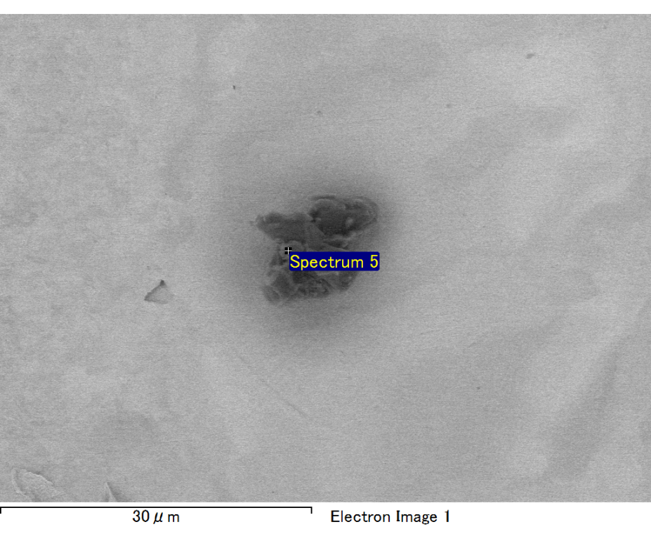

Spectrum processing :

Peak possibly omitted : 0.711 keV

Processing option : All elements analyzed (Normalised)

Number of iterations = 2

Standard :

C CaCO3 1-Jun-1999 12:00 AM

O SiO2 1-Jun-1999 12:00 AM

Mg MgO 1-Jun-1999 12:00 AM

Si SiO2 1-Jun-1999 12:00 AM

Au Au 1-Jun-1999 12:00 AM

|  |  |  |  |
| --- | --- | --- | --- |
| Element | Weight% | Atomic% |  |
|  |  |  |  |
| C K | 3.26 | 11.52 |  |
| O K | 21.88 | 57.98 |  |
| Mg K | 5.75 | 10.02 |  |
| Si K | 4.33 | 6.53 |  |
| Au M | 64.78 | 13.94 |  |
|  |  |  |  |
| Totals | 100.00 |  |  |

Spectrum Label: Spectrum 5

Livetime 60.0 s

Acquisition geometry ( degrees ):

Tilt = 10.0

Azimuth = 0.0

Elevation = 30.0

Accelerating voltage = 10.00 kV

Total spectrum counts = 43385

|  |  |  |  |
| --- | --- | --- | --- |
| Sample data : | Energy (eV) | Resn. (eV) | Area |
| Strobe : | 3.8 | 47.26 | 999882 |
|  |  |  |  |

No quant optimization performed

Sample: Sample 1

Type: Default

ID: