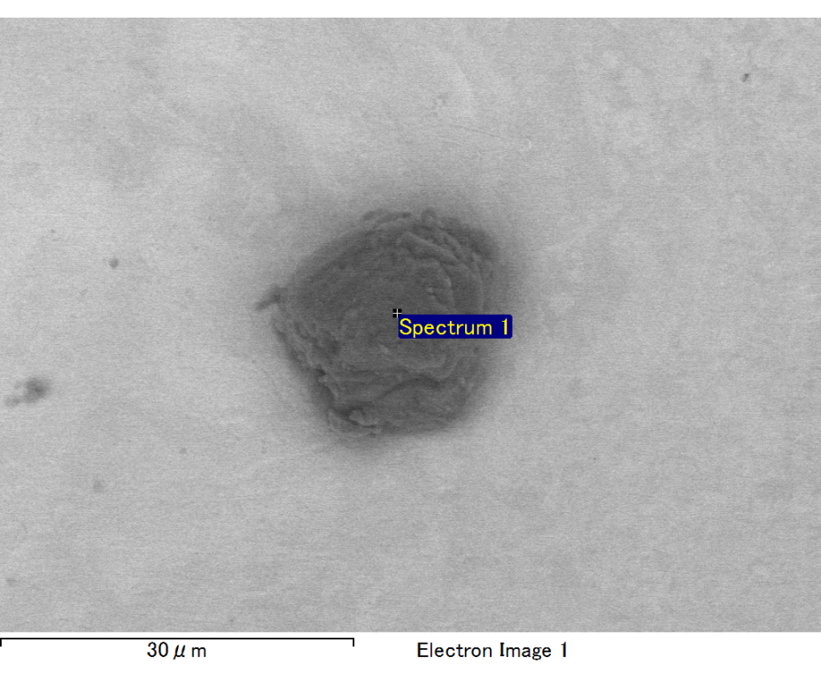

Spectrum processing :

No peaks omitted

Processing option : All elements analyzed (Normalised)

Number of iterations = 2

Standard :

C CaCO3 1-Jun-1999 12:00 AM

O SiO2 1-Jun-1999 12:00 AM

Mg MgO 1-Jun-1999 12:00 AM

Si SiO2 1-Jun-1999 12:00 AM

Fe Fe 1-Jun-1999 12:00 AM

Au Au 1-Jun-1999 12:00 AM

|  |  |  |  |
| --- | --- | --- | --- |
| Element | Weight% | Atomic% |  |
|  |  |  |  |
| C K | 2.62 | 9.05 |  |
| O K | 21.38 | 55.49 |  |
| Mg K | 6.01 | 10.27 |  |
| Si K | 4.35 | 6.43 |  |
| Fe L | 9.23 | 6.86 |  |
| Au M | 56.42 | 11.90 |  |
|  |  |  |  |
| Totals | 100.00 |  |  |

Spectrum Label: Spectrum 1

Livetime 60.0 s

Acquisition geometry ( degrees ):

Tilt = 15.0

Azimuth = 0.0

Elevation = 30.0

Accelerating voltage = 10.00 kV

Total spectrum counts = 43946

|  |  |  |  |
| --- | --- | --- | --- |
| Sample data : | Energy (eV) | Resn. (eV) | Area |
| Strobe : | 3.8 | 47.23 | 999869 |
|  |  |  |  |

No quant optimization performed

Sample: Sample 1

Type: Default

ID:

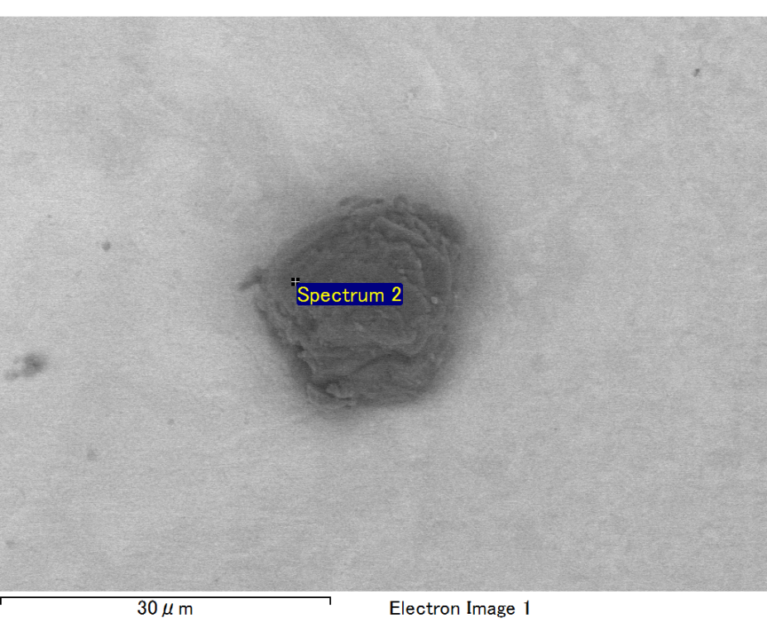

Spectrum processing :

No peaks omitted

Processing option : All elements analyzed (Normalised)

Number of iterations = 2

Standard :

C CaCO3 1-Jun-1999 12:00 AM

O SiO2 1-Jun-1999 12:00 AM

Mg MgO 1-Jun-1999 12:00 AM

Si SiO2 1-Jun-1999 12:00 AM

Fe Fe 1-Jun-1999 12:00 AM

Au Au 1-Jun-1999 12:00 AM

|  |  |  |  |
| --- | --- | --- | --- |
| Element | Weight% | Atomic% |  |
|  |  |  |  |
| C K | 2.16 | 7.40 |  |
| O K | 22.39 | 57.57 |  |
| Mg K | 6.07 | 10.27 |  |
| Si K | 4.46 | 6.54 |  |
| Fe L | 8.84 | 6.51 |  |
| Au M | 56.08 | 11.71 |  |
|  |  |  |  |
| Totals | 100.00 |  |  |

Spectrum Label: Spectrum 2

Livetime 60.0 s

Acquisition geometry ( degrees ):

Tilt = 15.0

Azimuth = 0.0

Elevation = 30.0

Accelerating voltage = 10.00 kV

Total spectrum counts = 44126

|  |  |  |  |
| --- | --- | --- | --- |
| Sample data : | Energy (eV) | Resn. (eV) | Area |
| Strobe : | 3.8 | 47.24 | 999765 |
|  |  |  |  |

No quant optimization performed

Sample: Sample 1

Type: Default

ID:

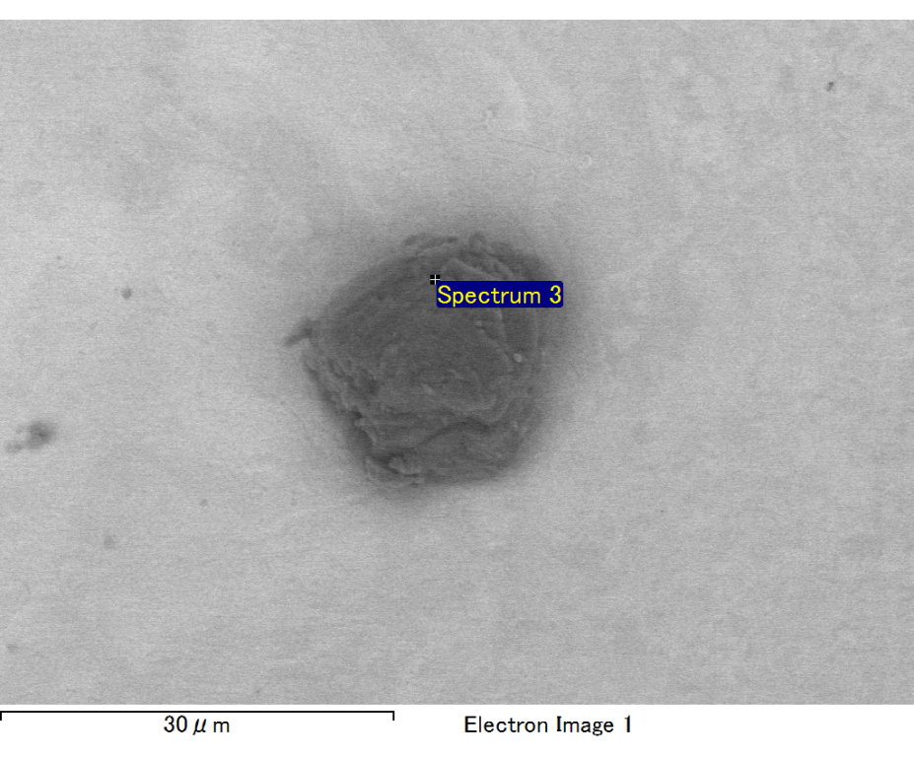

Spectrum processing :

No peaks omitted

Processing option : All elements analyzed (Normalised)

Number of iterations = 2

Standard :

C CaCO3 1-Jun-1999 12:00 AM

O SiO2 1-Jun-1999 12:00 AM

Mg MgO 1-Jun-1999 12:00 AM

Si SiO2 1-Jun-1999 12:00 AM

Fe Fe 1-Jun-1999 12:00 AM

Au Au 1-Jun-1999 12:00 AM

|  |  |  |  |
| --- | --- | --- | --- |
| Element | Weight% | Atomic% |  |
|  |  |  |  |
| C K | 2.35 | 8.40 |  |
| O K | 20.07 | 53.88 |  |
| Mg K | 6.52 | 11.52 |  |
| Si K | 3.36 | 5.14 |  |
| Fe L | 11.44 | 8.79 |  |
| Au M | 56.26 | 12.26 |  |
|  |  |  |  |
| Totals | 100.00 |  |  |

Spectrum Label: Spectrum 3

Livetime 60.0 s

Acquisition geometry ( degrees ):

Tilt = 15.0

Azimuth = 0.0

Elevation = 30.0

Accelerating voltage = 10.00 kV

Total spectrum counts = 45812

|  |  |  |  |
| --- | --- | --- | --- |
| Sample data : | Energy (eV) | Resn. (eV) | Area |
| Strobe : | 3.8 | 47.30 | 1000704 |
|  |  |  |  |

No quant optimization performed

Sample: Sample 1

Type: Default

ID:

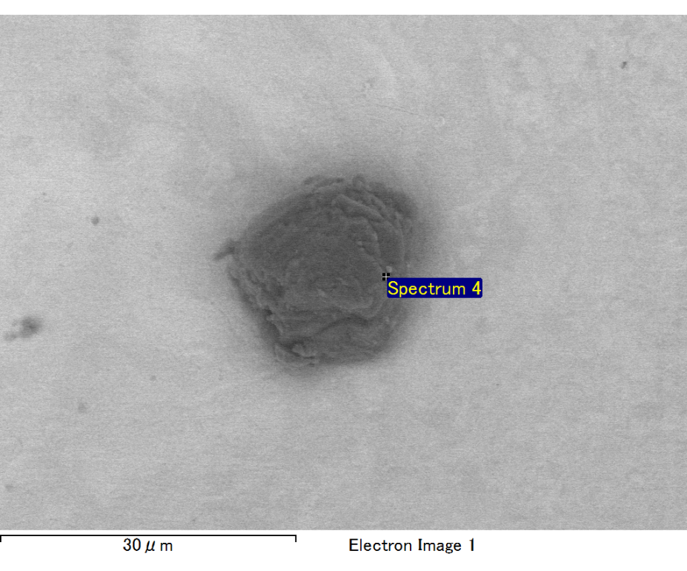

Spectrum processing :

No peaks omitted

Processing option : All elements analyzed (Normalised)

Number of iterations = 2

Standard :

C CaCO3 1-Jun-1999 12:00 AM

O SiO2 1-Jun-1999 12:00 AM

Mg MgO 1-Jun-1999 12:00 AM

Si SiO2 1-Jun-1999 12:00 AM

Fe Fe 1-Jun-1999 12:00 AM

Au Au 1-Jun-1999 12:00 AM

|  |  |  |  |
| --- | --- | --- | --- |
| Element | Weight% | Atomic% |  |
|  |  |  |  |
| C K | 2.68 | 12.50 |  |
| O K | 13.22 | 46.34 |  |
| Mg K | 4.24 | 9.79 |  |
| Si K | 3.26 | 6.52 |  |
| Fe L | 4.25 | 4.27 |  |
| Au M | 72.34 | 20.59 |  |
|  |  |  |  |
| Totals | 100.00 |  |  |

Spectrum Label: Spectrum 4

Livetime 60.0 s

Acquisition geometry ( degrees ):

Tilt = 15.0

Azimuth = 0.0

Elevation = 30.0

Accelerating voltage = 10.00 kV

Total spectrum counts = 43632

|  |  |  |  |
| --- | --- | --- | --- |
| Sample data : | Energy (eV) | Resn. (eV) | Area |
| Strobe : | 3.8 | 47.23 | 1000078 |
|  |  |  |  |

No quant optimization performed

Sample: Sample 1

Type: Default

ID:

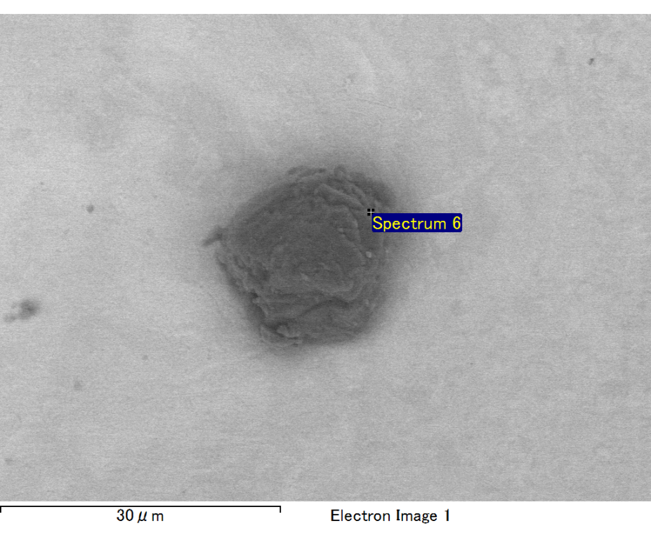

Spectrum processing :

Peak possibly omitted : 0.710 keV

Processing option : All elements analyzed (Normalised)

Number of iterations = 2

Standard :

C CaCO3 1-Jun-1999 12:00 AM

O SiO2 1-Jun-1999 12:00 AM

Mg MgO 1-Jun-1999 12:00 AM

Si SiO2 1-Jun-1999 12:00 AM

Au Au 1-Jun-1999 12:00 AM

|  |  |  |  |
| --- | --- | --- | --- |
| Element | Weight% | Atomic% |  |
|  |  |  |  |
| C K | 2.91 | 9.89 |  |
| O K | 23.85 | 60.74 |  |
| Mg K | 5.87 | 9.83 |  |
| Si K | 4.51 | 6.55 |  |
| Au M | 62.85 | 13.00 |  |
|  |  |  |  |
| Totals | 100.00 |  |  |

Spectrum Label: Spectrum 6

Livetime 60.0 s

Acquisition geometry ( degrees ):

Tilt = 15.0

Azimuth = 0.0

Elevation = 30.0

Accelerating voltage = 10.00 kV

Total spectrum counts = 45699

|  |  |  |  |
| --- | --- | --- | --- |
| Sample data : | Energy (eV) | Resn. (eV) | Area |
| Strobe : | 3.8 | 47.35 | 999794 |
|  |  |  |  |

No quant optimization performed

Sample: Sample 1

Type: Default

ID: