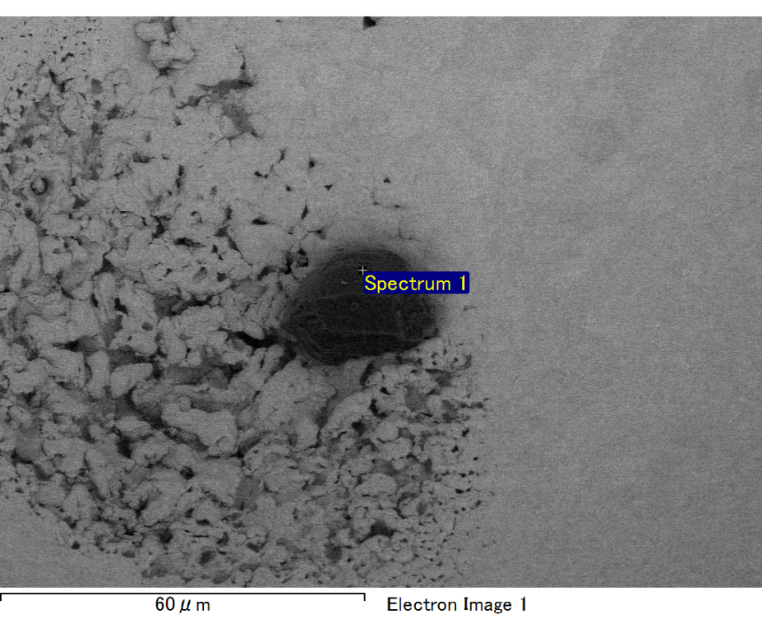

Spectrum processing :

No peaks omitted

Processing option : All elements analyzed (Normalised)

Number of iterations = 2

Standard :

C CaCO3 1-Jun-1999 12:00 AM

O SiO2 1-Jun-1999 12:00 AM

Mg MgO 1-Jun-1999 12:00 AM

Si SiO2 1-Jun-1999 12:00 AM

Au Au 1-Jun-1999 12:00 AM

|  |  |  |  |
| --- | --- | --- | --- |
| Element | Weight% | Atomic% |  |
|  |  |  |  |
| C K | 3.81 | 22.89 |  |
| O K | 5.91 | 26.62 |  |
| Mg K | 2.49 | 7.39 |  |
| Si K | 4.97 | 12.77 |  |
| Au M | 82.81 | 30.32 |  |
|  |  |  |  |
| Totals | 100.00 |  |  |

Spectrum Label: Spectrum 1

Livetime 60.0 s

Acquisition geometry ( degrees ):

Tilt = 15.0

Azimuth = 0.0

Elevation = 30.0

Accelerating voltage = 10.00 kV

Total spectrum counts = 38075

|  |  |  |  |
| --- | --- | --- | --- |
| Sample data : | Energy (eV) | Resn. (eV) | Area |
| Strobe : | 3.8 | 47.17 | 999894 |
|  |  |  |  |

No quant optimization performed

Sample: Sample 1

Type: Default

ID:

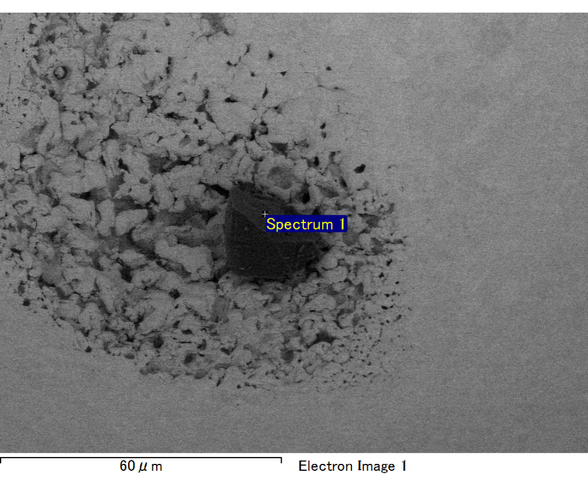

Spectrum processing :

Peak possibly omitted : 0.710 keV

Processing option : All elements analyzed (Normalised)

Number of iterations = 2

Standard :

C CaCO3 1-Jun-1999 12:00 AM

O SiO2 1-Jun-1999 12:00 AM

Mg MgO 1-Jun-1999 12:00 AM

Si SiO2 1-Jun-1999 12:00 AM

Au Au 1-Jun-1999 12:00 AM

|  |  |  |  |
| --- | --- | --- | --- |
| Element | Weight% | Atomic% |  |
|  |  |  |  |
| C K | 4.77 | 15.98 |  |
| O K | 22.47 | 56.57 |  |
| Mg K | 4.28 | 7.09 |  |
| Si K | 5.16 | 7.40 |  |
| Au M | 63.32 | 12.95 |  |
|  |  |  |  |
| Totals | 100.00 |  |  |

Spectrum Label: Spectrum 1

Livetime 60.0 s

Acquisition geometry ( degrees ):

Tilt = 15.0

Azimuth = 0.0

Elevation = 30.0

Accelerating voltage = 10.00 kV

Total spectrum counts = 43965

|  |  |  |  |
| --- | --- | --- | --- |
| Sample data : | Energy (eV) | Resn. (eV) | Area |
| Strobe : | 3.8 | 47.31 | 999599 |
|  |  |  |  |

No quant optimization performed

Sample: Sample 1

Type: Default

ID:

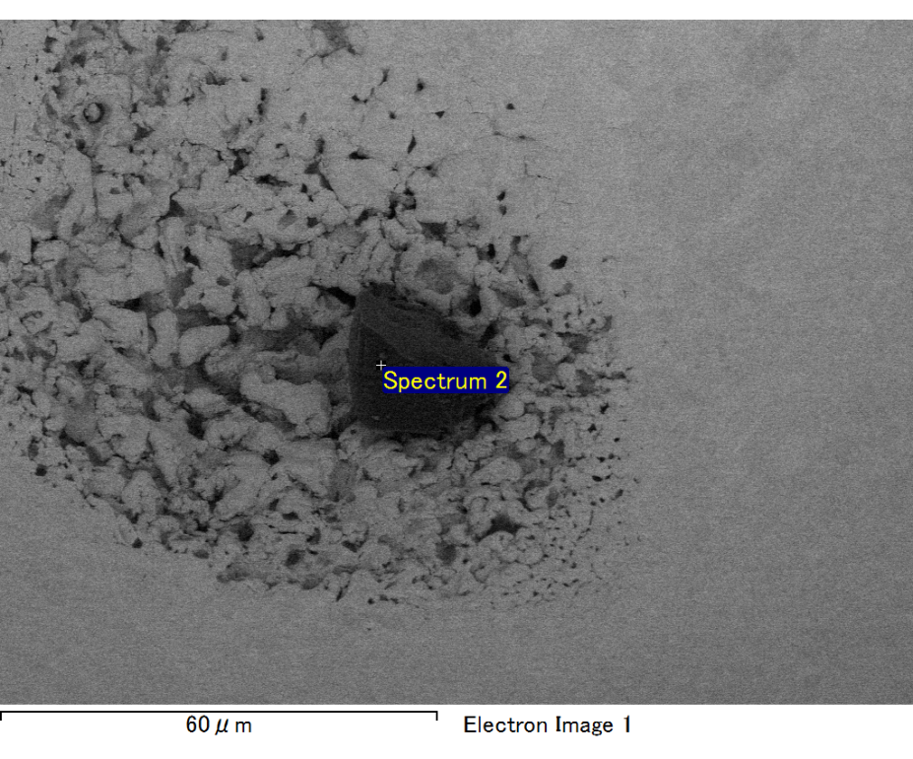

Spectrum processing :

No peaks omitted

Processing option : All elements analyzed (Normalised)

Number of iterations = 2

Standard :

C CaCO3 1-Jun-1999 12:00 AM

O SiO2 1-Jun-1999 12:00 AM

Mg MgO 1-Jun-1999 12:00 AM

Si SiO2 1-Jun-1999 12:00 AM

Au Au 1-Jun-1999 12:00 AM

|  |  |  |  |
| --- | --- | --- | --- |
| Element | Weight% | Atomic% |  |
|  |  |  |  |
| C K | 3.94 | 17.65 |  |
| O K | 12.48 | 41.96 |  |
| Mg K | 3.53 | 7.82 |  |
| Si K | 6.52 | 12.48 |  |
| Au M | 73.53 | 20.08 |  |
|  |  |  |  |
| Totals | 100.00 |  |  |

Spectrum Label: Spectrum 2

Livetime 60.0 s

Acquisition geometry ( degrees ):

Tilt = 15.0

Azimuth = 0.0

Elevation = 30.0

Accelerating voltage = 10.00 kV

Total spectrum counts = 39595

|  |  |  |  |
| --- | --- | --- | --- |
| Sample data : | Energy (eV) | Resn. (eV) | Area |
| Strobe : | 3.8 | 47.21 | 999718 |
|  |  |  |  |

No quant optimization performed

Sample: Sample 1

Type: Default

ID:

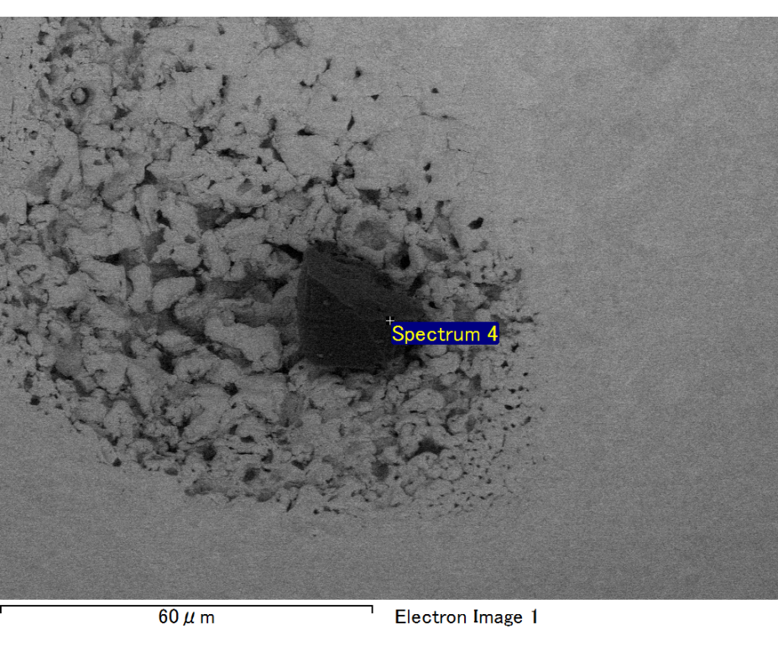

Spectrum processing :

No peaks omitted

Processing option : All elements analyzed (Normalised)

Number of iterations = 2

Standard :

C CaCO3 1-Jun-1999 12:00 AM

O SiO2 1-Jun-1999 12:00 AM

Mg MgO 1-Jun-1999 12:00 AM

Si SiO2 1-Jun-1999 12:00 AM

Fe Fe 1-Jun-1999 12:00 AM

Au Au 1-Jun-1999 12:00 AM

|  |  |  |  |
| --- | --- | --- | --- |
| Element | Weight% | Atomic% |  |
|  |  |  |  |
| C K | 2.98 | 9.88 |  |
| O K | 22.89 | 57.02 |  |
| Mg K | 4.75 | 7.78 |  |
| Si K | 6.27 | 8.90 |  |
| Fe L | 7.13 | 5.09 |  |
| Au M | 55.99 | 11.33 |  |
|  |  |  |  |
| Totals | 100.00 |  |  |

Spectrum Label: Spectrum 4

Livetime 60.0 s

Acquisition geometry ( degrees ):

Tilt = 15.0

Azimuth = 0.0

Elevation = 30.0

Accelerating voltage = 10.00 kV

Total spectrum counts = 42804

|  |  |  |  |
| --- | --- | --- | --- |
| Sample data : | Energy (eV) | Resn. (eV) | Area |
| Strobe : | 3.8 | 47.20 | 1000004 |
|  |  |  |  |

No quant optimization performed

Sample: Sample 1

Type: Default

ID:

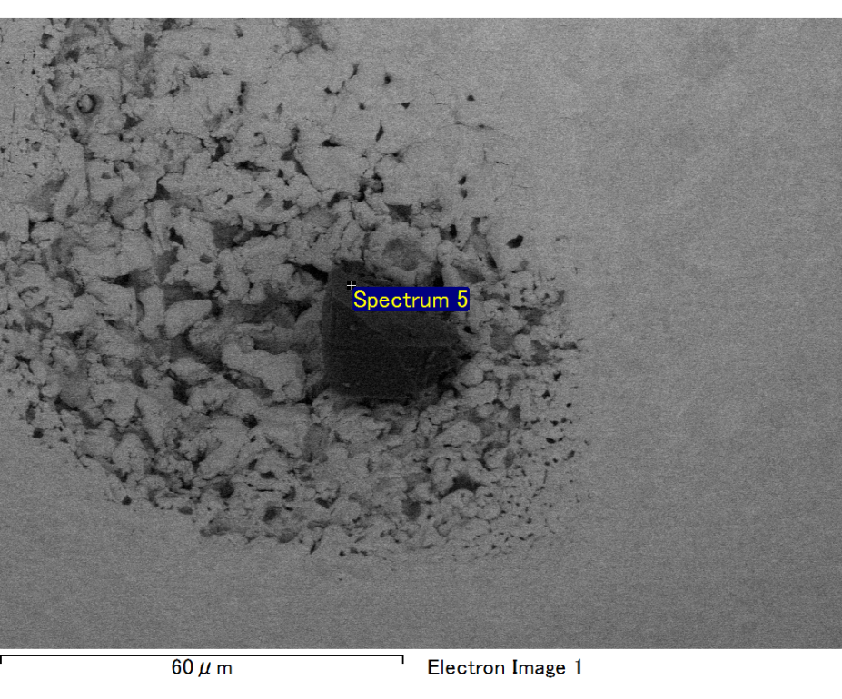

Spectrum processing :

No peaks omitted

Processing option : All elements analyzed (Normalised)

Number of iterations = 2

Standard :

C CaCO3 1-Jun-1999 12:00 AM

O SiO2 1-Jun-1999 12:00 AM

Mg MgO 1-Jun-1999 12:00 AM

Si SiO2 1-Jun-1999 12:00 AM

Fe Fe 1-Jun-1999 12:00 AM

Au Au 1-Jun-1999 12:00 AM

|  |  |  |  |
| --- | --- | --- | --- |
| Element | Weight% | Atomic% |  |
|  |  |  |  |
| C K | 3.81 | 12.44 |  |
| O K | 22.65 | 55.46 |  |
| Mg K | 4.57 | 7.36 |  |
| Si K | 6.16 | 8.59 |  |
| Fe L | 7.28 | 5.10 |  |
| Au M | 55.54 | 11.05 |  |
|  |  |  |  |
| Totals | 100.00 |  |  |

Spectrum Label: Spectrum 5

Livetime 60.0 s

Acquisition geometry ( degrees ):

Tilt = 15.0

Azimuth = 0.0

Elevation = 30.0

Accelerating voltage = 10.00 kV

Total spectrum counts = 43091

|  |  |  |  |
| --- | --- | --- | --- |
| Sample data : | Energy (eV) | Resn. (eV) | Area |
| Strobe : | 3.8 | 47.30 | 999846 |
|  |  |  |  |

No quant optimization performed

Sample: Sample 1

Type: Default

ID: