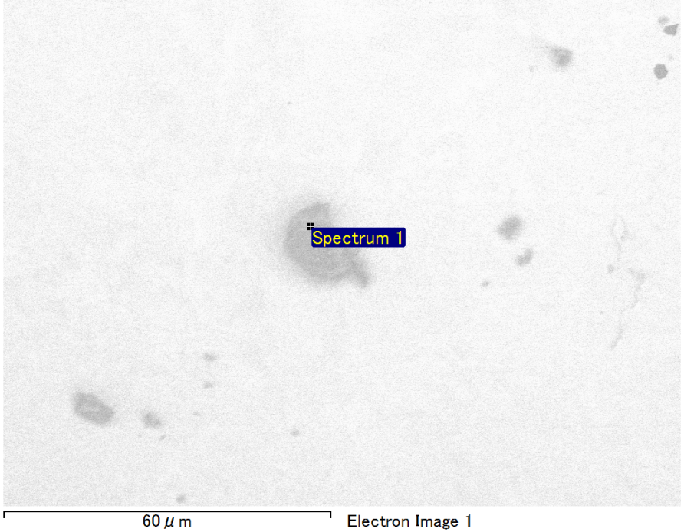

Spectrum Label: Spectrum 1

Livetime 90.0 s

Acquisition geometry ( degrees ):

Tilt = 0.0

Azimuth = 0.0

Elevation = 30.0

Accelerating voltage = 10.00 kV

Total spectrum counts = 65651

|  |  |  |  |
| --- | --- | --- | --- |
| Sample data : | Energy (eV) | Resn. (eV) | Area |
| Strobe : | 3.8 | 53.56 | 918707 |
|  |  |  |  |
| Optimization data : Manganese K series |  |  |  |
|  | Energy (eV) | Resn. (eV) | Area |
| Strobe : | .1 | 53.38 | 1150729 |
| Optimization element : | 5892.6 | 129.89 | 573533 |

Spectrum processing :

No peaks omitted

Processing option : Oxygen by stoichiometry (Normalised)

Number of iterations = 1

Standard :

Mg MgO 1-Jun-1999 12:00 AM

Si SiO2 1-Jun-1999 12:00 AM

Au Au 1-Jun-1999 12:00 AM

|  |  |  |  |  |  |
| --- | --- | --- | --- | --- | --- |
| Element | Weight% | Atomic% | Compd% | Formula |  |
|  |  |  |  |  |  |
| Mg K | 4.94 | 11.92 | 8.18 | MgO |  |
| Si K | 3.13 | 6.54 | 6.69 | SiO2 |  |
| Au M | 75.88 | 22.62 | 85.13 | Au2O3 |  |
| O | 16.06 | 58.92 |  |  |  |
| Totals | 100.00 |  |  |  |  |

Project: Project 1

Owner: Operator

Site: Site of Interest 11

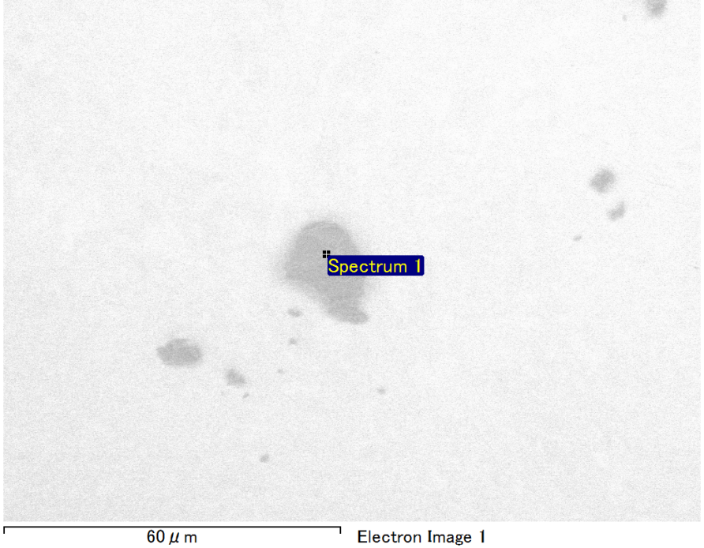

Spectrum Label: Spectrum 1

Livetime 90.0 s

Acquisition geometry ( degrees ):

Tilt = 0.0

Azimuth = 0.0

Elevation = 30.0

Accelerating voltage = 10.00 kV

Total spectrum counts = 66184

|  |  |  |  |
| --- | --- | --- | --- |
| Sample data : | Energy (eV) | Resn. (eV) | Area |
| Strobe : | 3.8 | 53.53 | 918942 |
|  |  |  |  |
| Optimization data : Manganese K series |  |  |  |
|  | Energy (eV) | Resn. (eV) | Area |
| Strobe : | .1 | 53.38 | 1150729 |
| Optimization element : | 5892.6 | 129.89 | 573533 |

Spectrum processing :

Peaks possibly omitted : 0.245, 0.710 keV

Processing option : Oxygen by stoichiometry (Normalised)

Number of iterations = 1

Standard :

Mg MgO 1-Jun-1999 12:00 AM

Si SiO2 1-Jun-1999 12:00 AM

Au Au 1-Jun-1999 12:00 AM

|  |  |  |  |  |  |
| --- | --- | --- | --- | --- | --- |
| Element | Weight% | Atomic% | Compd% | Formula |  |
|  |  |  |  |  |  |
| Mg K | 6.68 | 14.12 | 11.07 | MgO |  |
| Si K | 4.72 | 8.64 | 10.11 | SiO2 |  |
| Au M | 70.26 | 18.33 | 78.82 | Au2O3 |  |
| O | 18.34 | 58.91 |  |  |  |
| Totals | 100.00 |  |  |  |  |

Project: Project 1

Owner: Operator

Site: Site of Interest 12

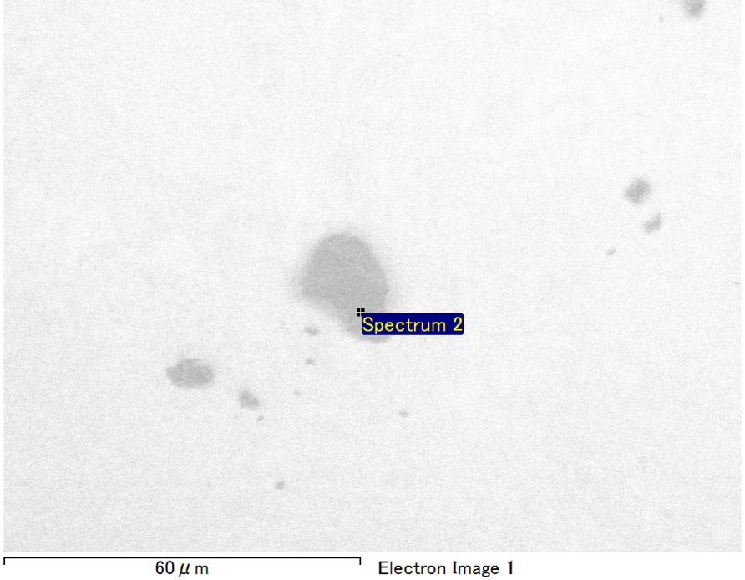

Spectrum Label: Spectrum 2

Livetime 90.0 s

Acquisition geometry ( degrees ):

Tilt = 0.0

Azimuth = 0.0

Elevation = 30.0

Accelerating voltage = 10.00 kV

Total spectrum counts = 65122

|  |  |  |  |
| --- | --- | --- | --- |
| Sample data : | Energy (eV) | Resn. (eV) | Area |
| Strobe : | 3.8 | 53.56 | 919499 |
|  |  |  |  |
| Optimization data : Manganese K series |  |  |  |
|  | Energy (eV) | Resn. (eV) | Area |
| Strobe : | .1 | 53.38 | 1150729 |
| Optimization element : | 5892.6 | 129.89 | 573533 |

Spectrum processing :

No peaks omitted

Processing option : Oxygen by stoichiometry (Normalised)

Number of iterations = 1

Standard :

Mg MgO 1-Jun-1999 12:00 AM

Si SiO2 1-Jun-1999 12:00 AM

Au Au 1-Jun-1999 12:00 AM

|  |  |  |  |  |  |
| --- | --- | --- | --- | --- | --- |
| Element | Weight% | Atomic% | Compd% | Formula |  |
|  |  |  |  |  |  |
| Mg K | 3.26 | 7.64 | 5.41 | MgO |  |
| Si K | 5.04 | 10.23 | 10.79 | SiO2 |  |
| Au M | 74.70 | 21.61 | 83.80 | Au2O3 |  |
| O | 16.99 | 60.52 |  |  |  |
| Totals | 100.00 |  |  |  |  |

Project: Project 1

Owner: Operator

Site: Site of Interest 12

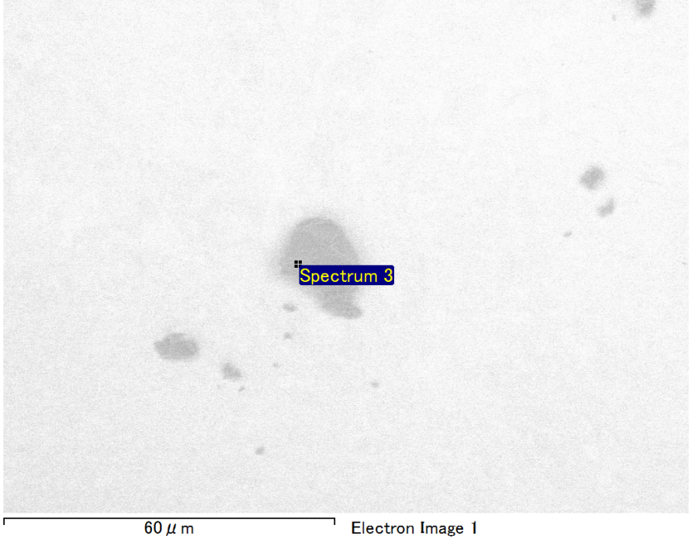

Spectrum Label: Spectrum 3

Livetime 90.0 s

Acquisition geometry ( degrees ):

Tilt = 0.0

Azimuth = 0.0

Elevation = 30.0

Accelerating voltage = 10.00 kV

Total spectrum counts = 65935

|  |  |  |  |
| --- | --- | --- | --- |
| Sample data : | Energy (eV) | Resn. (eV) | Area |
| Strobe : | 3.8 | 53.66 | 919947 |
|  |  |  |  |
| Optimization data : Manganese K series |  |  |  |
|  | Energy (eV) | Resn. (eV) | Area |
| Strobe : | .1 | 53.38 | 1150729 |
| Optimization element : | 5892.6 | 129.89 | 573533 |

Spectrum processing :

No peaks omitted

Processing option : Oxygen by stoichiometry (Normalised)

Number of iterations = 1

Standard :

Mg MgO 1-Jun-1999 12:00 AM

Si SiO2 1-Jun-1999 12:00 AM

Au Au 1-Jun-1999 12:00 AM

|  |  |  |  |  |  |
| --- | --- | --- | --- | --- | --- |
| Element | Weight% | Atomic% | Compd% | Formula |  |
|  |  |  |  |  |  |
| Mg K | 3.83 | 9.53 | 6.35 | MgO |  |
| Si K | 3.38 | 7.27 | 7.23 | SiO2 |  |
| Au M | 77.03 | 23.65 | 86.42 | Au2O3 |  |
| O | 15.76 | 59.55 |  |  |  |
| Totals | 100.00 |  |  |  |  |

Project: Project 1

Owner: Operator

Site: Site of Interest 12

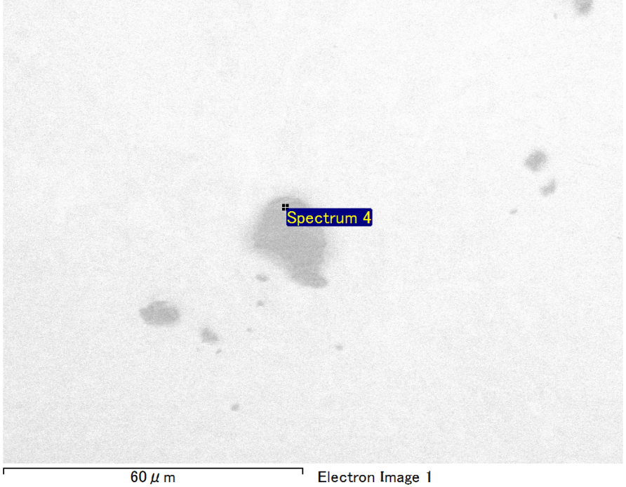

Spectrum Label: Spectrum 4

Livetime 90.0 s

Acquisition geometry ( degrees ):

Tilt = 0.0

Azimuth = 0.0

Elevation = 30.0

Accelerating voltage = 10.00 kV

Total spectrum counts = 66670

|  |  |  |  |
| --- | --- | --- | --- |
| Sample data : | Energy (eV) | Resn. (eV) | Area |
| Strobe : | 3.8 | 53.60 | 918776 |
|  |  |  |  |
| Optimization data : Manganese K series |  |  |  |
|  | Energy (eV) | Resn. (eV) | Area |
| Strobe : | .1 | 53.38 | 1150729 |
| Optimization element : | 5892.6 | 129.89 | 573533 |

Spectrum processing :

No peaks omitted

Processing option : Oxygen by stoichiometry (Normalised)

Number of iterations = 1

Standard :

C CaCO3 1-Jun-1999 12:00 AM

Mg MgO 1-Jun-1999 12:00 AM

Si SiO2 1-Jun-1999 12:00 AM

Au Au 1-Jun-1999 12:00 AM

|  |  |  |  |  |  |
| --- | --- | --- | --- | --- | --- |
| Element | Weight% | Atomic% | Compd% | Formula |  |
|  |  |  |  |  |  |
| C K | 3.97 | 12.78 | 14.53 | CO2 |  |
| Mg K | 5.60 | 8.92 | 9.29 | MgO |  |
| Si K | 3.27 | 4.51 | 7.00 | SiO2 |  |
| Au M | 61.67 | 12.12 | 69.18 | Au2O3 |  |
| O | 25.49 | 61.67 |  |  |  |
| Totals | 100.00 |  |  |  |  |

Project: Project 1

Owner: Operator

Site: Site of Interest 12