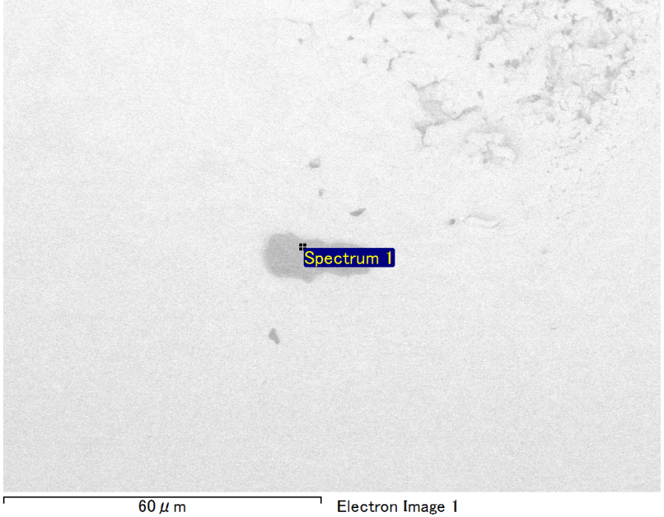

Spectrum Label: Spectrum 1

Livetime 90.0 s

Acquisition geometry ( degrees ):

Tilt = 0.0

Azimuth = 0.0

Elevation = 30.0

Accelerating voltage = 10.00 kV

Total spectrum counts = 66406

|  |  |  |  |
| --- | --- | --- | --- |
| Sample data : | Energy (eV) | Resn. (eV) | Area |
| Strobe : | 3.8 | 53.61 | 918086 |
|  |  |  |  |
| Optimization data : Manganese K series |  |  |  |
|  | Energy (eV) | Resn. (eV) | Area |
| Strobe : | .1 | 53.38 | 1150729 |
| Optimization element : | 5892.6 | 129.89 | 573533 |

Spectrum processing :

No peaks omitted

Processing option : Oxygen by stoichiometry (Normalised)

Number of iterations = 1

Standard :

Mg MgO 1-Jun-1999 12:00 AM

Si SiO2 1-Jun-1999 12:00 AM

Au Au 1-Jun-1999 12:00 AM

|  |  |  |  |  |  |
| --- | --- | --- | --- | --- | --- |
| Element | Weight% | Atomic% | Compd% | Formula |  |
|  |  |  |  |  |  |
| Mg K | 6.76 | 14.54 | 11.20 | MgO |  |
| Si K | 4.25 | 7.91 | 9.08 | SiO2 |  |
| Au M | 71.06 | 18.87 | 79.71 | Au2O3 |  |
| O | 17.94 | 58.67 |  |  |  |
| Totals | 100.00 |  |  |  |  |

Project: Project 1

Owner: Operator

Site: Site of Interest 14

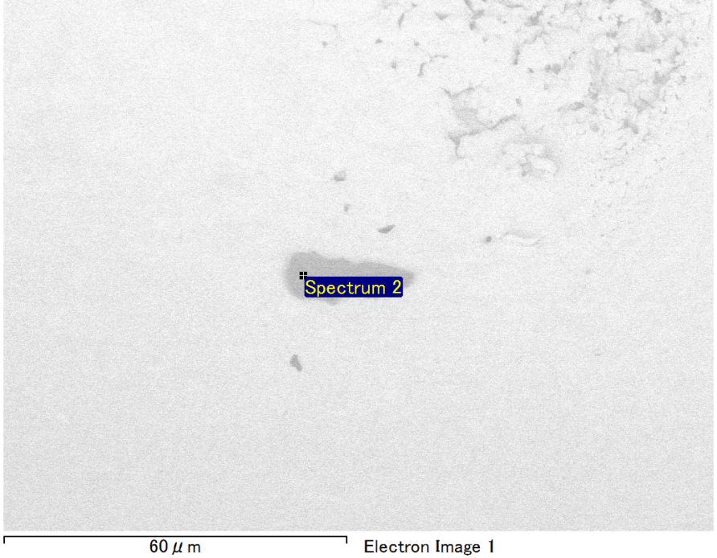

Spectrum Label: Spectrum 2

Livetime 90.0 s

Acquisition geometry ( degrees ):

Tilt = 0.0

Azimuth = 0.0

Elevation = 30.0

Accelerating voltage = 10.00 kV

Total spectrum counts = 65969

|  |  |  |  |
| --- | --- | --- | --- |
| Sample data : | Energy (eV) | Resn. (eV) | Area |
| Strobe : | 3.8 | 53.58 | 918829 |
|  |  |  |  |
| Optimization data : Manganese K series |  |  |  |
|  | Energy (eV) | Resn. (eV) | Area |
| Strobe : | .1 | 53.38 | 1150729 |
| Optimization element : | 5892.6 | 129.89 | 573533 |

Spectrum processing :

No peaks omitted

Processing option : Oxygen by stoichiometry (Normalised)

Number of iterations = 1

Standard :

Mg MgO 1-Jun-1999 12:00 AM

Si SiO2 1-Jun-1999 12:00 AM

Au Au 1-Jun-1999 12:00 AM

|  |  |  |  |  |  |
| --- | --- | --- | --- | --- | --- |
| Element | Weight% | Atomic% | Compd% | Formula |  |
|  |  |  |  |  |  |
| Mg K | 6.11 | 13.52 | 10.13 | MgO |  |
| Si K | 4.12 | 7.89 | 8.82 | SiO2 |  |
| Au M | 72.24 | 19.72 | 81.05 | Au2O3 |  |
| O | 17.52 | 58.87 |  |  |  |
| Totals | 100.00 |  |  |  |  |

Project: Project 1

Owner: Operator

Site: Site of Interest 14

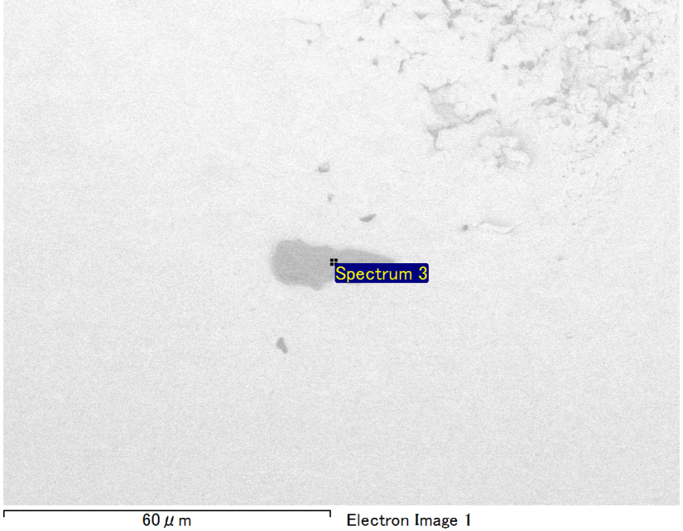

Spectrum Label: Spectrum 3

Livetime 90.0 s

Acquisition geometry ( degrees ):

Tilt = 0.0

Azimuth = 0.0

Elevation = 30.0

Accelerating voltage = 10.00 kV

Total spectrum counts = 66050

|  |  |  |  |
| --- | --- | --- | --- |
| Sample data : | Energy (eV) | Resn. (eV) | Area |
| Strobe : | 3.8 | 53.59 | 920853 |
|  |  |  |  |
| Optimization data : Manganese K series |  |  |  |
|  | Energy (eV) | Resn. (eV) | Area |
| Strobe : | .1 | 53.38 | 1150729 |
| Optimization element : | 5892.6 | 129.89 | 573533 |

Spectrum processing :

Peak possibly omitted : 0.240 keV

Processing option : Oxygen by stoichiometry (Normalised)

Number of iterations = 1

Standard :

Mg MgO 1-Jun-1999 12:00 AM

Si SiO2 1-Jun-1999 12:00 AM

Au Au 1-Jun-1999 12:00 AM

|  |  |  |  |  |  |
| --- | --- | --- | --- | --- | --- |
| Element | Weight% | Atomic% | Compd% | Formula |  |
|  |  |  |  |  |  |
| Mg K | 4.37 | 10.24 | 7.25 | MgO |  |
| Si K | 4.20 | 8.51 | 8.98 | SiO2 |  |
| Au M | 74.67 | 21.59 | 83.77 | Au2O3 |  |
| O | 16.76 | 59.65 |  |  |  |
| Totals | 100.00 |  |  |  |  |

Project: Project 1

Owner: Operator

Site: Site of Interest 14

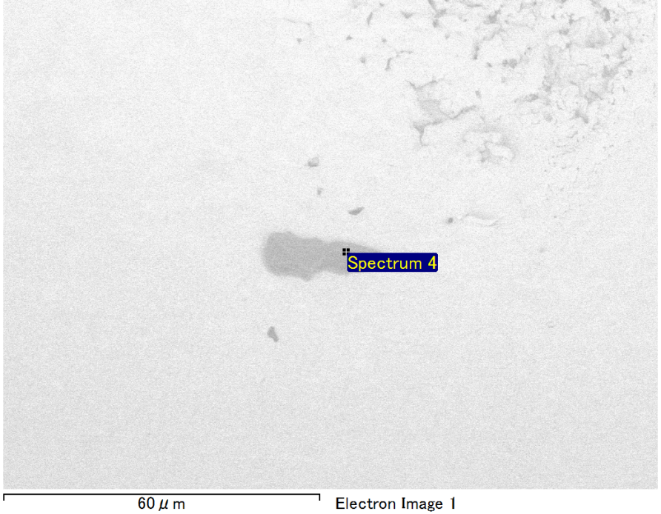

Spectrum Label: Spectrum 4

Livetime 90.0 s

Acquisition geometry ( degrees ):

Tilt = 0.0

Azimuth = 0.0

Elevation = 30.0

Accelerating voltage = 10.00 kV

Total spectrum counts = 65489

|  |  |  |  |
| --- | --- | --- | --- |
| Sample data : | Energy (eV) | Resn. (eV) | Area |
| Strobe : | 3.8 | 53.59 | 918192 |
|  |  |  |  |
| Optimization data : Manganese K series |  |  |  |
|  | Energy (eV) | Resn. (eV) | Area |
| Strobe : | .1 | 53.38 | 1150729 |
| Optimization element : | 5892.6 | 129.89 | 573533 |

Spectrum processing :

No peaks omitted

Processing option : Oxygen by stoichiometry (Normalised)

Number of iterations = 1

Standard :

Mg MgO 1-Jun-1999 12:00 AM

Si SiO2 1-Jun-1999 12:00 AM

Au Au 1-Jun-1999 12:00 AM

|  |  |  |  |  |  |
| --- | --- | --- | --- | --- | --- |
| Element | Weight% | Atomic% | Compd% | Formula |  |
|  |  |  |  |  |  |
| Mg K | 5.53 | 12.46 | 9.16 | MgO |  |
| Si K | 4.14 | 8.08 | 8.86 | SiO2 |  |
| Au M | 73.08 | 20.34 | 81.98 | Au2O3 |  |
| O | 17.26 | 59.12 |  |  |  |
| Totals | 100.00 |  |  |  |  |

Project: Project 1

Owner: Operator

Site: Site of Interest 14

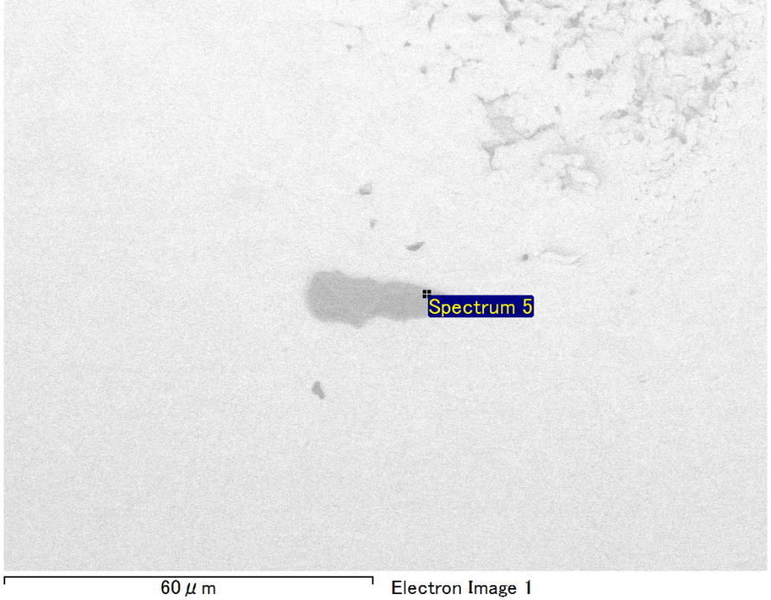

Spectrum Label: Spectrum 5

Livetime 90.0 s

Acquisition geometry ( degrees ):

Tilt = 0.0

Azimuth = 0.0

Elevation = 30.0

Accelerating voltage = 10.00 kV

Total spectrum counts = 65723

|  |  |  |  |
| --- | --- | --- | --- |
| Sample data : | Energy (eV) | Resn. (eV) | Area |
| Strobe : | 3.8 | 53.54 | 917509 |
|  |  |  |  |
| Optimization data : Manganese K series |  |  |  |
|  | Energy (eV) | Resn. (eV) | Area |
| Strobe : | .1 | 53.38 | 1150729 |
| Optimization element : | 5892.6 | 129.89 | 573533 |

Spectrum processing :

No peaks omitted

Processing option : Oxygen by stoichiometry (Normalised)

Number of iterations = 1

Standard :

Mg MgO 1-Jun-1999 12:00 AM

Si SiO2 1-Jun-1999 12:00 AM

Au Au 1-Jun-1999 12:00 AM

|  |  |  |  |  |  |
| --- | --- | --- | --- | --- | --- |
| Element | Weight% | Atomic% | Compd% | Formula |  |
|  |  |  |  |  |  |
| Mg K | 5.87 | 13.41 | 9.73 | MgO |  |
| Si K | 3.60 | 7.11 | 7.69 | SiO2 |  |
| Au M | 73.60 | 20.75 | 82.57 | Au2O3 |  |
| O | 16.93 | 58.74 |  |  |  |
| Totals | 100.00 |  |  |  |  |

Project: Project 1

Owner: Operator

Site: Site of Interest 14