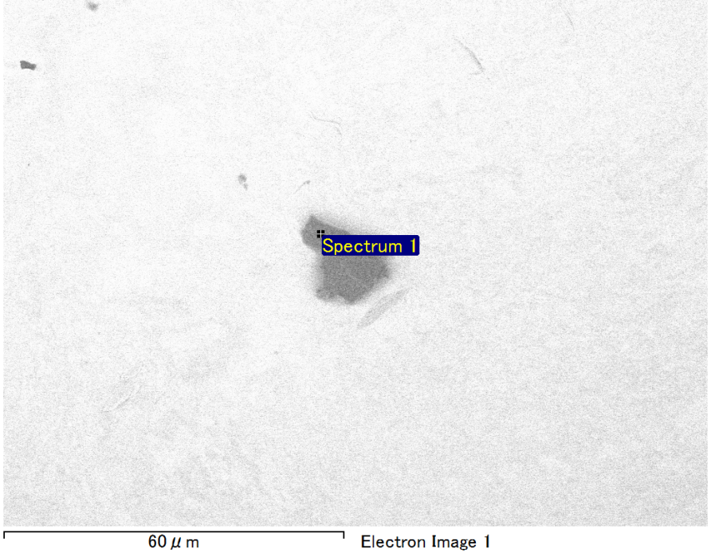

Spectrum Label: Spectrum 1

Livetime 90.0 s

Acquisition geometry ( degrees ):

Tilt = 0.0

Azimuth = 0.0

Elevation = 30.0

Accelerating voltage = 10.00 kV

Total spectrum counts = 69569

|  |  |  |  |
| --- | --- | --- | --- |
| Sample data : | Energy (eV) | Resn. (eV) | Area |
| Strobe : | 3.8 | 53.76 | 916654 |
|  |  |  |  |
| Optimization data : Manganese K series |  |  |  |
|  | Energy (eV) | Resn. (eV) | Area |
| Strobe : | .1 | 53.38 | 1150729 |
| Optimization element : | 5892.6 | 129.89 | 573533 |

Spectrum processing :

Peak possibly omitted : 0.715 keV

Processing option : Oxygen by stoichiometry (Normalised)

Number of iterations = 1

Standard :

Mg MgO 1-Jun-1999 12:00 AM

Si SiO2 1-Jun-1999 12:00 AM

Au Au 1-Jun-1999 12:00 AM

|  |  |  |  |  |  |
| --- | --- | --- | --- | --- | --- |
| Element | Weight% | Atomic% | Compd% | Formula |  |
|  |  |  |  |  |  |
| Mg K | 5.08 | 11.39 | 8.42 | MgO |  |
| Si K | 4.59 | 8.92 | 9.82 | SiO2 |  |
| Au M | 72.88 | 20.19 | 81.76 | Au2O3 |  |
| O | 17.45 | 59.50 |  |  |  |
| Totals | 100.00 |  |  |  |  |

Project: Project 1

Owner: Operator

Site: Site of Interest 4

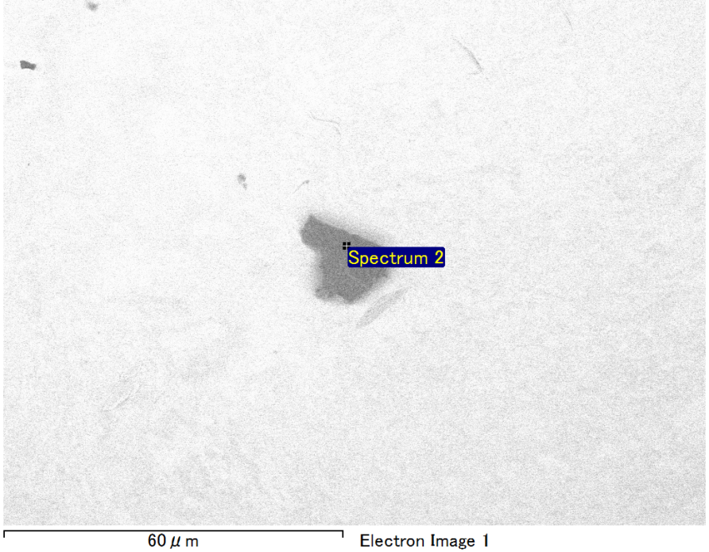

Spectrum Label: Spectrum 2

Livetime 90.0 s

Acquisition geometry ( degrees ):

Tilt = 0.0

Azimuth = 0.0

Elevation = 30.0

Accelerating voltage = 10.00 kV

Total spectrum counts = 69433

|  |  |  |  |
| --- | --- | --- | --- |
| Sample data : | Energy (eV) | Resn. (eV) | Area |
| Strobe : | 3.8 | 53.71 | 918432 |
|  |  |  |  |
| Optimization data : Manganese K series |  |  |  |
|  | Energy (eV) | Resn. (eV) | Area |
| Strobe : | .1 | 53.38 | 1150729 |
| Optimization element : | 5892.6 | 129.89 | 573533 |

Spectrum processing :

No peaks omitted

Processing option : Oxygen by stoichiometry (Normalised)

Number of iterations = 1

Standard :

Mg MgO 1-Jun-1999 12:00 AM

Si SiO2 1-Jun-1999 12:00 AM

Au Au 1-Jun-1999 12:00 AM

|  |  |  |  |  |  |
| --- | --- | --- | --- | --- | --- |
| Element | Weight% | Atomic% | Compd% | Formula |  |
|  |  |  |  |  |  |
| Mg K | 6.11 | 13.68 | 10.13 | MgO |  |
| Si K | 3.86 | 7.47 | 8.25 | SiO2 |  |
| Au M | 72.75 | 20.09 | 81.61 | Au2O3 |  |
| O | 17.28 | 58.76 |  |  |  |
| Totals | 100.00 |  |  |  |  |

Project: Project 1

Owner: Operator

Site: Site of Interest 4

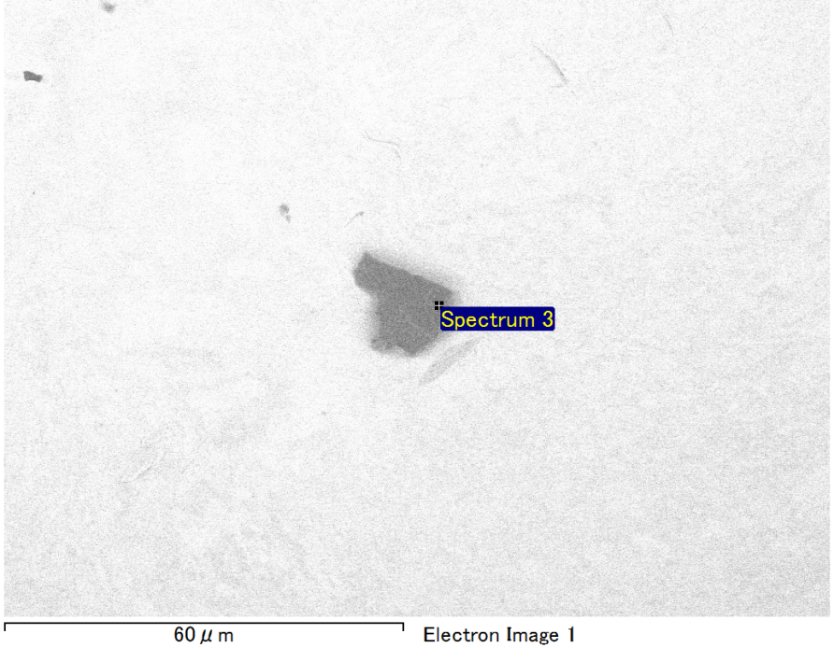

Spectrum Label: Spectrum 3

Livetime 90.0 s

Acquisition geometry ( degrees ):

Tilt = 0.0

Azimuth = 0.0

Elevation = 30.0

Accelerating voltage = 10.00 kV

Total spectrum counts = 69473

|  |  |  |  |
| --- | --- | --- | --- |
| Sample data : | Energy (eV) | Resn. (eV) | Area |
| Strobe : | 3.8 | 53.73 | 917068 |
|  |  |  |  |
| Optimization data : Manganese K series |  |  |  |
|  | Energy (eV) | Resn. (eV) | Area |
| Strobe : | .1 | 53.38 | 1150729 |
| Optimization element : | 5892.6 | 129.89 | 573533 |

Spectrum processing :

Peaks possibly omitted : 0.250, 0.725 keV

Processing option : Oxygen by stoichiometry (Normalised)

Number of iterations = 1

Standard :

Mg MgO 1-Jun-1999 12:00 AM

Si SiO2 1-Jun-1999 12:00 AM

Au Au 1-Jun-1999 12:00 AM

|  |  |  |  |  |  |
| --- | --- | --- | --- | --- | --- |
| Element | Weight% | Atomic% | Compd% | Formula |  |
|  |  |  |  |  |  |
| Mg K | 6.04 | 13.37 | 10.01 | MgO |  |
| Si K | 4.13 | 7.93 | 8.84 | SiO2 |  |
| Au M | 72.34 | 19.79 | 81.15 | Au2O3 |  |
| O | 17.49 | 58.91 |  |  |  |
| Totals | 100.00 |  |  |  |  |

Project: Project 1

Owner: Operator

Site: Site of Interest 4

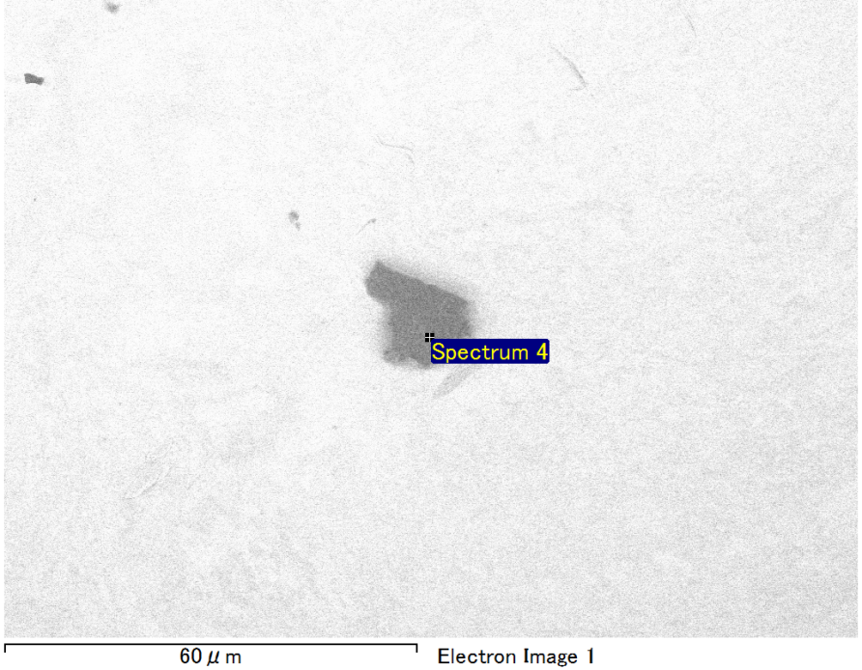

Spectrum Label: Spectrum 4

Livetime 90.0 s

Acquisition geometry ( degrees ):

Tilt = 0.0

Azimuth = 0.0

Elevation = 30.0

Accelerating voltage = 10.00 kV

Total spectrum counts = 70335

|  |  |  |  |
| --- | --- | --- | --- |
| Sample data : | Energy (eV) | Resn. (eV) | Area |
| Strobe : | 3.8 | 53.67 | 918032 |
|  |  |  |  |
| Optimization data : Manganese K series |  |  |  |
|  | Energy (eV) | Resn. (eV) | Area |
| Strobe : | .1 | 53.38 | 1150729 |
| Optimization element : | 5892.6 | 129.89 | 573533 |

Spectrum processing :

Peak possibly omitted : 0.241 keV

Processing option : Oxygen by stoichiometry (Normalised)

Number of iterations = 1

Standard :

Mg MgO 1-Jun-1999 12:00 AM

Si SiO2 1-Jun-1999 12:00 AM

Fe Fe 1-Jun-1999 12:00 AM

Au Au 1-Jun-1999 12:00 AM

|  |  |  |  |  |  |
| --- | --- | --- | --- | --- | --- |
| Element | Weight% | Atomic% | Compd% | Formula |  |
|  |  |  |  |  |  |
| Mg K | 5.47 | 10.89 | 9.07 | MgO |  |
| Si K | 3.70 | 6.37 | 7.91 | SiO2 |  |
| Fe L | 13.24 | 11.48 | 17.03 | FeO |  |
| Au M | 58.83 | 14.46 | 65.99 | Au2O3 |  |
| O | 18.77 | 56.80 |  |  |  |
| Totals | 100.00 |  |  |  |  |

Project: Project 1

Owner: Operator

Site: Site of Interest 4

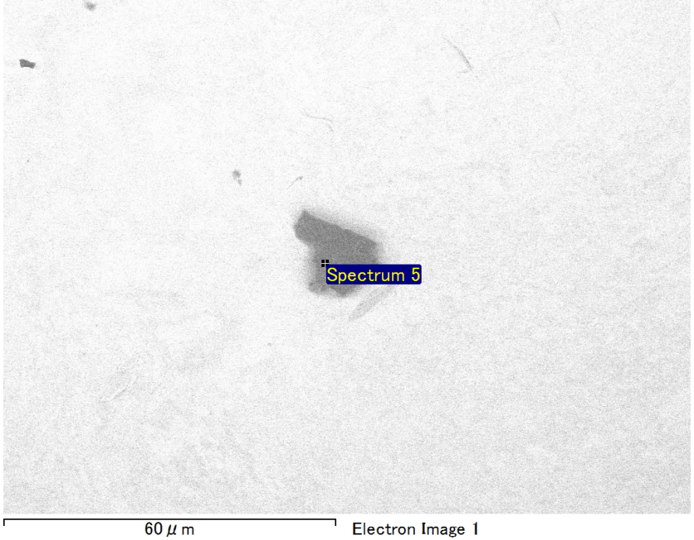

Spectrum Label: Spectrum 5

Livetime 90.0 s

Acquisition geometry ( degrees ):

Tilt = 0.0

Azimuth = 0.0

Elevation = 30.0

Accelerating voltage = 10.00 kV

Total spectrum counts = 69740

|  |  |  |  |
| --- | --- | --- | --- |
| Sample data : | Energy (eV) | Resn. (eV) | Area |
| Strobe : | 3.8 | 53.64 | 918130 |
|  |  |  |  |
| Optimization data : Manganese K series |  |  |  |
|  | Energy (eV) | Resn. (eV) | Area |
| Strobe : | .1 | 53.38 | 1150729 |
| Optimization element : | 5892.6 | 129.89 | 573533 |

Spectrum processing :

Peak possibly omitted : 0.255 keV

Processing option : Oxygen by stoichiometry (Normalised)

Number of iterations = 1

Standard :

Mg MgO 1-Jun-1999 12:00 AM

Si SiO2 1-Jun-1999 12:00 AM

Fe Fe 1-Jun-1999 12:00 AM

Au Au 1-Jun-1999 12:00 AM

|  |  |  |  |  |  |
| --- | --- | --- | --- | --- | --- |
| Element | Weight% | Atomic% | Compd% | Formula |  |
|  |  |  |  |  |  |
| Mg K | 5.63 | 11.04 | 9.34 | MgO |  |
| Si K | 3.93 | 6.67 | 8.41 | SiO2 |  |
| Fe L | 13.38 | 11.42 | 17.21 | FeO |  |
| Au M | 57.98 | 14.03 | 65.04 | Au2O3 |  |
| O | 19.08 | 56.84 |  |  |  |
| Totals | 100.00 |  |  |  |  |

Project: Project 1

Owner: Operator

Site: Site of Interest 4