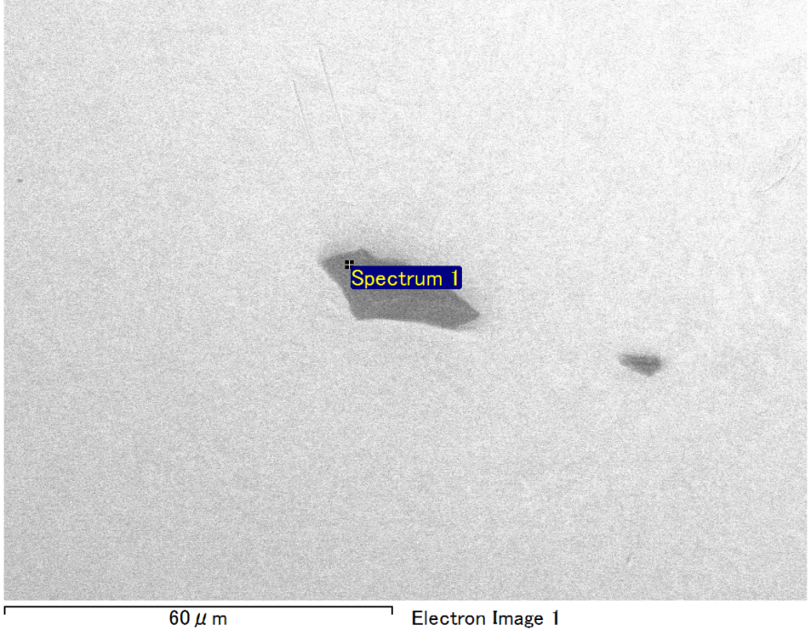

Spectrum Label: Spectrum 1

Livetime 90.0 s

Acquisition geometry ( degrees ):

Tilt = 0.0

Azimuth = 0.0

Elevation = 30.0

Accelerating voltage = 10.00 kV

Total spectrum counts = 69609

|  |  |  |  |
| --- | --- | --- | --- |
| Sample data : | Energy (eV) | Resn. (eV) | Area |
| Strobe : | 3.8 | 53.69 | 917483 |
|  |  |  |  |
| Optimization data : Manganese K series |  |  |  |
|  | Energy (eV) | Resn. (eV) | Area |
| Strobe : | .1 | 53.38 | 1150729 |
| Optimization element : | 5892.6 | 129.89 | 573533 |

Spectrum processing :

Peak possibly omitted : 0.710 keV

Processing option : Oxygen by stoichiometry (Normalised)

Number of iterations = 1

Standard :

Mg MgO 1-Jun-1999 12:00 AM

Si SiO2 1-Jun-1999 12:00 AM

Au Au 1-Jun-1999 12:00 AM

|  |  |  |  |  |  |
| --- | --- | --- | --- | --- | --- |
| Element | Weight% | Atomic% | Compd% | Formula |  |
|  |  |  |  |  |  |
| Mg K | 5.86 | 12.98 | 9.71 | MgO |  |
| Si K | 4.27 | 8.19 | 9.13 | SiO2 |  |
| Au M | 72.35 | 19.79 | 81.16 | Au2O3 |  |
| O | 17.53 | 59.04 |  |  |  |
| Totals | 100.00 |  |  |  |  |

Project: Project 1

Owner: Operator

Site: Site of Interest 5

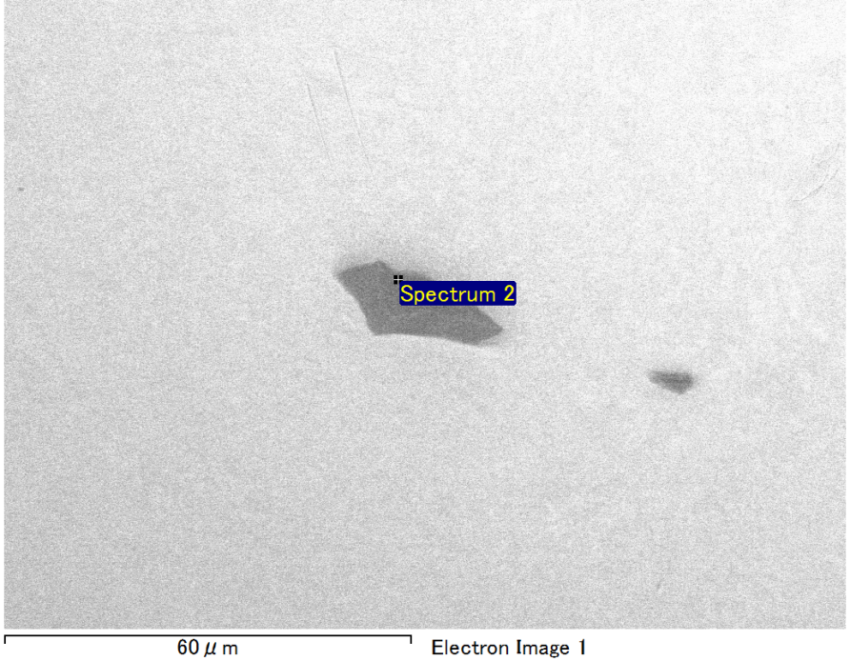

Spectrum Label: Spectrum 2

Livetime 90.0 s

Acquisition geometry ( degrees ):

Tilt = 0.0

Azimuth = 0.0

Elevation = 30.0

Accelerating voltage = 10.00 kV

Total spectrum counts = 69323

|  |  |  |  |
| --- | --- | --- | --- |
| Sample data : | Energy (eV) | Resn. (eV) | Area |
| Strobe : | 3.8 | 53.61 | 916300 |
|  |  |  |  |
| Optimization data : Manganese K series |  |  |  |
|  | Energy (eV) | Resn. (eV) | Area |
| Strobe : | .1 | 53.38 | 1150729 |
| Optimization element : | 5892.6 | 129.89 | 573533 |

Spectrum processing :

Peaks possibly omitted : 0.250, 0.935 keV

Processing option : Oxygen by stoichiometry (Normalised)

Number of iterations = 1

Standard :

Mg MgO 1-Jun-1999 12:00 AM

Si SiO2 1-Jun-1999 12:00 AM

Au Au 1-Jun-1999 12:00 AM

|  |  |  |  |  |  |
| --- | --- | --- | --- | --- | --- |
| Element | Weight% | Atomic% | Compd% | Formula |  |
|  |  |  |  |  |  |
| Mg K | 6.34 | 14.07 | 10.50 | MgO |  |
| Si K | 3.85 | 7.40 | 8.23 | SiO2 |  |
| Au M | 72.44 | 19.86 | 81.27 | Au2O3 |  |
| O | 17.38 | 58.67 |  |  |  |
| Totals | 100.00 |  |  |  |  |

Project: Project 1

Owner: Operator

Site: Site of Interest 5

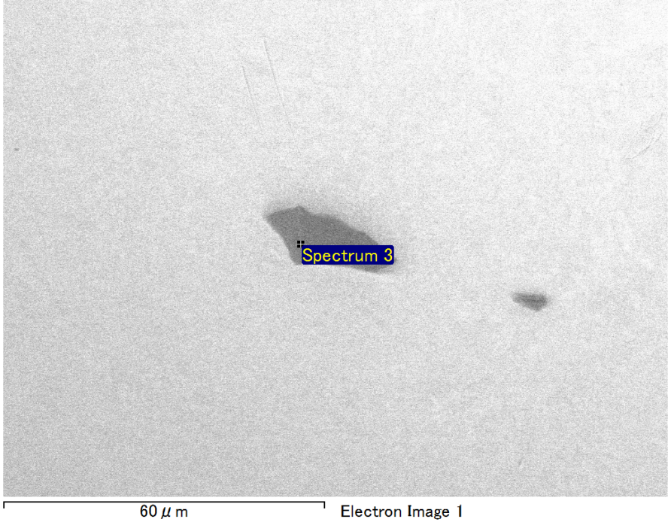

Spectrum Label: Spectrum 3

Livetime 90.0 s

Acquisition geometry ( degrees ):

Tilt = 0.0

Azimuth = 0.0

Elevation = 30.0

Accelerating voltage = 10.00 kV

Total spectrum counts = 69243

|  |  |  |  |
| --- | --- | --- | --- |
| Sample data : | Energy (eV) | Resn. (eV) | Area |
| Strobe : | 3.8 | 53.62 | 917106 |
|  |  |  |  |
| Optimization data : Manganese K series |  |  |  |
|  | Energy (eV) | Resn. (eV) | Area |
| Strobe : | .1 | 53.38 | 1150729 |
| Optimization element : | 5892.6 | 129.89 | 573533 |

Spectrum processing :

Peak possibly omitted : 0.710 keV

Processing option : Oxygen by stoichiometry (Normalised)

Number of iterations = 1

Standard :

C CaCO3 1-Jun-1999 12:00 AM

Mg MgO 1-Jun-1999 12:00 AM

Si SiO2 1-Jun-1999 12:00 AM

Au Au 1-Jun-1999 12:00 AM

|  |  |  |  |  |  |
| --- | --- | --- | --- | --- | --- |
| Element | Weight% | Atomic% | Compd% | Formula |  |
|  |  |  |  |  |  |
| C K | 3.35 | 11.78 | 12.28 | CO2 |  |
| Mg K | 4.30 | 7.47 | 7.13 | MgO |  |
| Si K | 3.21 | 4.83 | 6.87 | SiO2 |  |
| Au M | 65.71 | 14.09 | 73.72 | Au2O3 |  |
| O | 23.42 | 61.83 |  |  |  |
| Totals | 100.00 |  |  |  |  |

Project: Project 1

Owner: Operator

Site: Site of Interest 5

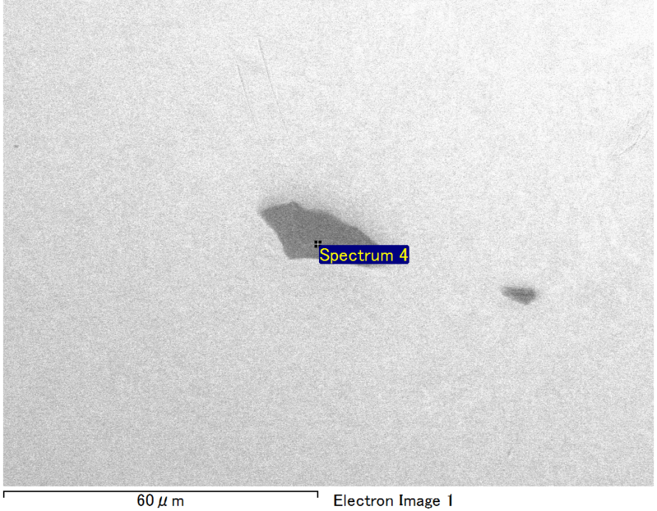

Spectrum Label: Spectrum 4

Livetime 90.0 s

Acquisition geometry ( degrees ):

Tilt = 0.0

Azimuth = 0.0

Elevation = 30.0

Accelerating voltage = 10.00 kV

Total spectrum counts = 69540

|  |  |  |  |
| --- | --- | --- | --- |
| Sample data : | Energy (eV) | Resn. (eV) | Area |
| Strobe : | 3.8 | 53.70 | 917656 |
|  |  |  |  |
| Optimization data : Manganese K series |  |  |  |
|  | Energy (eV) | Resn. (eV) | Area |
| Strobe : | .1 | 53.38 | 1150729 |
| Optimization element : | 5892.6 | 129.89 | 573533 |

Spectrum processing :

No peaks omitted

Processing option : Oxygen by stoichiometry (Normalised)

Number of iterations = 1

Standard :

Mg MgO 1-Jun-1999 12:00 AM

Si SiO2 1-Jun-1999 12:00 AM

Au Au 1-Jun-1999 12:00 AM

|  |  |  |  |  |  |
| --- | --- | --- | --- | --- | --- |
| Element | Weight% | Atomic% | Compd% | Formula |  |
|  |  |  |  |  |  |
| Mg K | 5.46 | 12.66 | 9.06 | MgO |  |
| Si K | 3.60 | 7.22 | 7.70 | SiO2 |  |
| Au M | 74.20 | 21.21 | 83.24 | Au2O3 |  |
| O | 16.74 | 58.91 |  |  |  |
| Totals | 100.00 |  |  |  |  |

Project: Project 1

Owner: Operator

Site: Site of Interest 5

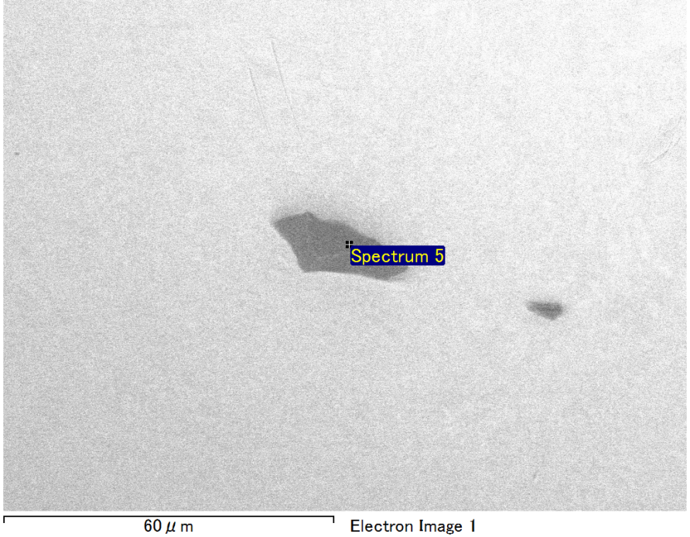

Spectrum Label: Spectrum 5

Livetime 90.0 s

Acquisition geometry ( degrees ):

Tilt = 0.0

Azimuth = 0.0

Elevation = 30.0

Accelerating voltage = 10.00 kV

Total spectrum counts = 69048

|  |  |  |  |
| --- | --- | --- | --- |
| Sample data : | Energy (eV) | Resn. (eV) | Area |
| Strobe : | 3.8 | 53.71 | 916380 |
|  |  |  |  |
| Optimization data : Manganese K series |  |  |  |
|  | Energy (eV) | Resn. (eV) | Area |
| Strobe : | .1 | 53.38 | 1150729 |
| Optimization element : | 5892.6 | 129.89 | 573533 |

Spectrum processing :

Peaks possibly omitted : 0.246, 0.719 keV

Processing option : Oxygen by stoichiometry (Normalised)

Number of iterations = 1

Standard :

Mg MgO 1-Jun-1999 12:00 AM

Si SiO2 1-Jun-1999 12:00 AM

Au Au 1-Jun-1999 12:00 AM

|  |  |  |  |  |  |
| --- | --- | --- | --- | --- | --- |
| Element | Weight% | Atomic% | Compd% | Formula |  |
|  |  |  |  |  |  |
| Mg K | 6.61 | 14.27 | 10.96 | MgO |  |
| Si K | 4.28 | 8.00 | 9.15 | SiO2 |  |
| Au M | 71.22 | 18.99 | 79.89 | Au2O3 |  |
| O | 17.90 | 58.75 |  |  |  |
| Totals | 100.00 |  |  |  |  |

Project: Project 1

Owner: Operator

Site: Site of Interest 5