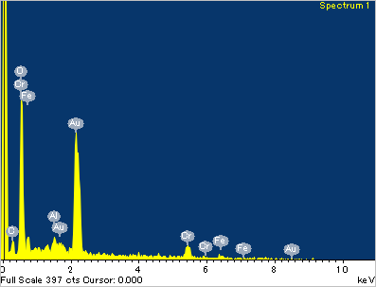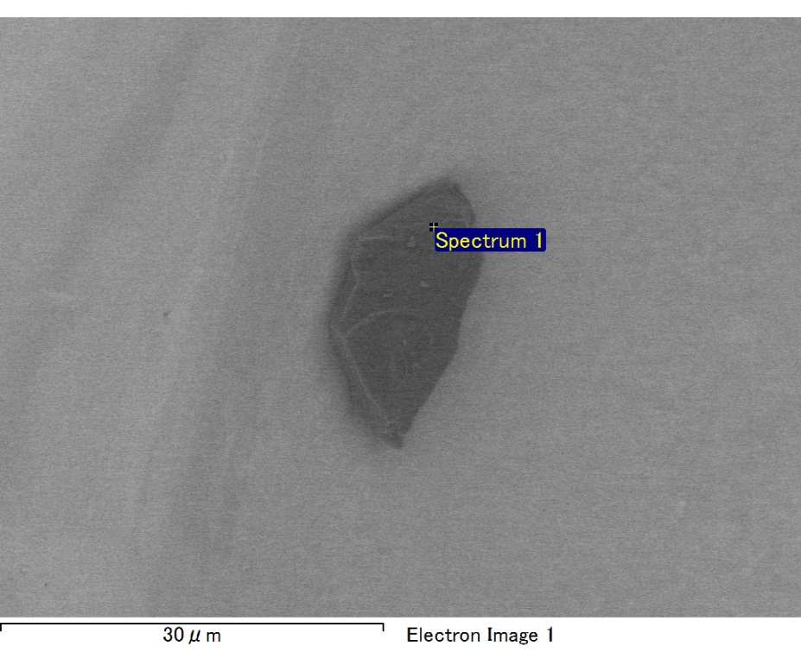

Spectrum processing :

No peaks omitted

Processing option : All elements analyzed (Normalised)

Number of iterations = 3

Standard :

C CaCO3 1-Jun-1999 12:00 AM

O SiO2 1-Jun-1999 12:00 AM

Al Al2O3 1-Jun-1999 12:00 AM

Cr Cr 1-Jun-1999 12:00 AM

Fe Fe 1-Jun-1999 12:00 AM

Au Au 1-Jun-1999 12:00 AM

|  |  |  |  |
| --- | --- | --- | --- |
| Element | Weight% | Atomic% |  |
|  |  |  |  |
| C K | 3.22 | 11.30 |  |
| O K | 19.54 | 51.52 |  |
| Al K | 0.80 | 1.26 |  |
| Cr L | 20.93 | 16.98 |  |
| Fe L | 13.03 | 9.84 |  |
| Au M | 42.48 | 9.10 |  |
|  |  |  |  |
| Totals | 100.00 |  |  |

Spectrum Label: Spectrum 1

Livetime 60.0 s

Acquisition geometry ( degrees ):

Tilt = 0.0

Azimuth = 0.0

Elevation = 30.0

Accelerating voltage = 10.00 kV

Total spectrum counts = 35630

|  |  |  |  |
| --- | --- | --- | --- |
| Sample data : | Energy (eV) | Resn. (eV) | Area |
| Strobe : | 3.8 | 47.25 | 999849 |
|  |  |  |  |

No quant optimization performed

Sample: Sample 1

Type: Default

ID:

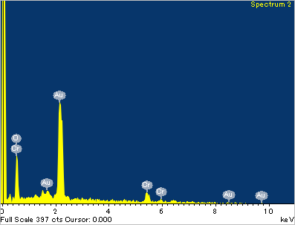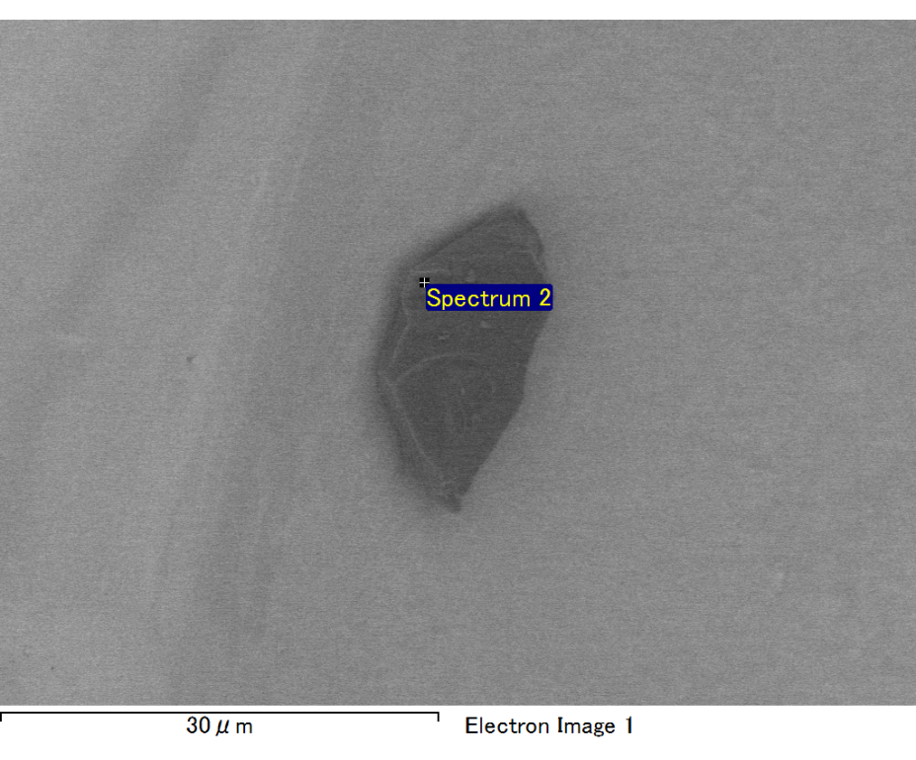

Spectrum processing :

Peak possibly omitted : 0.265 keV

Processing option : All elements analyzed (Normalised)

Number of iterations = 3

Standard :

O SiO2 1-Jun-1999 12:00 AM

Cr Cr 1-Jun-1999 12:00 AM

Au Au 1-Jun-1999 12:00 AM

|  |  |  |  |
| --- | --- | --- | --- |
| Element | Weight% | Atomic% |  |
|  |  |  |  |
| O K | 15.55 | 63.27 |  |
| Cr L | 9.58 | 11.99 |  |
| Au M | 74.87 | 24.74 |  |
|  |  |  |  |
| Totals | 100.00 |  |  |

Spectrum Label: Spectrum 2

Livetime 60.0 s

Acquisition geometry ( degrees ):

Tilt = 0.0

Azimuth = 0.0

Elevation = 30.0

Accelerating voltage = 10.00 kV

Total spectrum counts = 33988

|  |  |  |  |
| --- | --- | --- | --- |
| Sample data : | Energy (eV) | Resn. (eV) | Area |
| Strobe : | 3.8 | 47.24 | 1000132 |
|  |  |  |  |

No quant optimization performed

Sample: Sample 1

Type: Default

ID:

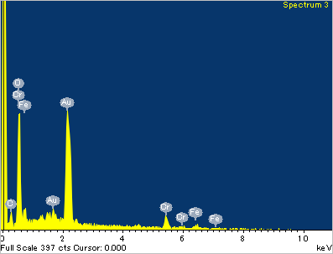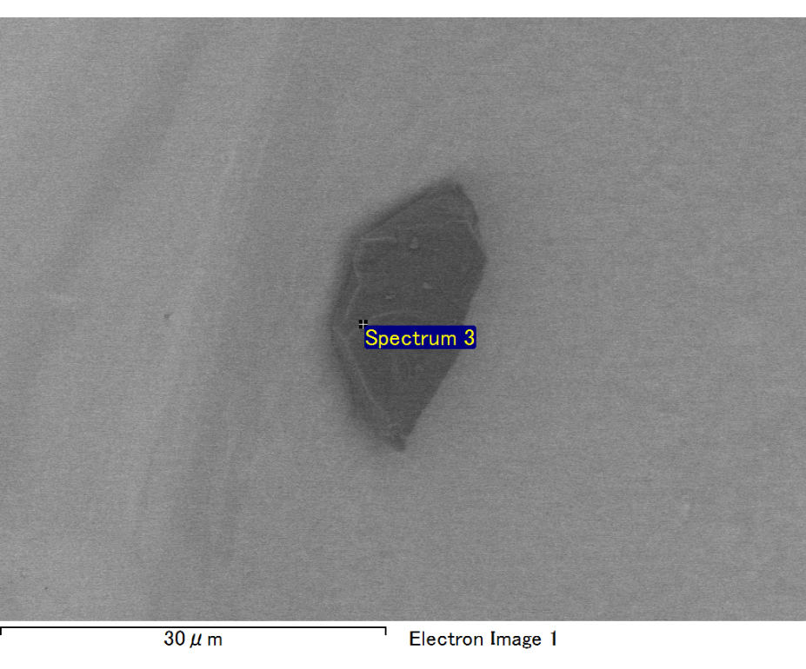

Spectrum processing :

No peaks omitted

Processing option : All elements analyzed (Normalised)

Number of iterations = 3

Standard :

C CaCO3 1-Jun-1999 12:00 AM

O SiO2 1-Jun-1999 12:00 AM

Cr Cr 1-Jun-1999 12:00 AM

Fe Fe 1-Jun-1999 12:00 AM

Au Au 1-Jun-1999 12:00 AM

|  |  |  |  |
| --- | --- | --- | --- |
| Element | Weight% | Atomic% |  |
|  |  |  |  |
| C K | 3.41 | 12.61 |  |
| O K | 18.89 | 52.40 |  |
| Cr L | 15.59 | 13.31 |  |
| Fe L | 13.50 | 10.73 |  |
| Au M | 48.60 | 10.95 |  |
|  |  |  |  |
| Totals | 100.00 |  |  |

Spectrum Label: Spectrum 3

Livetime 60.0 s

Acquisition geometry ( degrees ):

Tilt = 0.0

Azimuth = 0.0

Elevation = 30.0

Accelerating voltage = 10.00 kV

Total spectrum counts = 36356

|  |  |  |  |
| --- | --- | --- | --- |
| Sample data : | Energy (eV) | Resn. (eV) | Area |
| Strobe : | 3.8 | 47.17 | 1000504 |
|  |  |  |  |

No quant optimization performed

Sample: Sample 1

Type: Default

ID:

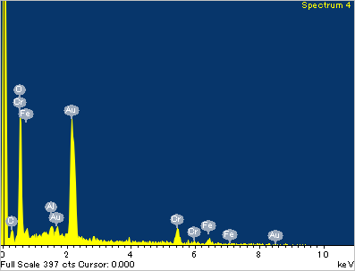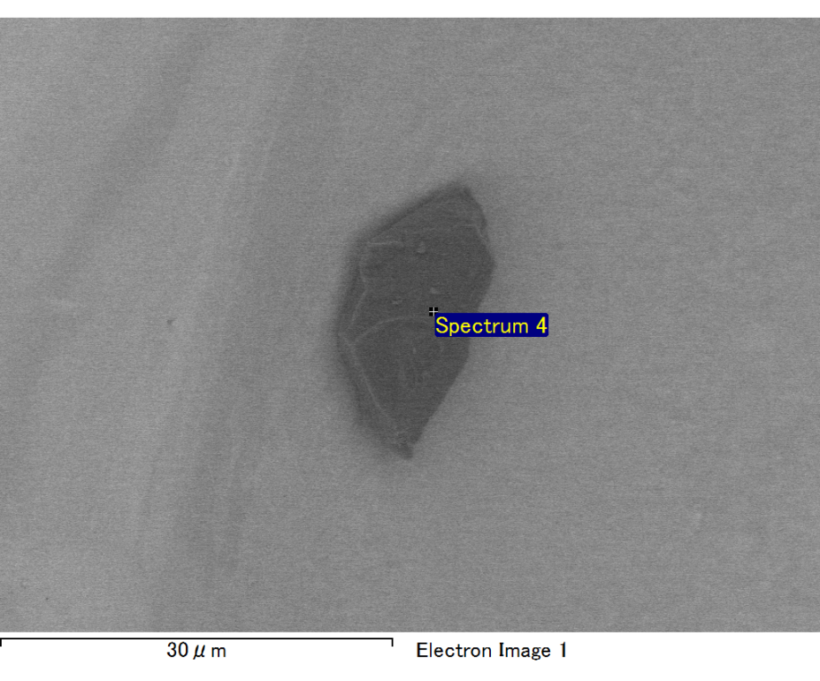

Spectrum processing :

No peaks omitted

Processing option : All elements analyzed (Normalised)

Number of iterations = 2

Standard :

C CaCO3 1-Jun-1999 12:00 AM

O SiO2 1-Jun-1999 12:00 AM

Al Al2O3 1-Jun-1999 12:00 AM

Cr Cr 1-Jun-1999 12:00 AM

Fe Fe 1-Jun-1999 12:00 AM

Au Au 1-Jun-1999 12:00 AM

|  |  |  |  |
| --- | --- | --- | --- |
| Element | Weight% | Atomic% |  |
|  |  |  |  |
| C K | 3.21 | 11.16 |  |
| O K | 24.24 | 63.22 |  |
| Al K | 1.04 | 1.61 |  |
| Cr L | 6.09 | 4.89 |  |
| Fe L | 9.83 | 7.34 |  |
| Au M | 55.58 | 11.78 |  |
|  |  |  |  |
| Totals | 100.00 |  |  |

Spectrum Label: Spectrum 4

Livetime 60.0 s

Acquisition geometry ( degrees ):

Tilt = 0.0

Azimuth = 0.0

Elevation = 30.0

Accelerating voltage = 10.00 kV

Total spectrum counts = 35336

|  |  |  |  |
| --- | --- | --- | --- |
| Sample data : | Energy (eV) | Resn. (eV) | Area |
| Strobe : | 3.8 | 47.22 | 1000009 |
|  |  |  |  |

No quant optimization performed

Sample: Sample 1

Type: Default

ID:

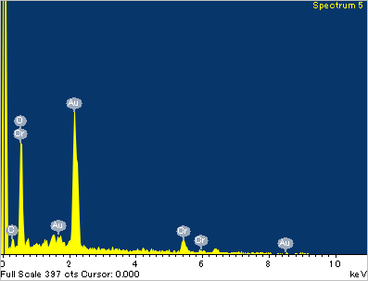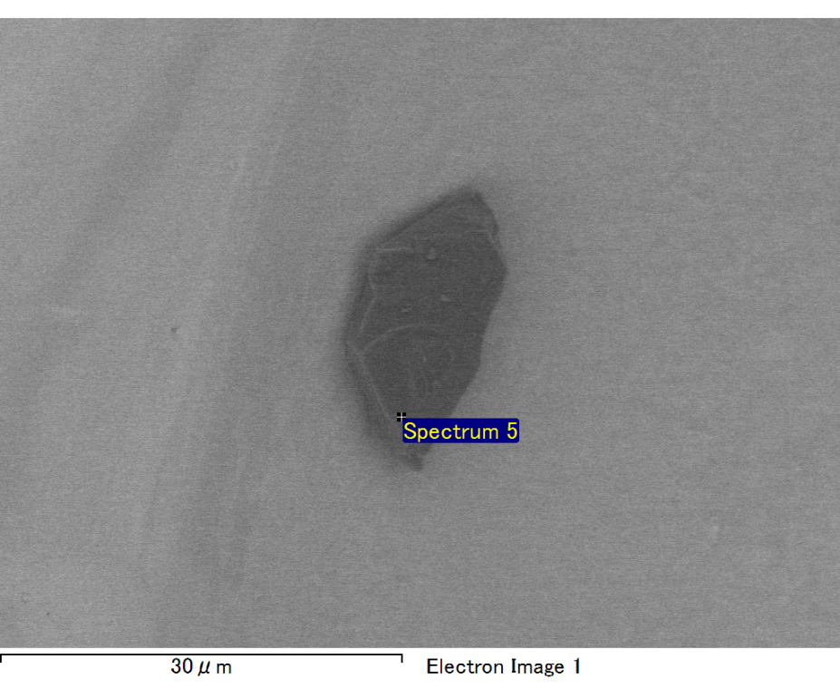

Spectrum processing :

No peaks omitted

Processing option : All elements analyzed (Normalised)

Number of iterations = 3

Standard :

C CaCO3 1-Jun-1999 12:00 AM

O SiO2 1-Jun-1999 12:00 AM

Cr Cr 1-Jun-1999 12:00 AM

Au Au 1-Jun-1999 12:00 AM

|  |  |  |  |
| --- | --- | --- | --- |
| Element | Weight% | Atomic% |  |
|  |  |  |  |
| C K | 3.20 | 12.31 |  |
| O K | 19.78 | 57.08 |  |
| Cr L | 19.22 | 17.06 |  |
| Au M | 57.80 | 13.55 |  |
|  |  |  |  |
| Totals | 100.00 |  |  |

Spectrum Label: Spectrum 5

Livetime 60.0 s

Acquisition geometry ( degrees ):

Tilt = 0.0

Azimuth = 0.0

Elevation = 30.0

Accelerating voltage = 10.00 kV

Total spectrum counts = 35398

|  |  |  |  |
| --- | --- | --- | --- |
| Sample data : | Energy (eV) | Resn. (eV) | Area |
| Strobe : | 3.8 | 47.19 | 1000599 |
|  |  |  |  |

No quant optimization performed

Sample: Sample 1

Type: Default

ID: