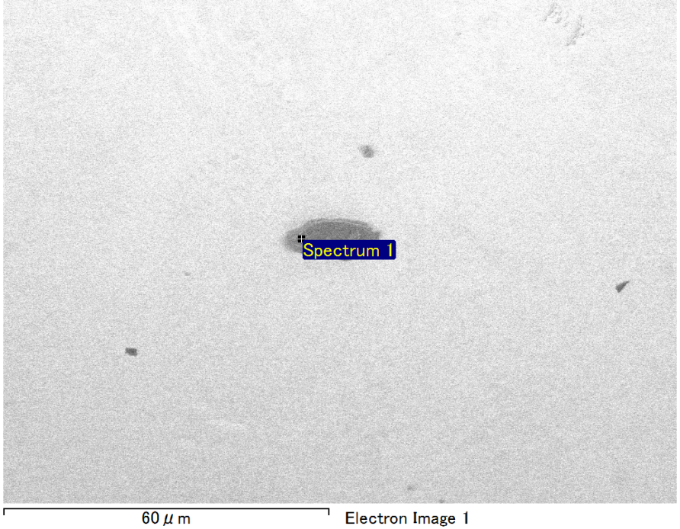

Spectrum Label: Spectrum 1

Livetime 90.0 s

Acquisition geometry ( degrees ):

Tilt = 0.0

Azimuth = 0.0

Elevation = 30.0

Accelerating voltage = 10.00 kV

Total spectrum counts = 69837

|  |  |  |  |
| --- | --- | --- | --- |
| Sample data : | Energy (eV) | Resn. (eV) | Area |
| Strobe : | 3.8 | 53.61 | 918902 |
|  |  |  |  |
| Optimization data : Manganese K series |  |  |  |
|  | Energy (eV) | Resn. (eV) | Area |
| Strobe : | .1 | 53.38 | 1150729 |
| Optimization element : | 5892.6 | 129.89 | 573533 |

Spectrum processing :

Peak possibly omitted : 0.251 keV

Processing option : Oxygen by stoichiometry (Normalised)

Number of iterations = 1

Standard :

Mg MgO 1-Jun-1999 12:00 AM

Si SiO2 1-Jun-1999 12:00 AM

Fe Fe 1-Jun-1999 12:00 AM

Au Au 1-Jun-1999 12:00 AM

|  |  |  |  |  |  |
| --- | --- | --- | --- | --- | --- |
| Element | Weight% | Atomic% | Compd% | Formula |  |
|  |  |  |  |  |  |
| Mg K | 5.27 | 10.66 | 8.74 | MgO |  |
| Si K | 3.49 | 6.12 | 7.48 | SiO2 |  |
| Fe L | 13.10 | 11.54 | 16.85 | FeO |  |
| Au M | 59.66 | 14.90 | 66.93 | Au2O3 |  |
| O | 18.47 | 56.78 |  |  |  |
| Totals | 100.00 |  |  |  |  |

Project: Project 1

Owner: Operator

Site: Site of Interest 17

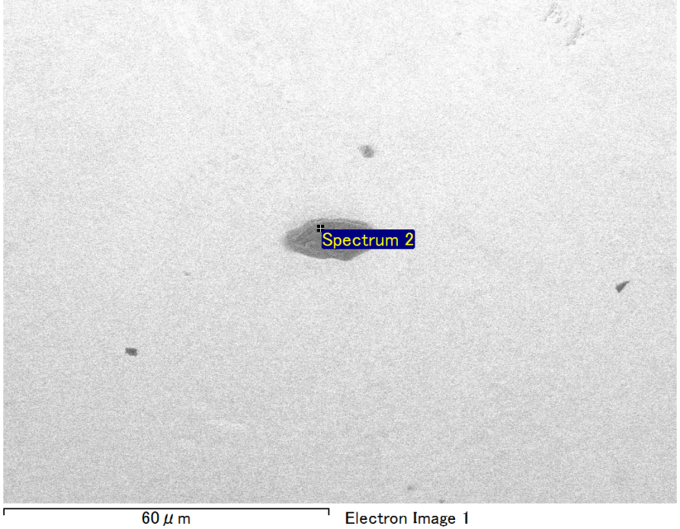

Spectrum Label: Spectrum 2

Livetime 90.0 s

Acquisition geometry ( degrees ):

Tilt = 0.0

Azimuth = 0.0

Elevation = 30.0

Accelerating voltage = 10.00 kV

Total spectrum counts = 68999

|  |  |  |  |
| --- | --- | --- | --- |
| Sample data : | Energy (eV) | Resn. (eV) | Area |
| Strobe : | 3.8 | 53.63 | 918529 |
|  |  |  |  |
| Optimization data : Manganese K series |  |  |  |
|  | Energy (eV) | Resn. (eV) | Area |
| Strobe : | .1 | 53.38 | 1150729 |
| Optimization element : | 5892.6 | 129.89 | 573533 |

Spectrum processing :

Peak possibly omitted : 0.711 keV

Processing option : Oxygen by stoichiometry (Normalised)

Number of iterations = 1

Standard :

Mg MgO 1-Jun-1999 12:00 AM

Si SiO2 1-Jun-1999 12:00 AM

Au Au 1-Jun-1999 12:00 AM

|  |  |  |  |  |  |
| --- | --- | --- | --- | --- | --- |
| Element | Weight% | Atomic% | Compd% | Formula |  |
|  |  |  |  |  |  |
| Mg K | 6.07 | 13.29 | 10.06 | MgO |  |
| Si K | 4.37 | 8.29 | 9.36 | SiO2 |  |
| Au M | 71.83 | 19.42 | 80.58 | Au2O3 |  |
| O | 17.73 | 59.00 |  |  |  |
| Totals | 100.00 |  |  |  |  |

Project: Project 1

Owner: Operator

Site: Site of Interest 17

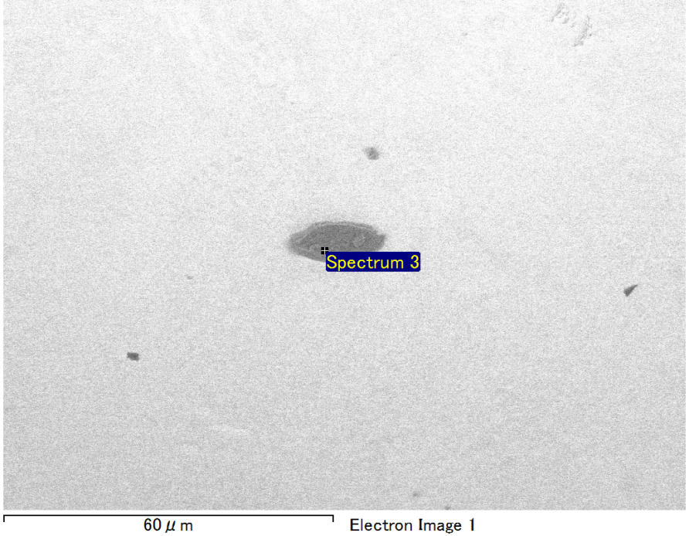

Spectrum Label: Spectrum 3

Livetime 90.0 s

Acquisition geometry ( degrees ):

Tilt = 0.0

Azimuth = 0.0

Elevation = 30.0

Accelerating voltage = 10.00 kV

Total spectrum counts = 68739

|  |  |  |  |
| --- | --- | --- | --- |
| Sample data : | Energy (eV) | Resn. (eV) | Area |
| Strobe : | 3.8 | 53.61 | 918212 |
|  |  |  |  |
| Optimization data : Manganese K series |  |  |  |
|  | Energy (eV) | Resn. (eV) | Area |
| Strobe : | .1 | 53.38 | 1150729 |
| Optimization element : | 5892.6 | 129.89 | 573533 |

Spectrum processing :

No peaks omitted

Processing option : Oxygen by stoichiometry (Normalised)

Number of iterations = 1

Standard :

Mg MgO 1-Jun-1999 12:00 AM

Si SiO2 1-Jun-1999 12:00 AM

Au Au 1-Jun-1999 12:00 AM

|  |  |  |  |  |  |
| --- | --- | --- | --- | --- | --- |
| Element | Weight% | Atomic% | Compd% | Formula |  |
|  |  |  |  |  |  |
| Mg K | 6.45 | 14.10 | 10.70 | MgO |  |
| Si K | 4.13 | 7.81 | 8.83 | SiO2 |  |
| Au M | 71.73 | 19.35 | 80.47 | Au2O3 |  |
| O | 17.69 | 58.74 |  |  |  |
| Totals | 100.00 |  |  |  |  |

Project: Project 1

Owner: Operator

Site: Site of Interest 17

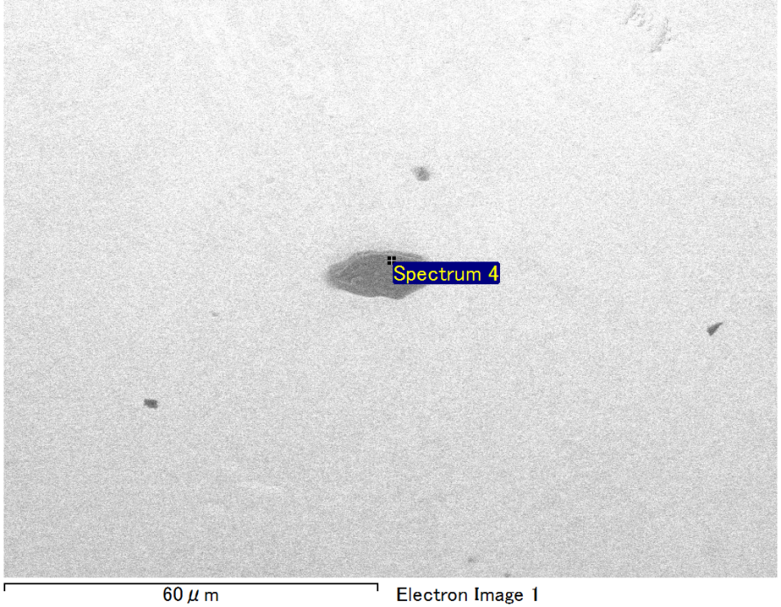

Spectrum Label: Spectrum 4

Livetime 90.0 s

Acquisition geometry ( degrees ):

Tilt = 0.0

Azimuth = 0.0

Elevation = 30.0

Accelerating voltage = 10.00 kV

Total spectrum counts = 68801

|  |  |  |  |
| --- | --- | --- | --- |
| Sample data : | Energy (eV) | Resn. (eV) | Area |
| Strobe : | 3.8 | 53.61 | 917413 |
|  |  |  |  |
| Optimization data : Manganese K series |  |  |  |
|  | Energy (eV) | Resn. (eV) | Area |
| Strobe : | .1 | 53.38 | 1150729 |
| Optimization element : | 5892.6 | 129.89 | 573533 |

Spectrum processing :

Peak possibly omitted : 0.715 keV

Processing option : Oxygen by stoichiometry (Normalised)

Number of iterations = 1

Standard :

Mg MgO 1-Jun-1999 12:00 AM

Si SiO2 1-Jun-1999 12:00 AM

Au Au 1-Jun-1999 12:00 AM

|  |  |  |  |  |  |
| --- | --- | --- | --- | --- | --- |
| Element | Weight% | Atomic% | Compd% | Formula |  |
|  |  |  |  |  |  |
| Mg K | 5.37 | 12.18 | 8.90 | MgO |  |
| Si K | 4.11 | 8.08 | 8.80 | SiO2 |  |
| Au M | 73.36 | 20.55 | 82.30 | Au2O3 |  |
| O | 17.16 | 59.18 |  |  |  |
| Totals | 100.00 |  |  |  |  |

Project: Project 1

Owner: Operator

Site: Site of Interest 17

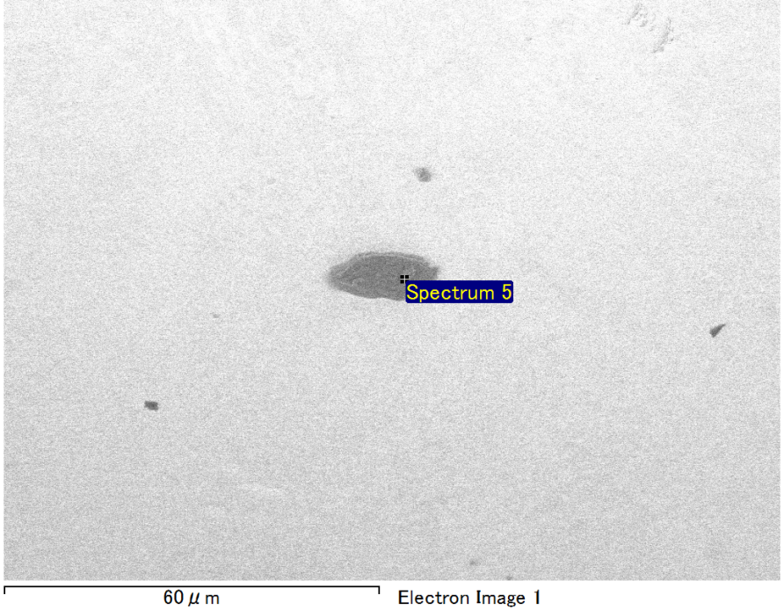

Spectrum Label: Spectrum 5

Livetime 90.0 s

Acquisition geometry ( degrees ):

Tilt = 0.0

Azimuth = 0.0

Elevation = 30.0

Accelerating voltage = 10.00 kV

Total spectrum counts = 68339

|  |  |  |  |
| --- | --- | --- | --- |
| Sample data : | Energy (eV) | Resn. (eV) | Area |
| Strobe : | 3.8 | 53.61 | 917253 |
|  |  |  |  |
| Optimization data : Manganese K series |  |  |  |
|  | Energy (eV) | Resn. (eV) | Area |
| Strobe : | .1 | 53.38 | 1150729 |
| Optimization element : | 5892.6 | 129.89 | 573533 |

Spectrum processing :

No peaks omitted

Processing option : Oxygen by stoichiometry (Normalised)

Number of iterations = 1

Standard :

Mg MgO 1-Jun-1999 12:00 AM

Si SiO2 1-Jun-1999 12:00 AM

Au Au 1-Jun-1999 12:00 AM

|  |  |  |  |  |  |
| --- | --- | --- | --- | --- | --- |
| Element | Weight% | Atomic% | Compd% | Formula |  |
|  |  |  |  |  |  |
| Mg K | 3.02 | 8.17 | 5.00 | MgO |  |
| Si K | 2.37 | 5.56 | 5.07 | SiO2 |  |
| Au M | 80.16 | 26.80 | 89.93 | Au2O3 |  |
| O | 14.45 | 59.48 |  |  |  |
| Totals | 100.00 |  |  |  |  |

Project: Project 1

Owner: Operator

Site: Site of Interest 17