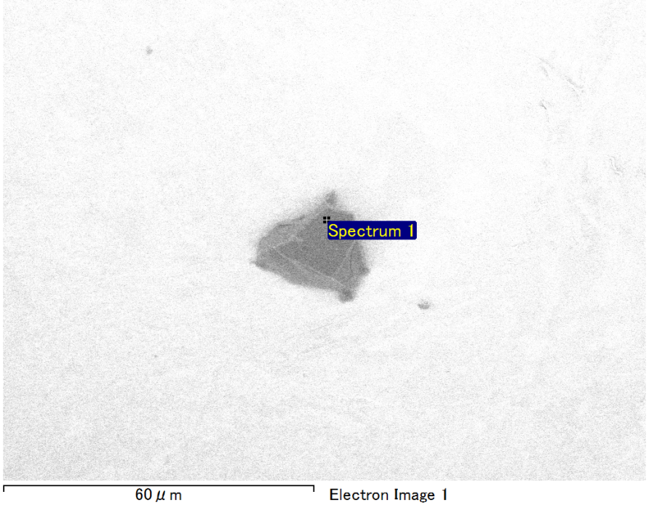

Spectrum Label: Spectrum 1

Livetime 90.0 s

Acquisition geometry ( degrees ):

Tilt = 0.0

Azimuth = 0.0

Elevation = 30.0

Accelerating voltage = 10.00 kV

Total spectrum counts = 68947

|  |  |  |  |
| --- | --- | --- | --- |
| Sample data : | Energy (eV) | Resn. (eV) | Area |
| Strobe : | 3.8 | 53.57 | 917664 |
|  |  |  |  |
| Optimization data : Manganese K series |  |  |  |
|  | Energy (eV) | Resn. (eV) | Area |
| Strobe : | .1 | 53.38 | 1150729 |
| Optimization element : | 5892.6 | 129.89 | 573533 |

Spectrum processing :

No peaks omitted

Processing option : Oxygen by stoichiometry (Normalised)

Number of iterations = 1

Standard :

Mg MgO 1-Jun-1999 12:00 AM

Si SiO2 1-Jun-1999 12:00 AM

Fe Fe 1-Jun-1999 12:00 AM

Au Au 1-Jun-1999 12:00 AM

|  |  |  |  |  |  |
| --- | --- | --- | --- | --- | --- |
| Element | Weight% | Atomic% | Compd% | Formula |  |
|  |  |  |  |  |  |
| Mg K | 5.14 | 10.31 | 8.52 | MgO |  |
| Si K | 3.49 | 6.05 | 7.46 | SiO2 |  |
| Fe L | 14.38 | 12.55 | 18.49 | FeO |  |
| Au M | 58.41 | 14.46 | 65.52 | Au2O3 |  |
| O | 18.59 | 56.64 |  |  |  |
| Totals | 100.00 |  |  |  |  |

Project: Project 1

Owner: Operator

Site: Site of Interest 25

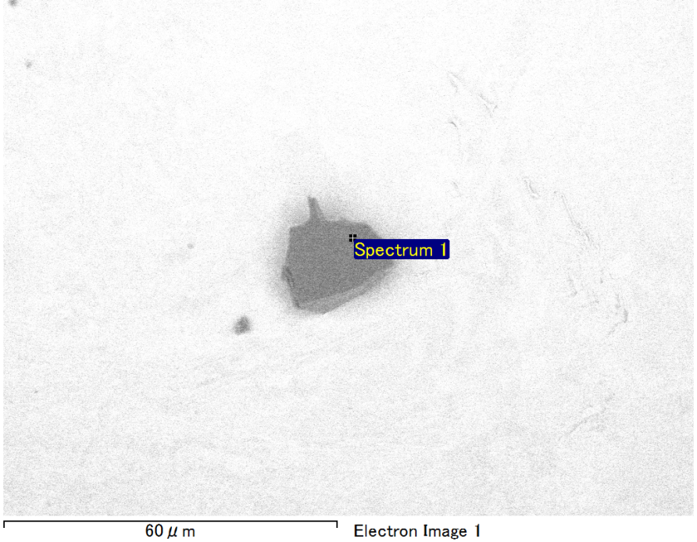

Spectrum Label: Spectrum 1

Livetime 90.0 s

Acquisition geometry ( degrees ):

Tilt = 0.0

Azimuth = 0.0

Elevation = 30.0

Accelerating voltage = 10.00 kV

Total spectrum counts = 66898

|  |  |  |  |
| --- | --- | --- | --- |
| Sample data : | Energy (eV) | Resn. (eV) | Area |
| Strobe : | 3.8 | 53.67 | 920234 |
|  |  |  |  |
| Optimization data : Manganese K series |  |  |  |
|  | Energy (eV) | Resn. (eV) | Area |
| Strobe : | .1 | 53.38 | 1150729 |
| Optimization element : | 5892.6 | 129.89 | 573533 |

Spectrum processing :

No peaks omitted

Processing option : Oxygen by stoichiometry (Normalised)

Number of iterations = 1

Standard :

C CaCO3 1-Jun-1999 12:00 AM

Mg MgO 1-Jun-1999 12:00 AM

Si SiO2 1-Jun-1999 12:00 AM

Au Au 1-Jun-1999 12:00 AM

|  |  |  |  |  |  |
| --- | --- | --- | --- | --- | --- |
| Element | Weight% | Atomic% | Compd% | Formula |  |
|  |  |  |  |  |  |
| C K | 3.61 | 13.97 | 13.24 | CO2 |  |
| Mg K | 2.17 | 4.15 | 3.61 | MgO |  |
| Si K | 1.58 | 2.62 | 3.39 | SiO2 |  |
| Au M | 71.10 | 16.77 | 79.77 | Au2O3 |  |
| O | 21.52 | 62.49 |  |  |  |
| Totals | 100.00 |  |  |  |  |

Project: Project 1

Owner: Operator

Site: Site of Interest 26

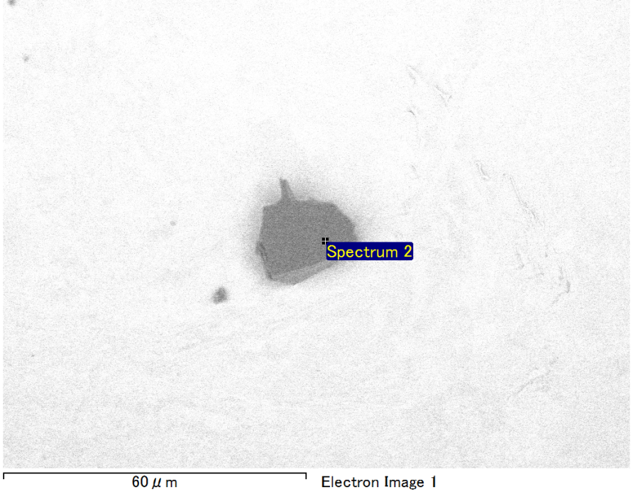

Spectrum Label: Spectrum 2

Livetime 90.0 s

Acquisition geometry ( degrees ):

Tilt = 0.0

Azimuth = 0.0

Elevation = 30.0

Accelerating voltage = 10.00 kV

Total spectrum counts = 68673

|  |  |  |  |
| --- | --- | --- | --- |
| Sample data : | Energy (eV) | Resn. (eV) | Area |
| Strobe : | 3.8 | 53.66 | 918591 |
|  |  |  |  |
| Optimization data : Manganese K series |  |  |  |
|  | Energy (eV) | Resn. (eV) | Area |
| Strobe : | .1 | 53.38 | 1150729 |
| Optimization element : | 5892.6 | 129.89 | 573533 |

Spectrum processing :

Peak possibly omitted : 0.715 keV

Processing option : Oxygen by stoichiometry (Normalised)

Number of iterations = 1

Standard :

C CaCO3 1-Jun-1999 12:00 AM

Mg MgO 1-Jun-1999 12:00 AM

Si SiO2 1-Jun-1999 12:00 AM

Au Au 1-Jun-1999 12:00 AM

|  |  |  |  |  |  |
| --- | --- | --- | --- | --- | --- |
| Element | Weight% | Atomic% | Compd% | Formula |  |
|  |  |  |  |  |  |
| C K | 3.72 | 12.21 | 13.63 | CO2 |  |
| Mg K | 4.88 | 7.92 | 8.09 | MgO |  |
| Si K | 3.87 | 5.43 | 8.28 | SiO2 |  |
| Au M | 62.40 | 12.49 | 70.00 | Au2O3 |  |
| O | 25.13 | 61.95 |  |  |  |
| Totals | 100.00 |  |  |  |  |

Project: Project 1

Owner: Operator

Site: Site of Interest 26

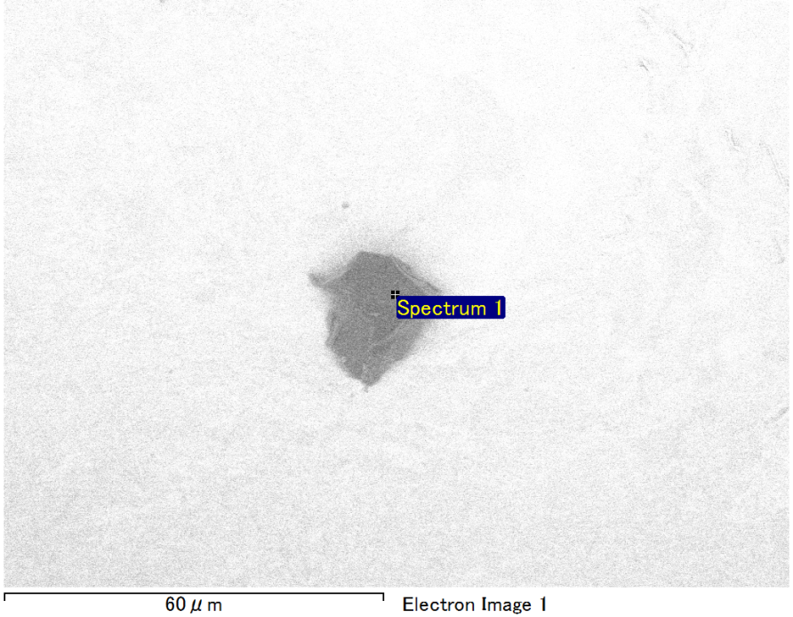

Spectrum Label: Spectrum 1

Livetime 90.0 s

Acquisition geometry ( degrees ):

Tilt = 0.0

Azimuth = 0.0

Elevation = 30.0

Accelerating voltage = 10.00 kV

Total spectrum counts = 69306

|  |  |  |  |
| --- | --- | --- | --- |
| Sample data : | Energy (eV) | Resn. (eV) | Area |
| Strobe : | 3.8 | 53.57 | 918421 |
|  |  |  |  |
| Optimization data : Manganese K series |  |  |  |
|  | Energy (eV) | Resn. (eV) | Area |
| Strobe : | .1 | 53.38 | 1150729 |
| Optimization element : | 5892.6 | 129.89 | 573533 |

Spectrum processing :

No peaks omitted

Processing option : Oxygen by stoichiometry (Normalised)

Number of iterations = 1

Standard :

Mg MgO 1-Jun-1999 12:00 AM

Si SiO2 1-Jun-1999 12:00 AM

Fe Fe 1-Jun-1999 12:00 AM

Au Au 1-Jun-1999 12:00 AM

|  |  |  |  |  |  |
| --- | --- | --- | --- | --- | --- |
| Element | Weight% | Atomic% | Compd% | Formula |  |
|  |  |  |  |  |  |
| Mg K | 5.11 | 10.13 | 8.47 | MgO |  |
| Si K | 3.40 | 5.83 | 7.27 | SiO2 |  |
| Fe L | 15.88 | 13.71 | 20.43 | FeO |  |
| Au M | 56.90 | 13.93 | 63.84 | Au2O3 |  |
| O | 18.71 | 56.40 |  |  |  |
| Totals | 100.00 |  |  |  |  |

Project: Project 1

Owner: Operator

Site: Site of Interest 27

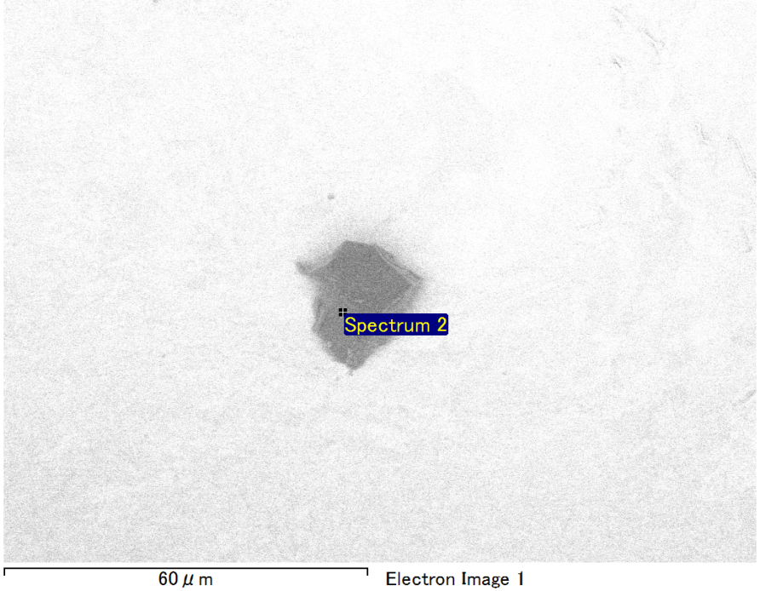

Spectrum Label: Spectrum 2

Livetime 90.0 s

Acquisition geometry ( degrees ):

Tilt = 0.0

Azimuth = 0.0

Elevation = 30.0

Accelerating voltage = 10.00 kV

Total spectrum counts = 68843

|  |  |  |  |
| --- | --- | --- | --- |
| Sample data : | Energy (eV) | Resn. (eV) | Area |
| Strobe : | 3.8 | 53.63 | 917196 |
|  |  |  |  |
| Optimization data : Manganese K series |  |  |  |
|  | Energy (eV) | Resn. (eV) | Area |
| Strobe : | .1 | 53.38 | 1150729 |
| Optimization element : | 5892.6 | 129.89 | 573533 |

Spectrum processing :

No peaks omitted

Processing option : Oxygen by stoichiometry (Normalised)

Number of iterations = 1

Standard :

Mg MgO 1-Jun-1999 12:00 AM

Si SiO2 1-Jun-1999 12:00 AM

Au Au 1-Jun-1999 12:00 AM

|  |  |  |  |  |  |
| --- | --- | --- | --- | --- | --- |
| Element | Weight% | Atomic% | Compd% | Formula |  |
|  |  |  |  |  |  |
| Mg K | 5.67 | 13.11 | 9.40 | MgO |  |
| Si K | 3.48 | 6.97 | 7.46 | SiO2 |  |
| Au M | 74.11 | 21.15 | 83.14 | Au2O3 |  |
| O | 16.73 | 58.77 |  |  |  |
| Totals | 100.00 |  |  |  |  |

Project: Project 1

Owner: Operator

Site: Site of Interest 27