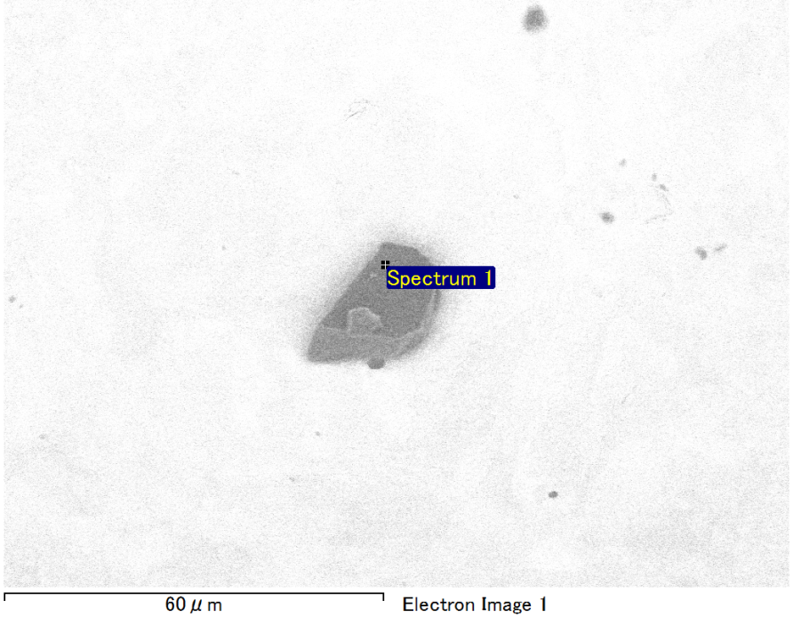

Spectrum Label: Spectrum 1

Livetime 90.0 s

Acquisition geometry ( degrees ):

Tilt = 0.0

Azimuth = 0.0

Elevation = 30.0

Accelerating voltage = 10.00 kV

Total spectrum counts = 68831

|  |  |  |  |
| --- | --- | --- | --- |
| Sample data : | Energy (eV) | Resn. (eV) | Area |
| Strobe : | 3.8 | 53.64 | 919127 |
|  |  |  |  |
| Optimization data : Manganese K series |  |  |  |
|  | Energy (eV) | Resn. (eV) | Area |
| Strobe : | .1 | 53.38 | 1150729 |
| Optimization element : | 5892.6 | 129.89 | 573533 |

Spectrum processing :

No peaks omitted

Processing option : Oxygen by stoichiometry (Normalised)

Number of iterations = 1

Standard :

Mg MgO 1-Jun-1999 12:00 AM

Si SiO2 1-Jun-1999 12:00 AM

Au Au 1-Jun-1999 12:00 AM

|  |  |  |  |  |  |
| --- | --- | --- | --- | --- | --- |
| Element | Weight% | Atomic% | Compd% | Formula |  |
|  |  |  |  |  |  |
| Mg K | 5.65 | 13.08 | 9.36 | MgO |  |
| Si K | 3.46 | 6.93 | 7.39 | SiO2 |  |
| Au M | 74.20 | 21.22 | 83.24 | Au2O3 |  |
| O | 16.70 | 58.77 |  |  |  |
| Totals | 100.00 |  |  |  |  |

Project: Project 1

Owner: Operator

Site: Site of Interest 28

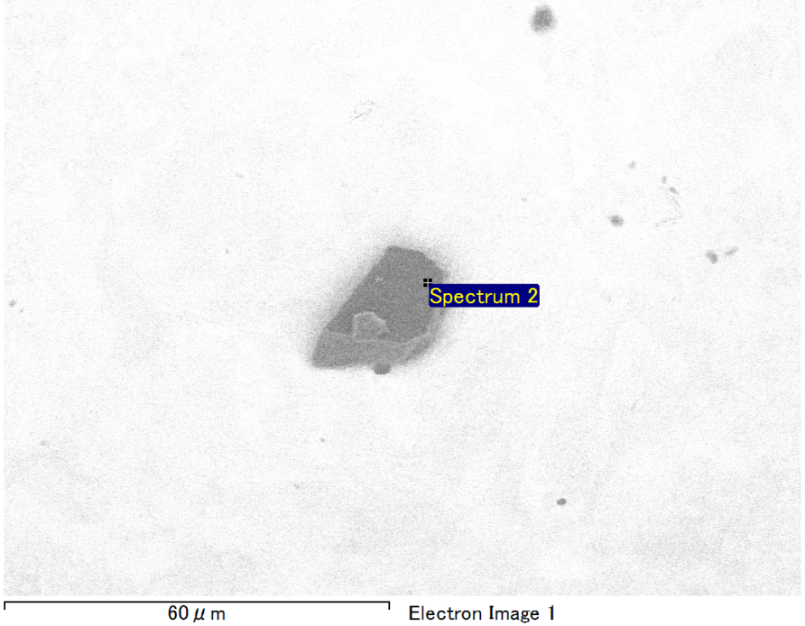

Spectrum Label: Spectrum 2

Livetime 90.0 s

Acquisition geometry ( degrees ):

Tilt = 0.0

Azimuth = 0.0

Elevation = 30.0

Accelerating voltage = 10.00 kV

Total spectrum counts = 68915

|  |  |  |  |
| --- | --- | --- | --- |
| Sample data : | Energy (eV) | Resn. (eV) | Area |
| Strobe : | 3.8 | 53.64 | 917915 |
|  |  |  |  |
| Optimization data : Manganese K series |  |  |  |
|  | Energy (eV) | Resn. (eV) | Area |
| Strobe : | .1 | 53.38 | 1150729 |
| Optimization element : | 5892.6 | 129.89 | 573533 |

Spectrum processing :

No peaks omitted

Processing option : Oxygen by stoichiometry (Normalised)

Number of iterations = 1

Standard :

Mg MgO 1-Jun-1999 12:00 AM

Si SiO2 1-Jun-1999 12:00 AM

Ag Ag 1-Jun-1999 12:00 AM

Au Au 1-Jun-1999 12:00 AM

|  |  |  |  |  |  |
| --- | --- | --- | --- | --- | --- |
| Element | Weight% | Atomic% | Compd% | Formula |  |
|  |  |  |  |  |  |
| Mg K | 4.85 | 11.38 | 8.04 | MgO |  |
| Si K | 3.72 | 7.55 | 7.95 | SiO2 |  |
| Ag L | 3.51 | 1.86 | 3.77 | Ag2O |  |
| Au M | 71.52 | 20.72 | 80.23 | Au2O3 |  |
| O | 16.40 | 58.49 |  |  |  |
| Totals | 100.00 |  |  |  |  |

Project: Project 1

Owner: Operator

Site: Site of Interest 28

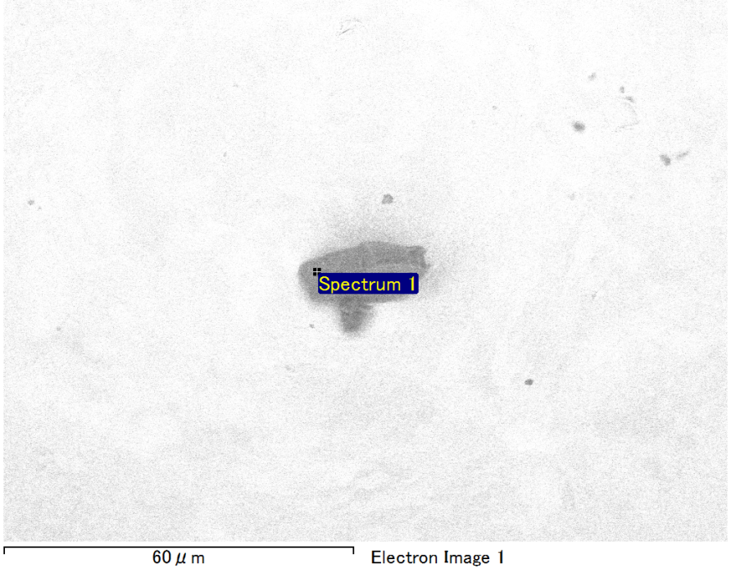

Spectrum Label: Spectrum 1

Livetime 90.0 s

Acquisition geometry ( degrees ):

Tilt = 0.0

Azimuth = 0.0

Elevation = 30.0

Accelerating voltage = 10.00 kV

Total spectrum counts = 69273

|  |  |  |  |
| --- | --- | --- | --- |
| Sample data : | Energy (eV) | Resn. (eV) | Area |
| Strobe : | 3.8 | 53.69 | 918830 |
|  |  |  |  |
| Optimization data : Manganese K series |  |  |  |
|  | Energy (eV) | Resn. (eV) | Area |
| Strobe : | .1 | 53.38 | 1150729 |
| Optimization element : | 5892.6 | 129.89 | 573533 |

Spectrum processing :

Peak possibly omitted : 0.705 keV

Processing option : Oxygen by stoichiometry (Normalised)

Number of iterations = 1

Standard :

Mg MgO 1-Jun-1999 12:00 AM

Si SiO2 1-Jun-1999 12:00 AM

Au Au 1-Jun-1999 12:00 AM

|  |  |  |  |  |  |
| --- | --- | --- | --- | --- | --- |
| Element | Weight% | Atomic% | Compd% | Formula |  |
|  |  |  |  |  |  |
| Mg K | 6.31 | 13.89 | 10.47 | MgO |  |
| Si K | 4.08 | 7.77 | 8.73 | SiO2 |  |
| Au M | 72.03 | 19.56 | 80.81 | Au2O3 |  |
| O | 17.58 | 58.78 |  |  |  |
| Totals | 100.00 |  |  |  |  |

Project: Project 1

Owner: Operator

Site: Site of Interest 29

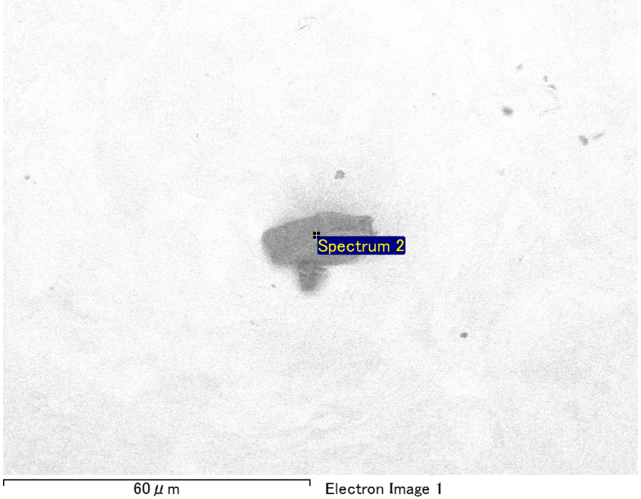

Spectrum Label: Spectrum 2

Livetime 90.0 s

Acquisition geometry ( degrees ):

Tilt = 0.0

Azimuth = 0.0

Elevation = 30.0

Accelerating voltage = 10.00 kV

Total spectrum counts = 69200

|  |  |  |  |
| --- | --- | --- | --- |
| Sample data : | Energy (eV) | Resn. (eV) | Area |
| Strobe : | 3.8 | 53.55 | 917215 |
|  |  |  |  |
| Optimization data : Manganese K series |  |  |  |
|  | Energy (eV) | Resn. (eV) | Area |
| Strobe : | .1 | 53.38 | 1150729 |
| Optimization element : | 5892.6 | 129.89 | 573533 |

Spectrum processing :

No peaks omitted

Processing option : Oxygen by stoichiometry (Normalised)

Number of iterations = 1

Standard :

C CaCO3 1-Jun-1999 12:00 AM

Na Albite 1-Jun-1999 12:00 AM

Mg MgO 1-Jun-1999 12:00 AM

Al Al2O3 1-Jun-1999 12:00 AM

Si SiO2 1-Jun-1999 12:00 AM

Au Au 1-Jun-1999 12:00 AM

|  |  |  |  |  |  |
| --- | --- | --- | --- | --- | --- |
| Element | Weight% | Atomic% | Compd% | Formula |  |
|  |  |  |  |  |  |
| C K | 3.90 | 12.94 | 14.31 | CO2 |  |
| Na K | 0.97 | 1.68 | 1.31 | Na2O |  |
| Mg K | 1.40 | 2.29 | 2.32 | MgO |  |
| Al K | 1.08 | 1.60 | 2.05 | Al2O3 |  |
| Si K | 4.28 | 6.06 | 9.15 | SiO2 |  |
| Au M | 63.17 | 12.76 | 70.87 | Au2O3 |  |
| O | 25.19 | 62.67 |  |  |  |
| Totals | 100.00 |  |  |  |  |

Project: Project 1

Owner: Operator

Site: Site of Interest 29

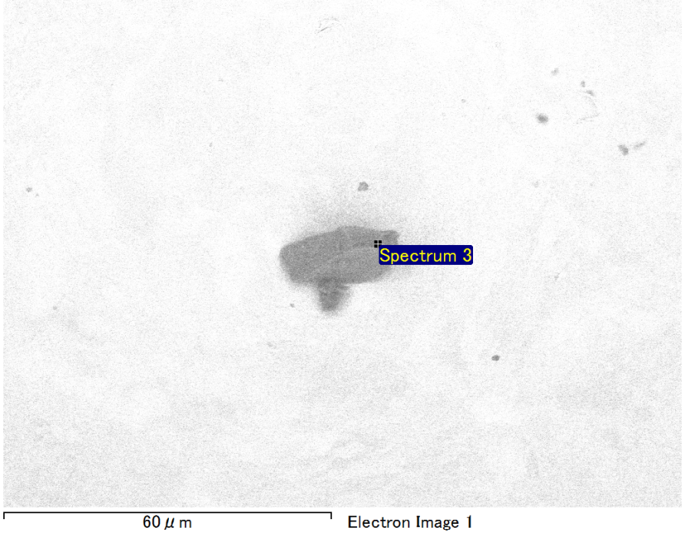

Spectrum Label: Spectrum 3

Livetime 90.0 s

Acquisition geometry ( degrees ):

Tilt = 0.0

Azimuth = 0.0

Elevation = 30.0

Accelerating voltage = 10.00 kV

Total spectrum counts = 68710

|  |  |  |  |
| --- | --- | --- | --- |
| Sample data : | Energy (eV) | Resn. (eV) | Area |
| Strobe : | 3.8 | 53.57 | 918984 |
|  |  |  |  |
| Optimization data : Manganese K series |  |  |  |
|  | Energy (eV) | Resn. (eV) | Area |
| Strobe : | .1 | 53.38 | 1150729 |
| Optimization element : | 5892.6 | 129.89 | 573533 |

Spectrum processing :

No peaks omitted

Processing option : Oxygen by stoichiometry (Normalised)

Number of iterations = 1

Standard :

Mg MgO 1-Jun-1999 12:00 AM

Si SiO2 1-Jun-1999 12:00 AM

Fe Fe 1-Jun-1999 12:00 AM

Au Au 1-Jun-1999 12:00 AM

|  |  |  |  |  |  |
| --- | --- | --- | --- | --- | --- |
| Element | Weight% | Atomic% | Compd% | Formula |  |
|  |  |  |  |  |  |
| Mg K | 5.80 | 11.55 | 9.62 | MgO |  |
| Si K | 3.53 | 6.09 | 7.56 | SiO2 |  |
| Fe L | 12.93 | 11.20 | 16.64 | FeO |  |
| Au M | 58.99 | 14.49 | 66.18 | Au2O3 |  |
| O | 18.74 | 56.67 |  |  |  |
| Totals | 100.00 |  |  |  |  |

Project: Project 1

Owner: Operator

Site: Site of Interest 29