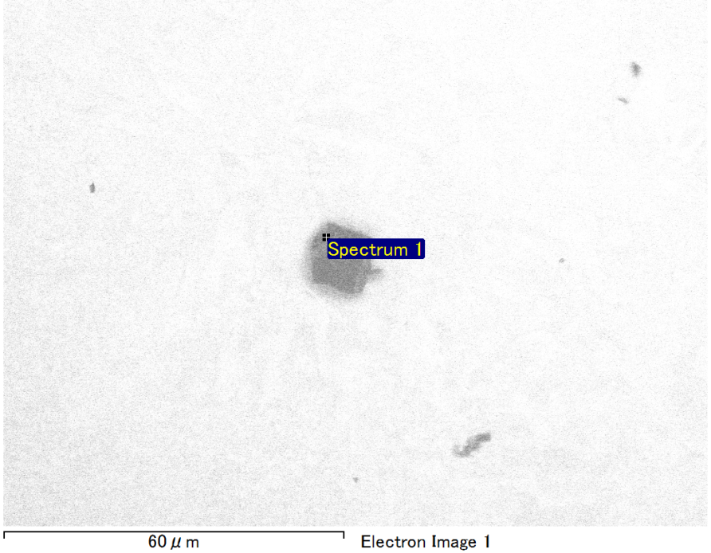

Spectrum Label: Spectrum 1

Livetime 90.0 s

Acquisition geometry ( degrees ):

Tilt = 0.0

Azimuth = 0.0

Elevation = 30.0

Accelerating voltage = 10.00 kV

Total spectrum counts = 69885

|  |  |  |  |
| --- | --- | --- | --- |
| Sample data : | Energy (eV) | Resn. (eV) | Area |
| Strobe : | 3.8 | 53.64 | 916963 |
|  |  |  |  |
| Optimization data : Manganese K series |  |  |  |
|  | Energy (eV) | Resn. (eV) | Area |
| Strobe : | .1 | 53.38 | 1150729 |
| Optimization element : | 5892.6 | 129.89 | 573533 |

Spectrum processing :

No peaks omitted

Processing option : Oxygen by stoichiometry (Normalised)

Number of iterations = 1

Standard :

Mg MgO 1-Jun-1999 12:00 AM

Si SiO2 1-Jun-1999 12:00 AM

Fe Fe 1-Jun-1999 12:00 AM

Au Au 1-Jun-1999 12:00 AM

|  |  |  |  |  |  |
| --- | --- | --- | --- | --- | --- |
| Element | Weight% | Atomic% | Compd% | Formula |  |
|  |  |  |  |  |  |
| Mg K | 4.96 | 10.24 | 8.22 | MgO |  |
| Si K | 3.27 | 5.84 | 6.99 | SiO2 |  |
| Fe L | 12.95 | 11.64 | 16.66 | FeO |  |
| Au M | 60.73 | 15.48 | 68.13 | Au2O3 |  |
| O | 18.10 | 56.79 |  |  |  |
| Totals | 100.00 |  |  |  |  |

Project: Project 1

Owner: Operator

Site: Site of Interest 30

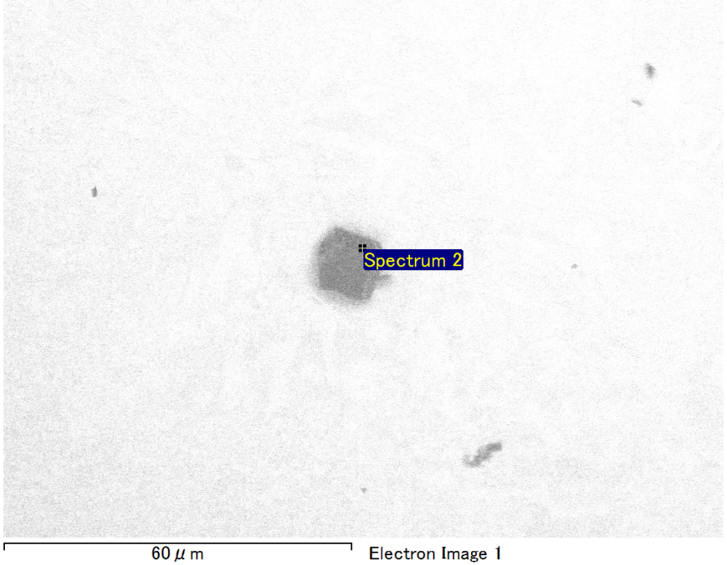

Spectrum Label: Spectrum 2

Livetime 90.0 s

Acquisition geometry ( degrees ):

Tilt = 0.0

Azimuth = 0.0

Elevation = 30.0

Accelerating voltage = 10.00 kV

Total spectrum counts = 68605

|  |  |  |  |
| --- | --- | --- | --- |
| Sample data : | Energy (eV) | Resn. (eV) | Area |
| Strobe : | 3.8 | 53.59 | 917836 |
|  |  |  |  |
| Optimization data : Manganese K series |  |  |  |
|  | Energy (eV) | Resn. (eV) | Area |
| Strobe : | .1 | 53.38 | 1150729 |
| Optimization element : | 5892.6 | 129.89 | 573533 |

Spectrum processing :

No peaks omitted

Processing option : Oxygen by stoichiometry (Normalised)

Number of iterations = 1

Standard :

Mg MgO 1-Jun-1999 12:00 AM

Si SiO2 1-Jun-1999 12:00 AM

Au Au 1-Jun-1999 12:00 AM

|  |  |  |  |  |  |
| --- | --- | --- | --- | --- | --- |
| Element | Weight% | Atomic% | Compd% | Formula |  |
|  |  |  |  |  |  |
| Mg K | 5.13 | 11.65 | 8.51 | MgO |  |
| Si K | 4.29 | 8.42 | 9.17 | SiO2 |  |
| Au M | 73.38 | 20.57 | 82.32 | Au2O3 |  |
| O | 17.20 | 59.35 |  |  |  |
| Totals | 100.00 |  |  |  |  |

Project: Project 1

Owner: Operator

Site: Site of Interest 30

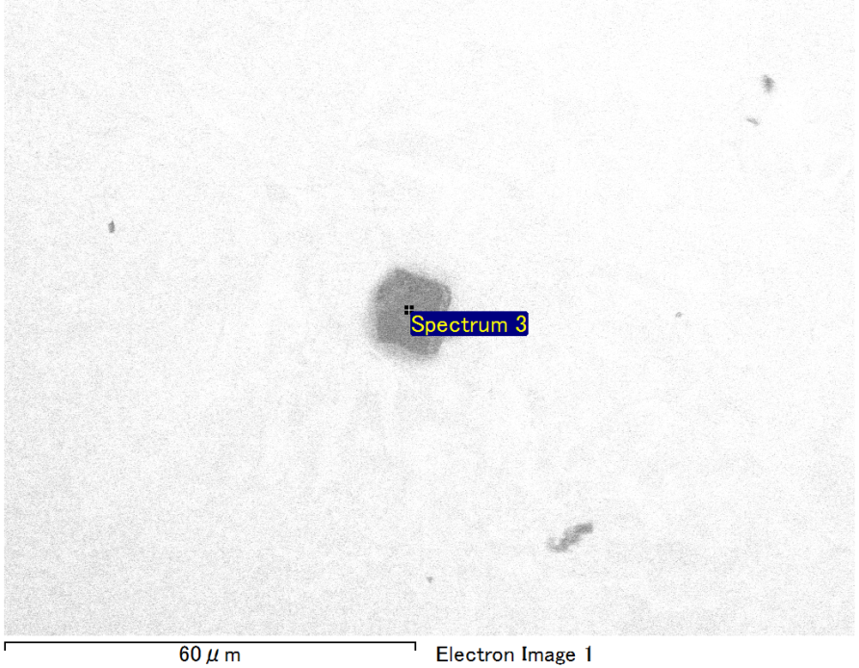

Spectrum Label: Spectrum 3

Livetime 90.0 s

Acquisition geometry ( degrees ):

Tilt = 0.0

Azimuth = 0.0

Elevation = 30.0

Accelerating voltage = 10.00 kV

Total spectrum counts = 68403

|  |  |  |  |
| --- | --- | --- | --- |
| Sample data : | Energy (eV) | Resn. (eV) | Area |
| Strobe : | 3.8 | 53.59 | 919324 |
|  |  |  |  |
| Optimization data : Manganese K series |  |  |  |
|  | Energy (eV) | Resn. (eV) | Area |
| Strobe : | .1 | 53.38 | 1150729 |
| Optimization element : | 5892.6 | 129.89 | 573533 |

Spectrum processing :

No peaks omitted

Processing option : Oxygen by stoichiometry (Normalised)

Number of iterations = 1

Standard :

Mg MgO 1-Jun-1999 12:00 AM

Si SiO2 1-Jun-1999 12:00 AM

Au Au 1-Jun-1999 12:00 AM

|  |  |  |  |  |  |
| --- | --- | --- | --- | --- | --- |
| Element | Weight% | Atomic% | Compd% | Formula |  |
|  |  |  |  |  |  |
| Mg K | 6.56 | 14.31 | 10.88 | MgO |  |
| Si K | 4.10 | 7.73 | 8.76 | SiO2 |  |
| Au M | 71.63 | 19.28 | 80.35 | Au2O3 |  |
| O | 17.71 | 58.68 |  |  |  |
| Totals | 100.00 |  |  |  |  |

Project: Project 1

Owner: Operator

Site: Site of Interest 30

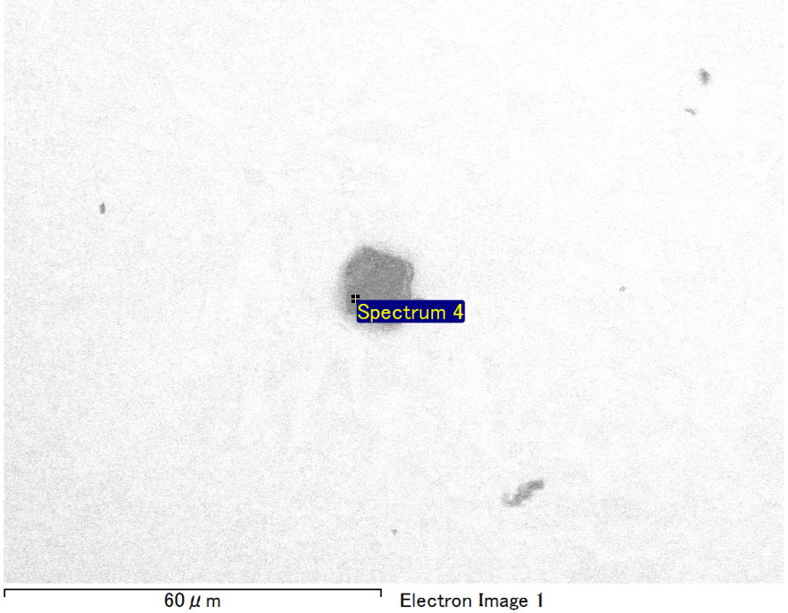

Spectrum Label: Spectrum 4

Livetime 90.0 s

Acquisition geometry ( degrees ):

Tilt = 0.0

Azimuth = 0.0

Elevation = 30.0

Accelerating voltage = 10.00 kV

Total spectrum counts = 68041

|  |  |  |  |
| --- | --- | --- | --- |
| Sample data : | Energy (eV) | Resn. (eV) | Area |
| Strobe : | 3.8 | 53.61 | 918130 |
|  |  |  |  |
| Optimization data : Manganese K series |  |  |  |
|  | Energy (eV) | Resn. (eV) | Area |
| Strobe : | .1 | 53.38 | 1150729 |
| Optimization element : | 5892.6 | 129.89 | 573533 |

Spectrum processing :

No peaks omitted

Processing option : Oxygen by stoichiometry (Normalised)

Number of iterations = 1

Standard :

Mg MgO 1-Jun-1999 12:00 AM

Si SiO2 1-Jun-1999 12:00 AM

Au Au 1-Jun-1999 12:00 AM

|  |  |  |  |  |  |
| --- | --- | --- | --- | --- | --- |
| Element | Weight% | Atomic% | Compd% | Formula |  |
|  |  |  |  |  |  |
| Mg K | 4.97 | 11.46 | 8.23 | MgO |  |
| Si K | 4.07 | 8.12 | 8.70 | SiO2 |  |
| Au M | 74.04 | 21.09 | 83.06 | Au2O3 |  |
| O | 16.92 | 59.33 |  |  |  |
| Totals | 100.00 |  |  |  |  |

Project: Project 1

Owner: Operator

Site: Site of Interest 30

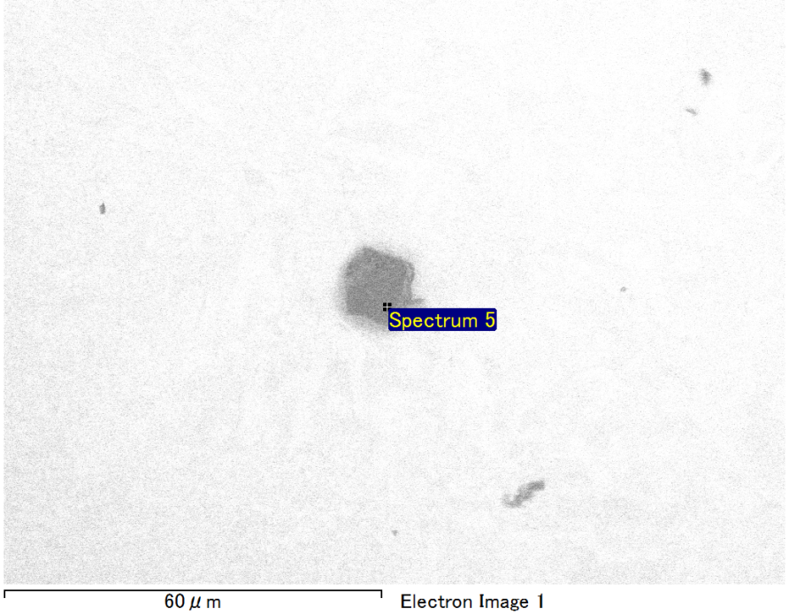

Spectrum Label: Spectrum 5

Livetime 90.0 s

Acquisition geometry ( degrees ):

Tilt = 0.0

Azimuth = 0.0

Elevation = 30.0

Accelerating voltage = 10.00 kV

Total spectrum counts = 68495

|  |  |  |  |
| --- | --- | --- | --- |
| Sample data : | Energy (eV) | Resn. (eV) | Area |
| Strobe : | 3.8 | 53.61 | 916983 |
|  |  |  |  |
| Optimization data : Manganese K series |  |  |  |
|  | Energy (eV) | Resn. (eV) | Area |
| Strobe : | .1 | 53.38 | 1150729 |
| Optimization element : | 5892.6 | 129.89 | 573533 |

Spectrum processing :

Peak possibly omitted : 0.714 keV

Processing option : Oxygen by stoichiometry (Normalised)

Number of iterations = 1

Standard :

Mg MgO 1-Jun-1999 12:00 AM

Si SiO2 1-Jun-1999 12:00 AM

Au Au 1-Jun-1999 12:00 AM

|  |  |  |  |  |  |
| --- | --- | --- | --- | --- | --- |
| Element | Weight% | Atomic% | Compd% | Formula |  |
|  |  |  |  |  |  |
| Mg K | 5.96 | 13.62 | 9.88 | MgO |  |
| Si K | 3.52 | 6.96 | 7.53 | SiO2 |  |
| Au M | 73.62 | 20.75 | 82.58 | Au2O3 |  |
| O | 16.90 | 58.67 |  |  |  |
| Totals | 100.00 |  |  |  |  |

Project: Project 1

Owner: Operator

Site: Site of Interest 30