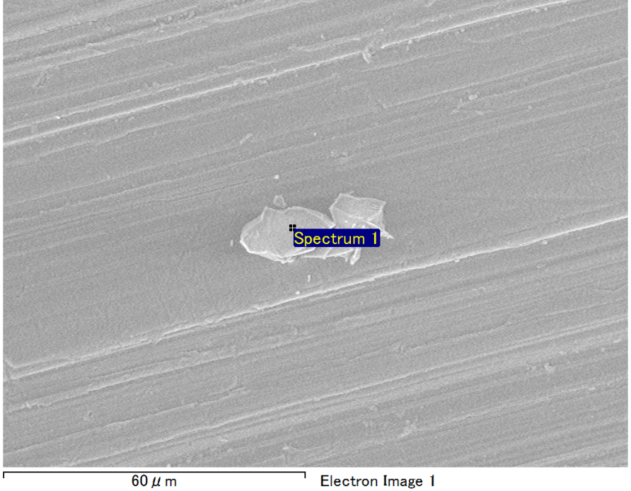

Spectrum Label: Spectrum 1

Livetime 90.0 s

Acquisition geometry ( degrees ):

Tilt = 0.0

Azimuth = 0.0

Elevation = 30.0

Accelerating voltage = 10.00 kV

Total spectrum counts = 68483

|  |  |  |  |
| --- | --- | --- | --- |
| Sample data : | Energy (eV) | Resn. (eV) | Area |
| Strobe : | 3.8 | 53.32 | 918212 |
|  |  |  |  |
| Optimization data : Manganese K series |  |  |  |
|  | Energy (eV) | Resn. (eV) | Area |
| Strobe : | .1 | 53.38 | 1150729 |
| Optimization element : | 5892.6 | 129.89 | 573533 |

Spectrum processing :

No peaks omitted

Processing option : Oxygen by stoichiometry (Normalised)

Number of iterations = 1

Standard :

Mg MgO 1-Jun-1999 12:00 AM

Al Al2O3 1-Jun-1999 12:00 AM

Si SiO2 1-Jun-1999 12:00 AM

|  |  |  |  |  |  |
| --- | --- | --- | --- | --- | --- |
| Element | Weight% | Atomic% | Compd% | Formula |  |
|  |  |  |  |  |  |
| Mg K | 4.59 | 3.84 | 7.61 | MgO |  |
| Al K | 44.07 | 33.22 | 83.26 | Al2O3 |  |
| Si K | 4.27 | 3.09 | 9.13 | SiO2 |  |
| O | 47.08 | 59.85 |  |  |  |
| Totals | 100.00 |  |  |  |  |

Project: Project 1

Owner: Operator

Site: Site of Interest 13