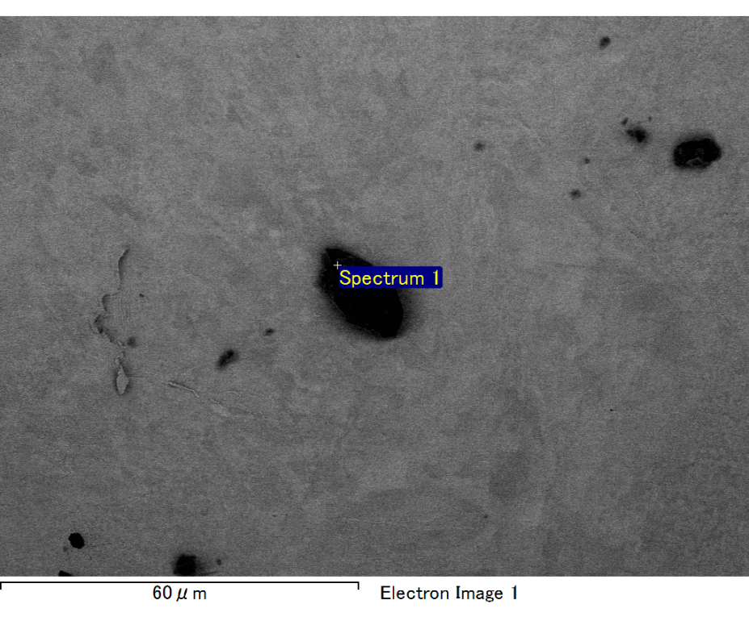

Spectrum processing :

No peaks omitted

Processing option : All elements analyzed (Normalised)

Number of iterations = 2

Standard :

C CaCO3 1-Jun-1999 12:00 AM

O SiO2 1-Jun-1999 12:00 AM

Mg MgO 1-Jun-1999 12:00 AM

Si SiO2 1-Jun-1999 12:00 AM

Fe Fe 1-Jun-1999 12:00 AM

Au Au 1-Jun-1999 12:00 AM

|  |  |  |  |
| --- | --- | --- | --- |
| Element | Weight% | Atomic% |  |
|  |  |  |  |
| C K | 2.65 | 9.23 |  |
| O K | 20.59 | 53.93 |  |
| Mg K | 5.58 | 9.61 |  |
| Si K | 4.46 | 6.66 |  |
| Fe L | 11.85 | 8.89 |  |
| Au M | 54.88 | 11.68 |  |
|  |  |  |  |
| Totals | 100.00 |  |  |

Spectrum Label: Spectrum 1

Livetime 60.0 s

Acquisition geometry ( degrees ):

Tilt = 15.0

Azimuth = 0.0

Elevation = 30.0

Accelerating voltage = 10.00 kV

Total spectrum counts = 52161

|  |  |  |  |
| --- | --- | --- | --- |
| Sample data : | Energy (eV) | Resn. (eV) | Area |
| Strobe : | 3.8 | 47.27 | 1000918 |
|  |  |  |  |

No quant optimization performed

Sample: Sample 1

Type: Default

ID:

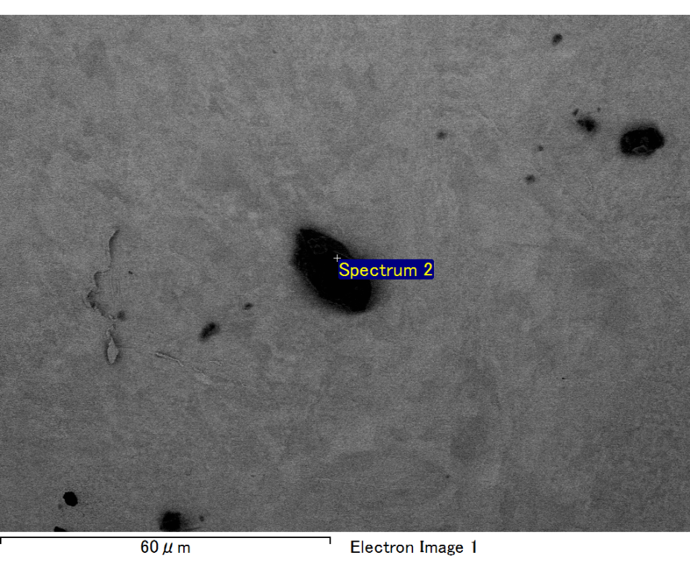

Spectrum processing :

No peaks omitted

Processing option : All elements analyzed (Normalised)

Number of iterations = 2

Standard :

C CaCO3 1-Jun-1999 12:00 AM

O SiO2 1-Jun-1999 12:00 AM

Mg MgO 1-Jun-1999 12:00 AM

Si SiO2 1-Jun-1999 12:00 AM

Fe Fe 1-Jun-1999 12:00 AM

Au Au 1-Jun-1999 12:00 AM

|  |  |  |  |
| --- | --- | --- | --- |
| Element | Weight% | Atomic% |  |
|  |  |  |  |
| C K | 2.19 | 8.13 |  |
| O K | 19.13 | 53.38 |  |
| Mg K | 5.58 | 10.25 |  |
| Si K | 4.12 | 6.55 |  |
| Fe L | 10.59 | 8.47 |  |
| Au M | 58.38 | 13.23 |  |
|  |  |  |  |
| Totals | 100.00 |  |  |

Spectrum Label: Spectrum 2

Livetime 60.0 s

Acquisition geometry ( degrees ):

Tilt = 15.0

Azimuth = 0.0

Elevation = 30.0

Accelerating voltage = 10.00 kV

Total spectrum counts = 50920

|  |  |  |  |
| --- | --- | --- | --- |
| Sample data : | Energy (eV) | Resn. (eV) | Area |
| Strobe : | 3.8 | 47.17 | 1000838 |
|  |  |  |  |

No quant optimization performed

Sample: Sample 1

Type: Default

ID:

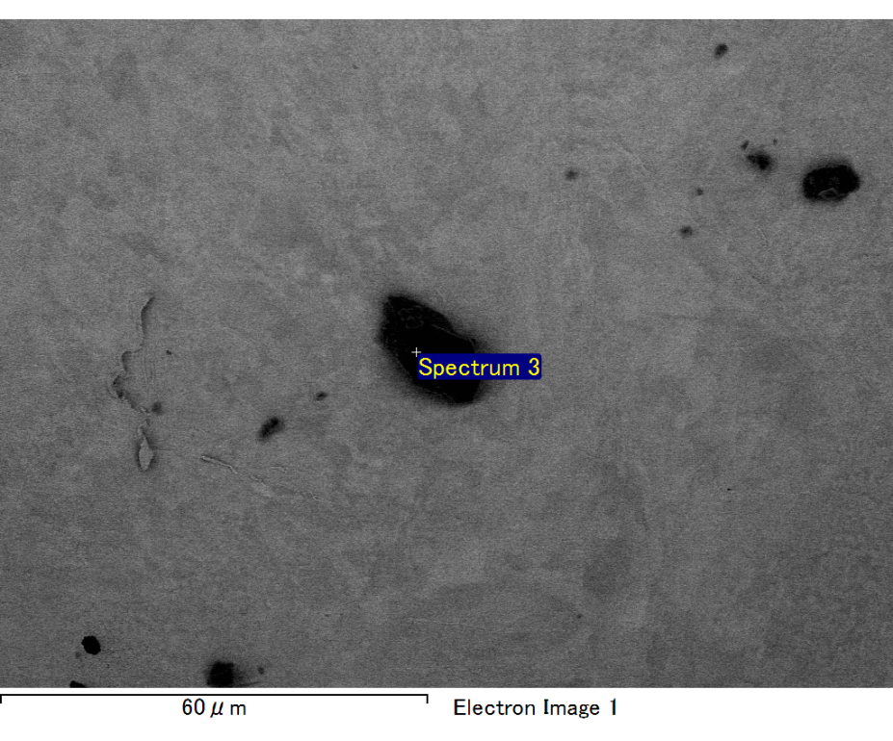

Spectrum processing :

No peaks omitted

Processing option : All elements analyzed (Normalised)

Number of iterations = 2

Standard :

C CaCO3 1-Jun-1999 12:00 AM

O SiO2 1-Jun-1999 12:00 AM

Mg MgO 1-Jun-1999 12:00 AM

Si SiO2 1-Jun-1999 12:00 AM

Fe Fe 1-Jun-1999 12:00 AM

Au Au 1-Jun-1999 12:00 AM

|  |  |  |  |
| --- | --- | --- | --- |
| Element | Weight% | Atomic% |  |
|  |  |  |  |
| C K | 2.79 | 9.72 |  |
| O K | 20.58 | 53.91 |  |
| Mg K | 5.54 | 9.55 |  |
| Si K | 4.12 | 6.15 |  |
| Fe L | 11.93 | 8.95 |  |
| Au M | 55.04 | 11.71 |  |
|  |  |  |  |
| Totals | 100.00 |  |  |

Spectrum Label: Spectrum 3

Livetime 60.0 s

Acquisition geometry ( degrees ):

Tilt = 15.0

Azimuth = 0.0

Elevation = 30.0

Accelerating voltage = 10.00 kV

Total spectrum counts = 51972

|  |  |  |  |
| --- | --- | --- | --- |
| Sample data : | Energy (eV) | Resn. (eV) | Area |
| Strobe : | 3.8 | 47.23 | 1000147 |
|  |  |  |  |

No quant optimization performed

Sample: Sample 1

Type: Default

ID:

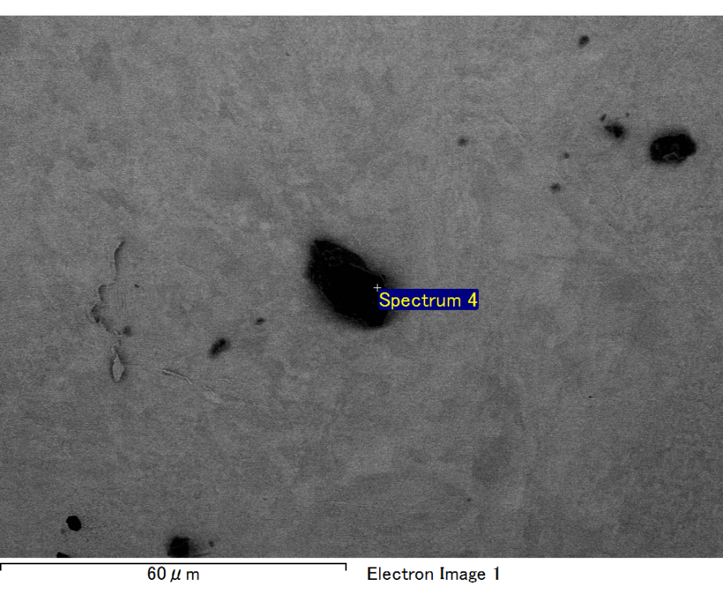

Spectrum processing :

No peaks omitted

Processing option : All elements analyzed (Normalised)

Number of iterations = 2

Standard :

C CaCO3 1-Jun-1999 12:00 AM

O SiO2 1-Jun-1999 12:00 AM

Mg MgO 1-Jun-1999 12:00 AM

Si SiO2 1-Jun-1999 12:00 AM

Fe Fe 1-Jun-1999 12:00 AM

Au Au 1-Jun-1999 12:00 AM

|  |  |  |  |
| --- | --- | --- | --- |
| Element | Weight% | Atomic% |  |
|  |  |  |  |
| C K | 2.42 | 8.75 |  |
| O K | 20.18 | 54.82 |  |
| Mg K | 5.32 | 9.50 |  |
| Si K | 3.79 | 5.87 |  |
| Fe L | 10.73 | 8.35 |  |
| Au M | 57.55 | 12.70 |  |
|  |  |  |  |
| Totals | 100.00 |  |  |

Spectrum Label: Spectrum 4

Livetime 60.0 s

Acquisition geometry ( degrees ):

Tilt = 15.0

Azimuth = 0.0

Elevation = 30.0

Accelerating voltage = 10.00 kV

Total spectrum counts = 50123

|  |  |  |  |
| --- | --- | --- | --- |
| Sample data : | Energy (eV) | Resn. (eV) | Area |
| Strobe : | 3.8 | 47.27 | 1000998 |
|  |  |  |  |

No quant optimization performed

Sample: Sample 1

Type: Default

ID:

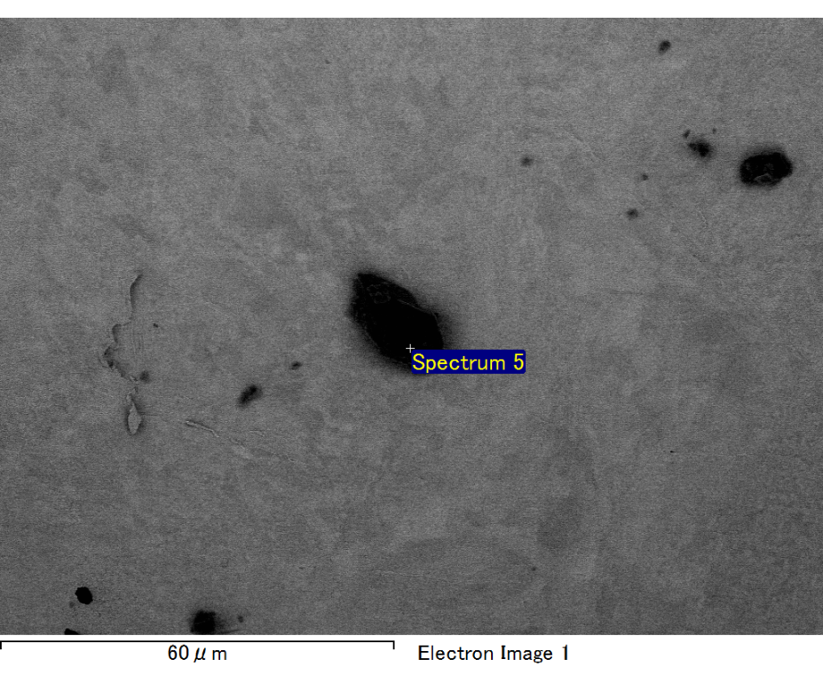

Spectrum processing :

No peaks omitted

Processing option : All elements analyzed (Normalised)

Number of iterations = 2

Standard :

C CaCO3 1-Jun-1999 12:00 AM

O SiO2 1-Jun-1999 12:00 AM

Mg MgO 1-Jun-1999 12:00 AM

Si SiO2 1-Jun-1999 12:00 AM

Fe Fe 1-Jun-1999 12:00 AM

Au Au 1-Jun-1999 12:00 AM

|  |  |  |  |
| --- | --- | --- | --- |
| Element | Weight% | Atomic% |  |
|  |  |  |  |
| C K | 2.43 | 8.79 |  |
| O K | 19.94 | 54.23 |  |
| Mg K | 5.50 | 9.84 |  |
| Si K | 3.59 | 5.56 |  |
| Fe L | 11.53 | 8.99 |  |
| Au M | 57.01 | 12.60 |  |
|  |  |  |  |
| Totals | 100.00 |  |  |

Spectrum Label: Spectrum 5

Livetime 60.0 s

Acquisition geometry ( degrees ):

Tilt = 15.0

Azimuth = 0.0

Elevation = 30.0

Accelerating voltage = 10.00 kV

Total spectrum counts = 50284

|  |  |  |  |
| --- | --- | --- | --- |
| Sample data : | Energy (eV) | Resn. (eV) | Area |
| Strobe : | 3.8 | 47.22 | 1000767 |
|  |  |  |  |

No quant optimization performed

Sample: Sample 1

Type: Default

ID: