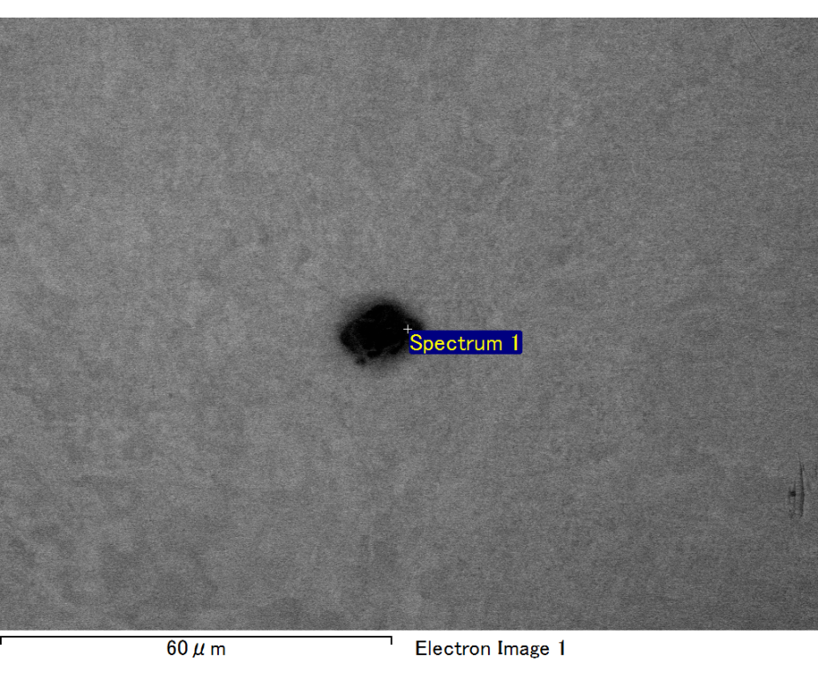

Spectrum processing :

Peaks possibly omitted : 0.710, 6.355 keV

Processing option : All elements analyzed (Normalised)

Number of iterations = 2

Standard :

C CaCO3 1-Jun-1999 12:00 AM

O SiO2 1-Jun-1999 12:00 AM

Mg MgO 1-Jun-1999 12:00 AM

Si SiO2 1-Jun-1999 12:00 AM

Au Au 1-Jun-1999 12:00 AM

|  |  |  |  |
| --- | --- | --- | --- |
| Element | Weight% | Atomic% |  |
|  |  |  |  |
| C K | 2.23 | 8.24 |  |
| O K | 21.28 | 59.11 |  |
| Mg K | 4.24 | 7.75 |  |
| Si K | 6.33 | 10.02 |  |
| Au M | 65.93 | 14.88 |  |
|  |  |  |  |
| Totals | 100.00 |  |  |

Spectrum Label: Spectrum 1

Livetime 60.0 s

Acquisition geometry ( degrees ):

Tilt = 15.0

Azimuth = 0.0

Elevation = 30.0

Accelerating voltage = 10.00 kV

Total spectrum counts = 50651

|  |  |  |  |
| --- | --- | --- | --- |
| Sample data : | Energy (eV) | Resn. (eV) | Area |
| Strobe : | 3.8 | 47.26 | 1000398 |
|  |  |  |  |

No quant optimization performed

Sample: Sample 1

Type: Default

ID:

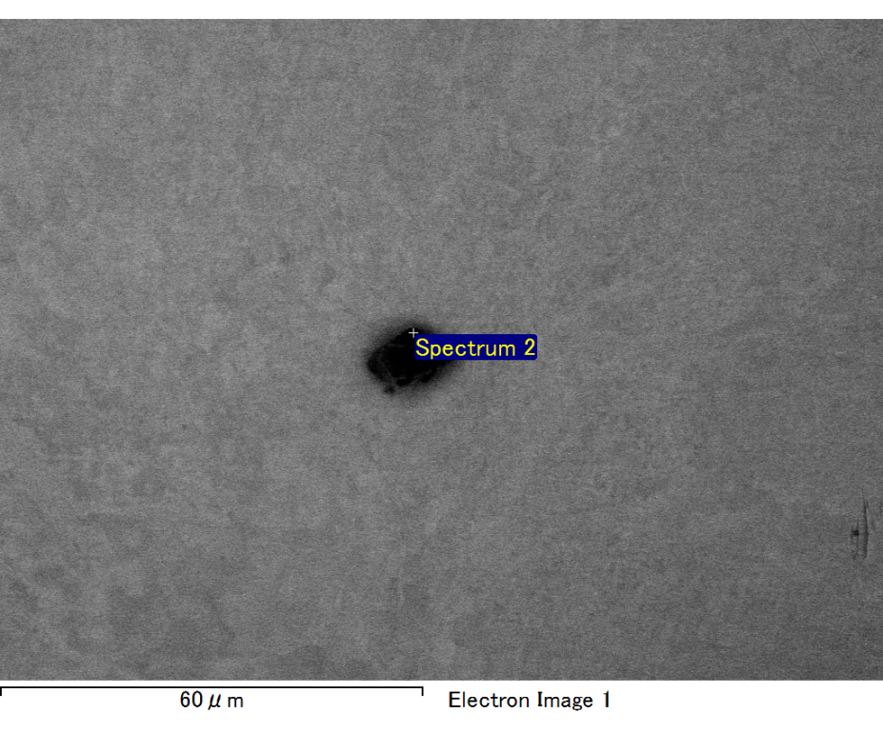

Spectrum processing :

No peaks omitted

Processing option : All elements analyzed (Normalised)

Number of iterations = 2

Standard :

C CaCO3 1-Jun-1999 12:00 AM

O SiO2 1-Jun-1999 12:00 AM

Mg MgO 1-Jun-1999 12:00 AM

Si SiO2 1-Jun-1999 12:00 AM

Fe Fe 1-Jun-1999 12:00 AM

Au Au 1-Jun-1999 12:00 AM

|  |  |  |  |
| --- | --- | --- | --- |
| Element | Weight% | Atomic% |  |
|  |  |  |  |
| C K | 2.92 | 10.04 |  |
| O K | 21.99 | 56.81 |  |
| Mg K | 4.35 | 7.39 |  |
| Si K | 5.91 | 8.70 |  |
| Fe L | 6.53 | 4.83 |  |
| Au M | 58.29 | 12.23 |  |
|  |  |  |  |
| Totals | 100.00 |  |  |

Spectrum Label: Spectrum 2

Livetime 60.0 s

Acquisition geometry ( degrees ):

Tilt = 15.0

Azimuth = 0.0

Elevation = 30.0

Accelerating voltage = 10.00 kV

Total spectrum counts = 51746

|  |  |  |  |
| --- | --- | --- | --- |
| Sample data : | Energy (eV) | Resn. (eV) | Area |
| Strobe : | 3.8 | 47.28 | 1001070 |
|  |  |  |  |

No quant optimization performed

Sample: Sample 1

Type: Default

ID:

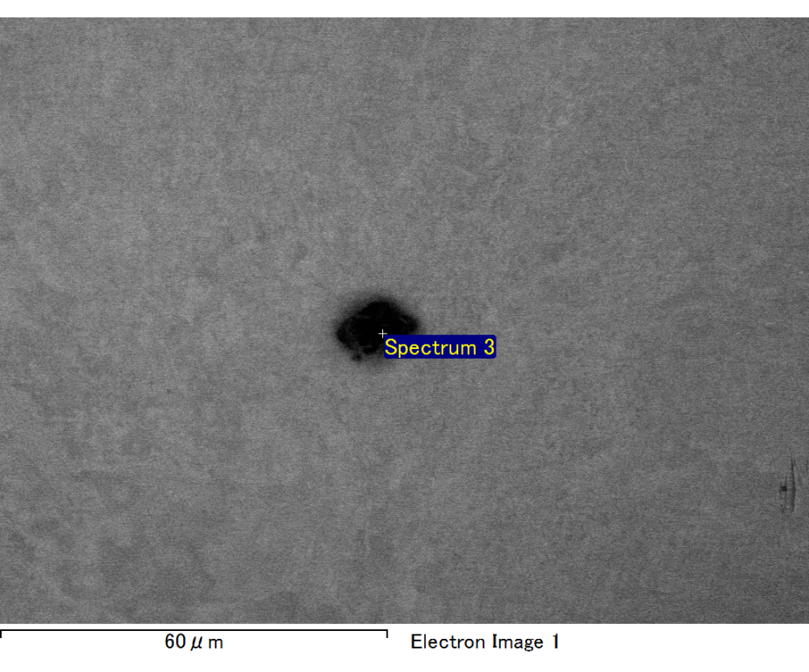

Spectrum processing :

Peak possibly omitted : 0.716 keV

Processing option : All elements analyzed (Normalised)

Number of iterations = 2

Standard :

C CaCO3 1-Jun-1999 12:00 AM

O SiO2 1-Jun-1999 12:00 AM

Mg MgO 1-Jun-1999 12:00 AM

Si SiO2 1-Jun-1999 12:00 AM

Au Au 1-Jun-1999 12:00 AM

|  |  |  |  |
| --- | --- | --- | --- |
| Element | Weight% | Atomic% |  |
|  |  |  |  |
| C K | 2.85 | 10.17 |  |
| O K | 21.41 | 57.26 |  |
| Mg K | 4.68 | 8.23 |  |
| Si K | 6.83 | 10.40 |  |
| Au M | 64.23 | 13.95 |  |
|  |  |  |  |
| Totals | 100.00 |  |  |

Spectrum Label: Spectrum 3

Livetime 60.0 s

Acquisition geometry ( degrees ):

Tilt = 15.0

Azimuth = 0.0

Elevation = 30.0

Accelerating voltage = 10.00 kV

Total spectrum counts = 49732

|  |  |  |  |
| --- | --- | --- | --- |
| Sample data : | Energy (eV) | Resn. (eV) | Area |
| Strobe : | 3.8 | 47.24 | 999710 |
|  |  |  |  |

No quant optimization performed

Sample: Sample 1

Type: Default

ID:

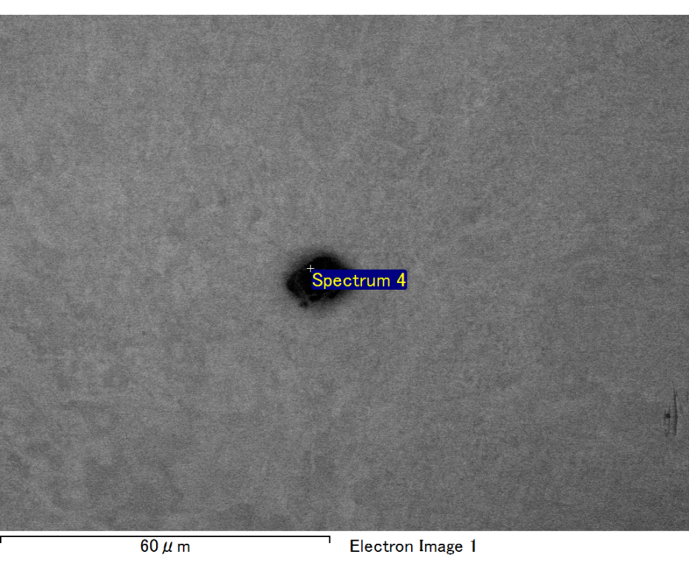

Spectrum processing :

No peaks omitted

Processing option : All elements analyzed (Normalised)

Number of iterations = 2

Standard :

C CaCO3 1-Jun-1999 12:00 AM

O SiO2 1-Jun-1999 12:00 AM

Mg MgO 1-Jun-1999 12:00 AM

Si SiO2 1-Jun-1999 12:00 AM

Fe Fe 1-Jun-1999 12:00 AM

Au Au 1-Jun-1999 12:00 AM

|  |  |  |  |
| --- | --- | --- | --- |
| Element | Weight% | Atomic% |  |
|  |  |  |  |
| C K | 2.18 | 7.35 |  |
| O K | 22.76 | 57.63 |  |
| Mg K | 4.91 | 8.18 |  |
| Si K | 6.45 | 9.30 |  |
| Fe L | 8.55 | 6.20 |  |
| Au M | 55.17 | 11.35 |  |
|  |  |  |  |
| Totals | 100.00 |  |  |

Spectrum Label: Spectrum 4

Livetime 60.0 s

Acquisition geometry ( degrees ):

Tilt = 15.0

Azimuth = 0.0

Elevation = 30.0

Accelerating voltage = 10.00 kV

Total spectrum counts = 51440

|  |  |  |  |
| --- | --- | --- | --- |
| Sample data : | Energy (eV) | Resn. (eV) | Area |
| Strobe : | 3.8 | 47.20 | 1000736 |
|  |  |  |  |

No quant optimization performed

Sample: Sample 1

Type: Default

ID:

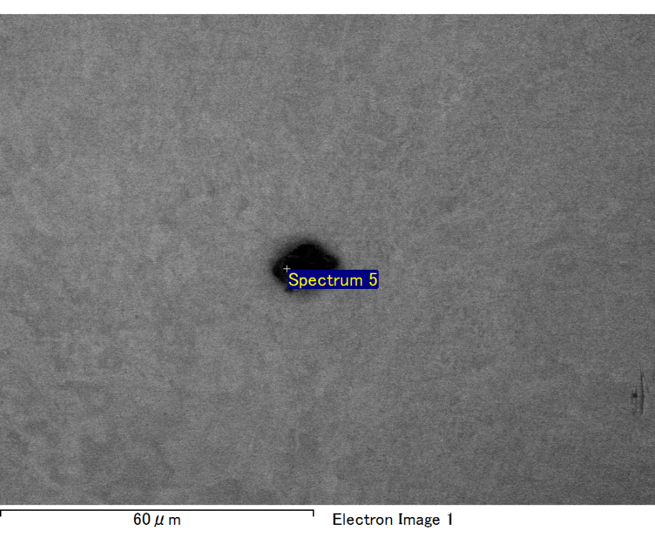

Spectrum processing :

No peaks omitted

Processing option : All elements analyzed (Normalised)

Number of iterations = 2

Standard :

C CaCO3 1-Jun-1999 12:00 AM

O SiO2 1-Jun-1999 12:00 AM

Mg MgO 1-Jun-1999 12:00 AM

Si SiO2 1-Jun-1999 12:00 AM

Fe Fe 1-Jun-1999 12:00 AM

Au Au 1-Jun-1999 12:00 AM

|  |  |  |  |
| --- | --- | --- | --- |
| Element | Weight% | Atomic% |  |
|  |  |  |  |
| C K | 2.19 | 8.14 |  |
| O K | 19.32 | 53.93 |  |
| Mg K | 4.56 | 8.37 |  |
| Si K | 6.33 | 10.06 |  |
| Fe L | 7.27 | 5.82 |  |
| Au M | 60.34 | 13.68 |  |
|  |  |  |  |
| Totals | 100.00 |  |  |

Spectrum Label: Spectrum 5

Livetime 60.0 s

Acquisition geometry ( degrees ):

Tilt = 15.0

Azimuth = 0.0

Elevation = 30.0

Accelerating voltage = 10.00 kV

Total spectrum counts = 50303

|  |  |  |  |
| --- | --- | --- | --- |
| Sample data : | Energy (eV) | Resn. (eV) | Area |
| Strobe : | 3.8 | 47.33 | 1000341 |
|  |  |  |  |

No quant optimization performed

Sample: Sample 1

Type: Default

ID: