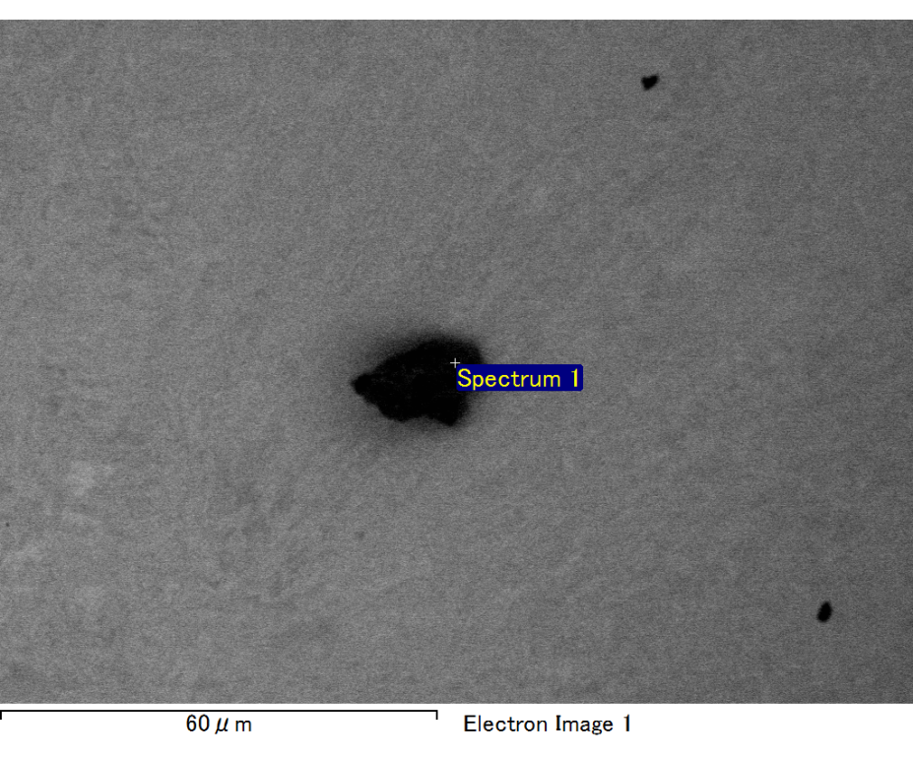

Spectrum processing :

No peaks omitted

Processing option : All elements analyzed (Normalised)

Number of iterations = 2

Standard :

C CaCO3 1-Jun-1999 12:00 AM

O SiO2 1-Jun-1999 12:00 AM

Mg MgO 1-Jun-1999 12:00 AM

Si SiO2 1-Jun-1999 12:00 AM

Fe Fe 1-Jun-1999 12:00 AM

Au Au 1-Jun-1999 12:00 AM

|  |  |  |  |
| --- | --- | --- | --- |
| Element | Weight% | Atomic% |  |
|  |  |  |  |
| C K | 2.98 | 10.76 |  |
| O K | 19.52 | 52.98 |  |
| Mg K | 4.32 | 7.72 |  |
| Si K | 5.30 | 8.20 |  |
| Fe L | 9.64 | 7.50 |  |
| Au M | 58.24 | 12.84 |  |
|  |  |  |  |
| Totals | 100.00 |  |  |

Spectrum Label: Spectrum 1

Livetime 60.0 s

Acquisition geometry ( degrees ):

Tilt = 15.0

Azimuth = 0.0

Elevation = 30.0

Accelerating voltage = 10.00 kV

Total spectrum counts = 50649

|  |  |  |  |
| --- | --- | --- | --- |
| Sample data : | Energy (eV) | Resn. (eV) | Area |
| Strobe : | 3.8 | 47.25 | 999855 |
|  |  |  |  |

No quant optimization performed

Sample: Sample 1

Type: Default

ID:

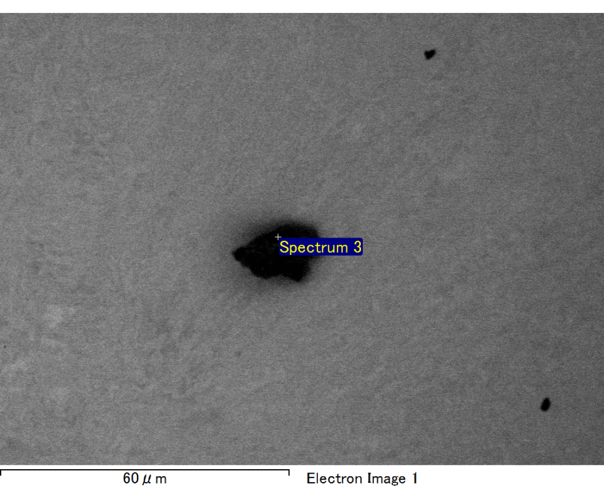

Spectrum processing :

No peaks omitted

Processing option : All elements analyzed (Normalised)

Number of iterations = 2

Standard :

C CaCO3 1-Jun-1999 12:00 AM

O SiO2 1-Jun-1999 12:00 AM

Mg MgO 1-Jun-1999 12:00 AM

Si SiO2 1-Jun-1999 12:00 AM

Fe Fe 1-Jun-1999 12:00 AM

Au Au 1-Jun-1999 12:00 AM

|  |  |  |  |
| --- | --- | --- | --- |
| Element | Weight% | Atomic% |  |
|  |  |  |  |
| C K | 3.30 | 12.84 |  |
| O K | 14.81 | 43.30 |  |
| Mg K | 3.39 | 6.52 |  |
| Si K | 3.25 | 5.42 |  |
| Fe L | 23.42 | 19.62 |  |
| Au M | 51.83 | 12.31 |  |
|  |  |  |  |
| Totals | 100.00 |  |  |

Spectrum Label: Spectrum 3

Livetime 60.0 s

Acquisition geometry ( degrees ):

Tilt = 15.0

Azimuth = 0.0

Elevation = 30.0

Accelerating voltage = 10.00 kV

Total spectrum counts = 48902

|  |  |  |  |
| --- | --- | --- | --- |
| Sample data : | Energy (eV) | Resn. (eV) | Area |
| Strobe : | 3.8 | 47.21 | 1000541 |
|  |  |  |  |

No quant optimization performed

Sample: Sample 1

Type: Default

ID:

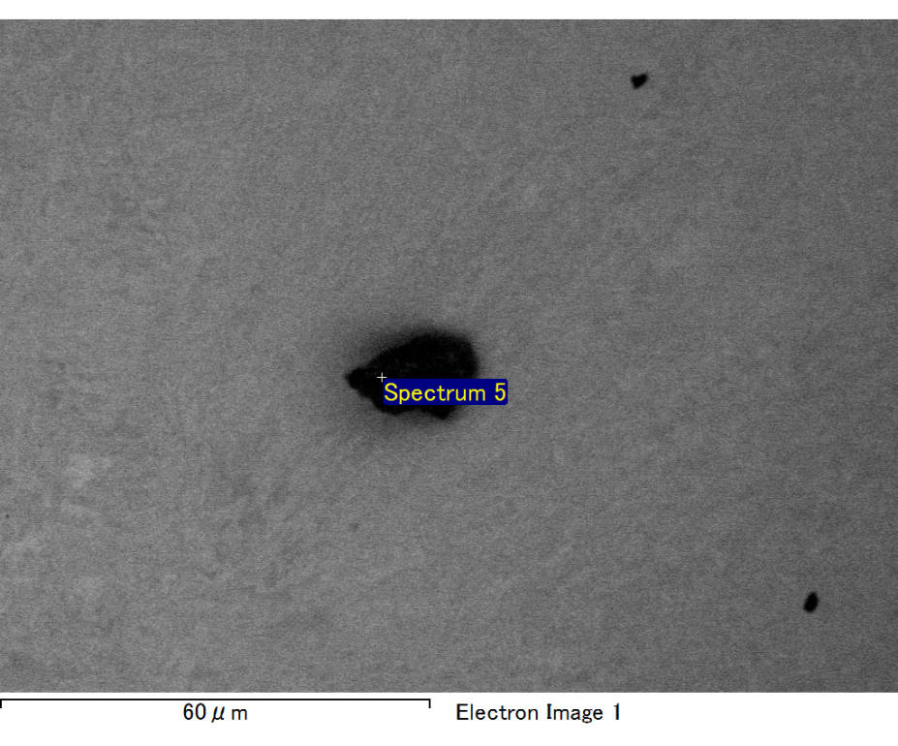

Spectrum processing :

Peak possibly omitted : 0.714 keV

Processing option : All elements analyzed (Normalised)

Number of iterations = 2

Standard :

C CaCO3 1-Jun-1999 12:00 AM

O SiO2 1-Jun-1999 12:00 AM

Mg MgO 1-Jun-1999 12:00 AM

Si SiO2 1-Jun-1999 12:00 AM

Au Au 1-Jun-1999 12:00 AM

|  |  |  |  |
| --- | --- | --- | --- |
| Element | Weight% | Atomic% |  |
|  |  |  |  |
| C K | 2.64 | 10.00 |  |
| O K | 20.19 | 57.47 |  |
| Mg K | 4.18 | 7.82 |  |
| Si K | 5.63 | 9.12 |  |
| Au M | 67.37 | 15.58 |  |
|  |  |  |  |
| Totals | 100.00 |  |  |

Spectrum Label: Spectrum 5

Livetime 60.0 s

Acquisition geometry ( degrees ):

Tilt = 15.0

Azimuth = 0.0

Elevation = 30.0

Accelerating voltage = 10.00 kV

Total spectrum counts = 48934

|  |  |  |  |
| --- | --- | --- | --- |
| Sample data : | Energy (eV) | Resn. (eV) | Area |
| Strobe : | 3.8 | 47.26 | 1000017 |
|  |  |  |  |

No quant optimization performed

Sample: Sample 1

Type: Default

ID:

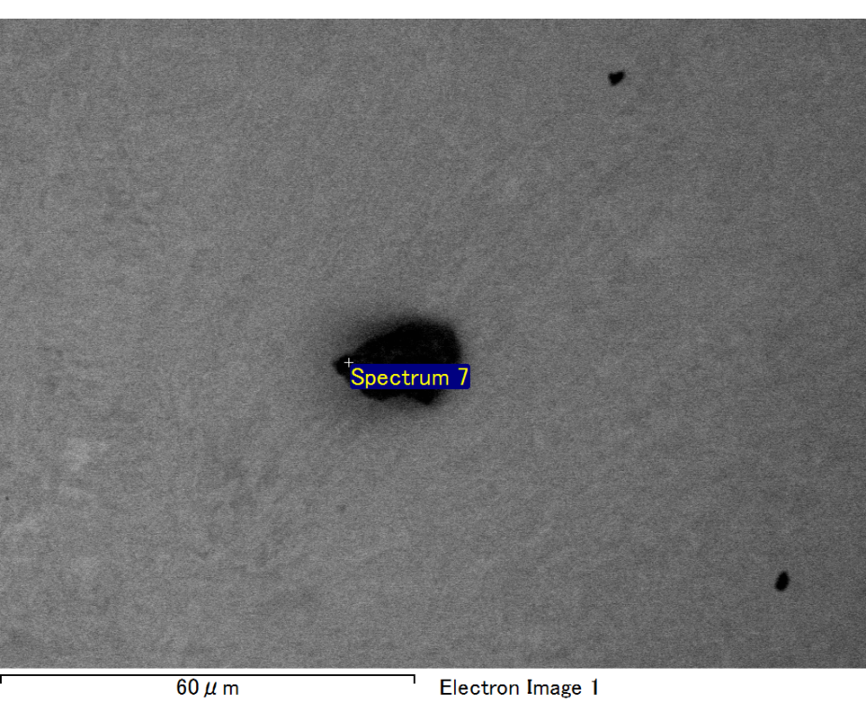

Spectrum processing :

Peaks possibly omitted : 0.711, 0.900 keV

Processing option : All elements analyzed (Normalised)

Number of iterations = 2

Standard :

C CaCO3 1-Jun-1999 12:00 AM

O SiO2 1-Jun-1999 12:00 AM

Mg MgO 1-Jun-1999 12:00 AM

Si SiO2 1-Jun-1999 12:00 AM

Au Au 1-Jun-1999 12:00 AM

|  |  |  |  |
| --- | --- | --- | --- |
| Element | Weight% | Atomic% |  |
|  |  |  |  |
| C K | 2.92 | 10.35 |  |
| O K | 21.77 | 57.94 |  |
| Mg K | 4.52 | 7.92 |  |
| Si K | 6.53 | 9.90 |  |
| Au M | 64.25 | 13.89 |  |
|  |  |  |  |
| Totals | 100.00 |  |  |

Spectrum Label: Spectrum 7

Livetime 60.0 s

Acquisition geometry ( degrees ):

Tilt = 15.0

Azimuth = 0.0

Elevation = 30.0

Accelerating voltage = 10.00 kV

Total spectrum counts = 49092

|  |  |  |  |
| --- | --- | --- | --- |
| Sample data : | Energy (eV) | Resn. (eV) | Area |
| Strobe : | 3.8 | 47.21 | 1001368 |
|  |  |  |  |

No quant optimization performed

Sample: Sample 1

Type: Default

ID:

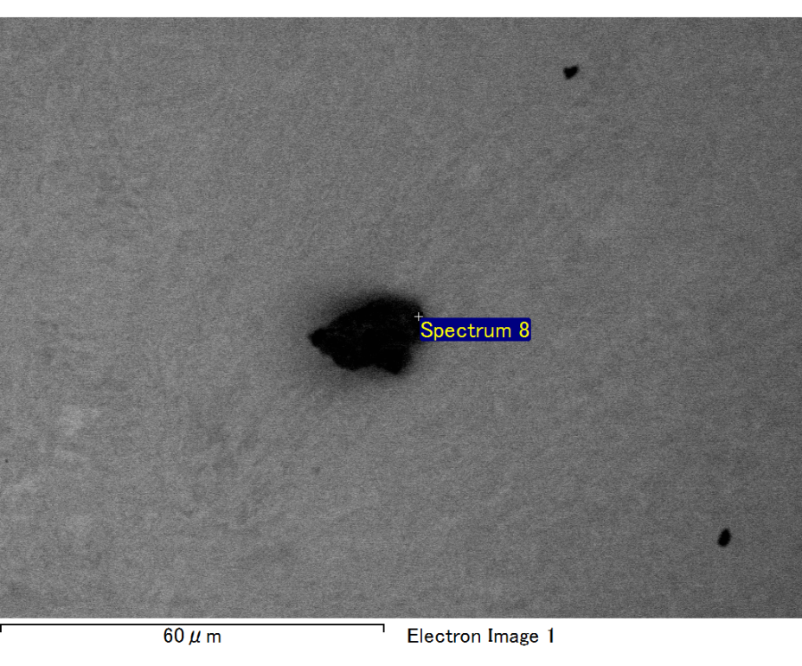

Spectrum processing :

No peaks omitted

Processing option : All elements analyzed (Normalised)

Number of iterations = 2

Standard :

C CaCO3 1-Jun-1999 12:00 AM

O SiO2 1-Jun-1999 12:00 AM

Mg MgO 1-Jun-1999 12:00 AM

Si SiO2 1-Jun-1999 12:00 AM

Fe Fe 1-Jun-1999 12:00 AM

Au Au 1-Jun-1999 12:00 AM

|  |  |  |  |
| --- | --- | --- | --- |
| Element | Weight% | Atomic% |  |
|  |  |  |  |
| C K | 2.95 | 11.84 |  |
| O K | 16.37 | 49.37 |  |
| Mg K | 3.58 | 7.10 |  |
| Si K | 4.29 | 7.36 |  |
| Fe L | 10.49 | 9.06 |  |
| Au M | 62.32 | 15.26 |  |
|  |  |  |  |
| Totals | 100.00 |  |  |

Spectrum Label: Spectrum 8

Livetime 60.0 s

Acquisition geometry ( degrees ):

Tilt = 15.0

Azimuth = 0.0

Elevation = 30.0

Accelerating voltage = 10.00 kV

Total spectrum counts = 49961

|  |  |  |  |
| --- | --- | --- | --- |
| Sample data : | Energy (eV) | Resn. (eV) | Area |
| Strobe : | 3.8 | 47.29 | 1000337 |
|  |  |  |  |

No quant optimization performed

Sample: Sample 1

Type: Default

ID: