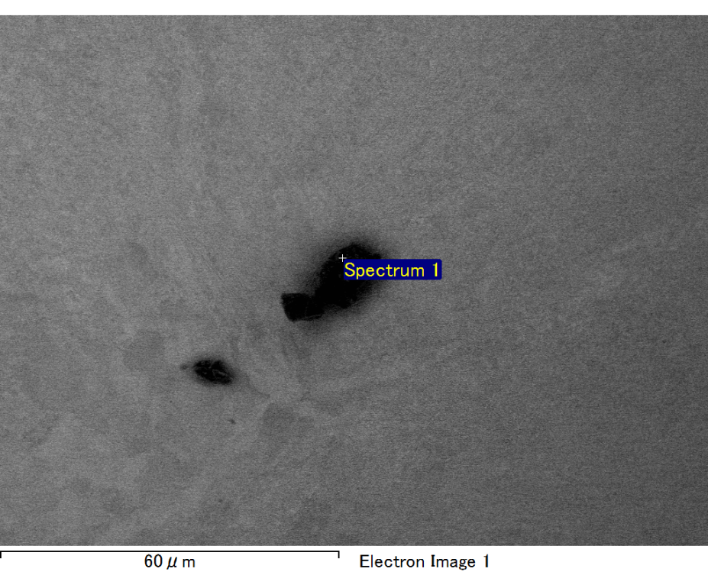

Spectrum processing :

No peaks omitted

Processing option : All elements analyzed (Normalised)

Number of iterations = 2

Standard :

C CaCO3 1-Jun-1999 12:00 AM

O SiO2 1-Jun-1999 12:00 AM

Mg MgO 1-Jun-1999 12:00 AM

Si SiO2 1-Jun-1999 12:00 AM

Fe Fe 1-Jun-1999 12:00 AM

Au Au 1-Jun-1999 12:00 AM

|  |  |  |  |
| --- | --- | --- | --- |
| Element | Weight% | Atomic% |  |
|  |  |  |  |
| C K | 3.92 | 15.47 |  |
| O K | 14.86 | 43.99 |  |
| Mg K | 2.86 | 5.57 |  |
| Si K | 3.30 | 5.56 |  |
| Fe L | 18.73 | 15.87 |  |
| Au M | 56.32 | 13.54 |  |
|  |  |  |  |
| Totals | 100.00 |  |  |

Spectrum Label: Spectrum 1

Livetime 60.0 s

Acquisition geometry ( degrees ):

Tilt = 15.0

Azimuth = 0.0

Elevation = 30.0

Accelerating voltage = 10.00 kV

Total spectrum counts = 51516

|  |  |  |  |
| --- | --- | --- | --- |
| Sample data : | Energy (eV) | Resn. (eV) | Area |
| Strobe : | 3.8 | 47.21 | 1001881 |
|  |  |  |  |

No quant optimization performed

Sample: Sample 1

Type: Default

ID:

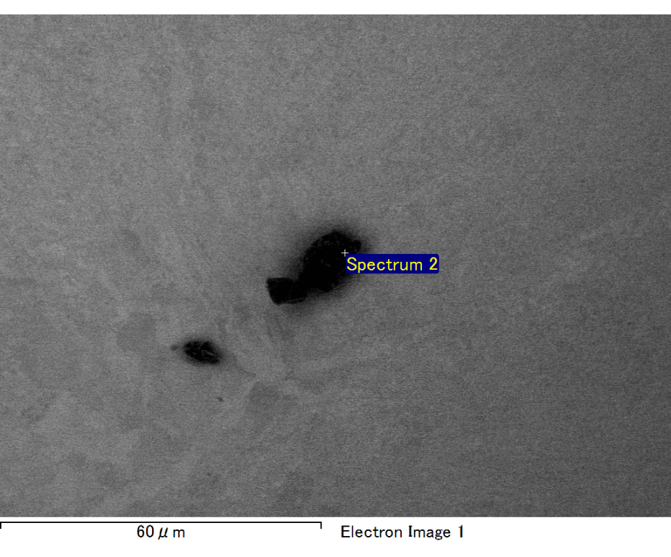

Spectrum processing :

Peak possibly omitted : 0.714 keV

Processing option : All elements analyzed (Normalised)

Number of iterations = 2

Standard :

C CaCO3 1-Jun-1999 12:00 AM

O SiO2 1-Jun-1999 12:00 AM

Mg MgO 1-Jun-1999 12:00 AM

Si SiO2 1-Jun-1999 12:00 AM

Au Au 1-Jun-1999 12:00 AM

|  |  |  |  |
| --- | --- | --- | --- |
| Element | Weight% | Atomic% |  |
|  |  |  |  |
| C K | 3.37 | 11.60 |  |
| O K | 22.64 | 58.52 |  |
| Mg K | 4.41 | 7.50 |  |
| Si K | 6.15 | 9.06 |  |
| Au M | 63.43 | 13.32 |  |
|  |  |  |  |
| Totals | 100.00 |  |  |

Spectrum Label: Spectrum 2

Livetime 60.0 s

Acquisition geometry ( degrees ):

Tilt = 15.0

Azimuth = 0.0

Elevation = 30.0

Accelerating voltage = 10.00 kV

Total spectrum counts = 52100

|  |  |  |  |
| --- | --- | --- | --- |
| Sample data : | Energy (eV) | Resn. (eV) | Area |
| Strobe : | 3.8 | 47.14 | 999308 |
|  |  |  |  |

No quant optimization performed

Sample: Sample 1

Type: Default

ID:

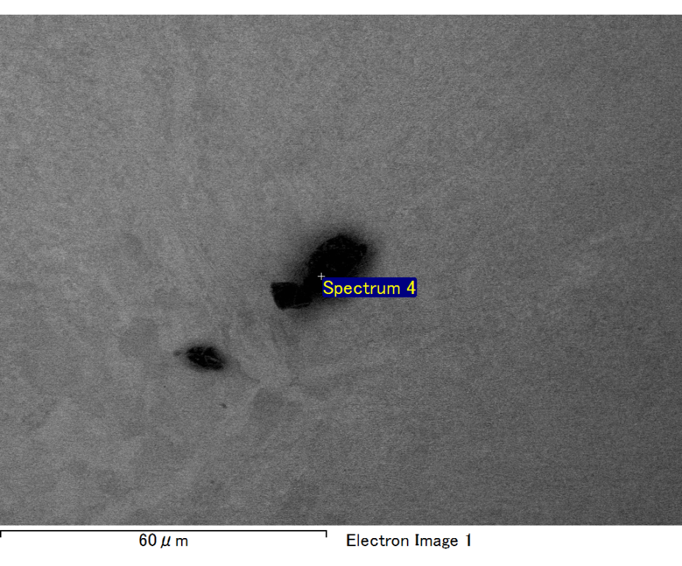

Spectrum processing :

Peak possibly omitted : 6.425 keV

Processing option : All elements analyzed (Normalised)

Number of iterations = 2

Standard :

C CaCO3 1-Jun-1999 12:00 AM

O SiO2 1-Jun-1999 12:00 AM

Mg MgO 1-Jun-1999 12:00 AM

Si SiO2 1-Jun-1999 12:00 AM

Au Au 1-Jun-1999 12:00 AM

|  |  |  |  |
| --- | --- | --- | --- |
| Element | Weight% | Atomic% |  |
|  |  |  |  |
| C K | 3.09 | 12.10 |  |
| O K | 17.77 | 52.24 |  |
| Mg K | 4.38 | 8.47 |  |
| Si K | 6.50 | 10.89 |  |
| Au M | 68.26 | 16.30 |  |
|  |  |  |  |
| Totals | 100.00 |  |  |

Spectrum Label: Spectrum 4

Livetime 60.0 s

Acquisition geometry ( degrees ):

Tilt = 15.0

Azimuth = 0.0

Elevation = 30.0

Accelerating voltage = 10.00 kV

Total spectrum counts = 48590

|  |  |  |  |
| --- | --- | --- | --- |
| Sample data : | Energy (eV) | Resn. (eV) | Area |
| Strobe : | 3.8 | 47.26 | 1000595 |
|  |  |  |  |

No quant optimization performed

Sample: Sample 1

Type: Default

ID:

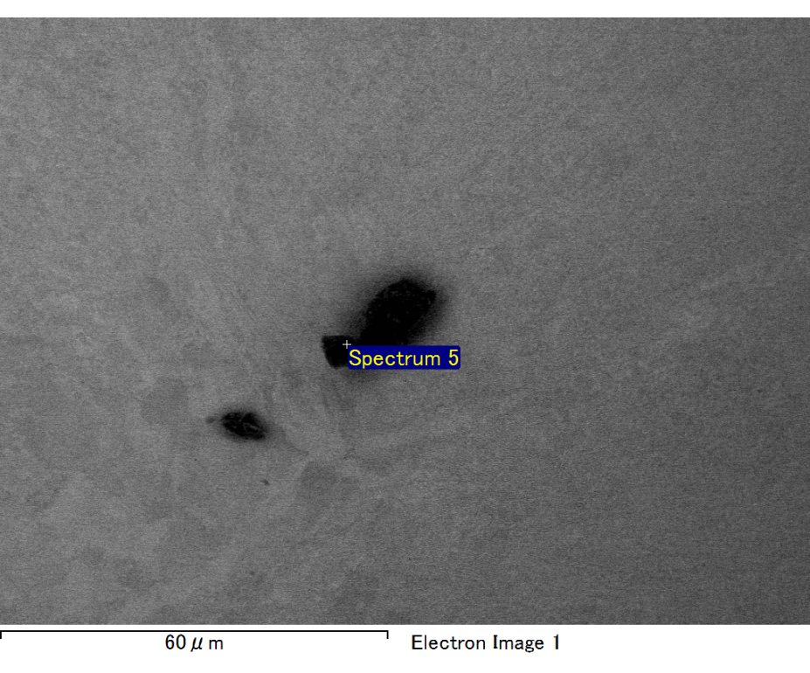

Spectrum processing :

No peaks omitted

Processing option : All elements analyzed (Normalised)

Number of iterations = 2

Standard :

C CaCO3 1-Jun-1999 12:00 AM

O SiO2 1-Jun-1999 12:00 AM

Mg MgO 1-Jun-1999 12:00 AM

Si SiO2 1-Jun-1999 12:00 AM

Au Au 1-Jun-1999 12:00 AM

|  |  |  |  |
| --- | --- | --- | --- |
| Element | Weight% | Atomic% |  |
|  |  |  |  |
| C K | 3.34 | 18.84 |  |
| O K | 7.74 | 32.78 |  |
| Mg K | 2.93 | 8.17 |  |
| Si K | 5.14 | 12.40 |  |
| Au M | 80.86 | 27.82 |  |
|  |  |  |  |
| Totals | 100.00 |  |  |

Spectrum Label: Spectrum 5

Livetime 60.0 s

Acquisition geometry ( degrees ):

Tilt = 15.0

Azimuth = 0.0

Elevation = 30.0

Accelerating voltage = 10.00 kV

Total spectrum counts = 46136

|  |  |  |  |
| --- | --- | --- | --- |
| Sample data : | Energy (eV) | Resn. (eV) | Area |
| Strobe : | 3.8 | 47.24 | 1001184 |
|  |  |  |  |

No quant optimization performed

Sample: Sample 1

Type: Default

ID:

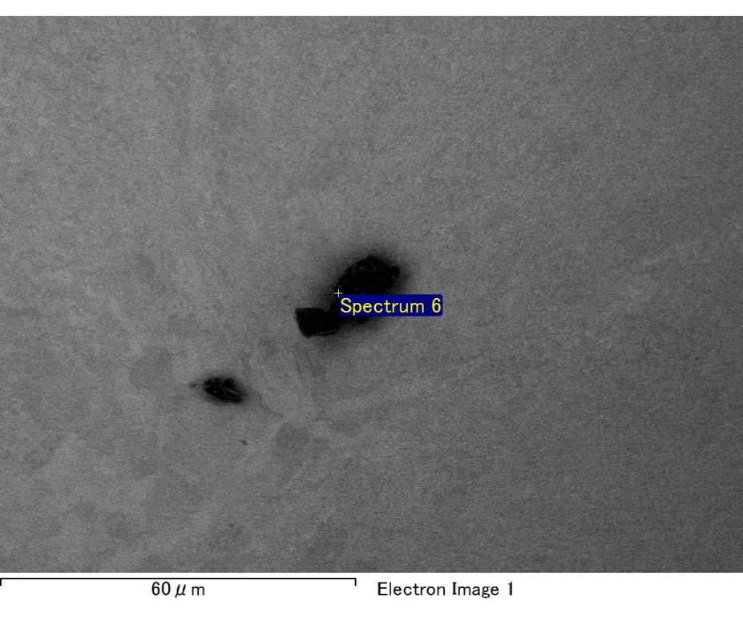

Spectrum processing :

Peaks possibly omitted : 0.260, 0.715, 6.390 keV

Processing option : All elements analyzed (Normalised)

Number of iterations = 2

Standard :

O SiO2 1-Jun-1999 12:00 AM

Mg MgO 1-Jun-1999 12:00 AM

Si SiO2 1-Jun-1999 12:00 AM

Au Au 1-Jun-1999 12:00 AM

|  |  |  |  |
| --- | --- | --- | --- |
| Element | Weight% | Atomic% |  |
|  |  |  |  |
| O K | 21.43 | 63.46 |  |
| Mg K | 4.82 | 9.40 |  |
| Si K | 6.50 | 10.97 |  |
| Au M | 67.24 | 16.17 |  |
|  |  |  |  |
| Totals | 100.00 |  |  |

Spectrum Label: Spectrum 6

Livetime 60.0 s

Acquisition geometry ( degrees ):

Tilt = 15.0

Azimuth = 0.0

Elevation = 30.0

Accelerating voltage = 10.00 kV

Total spectrum counts = 50360

|  |  |  |  |
| --- | --- | --- | --- |
| Sample data : | Energy (eV) | Resn. (eV) | Area |
| Strobe : | 3.8 | 47.18 | 1001227 |
|  |  |  |  |

No quant optimization performed

Sample: Sample 1

Type: Default

ID: