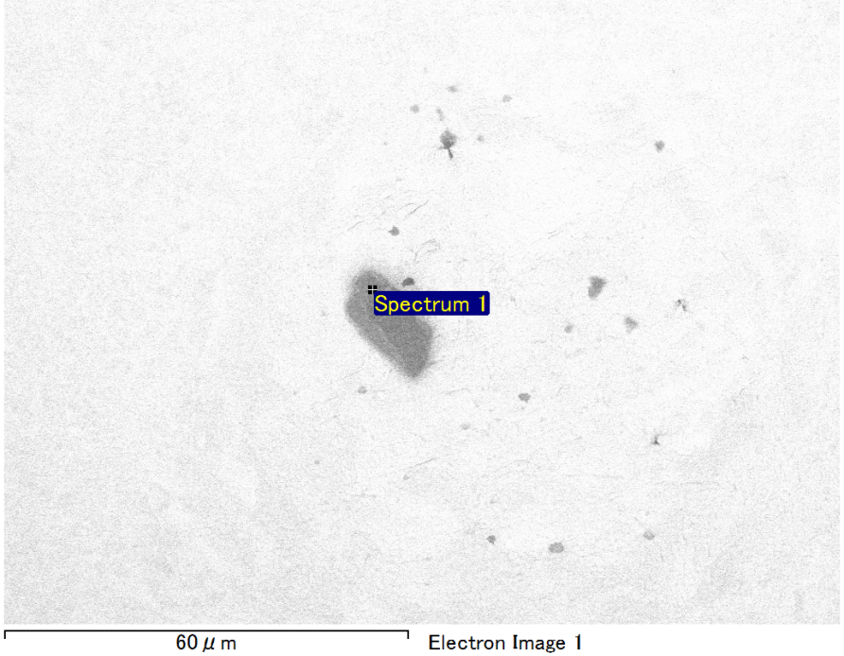

Spectrum Label: Spectrum 1

Livetime 90.0 s

Acquisition geometry ( degrees ):

Tilt = 0.0

Azimuth = 0.0

Elevation = 30.0

Accelerating voltage = 10.00 kV

Total spectrum counts = 68810

|  |  |  |  |
| --- | --- | --- | --- |
| Sample data : | Energy (eV) | Resn. (eV) | Area |
| Strobe : | 3.8 | 53.74 | 917199 |
|  |  |  |  |
| Optimization data : Manganese K series |  |  |  |
|  | Energy (eV) | Resn. (eV) | Area |
| Strobe : | .1 | 53.38 | 1150729 |
| Optimization element : | 5892.6 | 129.89 | 573533 |

Spectrum processing :

No peaks omitted

Processing option : Oxygen by stoichiometry (Normalised)

Number of iterations = 1

Standard :

Mg MgO 1-Jun-1999 12:00 AM

Si SiO2 1-Jun-1999 12:00 AM

Fe Fe 1-Jun-1999 12:00 AM

Au Au 1-Jun-1999 12:00 AM

|  |  |  |  |  |  |
| --- | --- | --- | --- | --- | --- |
| Element | Weight% | Atomic% | Compd% | Formula |  |
|  |  |  |  |  |  |
| Mg K | 5.61 | 11.27 | 9.30 | MgO |  |
| Si K | 3.35 | 5.82 | 7.16 | SiO2 |  |
| Fe L | 13.34 | 11.67 | 17.17 | FeO |  |
| Au M | 59.17 | 14.67 | 66.38 | Au2O3 |  |
| O | 18.53 | 56.58 |  |  |  |
| Totals | 100.00 |  |  |  |  |

Project: Project 1

Owner: Operator

Site: Site of Interest 10

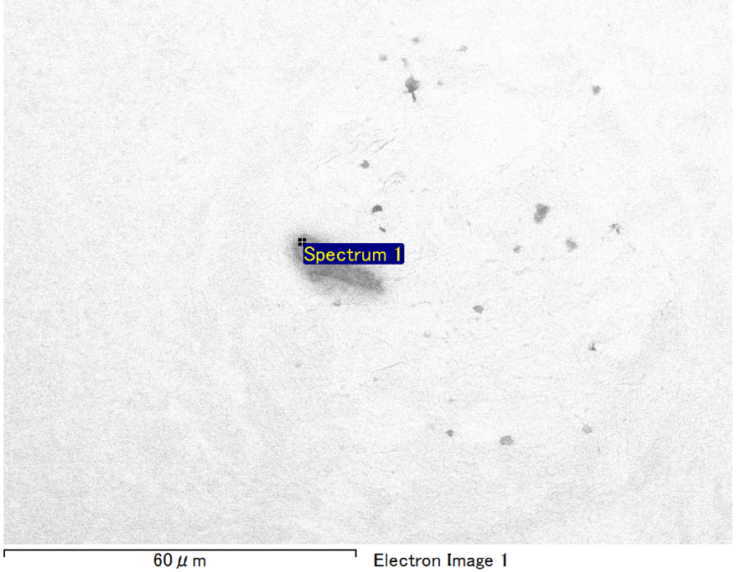

Spectrum Label: Spectrum 1

Livetime 90.0 s

Acquisition geometry ( degrees ):

Tilt = 0.0

Azimuth = 0.0

Elevation = 30.0

Accelerating voltage = 10.00 kV

Total spectrum counts = 69261

|  |  |  |  |
| --- | --- | --- | --- |
| Sample data : | Energy (eV) | Resn. (eV) | Area |
| Strobe : | 3.8 | 53.67 | 917243 |
|  |  |  |  |
| Optimization data : Manganese K series |  |  |  |
|  | Energy (eV) | Resn. (eV) | Area |
| Strobe : | .1 | 53.38 | 1150729 |
| Optimization element : | 5892.6 | 129.89 | 573533 |

Spectrum processing :

Peak possibly omitted : 0.235 keV

Processing option : Oxygen by stoichiometry (Normalised)

Number of iterations = 1

Standard :

Mg MgO 1-Jun-1999 12:00 AM

Si SiO2 1-Jun-1999 12:00 AM

Fe Fe 1-Jun-1999 12:00 AM

Au Au 1-Jun-1999 12:00 AM

|  |  |  |  |  |  |
| --- | --- | --- | --- | --- | --- |
| Element | Weight% | Atomic% | Compd% | Formula |  |
|  |  |  |  |  |  |
| Mg K | 4.91 | 9.73 | 8.15 | MgO |  |
| Si K | 3.91 | 6.70 | 8.36 | SiO2 |  |
| Fe L | 14.59 | 12.58 | 18.77 | FeO |  |
| Au M | 57.69 | 14.11 | 64.72 | Au2O3 |  |
| O | 18.89 | 56.88 |  |  |  |
| Totals | 100.00 |  |  |  |  |

Project: Project 1

Owner: Operator

Site: Site of Interest 11

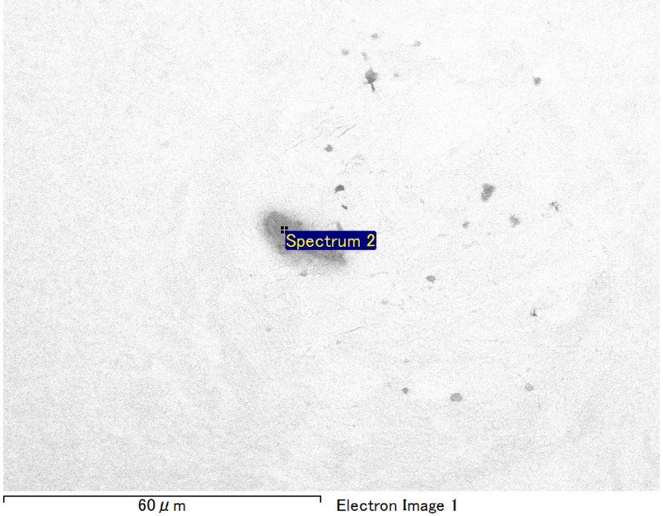

Spectrum Label: Spectrum 2

Livetime 90.0 s

Acquisition geometry ( degrees ):

Tilt = 0.0

Azimuth = 0.0

Elevation = 30.0

Accelerating voltage = 10.00 kV

Total spectrum counts = 69483

|  |  |  |  |
| --- | --- | --- | --- |
| Sample data : | Energy (eV) | Resn. (eV) | Area |
| Strobe : | 3.8 | 53.60 | 918159 |
|  |  |  |  |
| Optimization data : Manganese K series |  |  |  |
|  | Energy (eV) | Resn. (eV) | Area |
| Strobe : | .1 | 53.38 | 1150729 |
| Optimization element : | 5892.6 | 129.89 | 573533 |

Spectrum processing :

No peaks omitted

Processing option : Oxygen by stoichiometry (Normalised)

Number of iterations = 1

Standard :

Mg MgO 1-Jun-1999 12:00 AM

Si SiO2 1-Jun-1999 12:00 AM

Fe Fe 1-Jun-1999 12:00 AM

Au Au 1-Jun-1999 12:00 AM

|  |  |  |  |  |  |
| --- | --- | --- | --- | --- | --- |
| Element | Weight% | Atomic% | Compd% | Formula |  |
|  |  |  |  |  |  |
| Mg K | 5.30 | 10.43 | 8.79 | MgO |  |
| Si K | 3.86 | 6.57 | 8.26 | SiO2 |  |
| Fe L | 14.31 | 12.25 | 18.41 | FeO |  |
| Au M | 57.53 | 13.97 | 64.54 | Au2O3 |  |
| O | 19.00 | 56.78 |  |  |  |
| Totals | 100.00 |  |  |  |  |

Project: Project 1

Owner: Operator

Site: Site of Interest 11

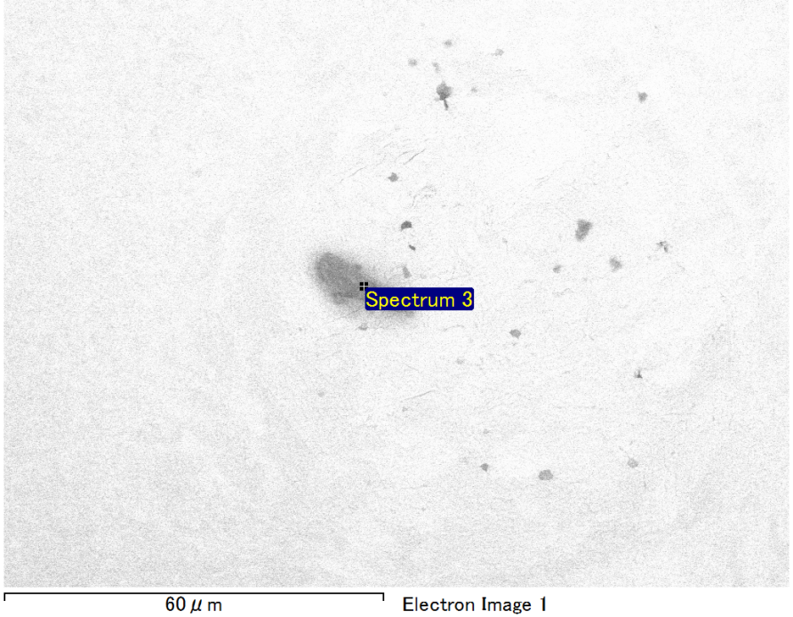

Spectrum Label: Spectrum 3

Livetime 90.0 s

Acquisition geometry ( degrees ):

Tilt = 0.0

Azimuth = 0.0

Elevation = 30.0

Accelerating voltage = 10.00 kV

Total spectrum counts = 69190

|  |  |  |  |
| --- | --- | --- | --- |
| Sample data : | Energy (eV) | Resn. (eV) | Area |
| Strobe : | 3.8 | 53.71 | 916919 |
|  |  |  |  |
| Optimization data : Manganese K series |  |  |  |
|  | Energy (eV) | Resn. (eV) | Area |
| Strobe : | .1 | 53.38 | 1150729 |
| Optimization element : | 5892.6 | 129.89 | 573533 |

Spectrum processing :

Peak possibly omitted : 0.725 keV

Processing option : Oxygen by stoichiometry (Normalised)

Number of iterations = 1

Standard :

Mg MgO 1-Jun-1999 12:00 AM

Si SiO2 1-Jun-1999 12:00 AM

Au Au 1-Jun-1999 12:00 AM

|  |  |  |  |  |  |
| --- | --- | --- | --- | --- | --- |
| Element | Weight% | Atomic% | Compd% | Formula |  |
|  |  |  |  |  |  |
| Mg K | 5.64 | 12.54 | 9.36 | MgO |  |
| Si K | 4.38 | 8.42 | 9.36 | SiO2 |  |
| Au M | 72.45 | 19.87 | 81.28 | Au2O3 |  |
| O | 17.53 | 59.18 |  |  |  |
| Totals | 100.00 |  |  |  |  |

Project: Project 1

Owner: Operator

Site: Site of Interest 11

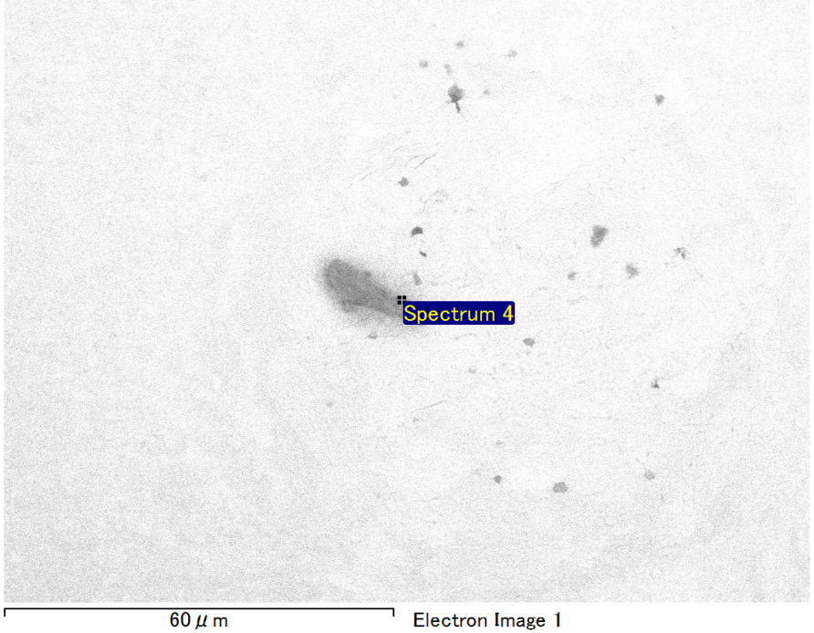

Spectrum Label: Spectrum 4

Livetime 90.0 s

Acquisition geometry ( degrees ):

Tilt = 0.0

Azimuth = 0.0

Elevation = 30.0

Accelerating voltage = 10.00 kV

Total spectrum counts = 69564

|  |  |  |  |
| --- | --- | --- | --- |
| Sample data : | Energy (eV) | Resn. (eV) | Area |
| Strobe : | 3.8 | 53.69 | 917759 |
|  |  |  |  |
| Optimization data : Manganese K series |  |  |  |
|  | Energy (eV) | Resn. (eV) | Area |
| Strobe : | .1 | 53.38 | 1150729 |
| Optimization element : | 5892.6 | 129.89 | 573533 |

Spectrum processing :

No peaks omitted

Processing option : Oxygen by stoichiometry (Normalised)

Number of iterations = 1

Standard :

C CaCO3 1-Jun-1999 12:00 AM

Mg MgO 1-Jun-1999 12:00 AM

Si SiO2 1-Jun-1999 12:00 AM

Fe Fe 1-Jun-1999 12:00 AM

Au Au 1-Jun-1999 12:00 AM

|  |  |  |  |  |  |
| --- | --- | --- | --- | --- | --- |
| Element | Weight% | Atomic% | Compd% | Formula |  |
|  |  |  |  |  |  |
| C K | 2.95 | 9.96 | 10.82 | CO2 |  |
| Mg K | 4.13 | 6.89 | 6.85 | MgO |  |
| Si K | 2.45 | 3.54 | 5.25 | SiO2 |  |
| Fe L | 12.13 | 8.79 | 15.60 | FeO |  |
| Au M | 54.80 | 11.27 | 61.48 | Au2O3 |  |
| O | 23.53 | 59.56 |  |  |  |
| Totals | 100.00 |  |  |  |  |

Project: Project 1

Owner: Operator

Site: Site of Interest 11