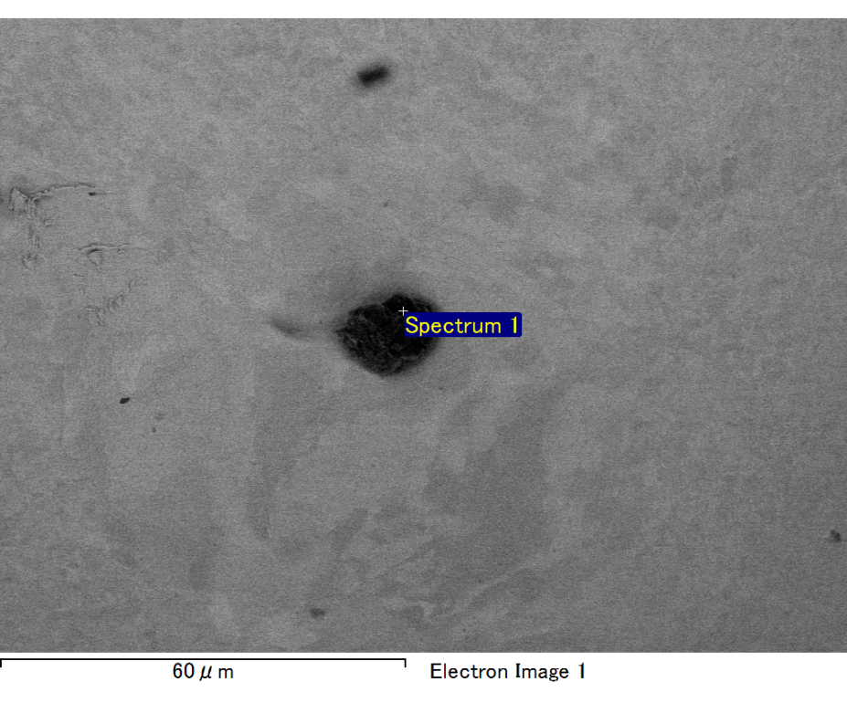

Spectrum processing :

No peaks omitted

Processing option : All elements analyzed (Normalised)

Number of iterations = 2

Standard :

C CaCO3 1-Jun-1999 12:00 AM

O SiO2 1-Jun-1999 12:00 AM

Mg MgO 1-Jun-1999 12:00 AM

Si SiO2 1-Jun-1999 12:00 AM

Fe Fe 1-Jun-1999 12:00 AM

Au Au 1-Jun-1999 12:00 AM

|  |  |  |  |
| --- | --- | --- | --- |
| Element | Weight% | Atomic% |  |
|  |  |  |  |
| C K | 2.51 | 8.60 |  |
| O K | 22.18 | 57.12 |  |
| Mg K | 4.16 | 7.06 |  |
| Si K | 5.74 | 8.43 |  |
| Fe L | 9.69 | 7.15 |  |
| Au M | 55.71 | 11.65 |  |
|  |  |  |  |
| Totals | 100.00 |  |  |

Spectrum Label: Spectrum 1

Livetime 60.0 s

Acquisition geometry ( degrees ):

Tilt = 15.0

Azimuth = 0.0

Elevation = 30.0

Accelerating voltage = 10.00 kV

Total spectrum counts = 53573

|  |  |  |  |
| --- | --- | --- | --- |
| Sample data : | Energy (eV) | Resn. (eV) | Area |
| Strobe : | 3.8 | 47.27 | 1001318 |
|  |  |  |  |

No quant optimization performed

Sample: Sample 1

Type: Default

ID:

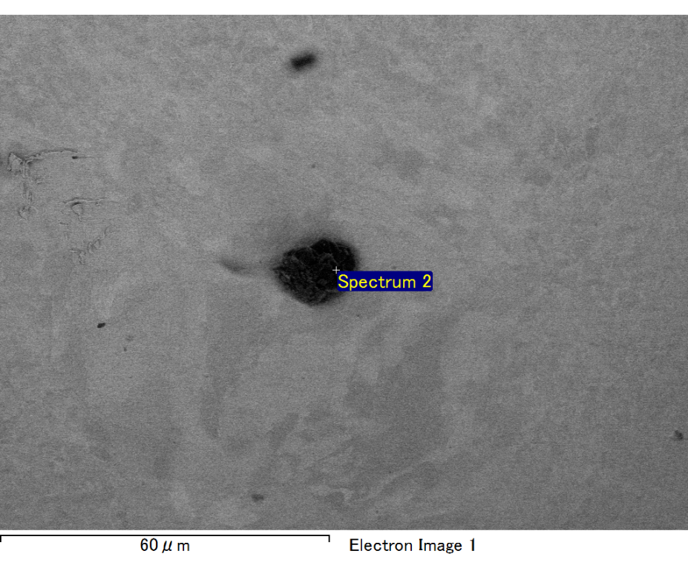

Spectrum processing :

No peaks omitted

Processing option : All elements analyzed (Normalised)

Number of iterations = 2

Standard :

C CaCO3 1-Jun-1999 12:00 AM

O SiO2 1-Jun-1999 12:00 AM

Mg MgO 1-Jun-1999 12:00 AM

Si SiO2 1-Jun-1999 12:00 AM

Fe Fe 1-Jun-1999 12:00 AM

Au Au 1-Jun-1999 12:00 AM

|  |  |  |  |
| --- | --- | --- | --- |
| Element | Weight% | Atomic% |  |
|  |  |  |  |
| C K | 2.77 | 11.83 |  |
| O K | 14.94 | 47.94 |  |
| Mg K | 3.80 | 8.03 |  |
| Si K | 5.41 | 9.89 |  |
| Fe L | 4.98 | 4.58 |  |
| Au M | 68.10 | 17.75 |  |
|  |  |  |  |
| Totals | 100.00 |  |  |

Spectrum Label: Spectrum 2

Livetime 60.0 s

Acquisition geometry ( degrees ):

Tilt = 15.0

Azimuth = 0.0

Elevation = 30.0

Accelerating voltage = 10.00 kV

Total spectrum counts = 48250

|  |  |  |  |
| --- | --- | --- | --- |
| Sample data : | Energy (eV) | Resn. (eV) | Area |
| Strobe : | 3.8 | 47.27 | 1000332 |
|  |  |  |  |

No quant optimization performed

Sample: Sample 1

Type: Default

ID:

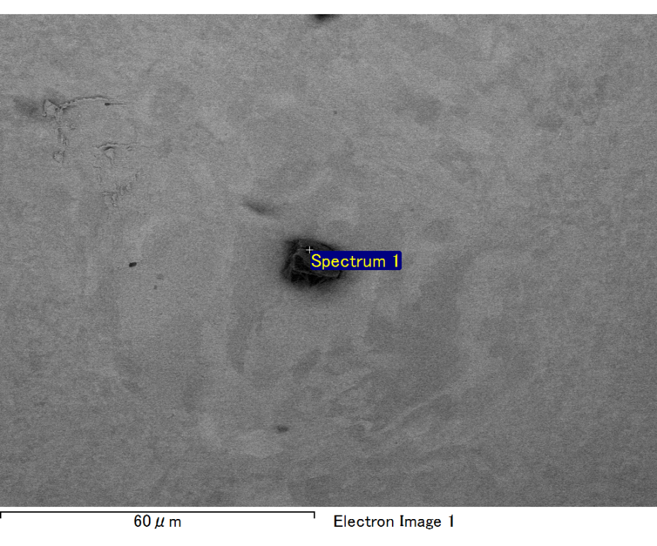

Spectrum processing :

Peaks possibly omitted : 0.706, 6.415 keV

Processing option : All elements analyzed (Normalised)

Number of iterations = 2

Standard :

C CaCO3 1-Jun-1999 12:00 AM

O SiO2 1-Jun-1999 12:00 AM

Mg MgO 1-Jun-1999 12:00 AM

Si SiO2 1-Jun-1999 12:00 AM

Au Au 1-Jun-1999 12:00 AM

|  |  |  |  |
| --- | --- | --- | --- |
| Element | Weight% | Atomic% |  |
|  |  |  |  |
| C K | 3.58 | 12.43 |  |
| O K | 22.44 | 58.46 |  |
| Mg K | 4.23 | 7.26 |  |
| Si K | 5.57 | 8.26 |  |
| Au M | 64.18 | 13.58 |  |
|  |  |  |  |
| Totals | 100.00 |  |  |

Spectrum Label: Spectrum 1

Livetime 60.0 s

Acquisition geometry ( degrees ):

Tilt = 15.0

Azimuth = 0.0

Elevation = 30.0

Accelerating voltage = 10.00 kV

Total spectrum counts = 53480

|  |  |  |  |
| --- | --- | --- | --- |
| Sample data : | Energy (eV) | Resn. (eV) | Area |
| Strobe : | 3.8 | 47.23 | 1000539 |
|  |  |  |  |

No quant optimization performed

Sample: Sample 1

Type: Default

ID:

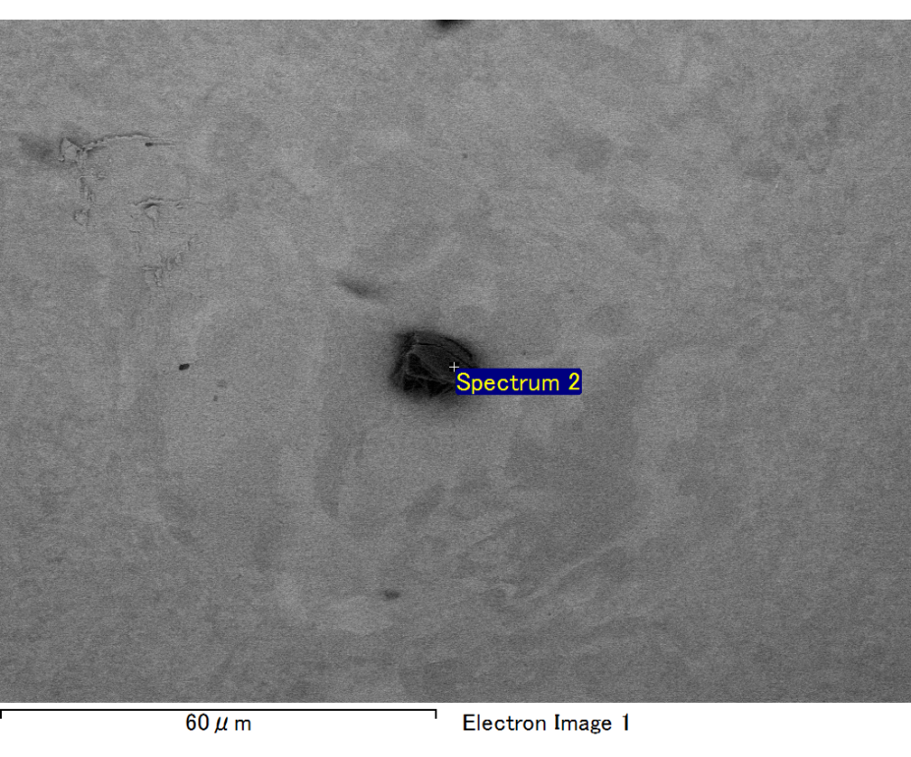

Spectrum processing :

No peaks omitted

Processing option : All elements analyzed (Normalised)

Number of iterations = 2

Standard :

C CaCO3 1-Jun-1999 12:00 AM

O SiO2 1-Jun-1999 12:00 AM

Mg MgO 1-Jun-1999 12:00 AM

Si SiO2 1-Jun-1999 12:00 AM

Fe Fe 1-Jun-1999 12:00 AM

Au Au 1-Jun-1999 12:00 AM

|  |  |  |  |
| --- | --- | --- | --- |
| Element | Weight% | Atomic% |  |
|  |  |  |  |
| C K | 2.73 | 9.57 |  |
| O K | 21.76 | 57.35 |  |
| Mg K | 4.10 | 7.11 |  |
| Si K | 5.38 | 8.07 |  |
| Fe L | 6.95 | 5.25 |  |
| Au M | 59.09 | 12.65 |  |
|  |  |  |  |
| Totals | 100.00 |  |  |

Spectrum Label: Spectrum 2

Livetime 60.0 s

Acquisition geometry ( degrees ):

Tilt = 15.0

Azimuth = 0.0

Elevation = 30.0

Accelerating voltage = 10.00 kV

Total spectrum counts = 53106

|  |  |  |  |
| --- | --- | --- | --- |
| Sample data : | Energy (eV) | Resn. (eV) | Area |
| Strobe : | 3.8 | 47.32 | 1000295 |
|  |  |  |  |

No quant optimization performed

Sample: Sample 1

Type: Default

ID:

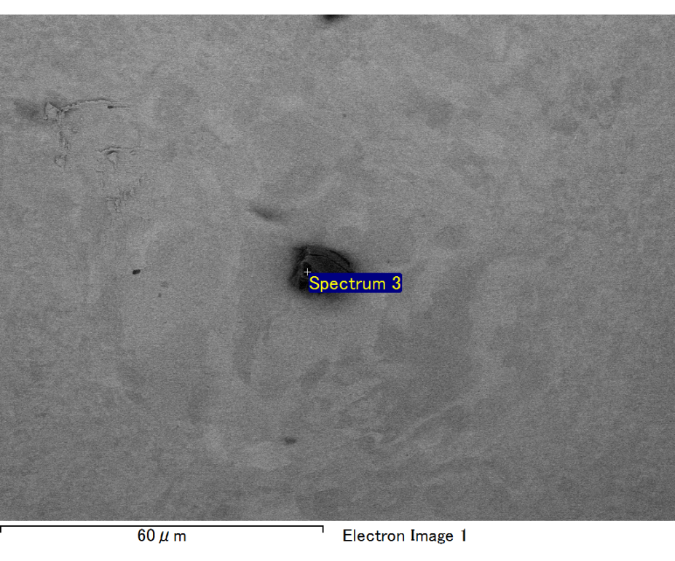

Spectrum processing :

No peaks omitted

Processing option : All elements analyzed (Normalised)

Number of iterations = 2

Standard :

C CaCO3 1-Jun-1999 12:00 AM

O SiO2 1-Jun-1999 12:00 AM

Mg MgO 1-Jun-1999 12:00 AM

Si SiO2 1-Jun-1999 12:00 AM

Au Au 1-Jun-1999 12:00 AM

|  |  |  |  |
| --- | --- | --- | --- |
| Element | Weight% | Atomic% |  |
|  |  |  |  |
| C K | 2.72 | 10.93 |  |
| O K | 17.82 | 53.67 |  |
| Mg K | 4.23 | 8.39 |  |
| Si K | 5.85 | 10.03 |  |
| Au M | 69.38 | 16.98 |  |
|  |  |  |  |
| Totals | 100.00 |  |  |

Spectrum Label: Spectrum 3

Livetime 60.0 s

Acquisition geometry ( degrees ):

Tilt = 15.0

Azimuth = 0.0

Elevation = 30.0

Accelerating voltage = 10.00 kV

Total spectrum counts = 48119

|  |  |  |  |
| --- | --- | --- | --- |
| Sample data : | Energy (eV) | Resn. (eV) | Area |
| Strobe : | 3.8 | 47.21 | 1001119 |
|  |  |  |  |

No quant optimization performed

Sample: Sample 1

Type: Default

ID: