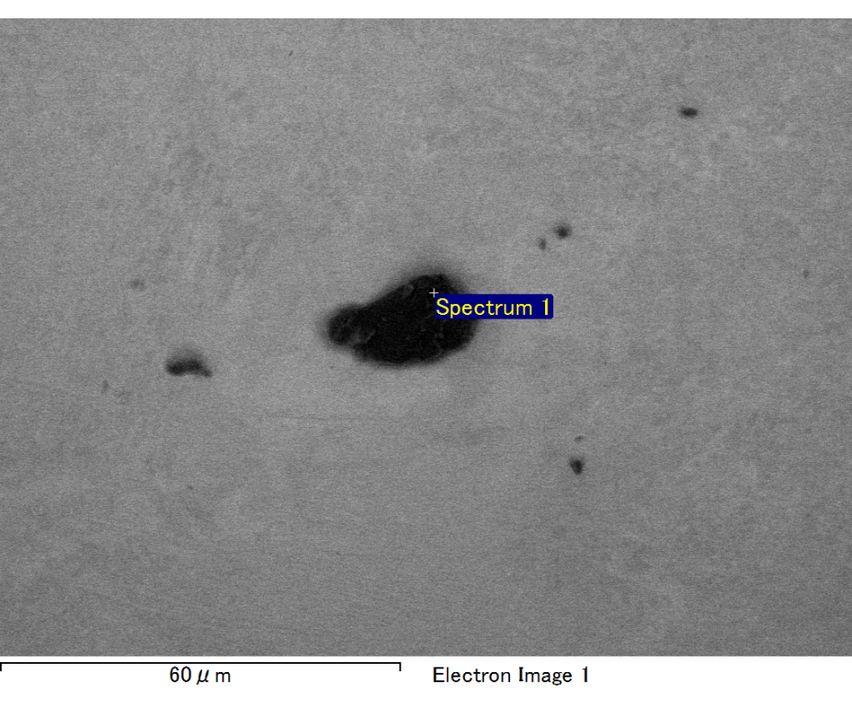

Spectrum processing :

No peaks omitted

Processing option : All elements analyzed (Normalised)

Number of iterations = 2

Standard :

C CaCO3 1-Jun-1999 12:00 AM

O SiO2 1-Jun-1999 12:00 AM

Mg MgO 1-Jun-1999 12:00 AM

Si SiO2 1-Jun-1999 12:00 AM

Fe Fe 1-Jun-1999 12:00 AM

Au Au 1-Jun-1999 12:00 AM

|  |  |  |  |
| --- | --- | --- | --- |
| Element | Weight% | Atomic% |  |
|  |  |  |  |
| C K | 2.04 | 7.14 |  |
| O K | 20.86 | 54.87 |  |
| Mg K | 6.02 | 10.42 |  |
| Si K | 4.46 | 6.69 |  |
| Fe L | 12.30 | 9.27 |  |
| Au M | 54.32 | 11.61 |  |
|  |  |  |  |
| Totals | 100.00 |  |  |

Spectrum Label: Spectrum 1

Livetime 60.0 s

Acquisition geometry ( degrees ):

Tilt = 15.0

Azimuth = 0.0

Elevation = 30.0

Accelerating voltage = 10.00 kV

Total spectrum counts = 50825

|  |  |  |  |
| --- | --- | --- | --- |
| Sample data : | Energy (eV) | Resn. (eV) | Area |
| Strobe : | 3.8 | 47.27 | 1000846 |
|  |  |  |  |

No quant optimization performed

Sample: Sample 1

Type: Default

ID:

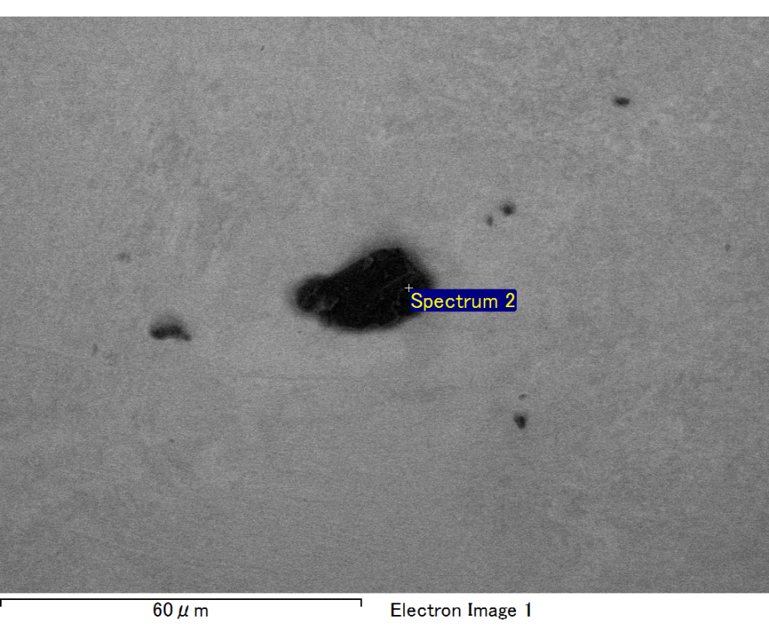

Spectrum processing :

No peaks omitted

Processing option : All elements analyzed (Normalised)

Number of iterations = 2

Standard :

C CaCO3 1-Jun-1999 12:00 AM

O SiO2 1-Jun-1999 12:00 AM

Mg MgO 1-Jun-1999 12:00 AM

Si SiO2 1-Jun-1999 12:00 AM

Fe Fe 1-Jun-1999 12:00 AM

Au Au 1-Jun-1999 12:00 AM

|  |  |  |  |
| --- | --- | --- | --- |
| Element | Weight% | Atomic% |  |
|  |  |  |  |
| C K | 1.88 | 7.28 |  |
| O K | 18.62 | 54.12 |  |
| Mg K | 5.53 | 10.57 |  |
| Si K | 4.09 | 6.78 |  |
| Fe L | 7.96 | 6.63 |  |
| Au M | 61.92 | 14.62 |  |
|  |  |  |  |
| Totals | 100.00 |  |  |

Spectrum Label: Spectrum 2

Livetime 60.0 s

Acquisition geometry ( degrees ):

Tilt = 15.0

Azimuth = 0.0

Elevation = 30.0

Accelerating voltage = 10.00 kV

Total spectrum counts = 48803

|  |  |  |  |
| --- | --- | --- | --- |
| Sample data : | Energy (eV) | Resn. (eV) | Area |
| Strobe : | 3.8 | 47.29 | 1000604 |
|  |  |  |  |

No quant optimization performed

Sample: Sample 1

Type: Default

ID:

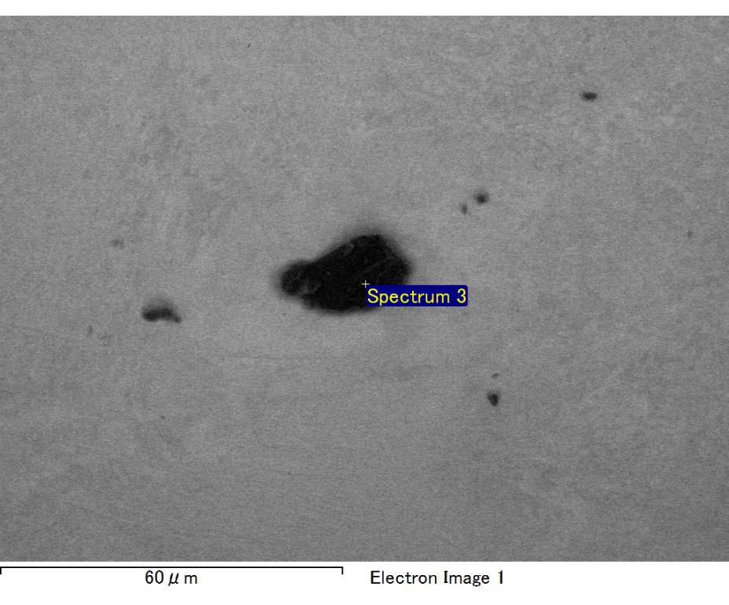

Spectrum processing :

Peak possibly omitted : 5.495 keV

Processing option : All elements analyzed (Normalised)

Number of iterations = 2

Standard :

C CaCO3 1-Jun-1999 12:00 AM

O SiO2 1-Jun-1999 12:00 AM

Mg MgO 1-Jun-1999 12:00 AM

Si SiO2 1-Jun-1999 12:00 AM

Fe Fe 1-Jun-1999 12:00 AM

Au Au 1-Jun-1999 12:00 AM

|  |  |  |  |
| --- | --- | --- | --- |
| Element | Weight% | Atomic% |  |
|  |  |  |  |
| C K | 2.61 | 8.95 |  |
| O K | 21.43 | 55.13 |  |
| Mg K | 6.43 | 10.88 |  |
| Si K | 4.37 | 6.41 |  |
| Fe L | 9.52 | 7.01 |  |
| Au M | 55.63 | 11.62 |  |
|  |  |  |  |
| Totals | 100.00 |  |  |

Spectrum Label: Spectrum 3

Livetime 60.0 s

Acquisition geometry ( degrees ):

Tilt = 15.0

Azimuth = 0.0

Elevation = 30.0

Accelerating voltage = 10.00 kV

Total spectrum counts = 50989

|  |  |  |  |
| --- | --- | --- | --- |
| Sample data : | Energy (eV) | Resn. (eV) | Area |
| Strobe : | 3.8 | 47.23 | 999491 |
|  |  |  |  |

No quant optimization performed

Sample: Sample 1

Type: Default

ID:

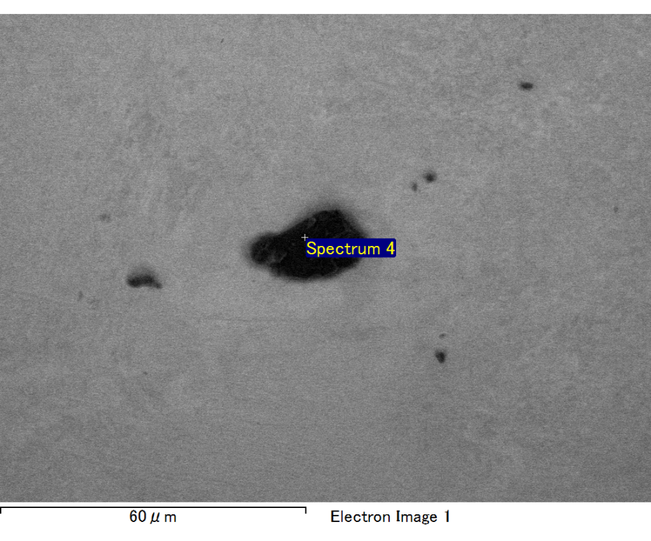

Spectrum processing :

No peaks omitted

Processing option : All elements analyzed (Normalised)

Number of iterations = 2

Standard :

C CaCO3 1-Jun-1999 12:00 AM

O SiO2 1-Jun-1999 12:00 AM

Mg MgO 1-Jun-1999 12:00 AM

Si SiO2 1-Jun-1999 12:00 AM

Fe Fe 1-Jun-1999 12:00 AM

Au Au 1-Jun-1999 12:00 AM

|  |  |  |  |
| --- | --- | --- | --- |
| Element | Weight% | Atomic% |  |
|  |  |  |  |
| C K | 2.52 | 8.77 |  |
| O K | 20.67 | 53.93 |  |
| Mg K | 6.14 | 10.54 |  |
| Si K | 4.21 | 6.26 |  |
| Fe L | 11.98 | 8.96 |  |
| Au M | 54.48 | 11.55 |  |
|  |  |  |  |
| Totals | 100.00 |  |  |

Spectrum Label: Spectrum 4

Livetime 60.0 s

Acquisition geometry ( degrees ):

Tilt = 15.0

Azimuth = 0.0

Elevation = 30.0

Accelerating voltage = 10.00 kV

Total spectrum counts = 51220

|  |  |  |  |
| --- | --- | --- | --- |
| Sample data : | Energy (eV) | Resn. (eV) | Area |
| Strobe : | 3.8 | 47.31 | 1001071 |
|  |  |  |  |

No quant optimization performed

Sample: Sample 1

Type: Default

ID:

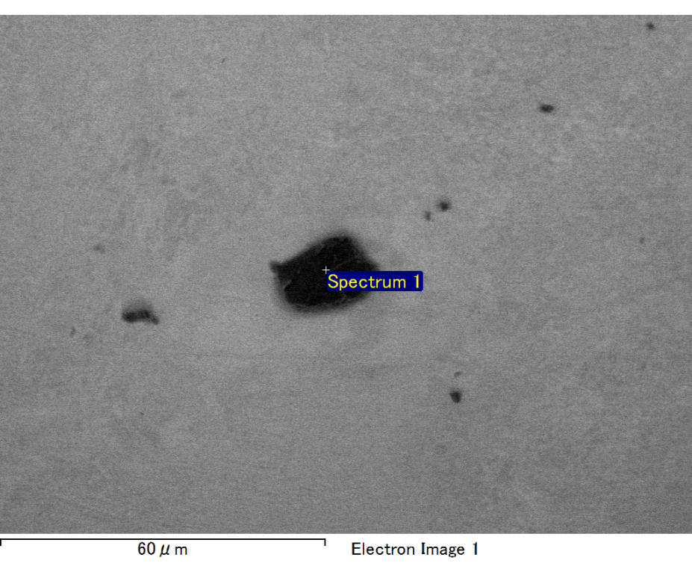

Spectrum processing :

No peaks omitted

Processing option : All elements analyzed (Normalised)

Number of iterations = 2

Standard :

C CaCO3 1-Jun-1999 12:00 AM

O SiO2 1-Jun-1999 12:00 AM

Mg MgO 1-Jun-1999 12:00 AM

Si SiO2 1-Jun-1999 12:00 AM

Fe Fe 1-Jun-1999 12:00 AM

Au Au 1-Jun-1999 12:00 AM

|  |  |  |  |
| --- | --- | --- | --- |
| Element | Weight% | Atomic% |  |
|  |  |  |  |
| C K | 2.31 | 7.81 |  |
| O K | 22.25 | 56.57 |  |
| Mg K | 6.04 | 10.11 |  |
| Si K | 4.47 | 6.47 |  |
| Fe L | 10.78 | 7.85 |  |
| Au M | 54.17 | 11.19 |  |
|  |  |  |  |
| Totals | 100.00 |  |  |

Spectrum Label: Spectrum 1

Livetime 60.0 s

Acquisition geometry ( degrees ):

Tilt = 15.0

Azimuth = 0.0

Elevation = 30.0

Accelerating voltage = 10.00 kV

Total spectrum counts = 52123

|  |  |  |  |
| --- | --- | --- | --- |
| Sample data : | Energy (eV) | Resn. (eV) | Area |
| Strobe : | 3.8 | 47.32 | 1000444 |
|  |  |  |  |

No quant optimization performed

Sample: Sample 1

Type: Default

ID: