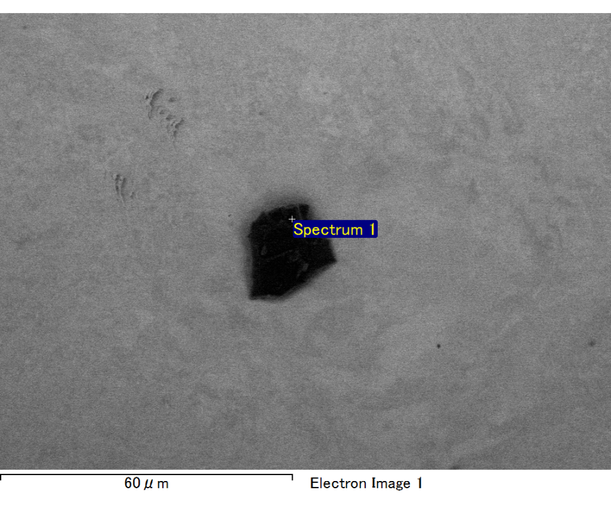

Spectrum processing :

No peaks omitted

Processing option : All elements analyzed (Normalised)

Number of iterations = 2

Standard :

C CaCO3 1-Jun-1999 12:00 AM

O SiO2 1-Jun-1999 12:00 AM

Mg MgO 1-Jun-1999 12:00 AM

Si SiO2 1-Jun-1999 12:00 AM

Fe Fe 1-Jun-1999 12:00 AM

Au Au 1-Jun-1999 12:00 AM

|  |  |  |  |
| --- | --- | --- | --- |
| Element | Weight% | Atomic% |  |
|  |  |  |  |
| C K | 2.81 | 9.65 |  |
| O K | 21.32 | 55.03 |  |
| Mg K | 6.18 | 10.50 |  |
| Si K | 4.15 | 6.10 |  |
| Fe L | 9.38 | 6.94 |  |
| Au M | 56.16 | 11.78 |  |
|  |  |  |  |
| Totals | 100.00 |  |  |

Spectrum Label: Spectrum 1

Livetime 60.0 s

Acquisition geometry ( degrees ):

Tilt = 15.0

Azimuth = 0.0

Elevation = 30.0

Accelerating voltage = 10.00 kV

Total spectrum counts = 51288

|  |  |  |  |
| --- | --- | --- | --- |
| Sample data : | Energy (eV) | Resn. (eV) | Area |
| Strobe : | 3.8 | 47.19 | 1000926 |
|  |  |  |  |

No quant optimization performed

Sample: Sample 1

Type: Default

ID:

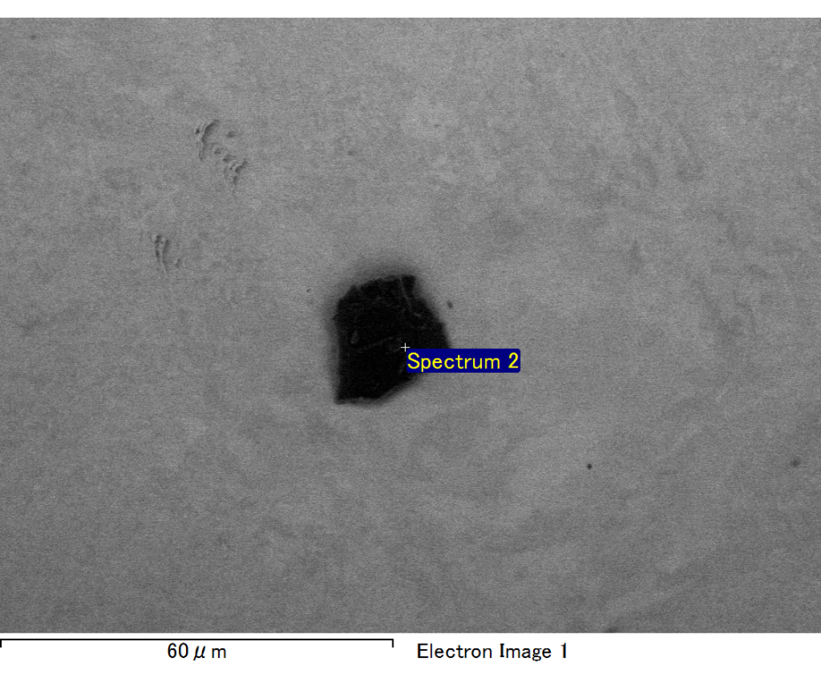

Spectrum processing :

No peaks omitted

Processing option : All elements analyzed (Normalised)

Number of iterations = 2

Standard :

C CaCO3 1-Jun-1999 12:00 AM

O SiO2 1-Jun-1999 12:00 AM

Mg MgO 1-Jun-1999 12:00 AM

Si SiO2 1-Jun-1999 12:00 AM

Fe Fe 1-Jun-1999 12:00 AM

Au Au 1-Jun-1999 12:00 AM

|  |  |  |  |
| --- | --- | --- | --- |
| Element | Weight% | Atomic% |  |
|  |  |  |  |
| C K | 3.06 | 10.51 |  |
| O K | 21.20 | 54.68 |  |
| Mg K | 5.23 | 8.88 |  |
| Si K | 5.60 | 8.22 |  |
| Fe L | 7.76 | 5.74 |  |
| Au M | 57.14 | 11.97 |  |
|  |  |  |  |
| Totals | 100.00 |  |  |

Spectrum Label: Spectrum 2

Livetime 60.0 s

Acquisition geometry ( degrees ):

Tilt = 15.0

Azimuth = 0.0

Elevation = 30.0

Accelerating voltage = 10.00 kV

Total spectrum counts = 50914

|  |  |  |  |
| --- | --- | --- | --- |
| Sample data : | Energy (eV) | Resn. (eV) | Area |
| Strobe : | 3.8 | 47.22 | 1000509 |
|  |  |  |  |

No quant optimization performed

Sample: Sample 1

Type: Default

ID:

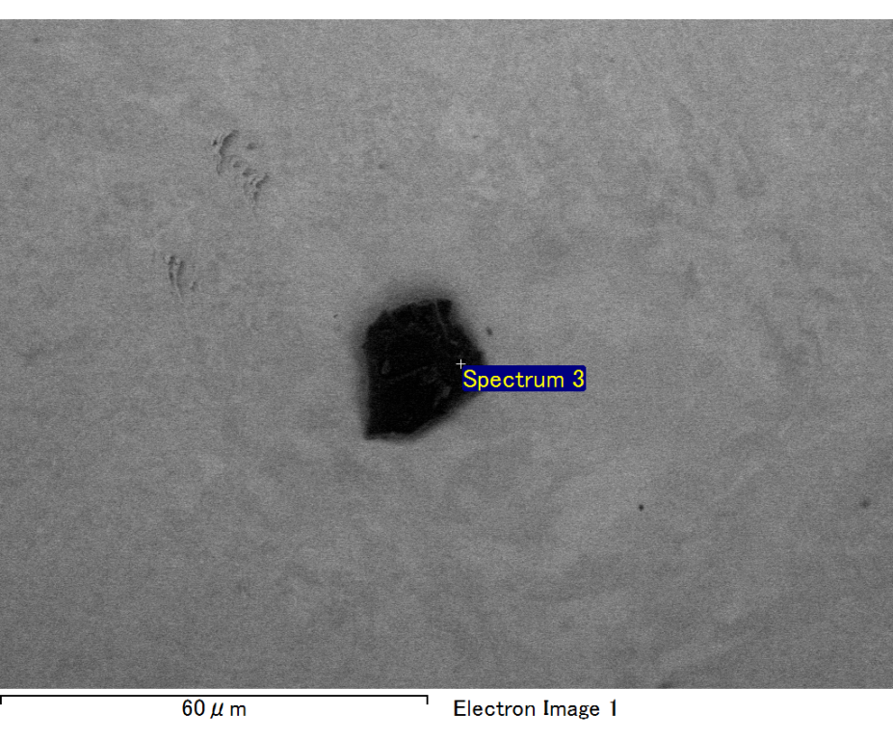

Spectrum processing :

No peaks omitted

Processing option : All elements analyzed (Normalised)

Number of iterations = 2

Standard :

C CaCO3 1-Jun-1999 12:00 AM

O SiO2 1-Jun-1999 12:00 AM

Mg MgO 1-Jun-1999 12:00 AM

Si SiO2 1-Jun-1999 12:00 AM

Fe Fe 1-Jun-1999 12:00 AM

Au Au 1-Jun-1999 12:00 AM

|  |  |  |  |
| --- | --- | --- | --- |
| Element | Weight% | Atomic% |  |
|  |  |  |  |
| C K | 2.14 | 7.72 |  |
| O K | 19.89 | 53.87 |  |
| Mg K | 6.22 | 11.09 |  |
| Si K | 4.42 | 6.82 |  |
| Fe L | 10.23 | 7.94 |  |
| Au M | 57.10 | 12.56 |  |
|  |  |  |  |
| Totals | 100.00 |  |  |

Spectrum Label: Spectrum 3

Livetime 60.0 s

Acquisition geometry ( degrees ):

Tilt = 15.0

Azimuth = 0.0

Elevation = 30.0

Accelerating voltage = 10.00 kV

Total spectrum counts = 51021

|  |  |  |  |
| --- | --- | --- | --- |
| Sample data : | Energy (eV) | Resn. (eV) | Area |
| Strobe : | 3.8 | 47.24 | 1000975 |
|  |  |  |  |

No quant optimization performed

Sample: Sample 1

Type: Default

ID:

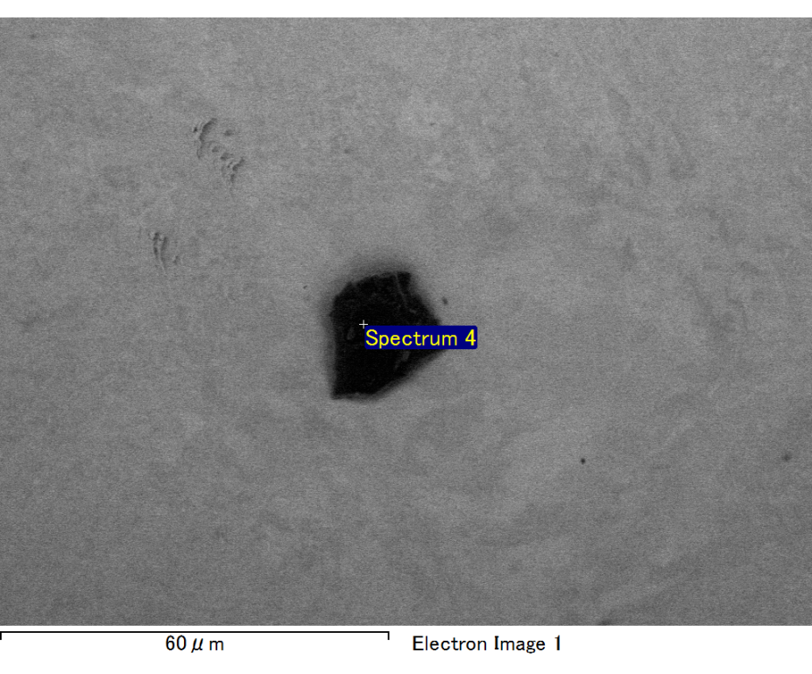

Spectrum processing :

No peaks omitted

Processing option : All elements analyzed (Normalised)

Number of iterations = 2

Standard :

C CaCO3 1-Jun-1999 12:00 AM

O SiO2 1-Jun-1999 12:00 AM

Mg MgO 1-Jun-1999 12:00 AM

Si SiO2 1-Jun-1999 12:00 AM

Fe Fe 1-Jun-1999 12:00 AM

Au Au 1-Jun-1999 12:00 AM

|  |  |  |  |
| --- | --- | --- | --- |
| Element | Weight% | Atomic% |  |
|  |  |  |  |
| C K | 2.58 | 8.99 |  |
| O K | 20.94 | 54.80 |  |
| Mg K | 5.74 | 9.88 |  |
| Si K | 4.05 | 6.04 |  |
| Fe L | 11.38 | 8.53 |  |
| Au M | 55.31 | 11.76 |  |
|  |  |  |  |
| Totals | 100.00 |  |  |

Spectrum Label: Spectrum 4

Livetime 60.0 s

Acquisition geometry ( degrees ):

Tilt = 15.0

Azimuth = 0.0

Elevation = 30.0

Accelerating voltage = 10.00 kV

Total spectrum counts = 50738

|  |  |  |  |
| --- | --- | --- | --- |
| Sample data : | Energy (eV) | Resn. (eV) | Area |
| Strobe : | 3.8 | 47.29 | 1000532 |
|  |  |  |  |

No quant optimization performed

Sample: Sample 1

Type: Default

ID:

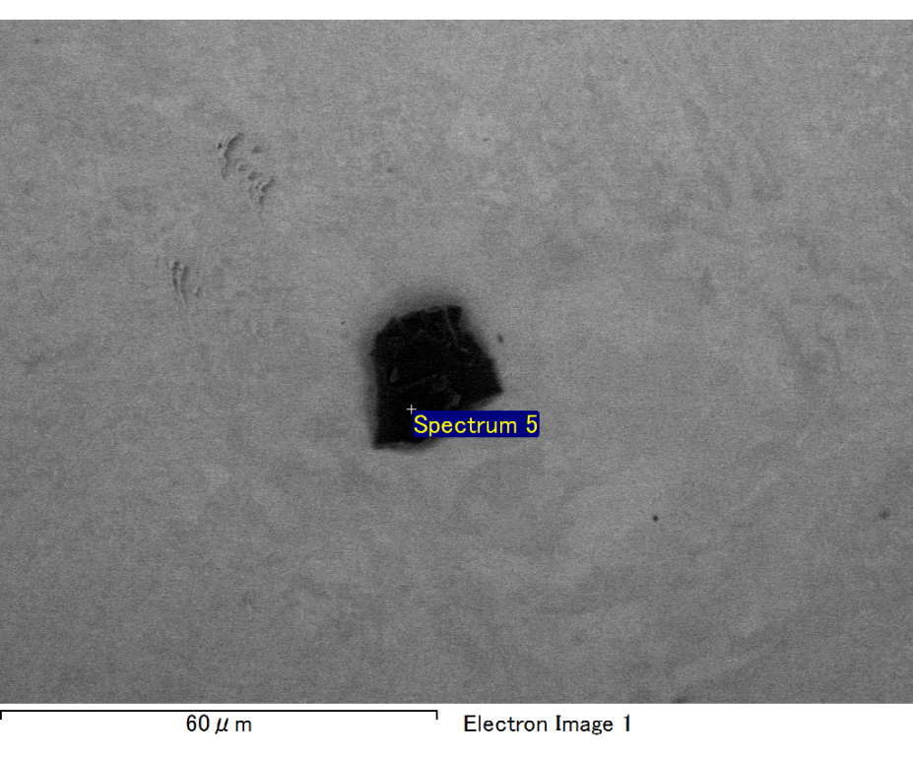

Spectrum processing :

No peaks omitted

Processing option : All elements analyzed (Normalised)

Number of iterations = 2

Standard :

C CaCO3 1-Jun-1999 12:00 AM

O SiO2 1-Jun-1999 12:00 AM

Mg MgO 1-Jun-1999 12:00 AM

Si SiO2 1-Jun-1999 12:00 AM

Au Au 1-Jun-1999 12:00 AM

|  |  |  |  |
| --- | --- | --- | --- |
| Element | Weight% | Atomic% |  |
|  |  |  |  |
| C K | 2.85 | 9.61 |  |
| O K | 23.99 | 60.73 |  |
| Mg K | 4.99 | 8.31 |  |
| Si K | 5.93 | 8.55 |  |
| Au M | 62.25 | 12.80 |  |
|  |  |  |  |
| Totals | 100.00 |  |  |

Spectrum Label: Spectrum 5

Livetime 60.0 s

Acquisition geometry ( degrees ):

Tilt = 15.0

Azimuth = 0.0

Elevation = 30.0

Accelerating voltage = 10.00 kV

Total spectrum counts = 50624

|  |  |  |  |
| --- | --- | --- | --- |
| Sample data : | Energy (eV) | Resn. (eV) | Area |
| Strobe : | 3.8 | 47.25 | 1000578 |
|  |  |  |  |

No quant optimization performed

Sample: Sample 1

Type: Default

ID: