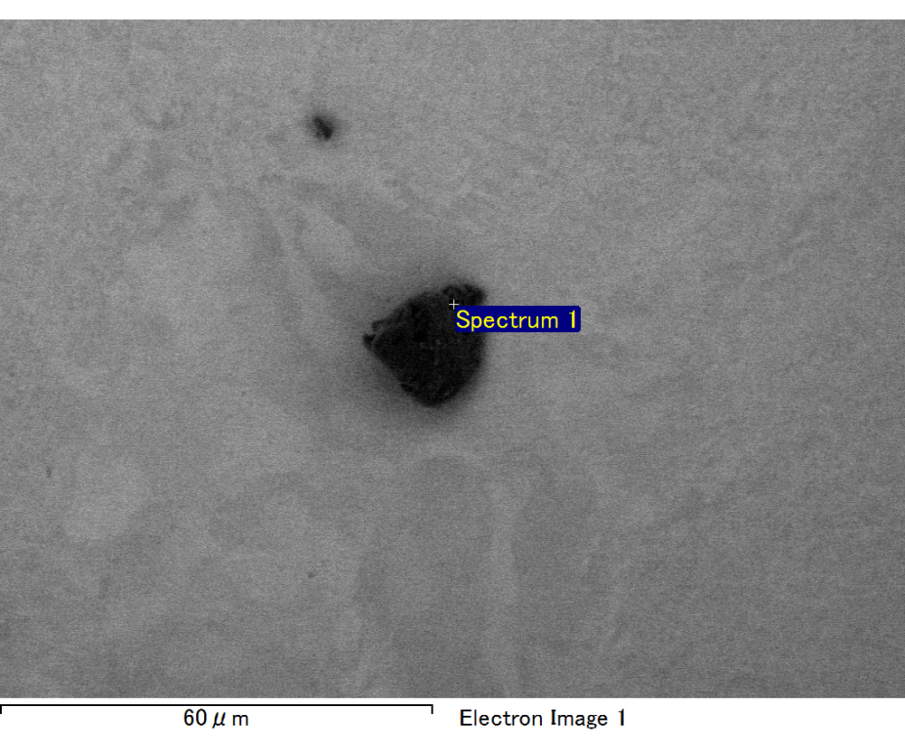

Spectrum processing :

No peaks omitted

Processing option : All elements analyzed (Normalised)

Number of iterations = 2

Standard :

C CaCO3 1-Jun-1999 12:00 AM

O SiO2 1-Jun-1999 12:00 AM

Mg MgO 1-Jun-1999 12:00 AM

Si SiO2 1-Jun-1999 12:00 AM

Fe Fe 1-Jun-1999 12:00 AM

Au Au 1-Jun-1999 12:00 AM

|  |  |  |  |
| --- | --- | --- | --- |
| Element | Weight% | Atomic% |  |
|  |  |  |  |
| C K | 2.19 | 8.08 |  |
| O K | 20.34 | 56.30 |  |
| Mg K | 4.06 | 7.40 |  |
| Si K | 5.68 | 8.95 |  |
| Fe L | 7.12 | 5.64 |  |
| Au M | 60.61 | 13.63 |  |
|  |  |  |  |
| Totals | 100.00 |  |  |

Spectrum Label: Spectrum 1

Livetime 60.0 s

Acquisition geometry ( degrees ):

Tilt = 15.0

Azimuth = 0.0

Elevation = 30.0

Accelerating voltage = 10.00 kV

Total spectrum counts = 53110

|  |  |  |  |
| --- | --- | --- | --- |
| Sample data : | Energy (eV) | Resn. (eV) | Area |
| Strobe : | 3.8 | 47.32 | 1001485 |
|  |  |  |  |

No quant optimization performed

Sample: Sample 1

Type: Default

ID:

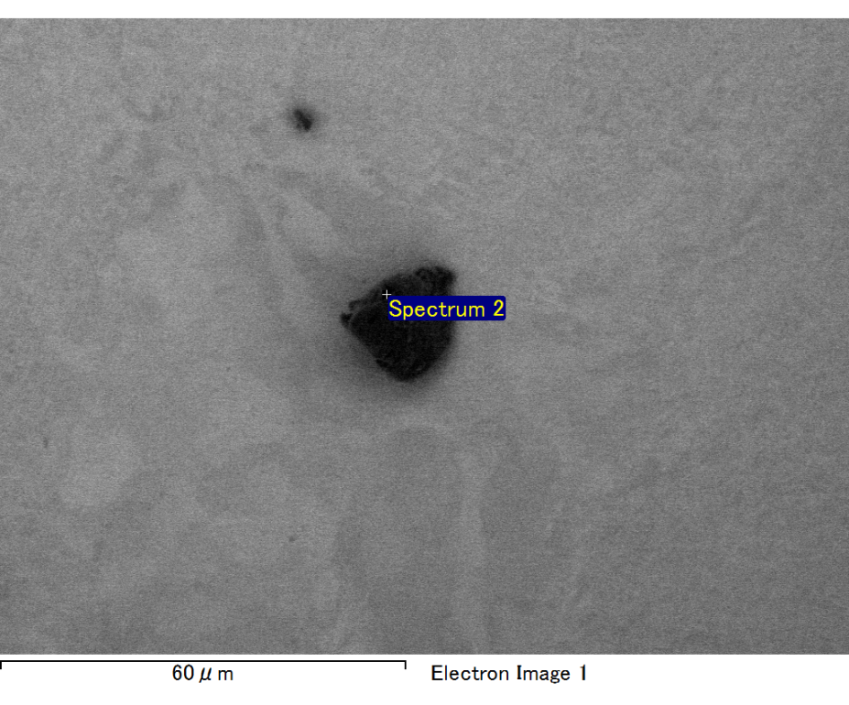

Spectrum processing :

Peak possibly omitted : 0.714 keV

Processing option : All elements analyzed (Normalised)

Number of iterations = 2

Standard :

C CaCO3 1-Jun-1999 12:00 AM

O SiO2 1-Jun-1999 12:00 AM

Mg MgO 1-Jun-1999 12:00 AM

Si SiO2 1-Jun-1999 12:00 AM

Au Au 1-Jun-1999 12:00 AM

|  |  |  |  |
| --- | --- | --- | --- |
| Element | Weight% | Atomic% |  |
|  |  |  |  |
| C K | 3.40 | 11.26 |  |
| O K | 23.13 | 57.58 |  |
| Mg K | 5.12 | 8.38 |  |
| Si K | 7.36 | 10.44 |  |
| Au M | 60.99 | 12.33 |  |
|  |  |  |  |
| Totals | 100.00 |  |  |

Spectrum Label: Spectrum 2

Livetime 60.0 s

Acquisition geometry ( degrees ):

Tilt = 15.0

Azimuth = 0.0

Elevation = 30.0

Accelerating voltage = 10.00 kV

Total spectrum counts = 50769

|  |  |  |  |
| --- | --- | --- | --- |
| Sample data : | Energy (eV) | Resn. (eV) | Area |
| Strobe : | 3.8 | 47.21 | 1000459 |
|  |  |  |  |

No quant optimization performed

Sample: Sample 1

Type: Default

ID:

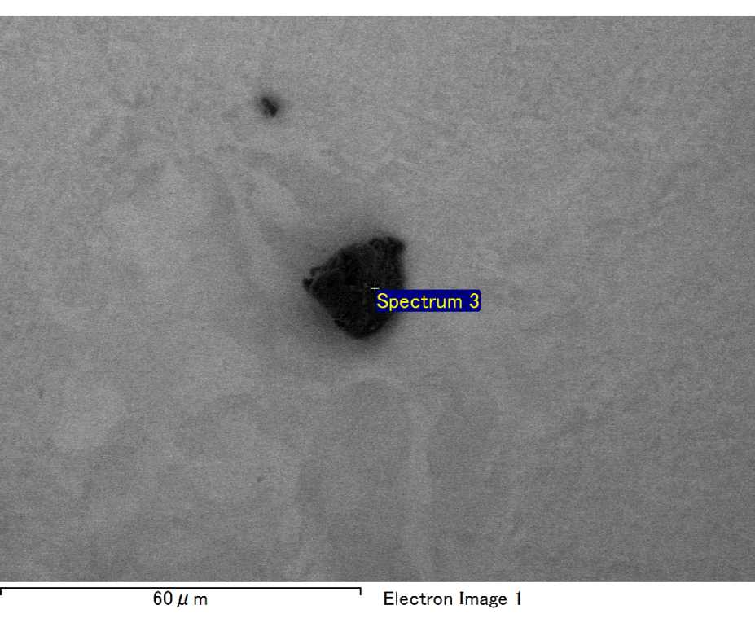

Spectrum processing :

No peaks omitted

Processing option : All elements analyzed (Normalised)

Number of iterations = 2

Standard :

C CaCO3 1-Jun-1999 12:00 AM

O SiO2 1-Jun-1999 12:00 AM

Mg MgO 1-Jun-1999 12:00 AM

Si SiO2 1-Jun-1999 12:00 AM

Fe Fe 1-Jun-1999 12:00 AM

Au Au 1-Jun-1999 12:00 AM

|  |  |  |  |
| --- | --- | --- | --- |
| Element | Weight% | Atomic% |  |
|  |  |  |  |
| C K | 3.10 | 11.65 |  |
| O K | 18.20 | 51.35 |  |
| Mg K | 4.18 | 7.77 |  |
| Si K | 5.87 | 9.43 |  |
| Fe L | 7.00 | 5.66 |  |
| Au M | 61.65 | 14.13 |  |
|  |  |  |  |
| Totals | 100.00 |  |  |

Spectrum Label: Spectrum 3

Livetime 60.0 s

Acquisition geometry ( degrees ):

Tilt = 15.0

Azimuth = 0.0

Elevation = 30.0

Accelerating voltage = 10.00 kV

Total spectrum counts = 50727

|  |  |  |  |
| --- | --- | --- | --- |
| Sample data : | Energy (eV) | Resn. (eV) | Area |
| Strobe : | 3.8 | 47.22 | 1000119 |
|  |  |  |  |

No quant optimization performed

Sample: Sample 1

Type: Default

ID:

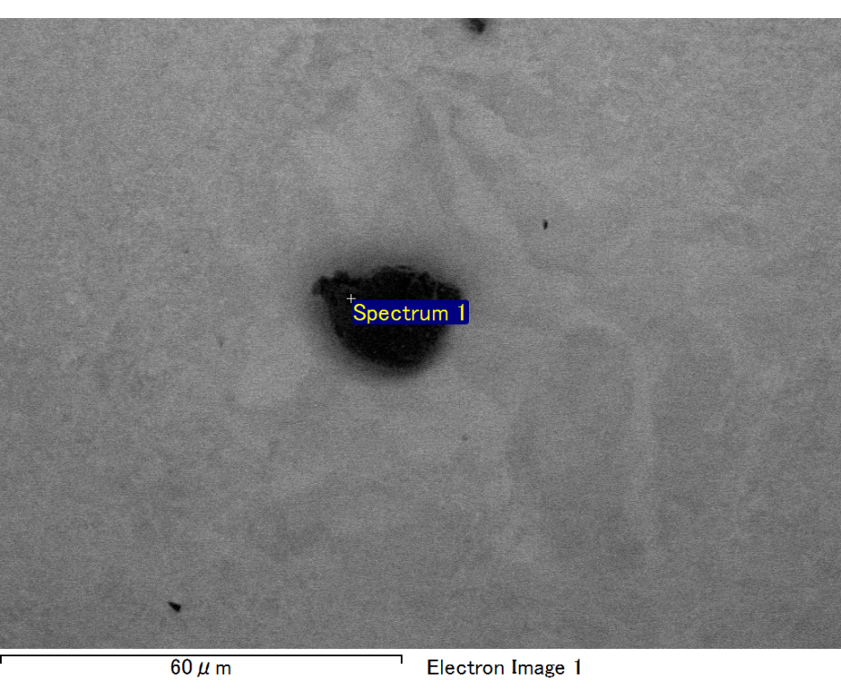

Spectrum processing :

No peaks omitted

Processing option : All elements analyzed (Normalised)

Number of iterations = 2

Standard :

C CaCO3 1-Jun-1999 12:00 AM

O SiO2 1-Jun-1999 12:00 AM

Mg MgO 1-Jun-1999 12:00 AM

Si SiO2 1-Jun-1999 12:00 AM

Fe Fe 1-Jun-1999 12:00 AM

Au Au 1-Jun-1999 12:00 AM

|  |  |  |  |
| --- | --- | --- | --- |
| Element | Weight% | Atomic% |  |
|  |  |  |  |
| C K | 3.19 | 11.59 |  |
| O K | 19.20 | 52.33 |  |
| Mg K | 4.37 | 7.84 |  |
| Si K | 6.17 | 9.57 |  |
| Fe L | 6.84 | 5.34 |  |
| Au M | 60.22 | 13.33 |  |
|  |  |  |  |
| Totals | 100.00 |  |  |

Spectrum Label: Spectrum 1

Livetime 60.0 s

Acquisition geometry ( degrees ):

Tilt = 15.0

Azimuth = 0.0

Elevation = 30.0

Accelerating voltage = 10.00 kV

Total spectrum counts = 51234

|  |  |  |  |
| --- | --- | --- | --- |
| Sample data : | Energy (eV) | Resn. (eV) | Area |
| Strobe : | 3.8 | 47.26 | 1000298 |
|  |  |  |  |

No quant optimization performed

Sample: Sample 1

Type: Default

ID:

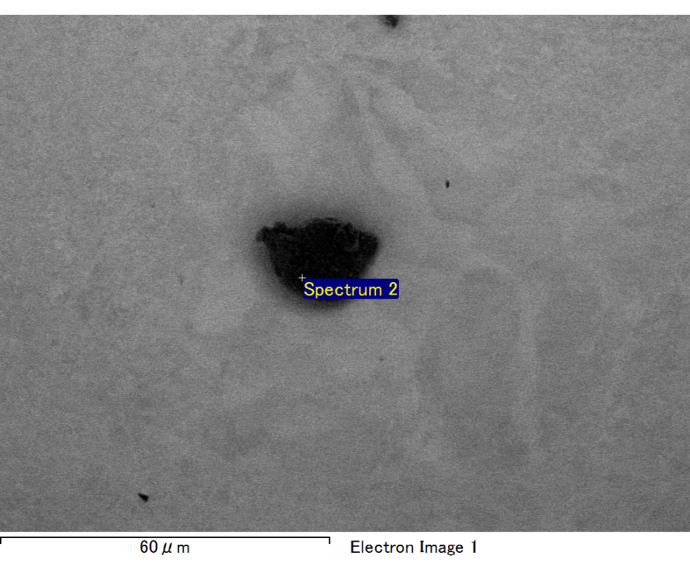

Spectrum processing :

Peak possibly omitted : 0.710 keV

Processing option : All elements analyzed (Normalised)

Number of iterations = 2

Standard :

C CaCO3 1-Jun-1999 12:00 AM

O SiO2 1-Jun-1999 12:00 AM

Mg MgO 1-Jun-1999 12:00 AM

Si SiO2 1-Jun-1999 12:00 AM

Au Au 1-Jun-1999 12:00 AM

|  |  |  |  |
| --- | --- | --- | --- |
| Element | Weight% | Atomic% |  |
|  |  |  |  |
| C K | 3.26 | 13.20 |  |
| O K | 17.33 | 52.64 |  |
| Mg K | 3.60 | 7.20 |  |
| Si K | 5.56 | 9.63 |  |
| Au M | 70.25 | 17.34 |  |
|  |  |  |  |
| Totals | 100.00 |  |  |

Spectrum Label: Spectrum 2

Livetime 60.0 s

Acquisition geometry ( degrees ):

Tilt = 15.0

Azimuth = 0.0

Elevation = 30.0

Accelerating voltage = 10.00 kV

Total spectrum counts = 47253

|  |  |  |  |
| --- | --- | --- | --- |
| Sample data : | Energy (eV) | Resn. (eV) | Area |
| Strobe : | 3.8 | 47.24 | 1000617 |
|  |  |  |  |

No quant optimization performed

Sample: Sample 1

Type: Default

ID: