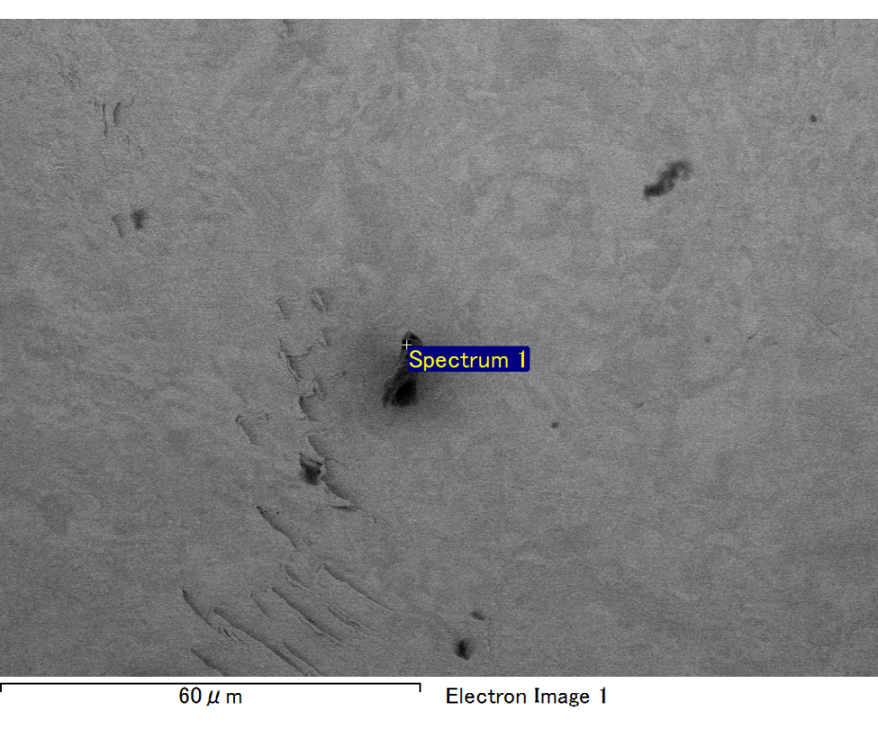

Spectrum processing :

Peak possibly omitted : 0.714 keV

Processing option : All elements analyzed (Normalised)

Number of iterations = 2

Standard :

C CaCO3 1-Jun-1999 12:00 AM

O SiO2 1-Jun-1999 12:00 AM

Mg MgO 1-Jun-1999 12:00 AM

Si SiO2 1-Jun-1999 12:00 AM

Au Au 1-Jun-1999 12:00 AM

|  |  |  |  |
| --- | --- | --- | --- |
| Element | Weight% | Atomic% |  |
|  |  |  |  |
| C K | 2.88 | 14.24 |  |
| O K | 13.25 | 49.18 |  |
| Mg K | 3.18 | 7.77 |  |
| Si K | 2.47 | 5.22 |  |
| Au M | 78.22 | 23.59 |  |
|  |  |  |  |
| Totals | 100.00 |  |  |

Spectrum Label: Spectrum 1

Livetime 60.0 s

Acquisition geometry ( degrees ):

Tilt = 15.0

Azimuth = 0.0

Elevation = 30.0

Accelerating voltage = 10.00 kV

Total spectrum counts = 54261

|  |  |  |  |
| --- | --- | --- | --- |
| Sample data : | Energy (eV) | Resn. (eV) | Area |
| Strobe : | 3.8 | 47.31 | 1000172 |
|  |  |  |  |

No quant optimization performed

Sample: Sample 1

Type: Default

ID:

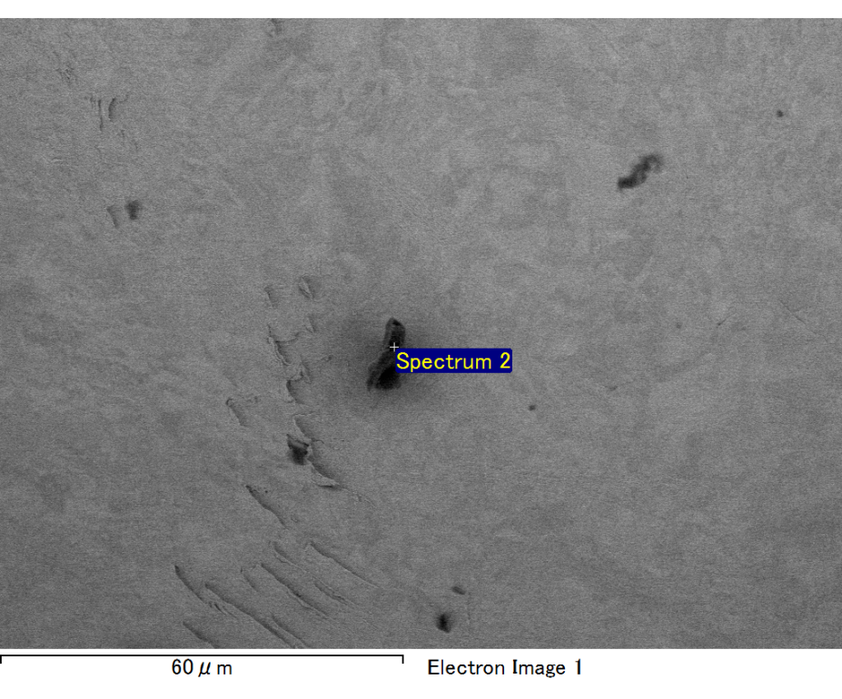

Spectrum processing :

No peaks omitted

Processing option : All elements analyzed (Normalised)

Number of iterations = 2

Standard :

C CaCO3 1-Jun-1999 12:00 AM

O SiO2 1-Jun-1999 12:00 AM

Mg MgO 1-Jun-1999 12:00 AM

Si SiO2 1-Jun-1999 12:00 AM

Fe Fe 1-Jun-1999 12:00 AM

Au Au 1-Jun-1999 12:00 AM

|  |  |  |  |
| --- | --- | --- | --- |
| Element | Weight% | Atomic% |  |
|  |  |  |  |
| C K | 3.46 | 13.48 |  |
| O K | 17.10 | 49.99 |  |
| Mg K | 4.63 | 8.91 |  |
| Si K | 3.44 | 5.73 |  |
| Fe L | 8.23 | 6.89 |  |
| Au M | 63.14 | 15.00 |  |
|  |  |  |  |
| Totals | 100.00 |  |  |

Spectrum Label: Spectrum 2

Livetime 60.0 s

Acquisition geometry ( degrees ):

Tilt = 15.0

Azimuth = 0.0

Elevation = 30.0

Accelerating voltage = 10.00 kV

Total spectrum counts = 53054

|  |  |  |  |
| --- | --- | --- | --- |
| Sample data : | Energy (eV) | Resn. (eV) | Area |
| Strobe : | 3.8 | 47.30 | 1001145 |
|  |  |  |  |

No quant optimization performed

Sample: Sample 1

Type: Default

ID:

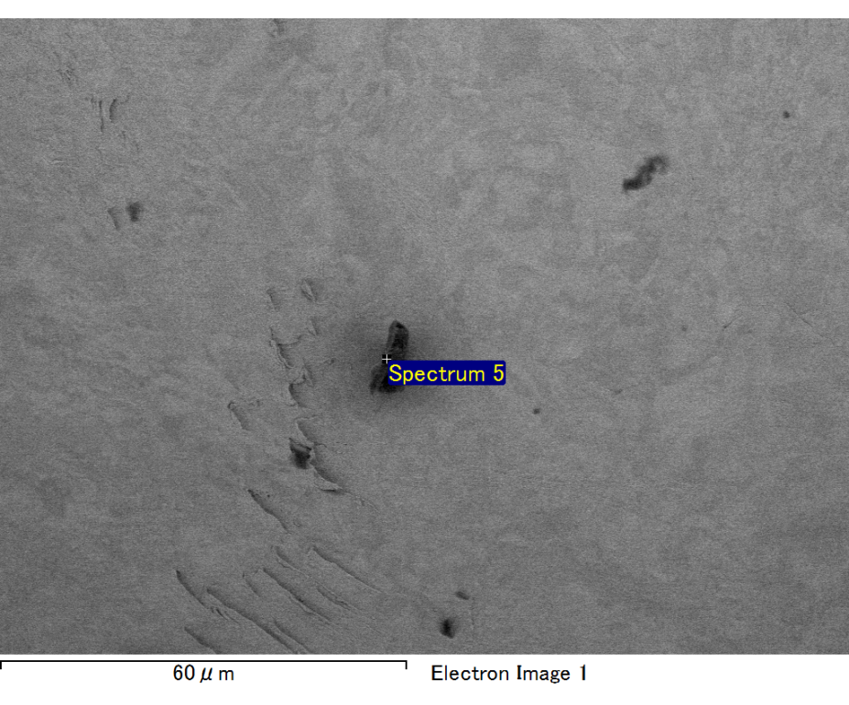

Spectrum processing :

Peak possibly omitted : 6.360 keV

Processing option : All elements analyzed (Normalised)

Number of iterations = 2

Standard :

C CaCO3 1-Jun-1999 12:00 AM

O SiO2 1-Jun-1999 12:00 AM

Mg MgO 1-Jun-1999 12:00 AM

Si SiO2 1-Jun-1999 12:00 AM

Au Au 1-Jun-1999 12:00 AM

|  |  |  |  |
| --- | --- | --- | --- |
| Element | Weight% | Atomic% |  |
|  |  |  |  |
| C K | 3.96 | 19.21 |  |
| O K | 11.65 | 42.43 |  |
| Mg K | 3.52 | 8.44 |  |
| Si K | 3.37 | 6.99 |  |
| Au M | 77.50 | 22.93 |  |
|  |  |  |  |
| Totals | 100.00 |  |  |

Spectrum Label: Spectrum 5

Livetime 60.0 s

Acquisition geometry ( degrees ):

Tilt = 15.0

Azimuth = 0.0

Elevation = 30.0

Accelerating voltage = 10.00 kV

Total spectrum counts = 49079

|  |  |  |  |
| --- | --- | --- | --- |
| Sample data : | Energy (eV) | Resn. (eV) | Area |
| Strobe : | 3.8 | 47.22 | 1001473 |
|  |  |  |  |

No quant optimization performed

Sample: Sample 1

Type: Default

ID: