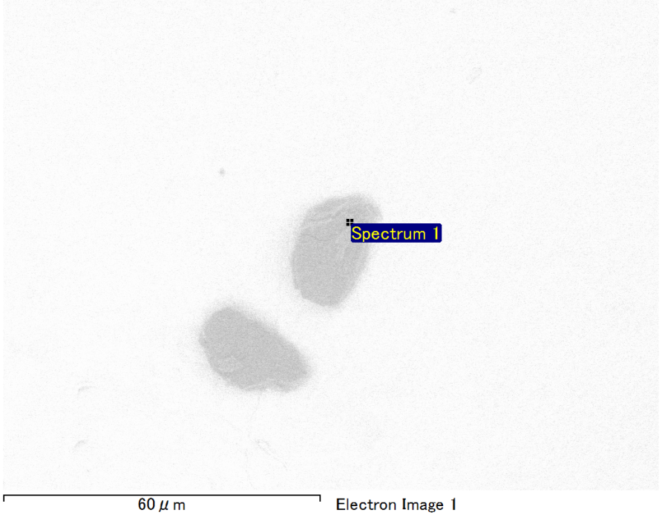

Spectrum Label: Spectrum 1

Livetime 90.0 s

Acquisition geometry ( degrees ):

Tilt = 0.0

Azimuth = 0.0

Elevation = 30.0

Accelerating voltage = 10.00 kV

Total spectrum counts = 64058

|  |  |  |  |
| --- | --- | --- | --- |
| Sample data : | Energy (eV) | Resn. (eV) | Area |
| Strobe : | 3.8 | 53.62 | 920481 |
|  |  |  |  |
| Optimization data : Manganese K series |  |  |  |
|  | Energy (eV) | Resn. (eV) | Area |
| Strobe : | .1 | 53.38 | 1150729 |
| Optimization element : | 5892.6 | 129.89 | 573533 |

Spectrum processing :

No peaks omitted

Processing option : Oxygen by stoichiometry (Normalised)

Number of iterations = 1

Standard :

Mg MgO 1-Jun-1999 12:00 AM

Si SiO2 1-Jun-1999 12:00 AM

Ca Wollastonite 1-Jun-1999 12:00 AM

Au Au 1-Jun-1999 12:00 AM

|  |  |  |  |  |  |
| --- | --- | --- | --- | --- | --- |
| Element | Weight% | Atomic% | Compd% | Formula |  |
|  |  |  |  |  |  |
| Mg K | 2.42 | 5.08 | 4.01 | MgO |  |
| Si K | 6.23 | 11.34 | 13.33 | SiO2 |  |
| Ca K | 4.60 | 5.86 | 6.43 | CaO |  |
| Au M | 67.95 | 17.63 | 76.23 | Au2O3 |  |
| O | 18.80 | 60.08 |  |  |  |
| Totals | 100.00 |  |  |  |  |

Project: Project 1

Owner: Operator

Site: Site of Interest 2

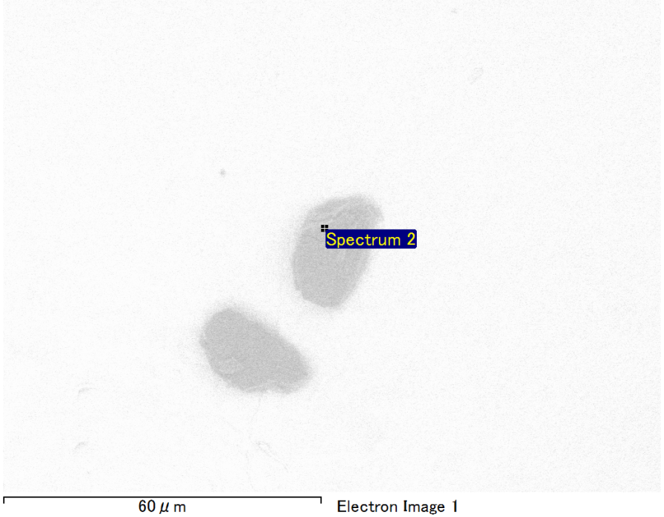

Spectrum Label: Spectrum 2

Livetime 90.0 s

Acquisition geometry ( degrees ):

Tilt = 0.0

Azimuth = 0.0

Elevation = 30.0

Accelerating voltage = 10.00 kV

Total spectrum counts = 63855

|  |  |  |  |
| --- | --- | --- | --- |
| Sample data : | Energy (eV) | Resn. (eV) | Area |
| Strobe : | 3.8 | 53.63 | 919690 |
|  |  |  |  |
| Optimization data : Manganese K series |  |  |  |
|  | Energy (eV) | Resn. (eV) | Area |
| Strobe : | .1 | 53.38 | 1150729 |
| Optimization element : | 5892.6 | 129.89 | 573533 |

Spectrum processing :

No peaks omitted

Processing option : Oxygen by stoichiometry (Normalised)

Number of iterations = 1

Standard :

Mg MgO 1-Jun-1999 12:00 AM

Si SiO2 1-Jun-1999 12:00 AM

Ca Wollastonite 1-Jun-1999 12:00 AM

Au Au 1-Jun-1999 12:00 AM

|  |  |  |  |  |  |
| --- | --- | --- | --- | --- | --- |
| Element | Weight% | Atomic% | Compd% | Formula |  |
|  |  |  |  |  |  |
| Mg K | 2.25 | 5.47 | 3.73 | MgO |  |
| Si K | 4.12 | 8.68 | 8.81 | SiO2 |  |
| Ca K | 2.21 | 3.26 | 3.09 | CaO |  |
| Au M | 75.21 | 22.60 | 84.38 | Au2O3 |  |
| O | 16.21 | 59.99 |  |  |  |
| Totals | 100.00 |  |  |  |  |

Project: Project 1

Owner: Operator

Site: Site of Interest 2

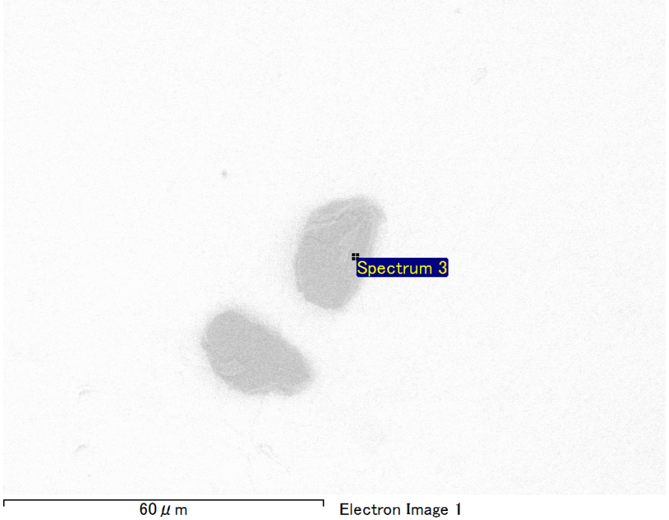

Spectrum Label: Spectrum 3

Livetime 90.0 s

Acquisition geometry ( degrees ):

Tilt = 0.0

Azimuth = 0.0

Elevation = 30.0

Accelerating voltage = 10.00 kV

Total spectrum counts = 63575

|  |  |  |  |
| --- | --- | --- | --- |
| Sample data : | Energy (eV) | Resn. (eV) | Area |
| Strobe : | 3.8 | 53.65 | 918779 |
|  |  |  |  |
| Optimization data : Manganese K series |  |  |  |
|  | Energy (eV) | Resn. (eV) | Area |
| Strobe : | .1 | 53.38 | 1150729 |
| Optimization element : | 5892.6 | 129.89 | 573533 |

Spectrum processing :

No peaks omitted

Processing option : Oxygen by stoichiometry (Normalised)

Number of iterations = 1

Standard :

Mg MgO 1-Jun-1999 12:00 AM

Si SiO2 1-Jun-1999 12:00 AM

Ca Wollastonite 1-Jun-1999 12:00 AM

Au Au 1-Jun-1999 12:00 AM

|  |  |  |  |  |  |
| --- | --- | --- | --- | --- | --- |
| Element | Weight% | Atomic% | Compd% | Formula |  |
|  |  |  |  |  |  |
| Mg K | 1.79 | 4.39 | 2.97 | MgO |  |
| Si K | 3.68 | 7.81 | 7.87 | SiO2 |  |
| Ca K | 3.80 | 5.65 | 5.32 | CaO |  |
| Au M | 74.73 | 22.60 | 83.83 | Au2O3 |  |
| O | 16.00 | 59.55 |  |  |  |
| Totals | 100.00 |  |  |  |  |

Project: Project 1

Owner: Operator

Site: Site of Interest 2

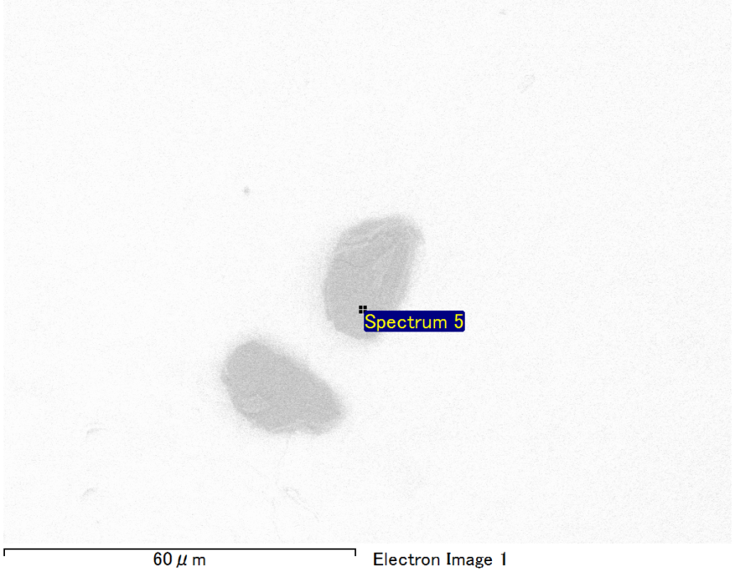

Spectrum Label: Spectrum 5

Livetime 90.0 s

Acquisition geometry ( degrees ):

Tilt = 0.0

Azimuth = 0.0

Elevation = 30.0

Accelerating voltage = 10.00 kV

Total spectrum counts = 63699

|  |  |  |  |
| --- | --- | --- | --- |
| Sample data : | Energy (eV) | Resn. (eV) | Area |
| Strobe : | 3.8 | 53.58 | 919926 |
|  |  |  |  |
| Optimization data : Manganese K series |  |  |  |
|  | Energy (eV) | Resn. (eV) | Area |
| Strobe : | .1 | 53.38 | 1150729 |
| Optimization element : | 5892.6 | 129.89 | 573533 |

Spectrum processing :

No peaks omitted

Processing option : Oxygen by stoichiometry (Normalised)

Number of iterations = 1

Standard :

Mg MgO 1-Jun-1999 12:00 AM

Si SiO2 1-Jun-1999 12:00 AM

Ca Wollastonite 1-Jun-1999 12:00 AM

Au Au 1-Jun-1999 12:00 AM

|  |  |  |  |  |  |
| --- | --- | --- | --- | --- | --- |
| Element | Weight% | Atomic% | Compd% | Formula |  |
|  |  |  |  |  |  |
| Mg K | 1.20 | 2.95 | 1.99 | MgO |  |
| Si K | 4.42 | 9.39 | 9.45 | SiO2 |  |
| Ca K | 2.98 | 4.45 | 4.18 | CaO |  |
| Au M | 75.22 | 22.81 | 84.39 | Au2O3 |  |
| O | 16.18 | 60.40 |  |  |  |
| Totals | 100.00 |  |  |  |  |

Project: Project 1

Owner: Operator

Site: Site of Interest 2