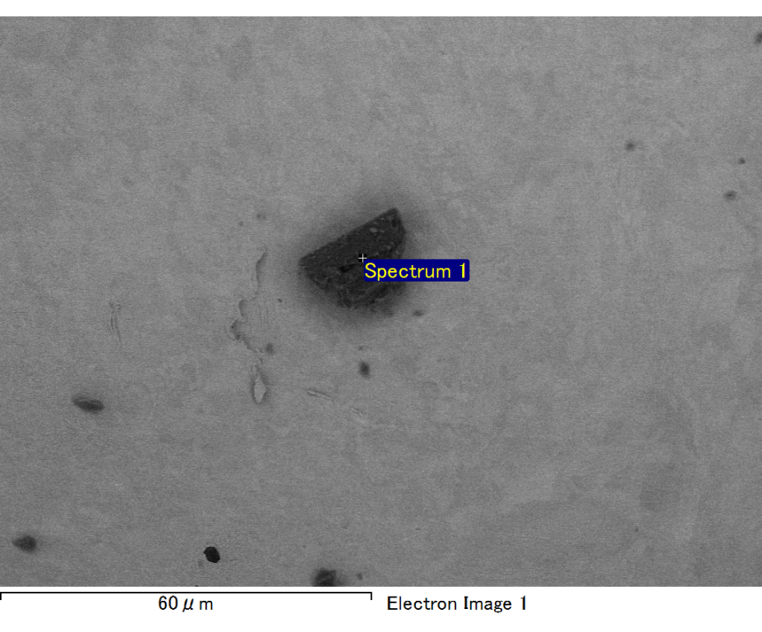

Spectrum processing :

No peaks omitted

Processing option : All elements analyzed (Normalised)

Number of iterations = 2

Standard :

C CaCO3 1-Jun-1999 12:00 AM

O SiO2 1-Jun-1999 12:00 AM

Mg MgO 1-Jun-1999 12:00 AM

Si SiO2 1-Jun-1999 12:00 AM

Fe Fe 1-Jun-1999 12:00 AM

Au Au 1-Jun-1999 12:00 AM

|  |  |  |  |
| --- | --- | --- | --- |
| Element | Weight% | Atomic% |  |
|  |  |  |  |
| C K | 2.94 | 10.67 |  |
| O K | 19.81 | 53.92 |  |
| Mg K | 4.29 | 7.69 |  |
| Si K | 4.66 | 7.23 |  |
| Fe L | 9.64 | 7.52 |  |
| Au M | 58.65 | 12.97 |  |
|  |  |  |  |
| Totals | 100.00 |  |  |

Spectrum Label: Spectrum 1

Livetime 60.0 s

Acquisition geometry ( degrees ):

Tilt = 15.0

Azimuth = 0.0

Elevation = 30.0

Accelerating voltage = 10.00 kV

Total spectrum counts = 52233

|  |  |  |  |
| --- | --- | --- | --- |
| Sample data : | Energy (eV) | Resn. (eV) | Area |
| Strobe : | 3.8 | 47.39 | 1001103 |
|  |  |  |  |

No quant optimization performed

Sample: Sample 1

Type: Default

ID:

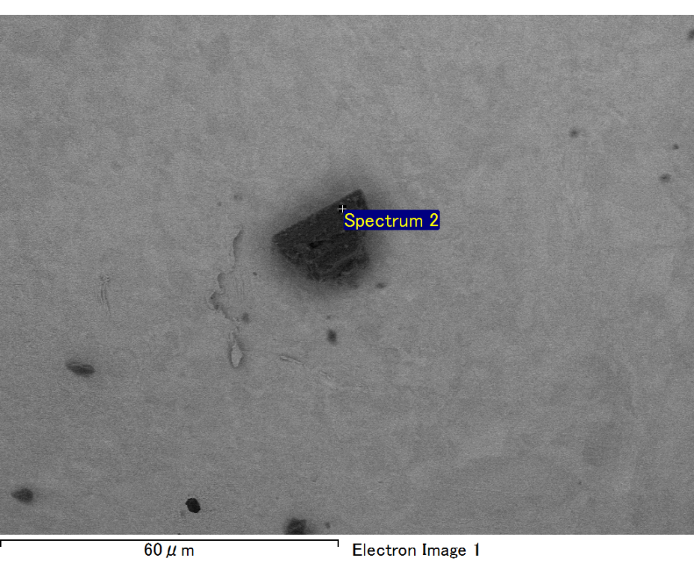

Spectrum processing :

No peaks omitted

Processing option : All elements analyzed (Normalised)

Number of iterations = 2

Standard :

C CaCO3 1-Jun-1999 12:00 AM

O SiO2 1-Jun-1999 12:00 AM

Mg MgO 1-Jun-1999 12:00 AM

Si SiO2 1-Jun-1999 12:00 AM

Fe Fe 1-Jun-1999 12:00 AM

Au Au 1-Jun-1999 12:00 AM

|  |  |  |  |
| --- | --- | --- | --- |
| Element | Weight% | Atomic% |  |
|  |  |  |  |
| C K | 2.89 | 9.76 |  |
| O K | 22.17 | 56.25 |  |
| Mg K | 4.36 | 7.27 |  |
| Si K | 6.53 | 9.44 |  |
| Fe L | 7.83 | 5.69 |  |
| Au M | 56.22 | 11.59 |  |
|  |  |  |  |
| Totals | 100.00 |  |  |

Spectrum Label: Spectrum 2

Livetime 60.0 s

Acquisition geometry ( degrees ):

Tilt = 15.0

Azimuth = 0.0

Elevation = 30.0

Accelerating voltage = 10.00 kV

Total spectrum counts = 52083

|  |  |  |  |
| --- | --- | --- | --- |
| Sample data : | Energy (eV) | Resn. (eV) | Area |
| Strobe : | 3.8 | 47.43 | 1000414 |
|  |  |  |  |

No quant optimization performed

Sample: Sample 1

Type: Default

ID:

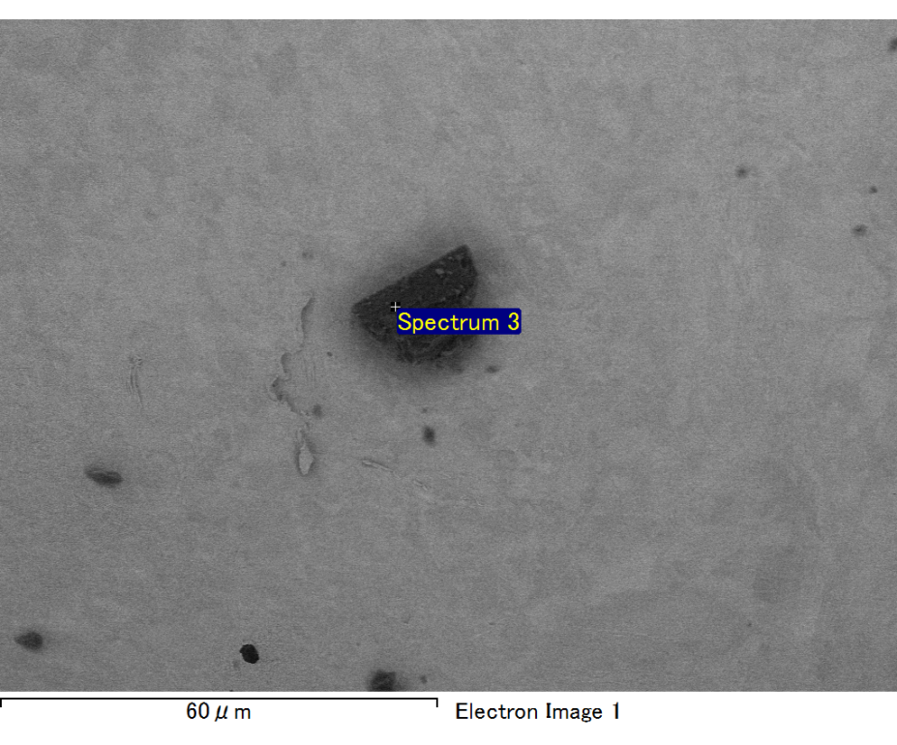

Spectrum processing :

No peaks omitted

Processing option : All elements analyzed (Normalised)

Number of iterations = 2

Standard :

C CaCO3 1-Jun-1999 12:00 AM

O SiO2 1-Jun-1999 12:00 AM

Mg MgO 1-Jun-1999 12:00 AM

Si SiO2 1-Jun-1999 12:00 AM

Fe Fe 1-Jun-1999 12:00 AM

Au Au 1-Jun-1999 12:00 AM

|  |  |  |  |
| --- | --- | --- | --- |
| Element | Weight% | Atomic% |  |
|  |  |  |  |
| C K | 2.27 | 7.56 |  |
| O K | 23.79 | 59.57 |  |
| Mg K | 4.56 | 7.51 |  |
| Si K | 6.26 | 8.93 |  |
| Fe L | 6.99 | 5.02 |  |
| Au M | 56.14 | 11.42 |  |
|  |  |  |  |
| Totals | 100.00 |  |  |

Spectrum Label: Spectrum 3

Livetime 60.0 s

Acquisition geometry ( degrees ):

Tilt = 15.0

Azimuth = 0.0

Elevation = 30.0

Accelerating voltage = 10.00 kV

Total spectrum counts = 50934

|  |  |  |  |
| --- | --- | --- | --- |
| Sample data : | Energy (eV) | Resn. (eV) | Area |
| Strobe : | 3.8 | 47.43 | 999676 |
|  |  |  |  |

No quant optimization performed

Sample: Sample 1

Type: Default

ID:

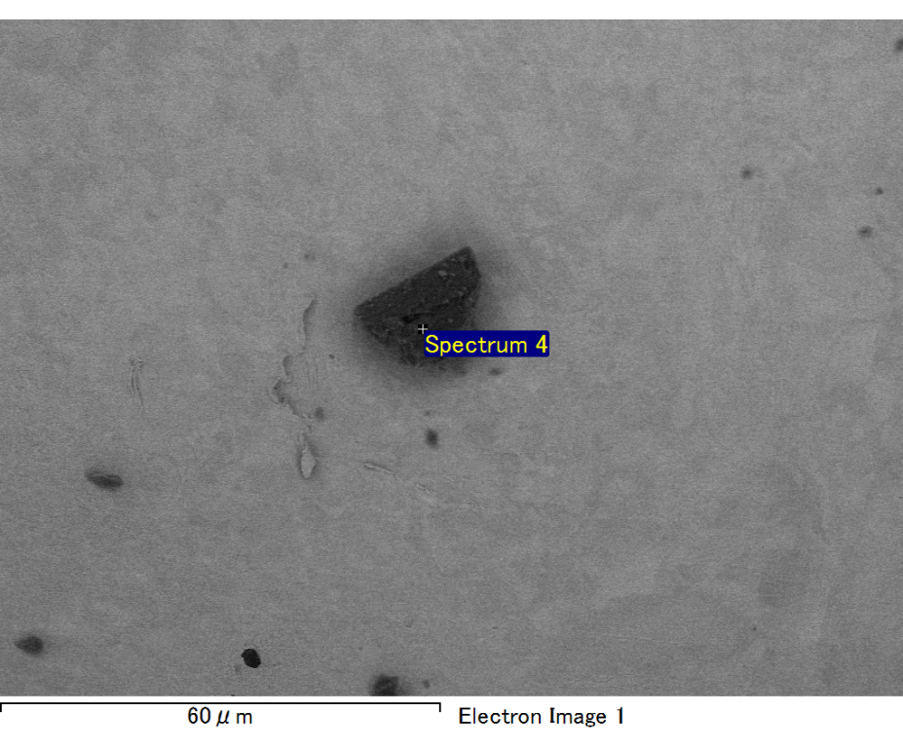

Spectrum processing :

No peaks omitted

Processing option : All elements analyzed (Normalised)

Number of iterations = 2

Standard :

C CaCO3 1-Jun-1999 12:00 AM

O SiO2 1-Jun-1999 12:00 AM

Mg MgO 1-Jun-1999 12:00 AM

Si SiO2 1-Jun-1999 12:00 AM

Ca Wollastonite 1-Jun-1999 12:00 AM

Au Au 1-Jun-1999 12:00 AM

|  |  |  |  |
| --- | --- | --- | --- |
| Element | Weight% | Atomic% |  |
|  |  |  |  |
| C K | 2.48 | 9.58 |  |
| O K | 17.76 | 51.44 |  |
| Mg K | 3.07 | 5.86 |  |
| Si K | 7.68 | 12.67 |  |
| Ca K | 4.58 | 5.30 |  |
| Au M | 64.43 | 15.16 |  |
|  |  |  |  |
| Totals | 100.00 |  |  |

Spectrum Label: Spectrum 4

Livetime 60.0 s

Acquisition geometry ( degrees ):

Tilt = 15.0

Azimuth = 0.0

Elevation = 30.0

Accelerating voltage = 10.00 kV

Total spectrum counts = 49775

|  |  |  |  |
| --- | --- | --- | --- |
| Sample data : | Energy (eV) | Resn. (eV) | Area |
| Strobe : | 3.8 | 47.45 | 999894 |
|  |  |  |  |

No quant optimization performed

Sample: Sample 1

Type: Default

ID:

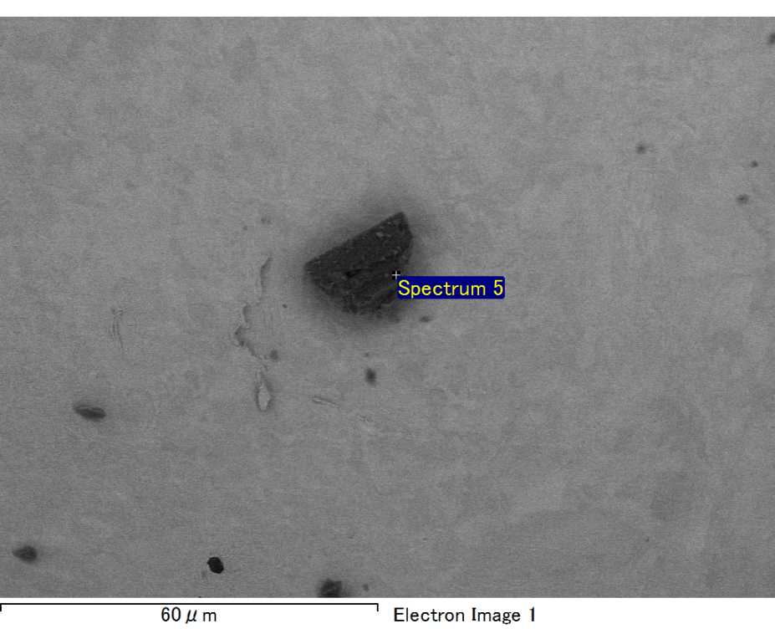

Spectrum processing :

No peaks omitted

Processing option : All elements analyzed (Normalised)

Number of iterations = 2

Standard :

C CaCO3 1-Jun-1999 12:00 AM

O SiO2 1-Jun-1999 12:00 AM

Mg MgO 1-Jun-1999 12:00 AM

Si SiO2 1-Jun-1999 12:00 AM

Ca Wollastonite 1-Jun-1999 12:00 AM

Au Au 1-Jun-1999 12:00 AM

|  |  |  |  |
| --- | --- | --- | --- |
| Element | Weight% | Atomic% |  |
|  |  |  |  |
| C K | 2.90 | 9.97 |  |
| O K | 22.38 | 57.64 |  |
| Mg K | 3.38 | 5.72 |  |
| Si K | 6.93 | 10.17 |  |
| Ca K | 3.70 | 3.80 |  |
| Au M | 60.71 | 12.70 |  |
|  |  |  |  |
| Totals | 100.00 |  |  |

Spectrum Label: Spectrum 5

Livetime 60.0 s

Acquisition geometry ( degrees ):

Tilt = 15.0

Azimuth = 0.0

Elevation = 30.0

Accelerating voltage = 10.00 kV

Total spectrum counts = 50350

|  |  |  |  |
| --- | --- | --- | --- |
| Sample data : | Energy (eV) | Resn. (eV) | Area |
| Strobe : | 3.8 | 47.37 | 999483 |
|  |  |  |  |

No quant optimization performed

Sample: Sample 1

Type: Default

ID: