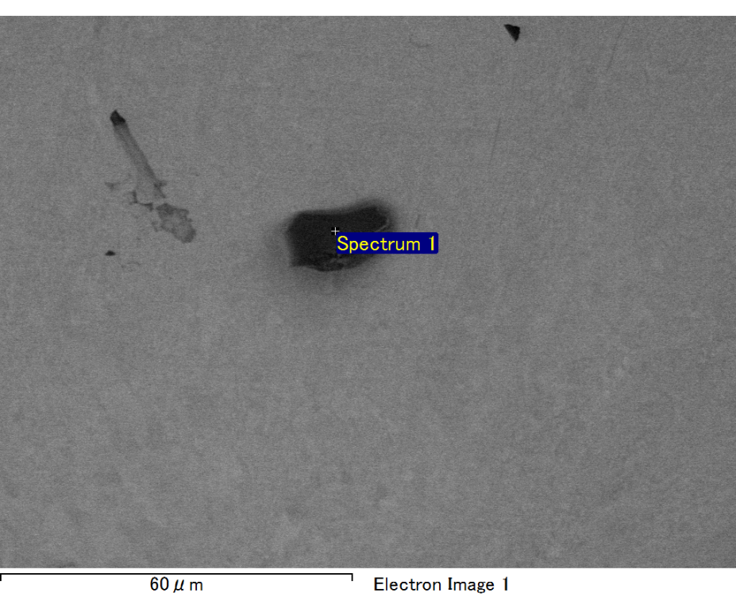

Spectrum processing :

No peaks omitted

Processing option : All elements analyzed (Normalised)

Number of iterations = 2

Standard :

C CaCO3 1-Jun-1999 12:00 AM

O SiO2 1-Jun-1999 12:00 AM

Mg MgO 1-Jun-1999 12:00 AM

Si SiO2 1-Jun-1999 12:00 AM

Fe Fe 1-Jun-1999 12:00 AM

Au Au 1-Jun-1999 12:00 AM

|  |  |  |  |
| --- | --- | --- | --- |
| Element | Weight% | Atomic% |  |
|  |  |  |  |
| C K | 2.27 | 7.70 |  |
| O K | 21.48 | 54.71 |  |
| Mg K | 6.32 | 10.60 |  |
| Si K | 4.37 | 6.34 |  |
| Fe L | 13.55 | 9.89 |  |
| Au M | 52.00 | 10.76 |  |
|  |  |  |  |
| Totals | 100.00 |  |  |

Spectrum Label: Spectrum 1

Livetime 60.0 s

Acquisition geometry ( degrees ):

Tilt = 15.0

Azimuth = 0.0

Elevation = 30.0

Accelerating voltage = 10.00 kV

Total spectrum counts = 49358

|  |  |  |  |
| --- | --- | --- | --- |
| Sample data : | Energy (eV) | Resn. (eV) | Area |
| Strobe : | 3.8 | 47.43 | 999789 |
|  |  |  |  |

No quant optimization performed

Sample: Sample 1

Type: Default

ID:

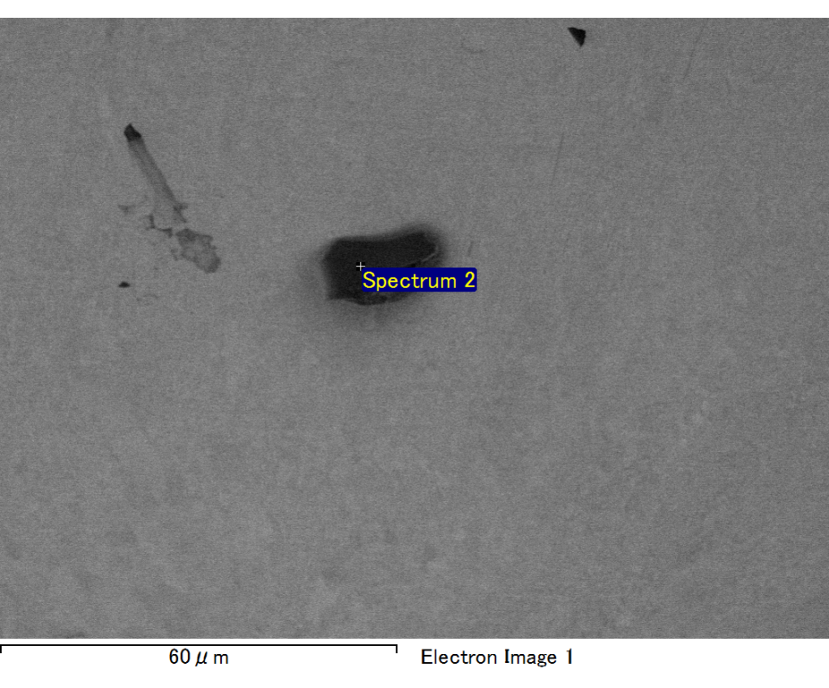

Spectrum processing :

No peaks omitted

Processing option : All elements analyzed (Normalised)

Number of iterations = 2

Standard :

C CaCO3 1-Jun-1999 12:00 AM

O SiO2 1-Jun-1999 12:00 AM

Mg MgO 1-Jun-1999 12:00 AM

Si SiO2 1-Jun-1999 12:00 AM

Fe Fe 1-Jun-1999 12:00 AM

Au Au 1-Jun-1999 12:00 AM

|  |  |  |  |
| --- | --- | --- | --- |
| Element | Weight% | Atomic% |  |
|  |  |  |  |
| C K | 2.39 | 7.99 |  |
| O K | 22.07 | 55.40 |  |
| Mg K | 6.42 | 10.60 |  |
| Si K | 4.82 | 6.89 |  |
| Fe L | 11.65 | 8.38 |  |
| Au M | 52.66 | 10.74 |  |
|  |  |  |  |
| Totals | 100.00 |  |  |

Spectrum Label: Spectrum 2

Livetime 60.0 s

Acquisition geometry ( degrees ):

Tilt = 15.0

Azimuth = 0.0

Elevation = 30.0

Accelerating voltage = 10.00 kV

Total spectrum counts = 48697

|  |  |  |  |
| --- | --- | --- | --- |
| Sample data : | Energy (eV) | Resn. (eV) | Area |
| Strobe : | 3.8 | 47.35 | 1000388 |
|  |  |  |  |

No quant optimization performed

Sample: Sample 1

Type: Default

ID:

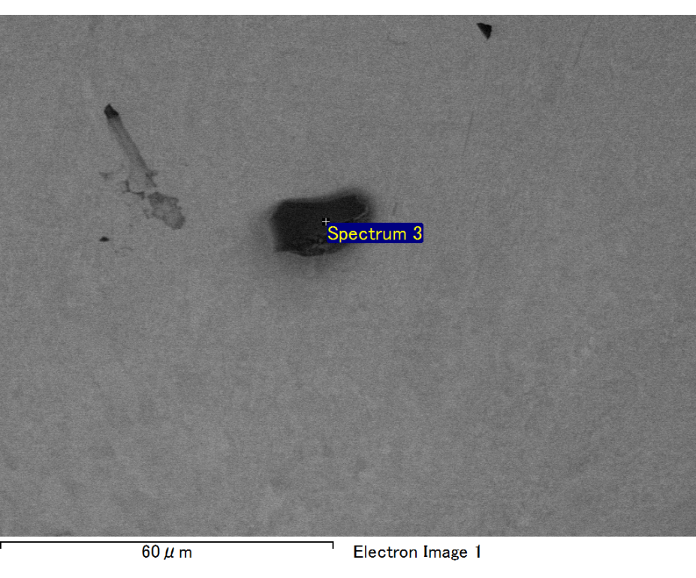

Spectrum processing :

No peaks omitted

Processing option : All elements analyzed (Normalised)

Number of iterations = 2

Standard :

C CaCO3 1-Jun-1999 12:00 AM

O SiO2 1-Jun-1999 12:00 AM

Mg MgO 1-Jun-1999 12:00 AM

Si SiO2 1-Jun-1999 12:00 AM

Fe Fe 1-Jun-1999 12:00 AM

Au Au 1-Jun-1999 12:00 AM

|  |  |  |  |
| --- | --- | --- | --- |
| Element | Weight% | Atomic% |  |
|  |  |  |  |
| C K | 2.24 | 7.43 |  |
| O K | 23.00 | 57.28 |  |
| Mg K | 5.87 | 9.61 |  |
| Si K | 4.63 | 6.57 |  |
| Fe L | 11.94 | 8.52 |  |
| Au M | 52.33 | 10.59 |  |
|  |  |  |  |
| Totals | 100.00 |  |  |

Spectrum Label: Spectrum 3

Livetime 60.0 s

Acquisition geometry ( degrees ):

Tilt = 15.0

Azimuth = 0.0

Elevation = 30.0

Accelerating voltage = 10.00 kV

Total spectrum counts = 49480

|  |  |  |  |
| --- | --- | --- | --- |
| Sample data : | Energy (eV) | Resn. (eV) | Area |
| Strobe : | 3.8 | 47.47 | 1001519 |
|  |  |  |  |

No quant optimization performed

Sample: Sample 1

Type: Default

ID:

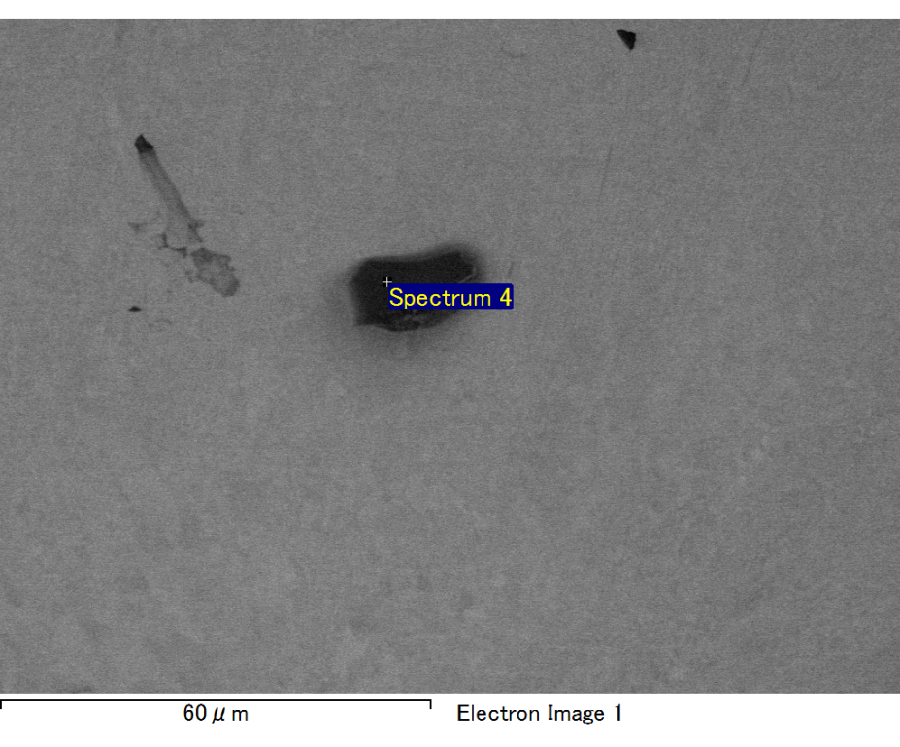

Spectrum processing :

No peaks omitted

Processing option : All elements analyzed (Normalised)

Number of iterations = 2

Standard :

C CaCO3 1-Jun-1999 12:00 AM

O SiO2 1-Jun-1999 12:00 AM

Mg MgO 1-Jun-1999 12:00 AM

Si SiO2 1-Jun-1999 12:00 AM

Fe Fe 1-Jun-1999 12:00 AM

Au Au 1-Jun-1999 12:00 AM

|  |  |  |  |
| --- | --- | --- | --- |
| Element | Weight% | Atomic% |  |
|  |  |  |  |
| C K | 2.00 | 6.98 |  |
| O K | 21.19 | 55.43 |  |
| Mg K | 6.31 | 10.85 |  |
| Si K | 4.57 | 6.81 |  |
| Fe L | 11.02 | 8.26 |  |
| Au M | 54.91 | 11.67 |  |
|  |  |  |  |
| Totals | 100.00 |  |  |

Spectrum Label: Spectrum 4

Livetime 60.0 s

Acquisition geometry ( degrees ):

Tilt = 15.0

Azimuth = 0.0

Elevation = 30.0

Accelerating voltage = 10.00 kV

Total spectrum counts = 47838

|  |  |  |  |
| --- | --- | --- | --- |
| Sample data : | Energy (eV) | Resn. (eV) | Area |
| Strobe : | 3.8 | 47.44 | 1000919 |
|  |  |  |  |

No quant optimization performed

Sample: Sample 1

Type: Default

ID:

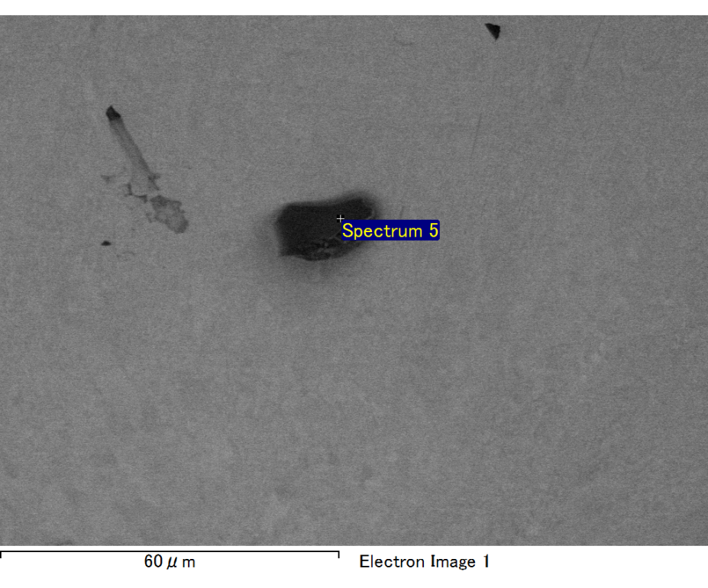

Spectrum processing :

No peaks omitted

Processing option : All elements analyzed (Normalised)

Number of iterations = 2

Standard :

C CaCO3 1-Jun-1999 12:00 AM

O SiO2 1-Jun-1999 12:00 AM

Mg MgO 1-Jun-1999 12:00 AM

Si SiO2 1-Jun-1999 12:00 AM

Fe Fe 1-Jun-1999 12:00 AM

Au Au 1-Jun-1999 12:00 AM

|  |  |  |  |
| --- | --- | --- | --- |
| Element | Weight% | Atomic% |  |
|  |  |  |  |
| C K | 2.92 | 9.68 |  |
| O K | 21.69 | 53.95 |  |
| Mg K | 6.25 | 10.24 |  |
| Si K | 4.14 | 5.86 |  |
| Fe L | 13.98 | 9.96 |  |
| Au M | 51.02 | 10.31 |  |
|  |  |  |  |
| Totals | 100.00 |  |  |

Spectrum Label: Spectrum 5

Livetime 60.0 s

Acquisition geometry ( degrees ):

Tilt = 15.0

Azimuth = 0.0

Elevation = 30.0

Accelerating voltage = 10.00 kV

Total spectrum counts = 49174

|  |  |  |  |
| --- | --- | --- | --- |
| Sample data : | Energy (eV) | Resn. (eV) | Area |
| Strobe : | 3.8 | 47.45 | 1000514 |
|  |  |  |  |

No quant optimization performed

Sample: Sample 1

Type: Default

ID: