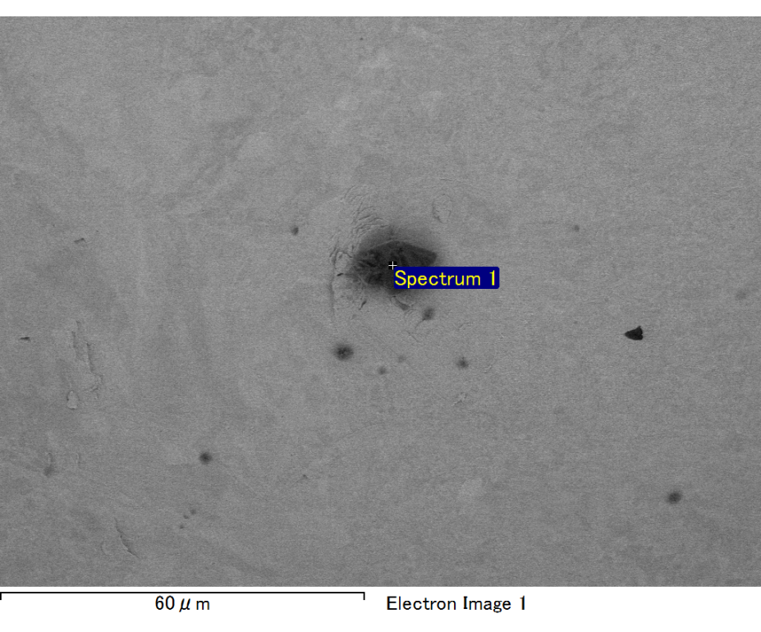

Spectrum processing :

No peaks omitted

Processing option : All elements analyzed (Normalised)

Number of iterations = 2

Standard :

C CaCO3 1-Jun-1999 12:00 AM

O SiO2 1-Jun-1999 12:00 AM

Mg MgO 1-Jun-1999 12:00 AM

Si SiO2 1-Jun-1999 12:00 AM

Fe Fe 1-Jun-1999 12:00 AM

Au Au 1-Jun-1999 12:00 AM

|  |  |  |  |
| --- | --- | --- | --- |
| Element | Weight% | Atomic% |  |
|  |  |  |  |
| C K | 2.51 | 8.66 |  |
| O K | 22.27 | 57.71 |  |
| Mg K | 4.40 | 7.51 |  |
| Si K | 6.15 | 9.08 |  |
| Fe L | 6.45 | 4.79 |  |
| Au M | 58.20 | 12.25 |  |
|  |  |  |  |
| Totals | 100.00 |  |  |

Spectrum Label: Spectrum 1

Livetime 60.0 s

Acquisition geometry ( degrees ):

Tilt = 15.0

Azimuth = 0.0

Elevation = 30.0

Accelerating voltage = 10.00 kV

Total spectrum counts = 52609

|  |  |  |  |
| --- | --- | --- | --- |
| Sample data : | Energy (eV) | Resn. (eV) | Area |
| Strobe : | 3.8 | 47.40 | 999994 |
|  |  |  |  |

No quant optimization performed

Sample: Sample 1

Type: Default

ID:

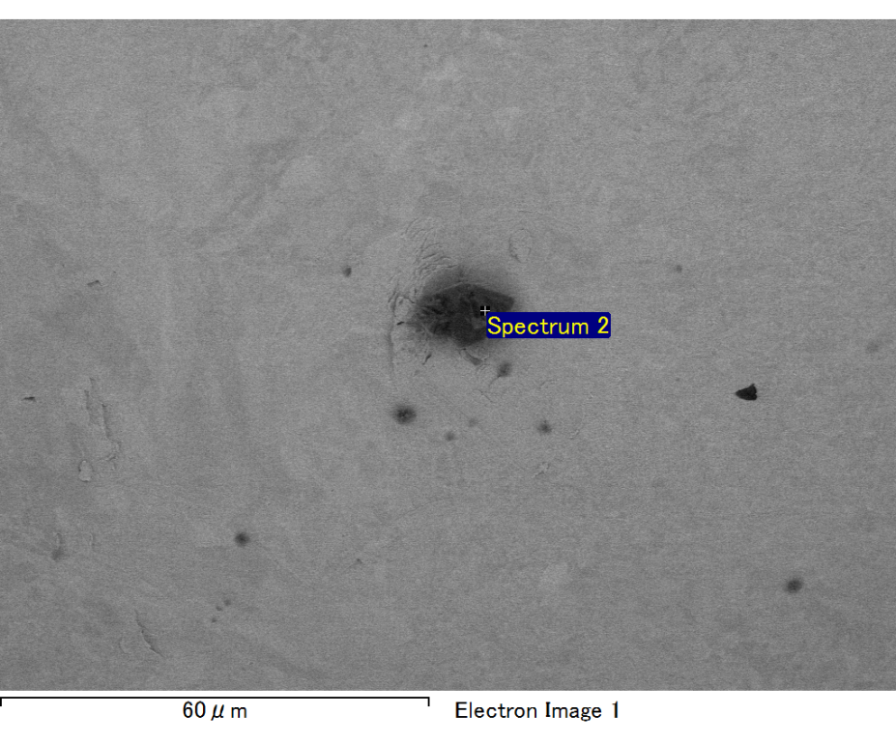

Spectrum processing :

No peaks omitted

Processing option : All elements analyzed (Normalised)

Number of iterations = 2

Standard :

C CaCO3 1-Jun-1999 12:00 AM

O SiO2 1-Jun-1999 12:00 AM

Mg MgO 1-Jun-1999 12:00 AM

Si SiO2 1-Jun-1999 12:00 AM

Fe Fe 1-Jun-1999 12:00 AM

Au Au 1-Jun-1999 12:00 AM

|  |  |  |  |
| --- | --- | --- | --- |
| Element | Weight% | Atomic% |  |
|  |  |  |  |
| C K | 2.70 | 9.60 |  |
| O K | 21.04 | 56.18 |  |
| Mg K | 4.29 | 7.54 |  |
| Si K | 5.34 | 8.12 |  |
| Fe L | 7.48 | 5.72 |  |
| Au M | 59.16 | 12.83 |  |
|  |  |  |  |
| Totals | 100.00 |  |  |

Spectrum Label: Spectrum 2

Livetime 60.0 s

Acquisition geometry ( degrees ):

Tilt = 15.0

Azimuth = 0.0

Elevation = 30.0

Accelerating voltage = 10.00 kV

Total spectrum counts = 53508

|  |  |  |  |
| --- | --- | --- | --- |
| Sample data : | Energy (eV) | Resn. (eV) | Area |
| Strobe : | 3.8 | 47.40 | 1000454 |
|  |  |  |  |

No quant optimization performed

Sample: Sample 1

Type: Default

ID:

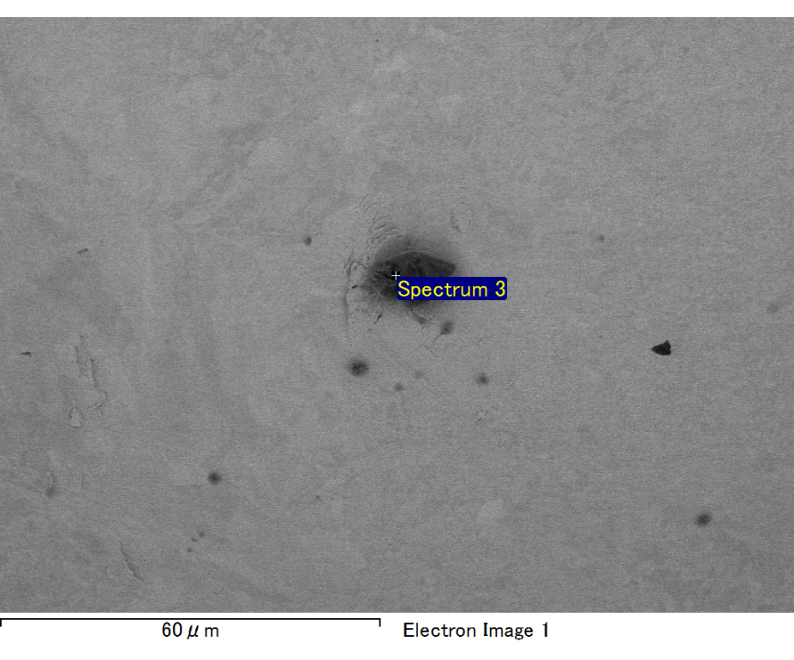

Spectrum processing :

No peaks omitted

Processing option : All elements analyzed (Normalised)

Number of iterations = 2

Standard :

C CaCO3 1-Jun-1999 12:00 AM

O SiO2 1-Jun-1999 12:00 AM

Mg MgO 1-Jun-1999 12:00 AM

Si SiO2 1-Jun-1999 12:00 AM

Au Au 1-Jun-1999 12:00 AM

|  |  |  |  |
| --- | --- | --- | --- |
| Element | Weight% | Atomic% |  |
|  |  |  |  |
| C K | 3.12 | 16.72 |  |
| O K | 11.19 | 44.97 |  |
| Mg K | 2.04 | 5.39 |  |
| Si K | 2.85 | 6.53 |  |
| Au M | 80.80 | 26.39 |  |
|  |  |  |  |
| Totals | 100.00 |  |  |

Spectrum Label: Spectrum 3

Livetime 60.0 s

Acquisition geometry ( degrees ):

Tilt = 15.0

Azimuth = 0.0

Elevation = 30.0

Accelerating voltage = 10.00 kV

Total spectrum counts = 52920

|  |  |  |  |
| --- | --- | --- | --- |
| Sample data : | Energy (eV) | Resn. (eV) | Area |
| Strobe : | 3.8 | 47.46 | 999590 |
|  |  |  |  |

No quant optimization performed

Sample: Sample 1

Type: Default

ID:

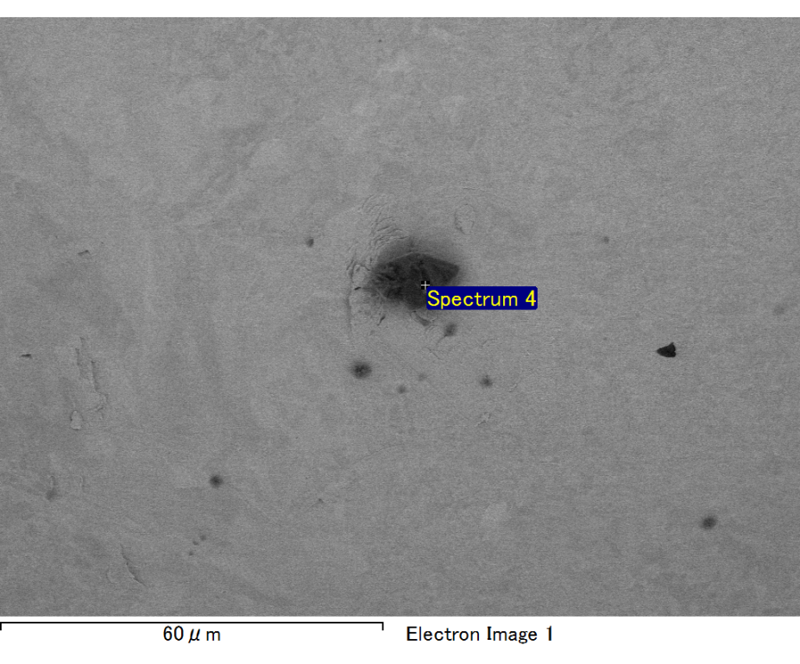

Spectrum processing :

Peak possibly omitted : 0.715 keV

Processing option : All elements analyzed (Normalised)

Number of iterations = 2

Standard :

C CaCO3 1-Jun-1999 12:00 AM

O SiO2 1-Jun-1999 12:00 AM

Mg MgO 1-Jun-1999 12:00 AM

Si SiO2 1-Jun-1999 12:00 AM

Au Au 1-Jun-1999 12:00 AM

|  |  |  |  |
| --- | --- | --- | --- |
| Element | Weight% | Atomic% |  |
|  |  |  |  |
| C K | 2.66 | 10.02 |  |
| O K | 20.39 | 57.59 |  |
| Mg K | 4.16 | 7.74 |  |
| Si K | 5.75 | 9.26 |  |
| Au M | 67.03 | 15.38 |  |
|  |  |  |  |
| Totals | 100.00 |  |  |

Spectrum Label: Spectrum 4

Livetime 60.0 s

Acquisition geometry ( degrees ):

Tilt = 15.0

Azimuth = 0.0

Elevation = 30.0

Accelerating voltage = 10.00 kV

Total spectrum counts = 51762

|  |  |  |  |
| --- | --- | --- | --- |
| Sample data : | Energy (eV) | Resn. (eV) | Area |
| Strobe : | 3.8 | 47.38 | 1000899 |
|  |  |  |  |

No quant optimization performed

Sample: Sample 1

Type: Default

ID: