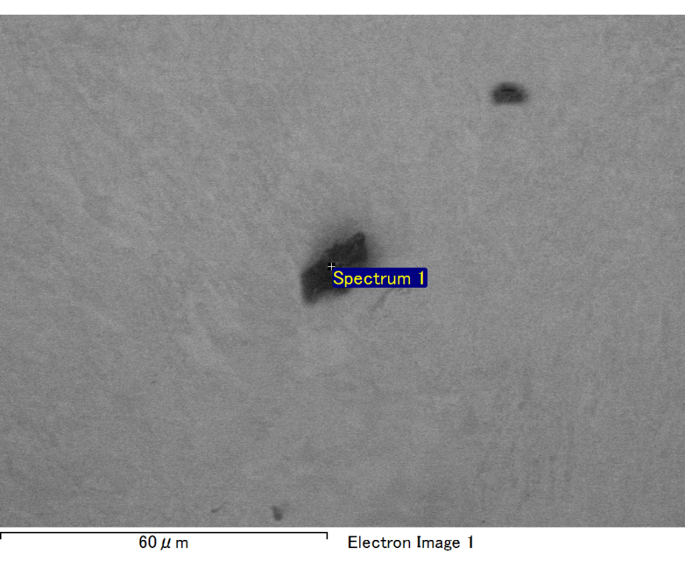

Spectrum processing :

Peak possibly omitted : 1.045 keV

Processing option : All elements analyzed (Normalised)

Number of iterations = 2

Standard :

C CaCO3 1-Jun-1999 12:00 AM

O SiO2 1-Jun-1999 12:00 AM

Al Al2O3 1-Jun-1999 12:00 AM

Si SiO2 1-Jun-1999 12:00 AM

Au Au 1-Jun-1999 12:00 AM

|  |  |  |  |
| --- | --- | --- | --- |
| Element | Weight% | Atomic% |  |
|  |  |  |  |
| C K | 3.82 | 25.59 |  |
| O K | 4.07 | 20.50 |  |
| Al K | 2.03 | 6.05 |  |
| Si K | 4.47 | 12.84 |  |
| Au M | 85.61 | 35.02 |  |
|  |  |  |  |
| Totals | 100.00 |  |  |

Spectrum Label: Spectrum 1

Livetime 60.0 s

Acquisition geometry ( degrees ):

Tilt = 15.0

Azimuth = 0.0

Elevation = 30.0

Accelerating voltage = 10.00 kV

Total spectrum counts = 45420

|  |  |  |  |
| --- | --- | --- | --- |
| Sample data : | Energy (eV) | Resn. (eV) | Area |
| Strobe : | 3.8 | 47.35 | 1000207 |
|  |  |  |  |

No quant optimization performed

Sample: Sample 1

Type: Default

ID:

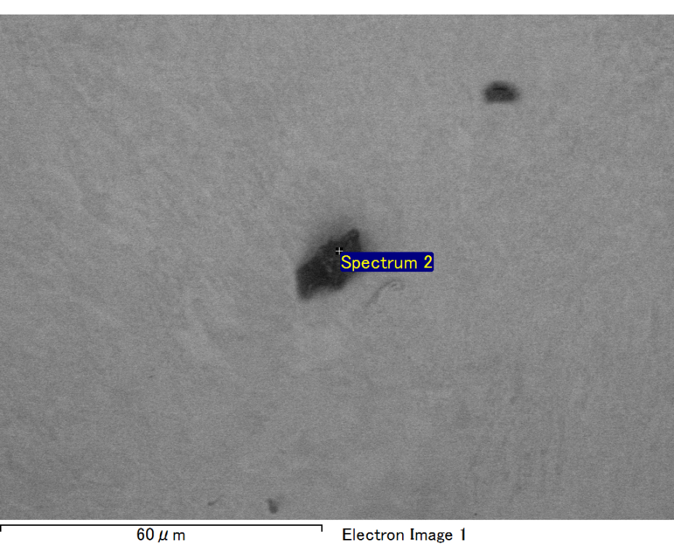

Spectrum processing :

Peak possibly omitted : 0.715 keV

Processing option : All elements analyzed (Normalised)

Number of iterations = 2

Standard :

C CaCO3 1-Jun-1999 12:00 AM

O SiO2 1-Jun-1999 12:00 AM

Mg MgO 1-Jun-1999 12:00 AM

Si SiO2 1-Jun-1999 12:00 AM

Au Au 1-Jun-1999 12:00 AM

|  |  |  |  |
| --- | --- | --- | --- |
| Element | Weight% | Atomic% |  |
|  |  |  |  |
| C K | 3.12 | 10.92 |  |
| O K | 22.29 | 58.61 |  |
| Mg K | 4.23 | 7.31 |  |
| Si K | 6.33 | 9.49 |  |
| Au M | 64.03 | 13.67 |  |
|  |  |  |  |
| Totals | 100.00 |  |  |

Spectrum Label: Spectrum 2

Livetime 60.0 s

Acquisition geometry ( degrees ):

Tilt = 15.0

Azimuth = 0.0

Elevation = 30.0

Accelerating voltage = 10.00 kV

Total spectrum counts = 50269

|  |  |  |  |
| --- | --- | --- | --- |
| Sample data : | Energy (eV) | Resn. (eV) | Area |
| Strobe : | 3.8 | 47.39 | 1000980 |
|  |  |  |  |

No quant optimization performed

Sample: Sample 1

Type: Default

ID:

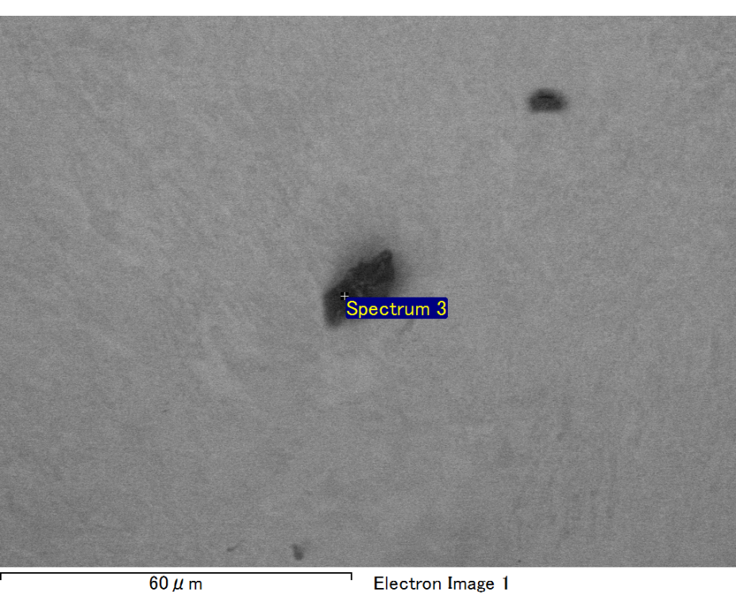

Spectrum processing :

No peaks omitted

Processing option : All elements analyzed (Normalised)

Number of iterations = 2

Standard :

C CaCO3 1-Jun-1999 12:00 AM

O SiO2 1-Jun-1999 12:00 AM

Na Albite 1-Jun-1999 12:00 AM

Al Al2O3 1-Jun-1999 12:00 AM

Si SiO2 1-Jun-1999 12:00 AM

Au Au 1-Jun-1999 12:00 AM

|  |  |  |  |
| --- | --- | --- | --- |
| Element | Weight% | Atomic% |  |
|  |  |  |  |
| C K | 3.15 | 12.12 |  |
| O K | 17.86 | 51.57 |  |
| Na K | 1.84 | 3.69 |  |
| Al K | 2.90 | 4.97 |  |
| Si K | 7.25 | 11.93 |  |
| Au M | 67.00 | 15.72 |  |
|  |  |  |  |
| Totals | 100.00 |  |  |

Spectrum Label: Spectrum 3

Livetime 60.0 s

Acquisition geometry ( degrees ):

Tilt = 15.0

Azimuth = 0.0

Elevation = 30.0

Accelerating voltage = 10.00 kV

Total spectrum counts = 49666

|  |  |  |  |
| --- | --- | --- | --- |
| Sample data : | Energy (eV) | Resn. (eV) | Area |
| Strobe : | 3.8 | 47.45 | 999996 |
|  |  |  |  |

No quant optimization performed

Sample: Sample 1

Type: Default

ID:

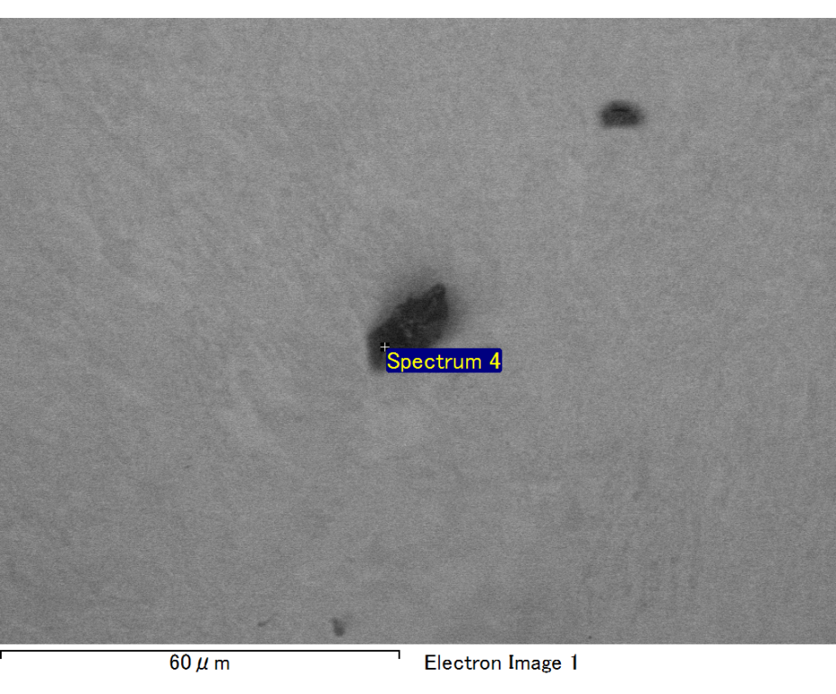

Spectrum processing :

No peaks omitted

Processing option : All elements analyzed (Normalised)

Number of iterations = 2

Standard :

C CaCO3 1-Jun-1999 12:00 AM

O SiO2 1-Jun-1999 12:00 AM

Na Albite 1-Jun-1999 12:00 AM

Al Al2O3 1-Jun-1999 12:00 AM

Si SiO2 1-Jun-1999 12:00 AM

Au Au 1-Jun-1999 12:00 AM

|  |  |  |  |
| --- | --- | --- | --- |
| Element | Weight% | Atomic% |  |
|  |  |  |  |
| C K | 2.61 | 9.37 |  |
| O K | 21.11 | 56.80 |  |
| Na K | 1.98 | 3.70 |  |
| Al K | 2.77 | 4.43 |  |
| Si K | 7.66 | 11.74 |  |
| Au M | 63.87 | 13.96 |  |
|  |  |  |  |
| Totals | 100.00 |  |  |

Spectrum Label: Spectrum 4

Livetime 60.0 s

Acquisition geometry ( degrees ):

Tilt = 15.0

Azimuth = 0.0

Elevation = 30.0

Accelerating voltage = 10.00 kV

Total spectrum counts = 50928

|  |  |  |  |
| --- | --- | --- | --- |
| Sample data : | Energy (eV) | Resn. (eV) | Area |
| Strobe : | 3.8 | 47.35 | 999360 |
|  |  |  |  |

No quant optimization performed

Sample: Sample 1

Type: Default

ID: