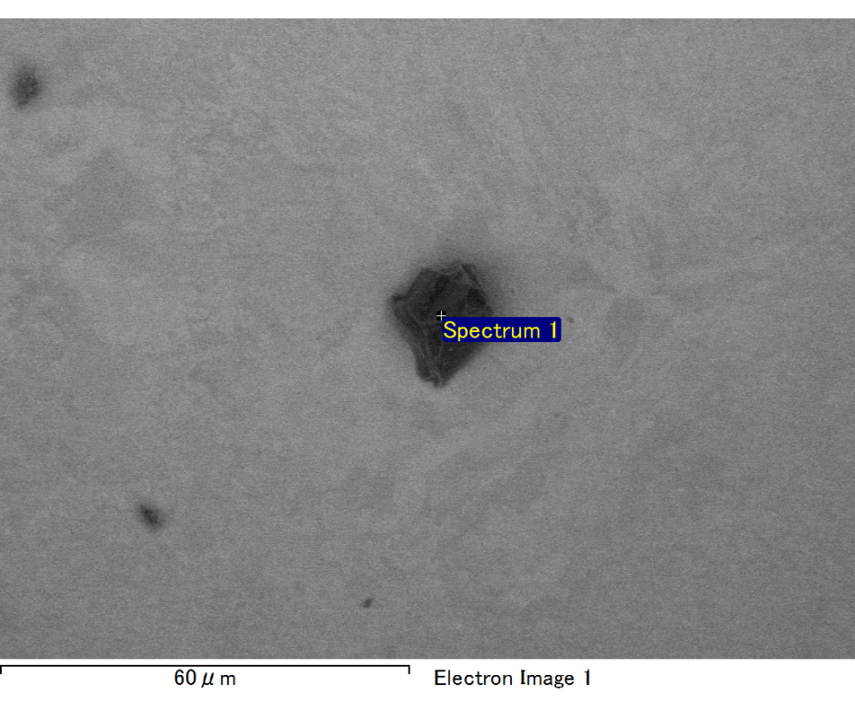

Spectrum processing :

No peaks omitted

Processing option : All elements analyzed (Normalised)

Number of iterations = 2

Standard :

C CaCO3 1-Jun-1999 12:00 AM

O SiO2 1-Jun-1999 12:00 AM

Na Albite 1-Jun-1999 12:00 AM

Al Al2O3 1-Jun-1999 12:00 AM

Si SiO2 1-Jun-1999 12:00 AM

Au Au 1-Jun-1999 12:00 AM

|  |  |  |  |
| --- | --- | --- | --- |
| Element | Weight% | Atomic% |  |
|  |  |  |  |
| C K | 3.19 | 11.30 |  |
| O K | 19.96 | 53.01 |  |
| Na K | 1.49 | 2.75 |  |
| Al K | 6.89 | 10.84 |  |
| Si K | 5.65 | 8.55 |  |
| Au M | 62.83 | 13.55 |  |
|  |  |  |  |
| Totals | 100.00 |  |  |

Spectrum Label: Spectrum 1

Livetime 60.0 s

Acquisition geometry ( degrees ):

Tilt = 15.0

Azimuth = 0.0

Elevation = 30.0

Accelerating voltage = 10.00 kV

Total spectrum counts = 53395

|  |  |  |  |
| --- | --- | --- | --- |
| Sample data : | Energy (eV) | Resn. (eV) | Area |
| Strobe : | 3.8 | 47.43 | 1000368 |
|  |  |  |  |

No quant optimization performed

Sample: Sample 1

Type: Default

ID:

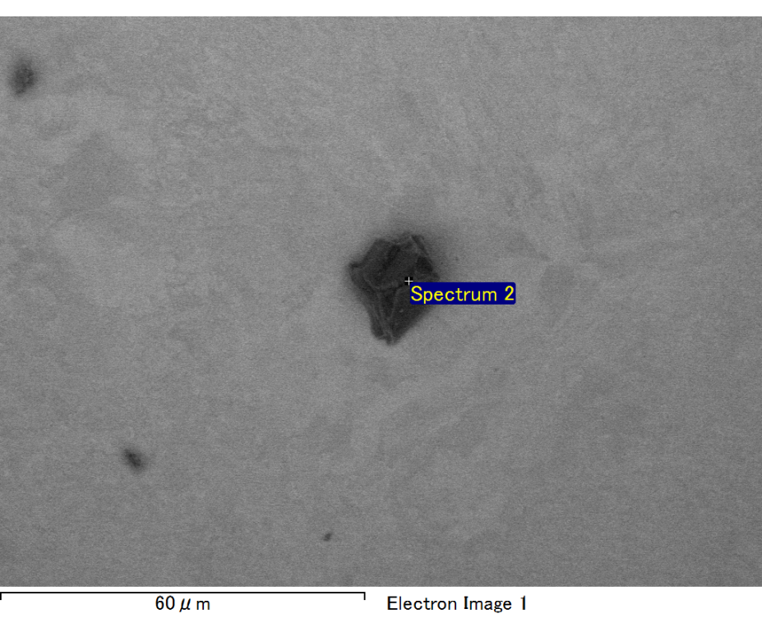

Spectrum processing :

No peaks omitted

Processing option : All elements analyzed (Normalised)

Number of iterations = 2

Standard :

C CaCO3 1-Jun-1999 12:00 AM

O SiO2 1-Jun-1999 12:00 AM

Na Albite 1-Jun-1999 12:00 AM

Al Al2O3 1-Jun-1999 12:00 AM

Si SiO2 1-Jun-1999 12:00 AM

Au Au 1-Jun-1999 12:00 AM

|  |  |  |  |
| --- | --- | --- | --- |
| Element | Weight% | Atomic% |  |
|  |  |  |  |
| C K | 3.28 | 12.34 |  |
| O K | 18.90 | 53.30 |  |
| Na K | 1.54 | 3.03 |  |
| Al K | 2.77 | 4.63 |  |
| Si K | 7.17 | 11.52 |  |
| Au M | 66.33 | 15.19 |  |
|  |  |  |  |
| Totals | 100.00 |  |  |

Spectrum Label: Spectrum 2

Livetime 60.0 s

Acquisition geometry ( degrees ):

Tilt = 15.0

Azimuth = 0.0

Elevation = 30.0

Accelerating voltage = 10.00 kV

Total spectrum counts = 51555

|  |  |  |  |
| --- | --- | --- | --- |
| Sample data : | Energy (eV) | Resn. (eV) | Area |
| Strobe : | 3.8 | 47.47 | 1000855 |
|  |  |  |  |

No quant optimization performed

Sample: Sample 1

Type: Default

ID:

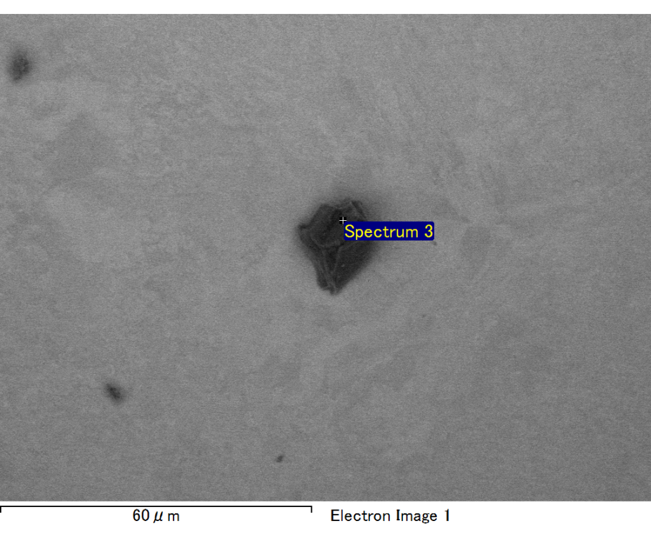

Spectrum processing :

No peaks omitted

Processing option : All elements analyzed (Normalised)

Number of iterations = 2

Standard :

C CaCO3 1-Jun-1999 12:00 AM

O SiO2 1-Jun-1999 12:00 AM

Na Albite 1-Jun-1999 12:00 AM

Al Al2O3 1-Jun-1999 12:00 AM

Si SiO2 1-Jun-1999 12:00 AM

Au Au 1-Jun-1999 12:00 AM

|  |  |  |  |
| --- | --- | --- | --- |
| Element | Weight% | Atomic% |  |
|  |  |  |  |
| C K | 3.05 | 10.32 |  |
| O K | 23.05 | 58.50 |  |
| Na K | 2.00 | 3.54 |  |
| Al K | 2.90 | 4.37 |  |
| Si K | 7.30 | 10.55 |  |
| Au M | 61.69 | 12.72 |  |
|  |  |  |  |
| Totals | 100.00 |  |  |

Spectrum Label: Spectrum 3

Livetime 60.0 s

Acquisition geometry ( degrees ):

Tilt = 15.0

Azimuth = 0.0

Elevation = 30.0

Accelerating voltage = 10.00 kV

Total spectrum counts = 52914

|  |  |  |  |
| --- | --- | --- | --- |
| Sample data : | Energy (eV) | Resn. (eV) | Area |
| Strobe : | 3.8 | 47.39 | 1000624 |
|  |  |  |  |

No quant optimization performed

Sample: Sample 1

Type: Default

ID:

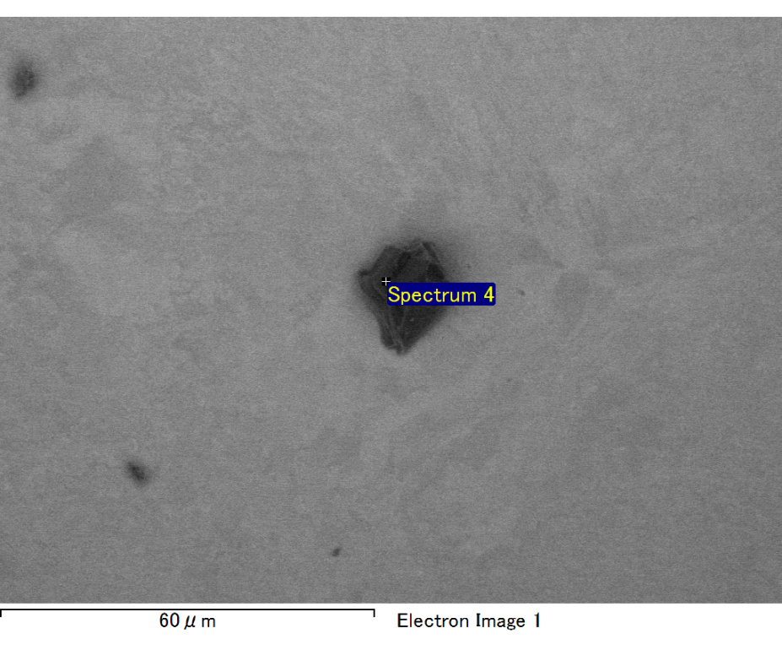

Spectrum processing :

Peak possibly omitted : 3.715 keV

Processing option : All elements analyzed (Normalised)

Number of iterations = 2

Standard :

C CaCO3 1-Jun-1999 12:00 AM

O SiO2 1-Jun-1999 12:00 AM

Na Albite 1-Jun-1999 12:00 AM

Al Al2O3 1-Jun-1999 12:00 AM

Si SiO2 1-Jun-1999 12:00 AM

Au Au 1-Jun-1999 12:00 AM

|  |  |  |  |
| --- | --- | --- | --- |
| Element | Weight% | Atomic% |  |
|  |  |  |  |
| C K | 2.68 | 8.83 |  |
| O K | 24.04 | 59.47 |  |
| Na K | 2.20 | 3.78 |  |
| Al K | 3.41 | 4.99 |  |
| Si K | 7.72 | 10.88 |  |
| Au M | 59.96 | 12.05 |  |
|  |  |  |  |
| Totals | 100.00 |  |  |

Spectrum Label: Spectrum 4

Livetime 60.0 s

Acquisition geometry ( degrees ):

Tilt = 15.0

Azimuth = 0.0

Elevation = 30.0

Accelerating voltage = 10.00 kV

Total spectrum counts = 51988

|  |  |  |  |
| --- | --- | --- | --- |
| Sample data : | Energy (eV) | Resn. (eV) | Area |
| Strobe : | 3.8 | 47.40 | 1000352 |
|  |  |  |  |

No quant optimization performed

Sample: Sample 1

Type: Default

ID:

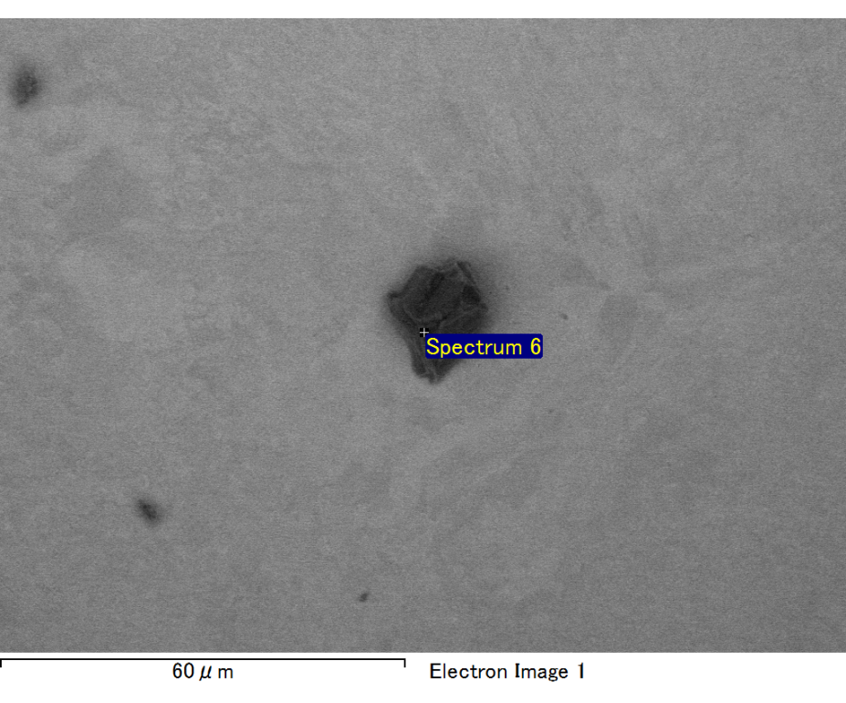

Spectrum processing :

Peaks possibly omitted : 0.256, 3.300 keV

Processing option : All elements analyzed (Normalised)

Number of iterations = 2

Standard :

O SiO2 1-Jun-1999 12:00 AM

Na Albite 1-Jun-1999 12:00 AM

Al Al2O3 1-Jun-1999 12:00 AM

Si SiO2 1-Jun-1999 12:00 AM

Au Au 1-Jun-1999 12:00 AM

|  |  |  |  |
| --- | --- | --- | --- |
| Element | Weight% | Atomic% |  |
|  |  |  |  |
| O K | 9.76 | 43.77 |  |
| Na K | 0.95 | 2.96 |  |
| Al K | 2.64 | 7.03 |  |
| Si K | 6.70 | 17.13 |  |
| Au M | 79.94 | 29.12 |  |
|  |  |  |  |
| Totals | 100.00 |  |  |

Spectrum Label: Spectrum 6

Livetime 60.0 s

Acquisition geometry ( degrees ):

Tilt = 15.0

Azimuth = 0.0

Elevation = 30.0

Accelerating voltage = 10.00 kV

Total spectrum counts = 48208

|  |  |  |  |
| --- | --- | --- | --- |
| Sample data : | Energy (eV) | Resn. (eV) | Area |
| Strobe : | 3.8 | 47.47 | 1000824 |
|  |  |  |  |

No quant optimization performed

Sample: Sample 1

Type: Default

ID: