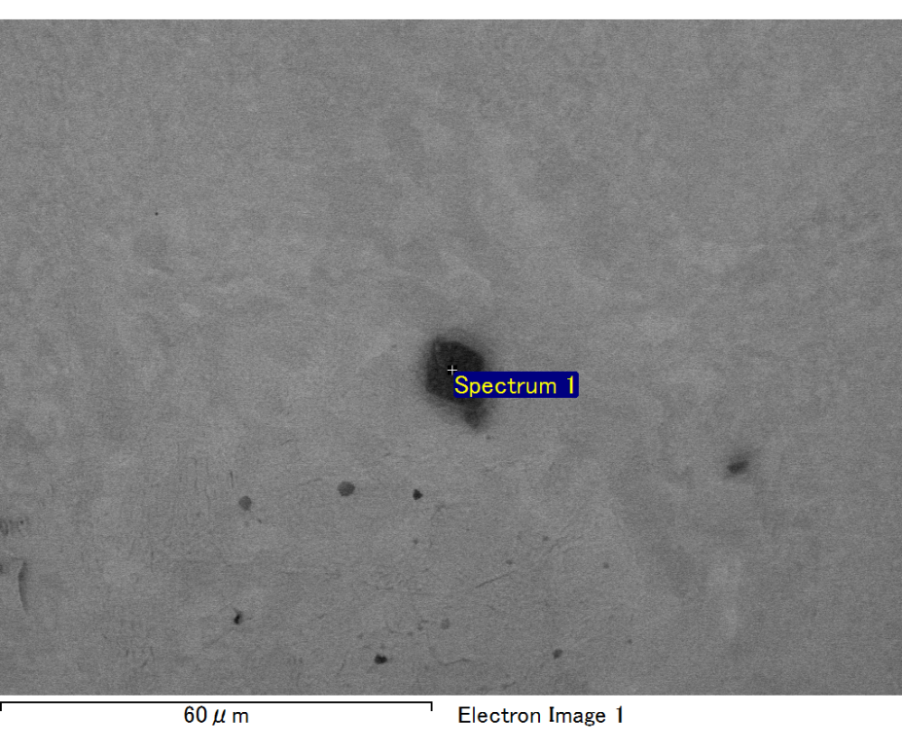

Spectrum processing :

No peaks omitted

Processing option : All elements analyzed (Normalised)

Number of iterations = 2

Standard :

C CaCO3 1-Jun-1999 12:00 AM

O SiO2 1-Jun-1999 12:00 AM

Mg MgO 1-Jun-1999 12:00 AM

Al Al2O3 1-Jun-1999 12:00 AM

Si SiO2 1-Jun-1999 12:00 AM

Fe Fe 1-Jun-1999 12:00 AM

Au Au 1-Jun-1999 12:00 AM

|  |  |  |  |
| --- | --- | --- | --- |
| Element | Weight% | Atomic% |  |
|  |  |  |  |
| C K | 2.03 | 7.65 |  |
| O K | 19.46 | 54.96 |  |
| Mg K | 4.53 | 8.43 |  |
| Al K | 0.77 | 1.29 |  |
| Si K | 4.72 | 7.60 |  |
| Fe L | 7.52 | 6.09 |  |
| Au M | 60.96 | 13.99 |  |
|  |  |  |  |
| Totals | 100.00 |  |  |

Spectrum Label: Spectrum 1

Livetime 60.0 s

Acquisition geometry ( degrees ):

Tilt = 15.0

Azimuth = 0.0

Elevation = 30.0

Accelerating voltage = 10.00 kV

Total spectrum counts = 50662

|  |  |  |  |
| --- | --- | --- | --- |
| Sample data : | Energy (eV) | Resn. (eV) | Area |
| Strobe : | 3.8 | 47.39 | 1000702 |
|  |  |  |  |

No quant optimization performed

Sample: Sample 1

Type: Default

ID:

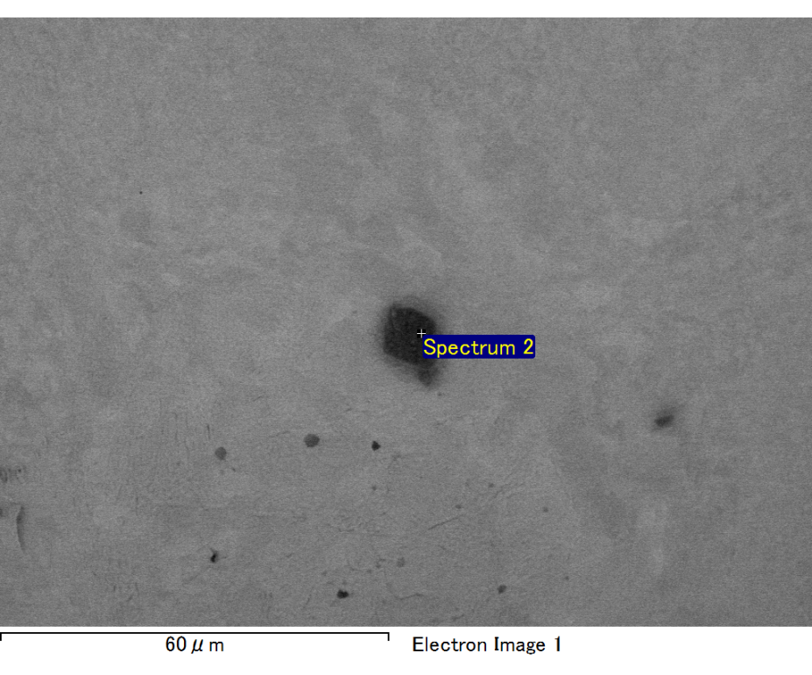

Spectrum processing :

No peaks omitted

Processing option : All elements analyzed (Normalised)

Number of iterations = 2

Standard :

C CaCO3 1-Jun-1999 12:00 AM

O SiO2 1-Jun-1999 12:00 AM

Mg MgO 1-Jun-1999 12:00 AM

Si SiO2 1-Jun-1999 12:00 AM

Fe Fe 1-Jun-1999 12:00 AM

Au Au 1-Jun-1999 12:00 AM

|  |  |  |  |
| --- | --- | --- | --- |
| Element | Weight% | Atomic% |  |
|  |  |  |  |
| C K | 2.87 | 10.63 |  |
| O K | 18.89 | 52.58 |  |
| Mg K | 5.50 | 10.06 |  |
| Si K | 4.06 | 6.44 |  |
| Fe L | 8.34 | 6.65 |  |
| Au M | 60.35 | 13.64 |  |
|  |  |  |  |
| Totals | 100.00 |  |  |

Spectrum Label: Spectrum 2

Livetime 60.0 s

Acquisition geometry ( degrees ):

Tilt = 15.0

Azimuth = 0.0

Elevation = 30.0

Accelerating voltage = 10.00 kV

Total spectrum counts = 49713

|  |  |  |  |
| --- | --- | --- | --- |
| Sample data : | Energy (eV) | Resn. (eV) | Area |
| Strobe : | 3.8 | 47.40 | 999928 |
|  |  |  |  |

No quant optimization performed

Sample: Sample 1

Type: Default

ID:

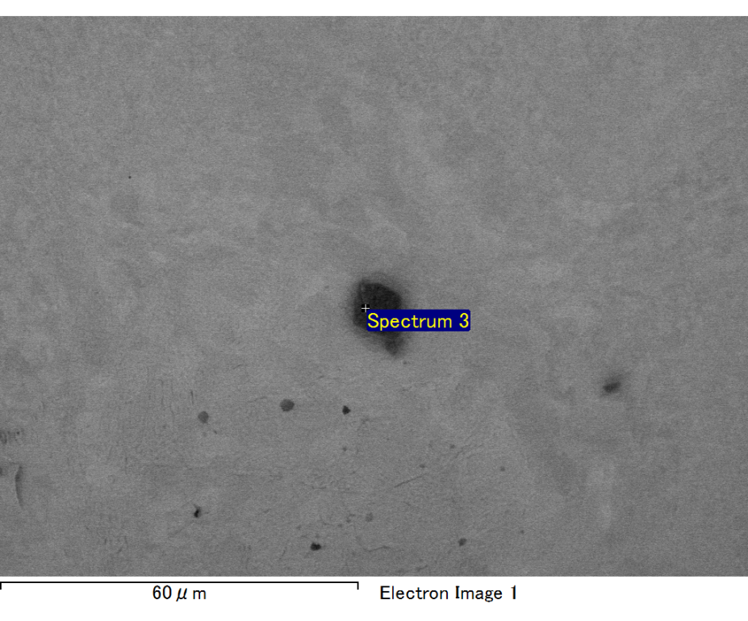

Spectrum processing :

No peaks omitted

Processing option : All elements analyzed (Normalised)

Number of iterations = 2

Standard :

C CaCO3 1-Jun-1999 12:00 AM

O SiO2 1-Jun-1999 12:00 AM

Mg MgO 1-Jun-1999 12:00 AM

Si SiO2 1-Jun-1999 12:00 AM

Fe Fe 1-Jun-1999 12:00 AM

Au Au 1-Jun-1999 12:00 AM

|  |  |  |  |
| --- | --- | --- | --- |
| Element | Weight% | Atomic% |  |
|  |  |  |  |
| C K | 2.14 | 9.93 |  |
| O K | 13.41 | 46.61 |  |
| Mg K | 4.41 | 10.08 |  |
| Si K | 3.30 | 6.53 |  |
| Fe L | 7.27 | 7.24 |  |
| Au M | 69.46 | 19.61 |  |
|  |  |  |  |
| Totals | 100.00 |  |  |

Spectrum Label: Spectrum 3

Livetime 60.0 s

Acquisition geometry ( degrees ):

Tilt = 15.0

Azimuth = 0.0

Elevation = 30.0

Accelerating voltage = 10.00 kV

Total spectrum counts = 47762

|  |  |  |  |
| --- | --- | --- | --- |
| Sample data : | Energy (eV) | Resn. (eV) | Area |
| Strobe : | 3.8 | 47.38 | 999119 |
|  |  |  |  |

No quant optimization performed

Sample: Sample 1

Type: Default

ID:

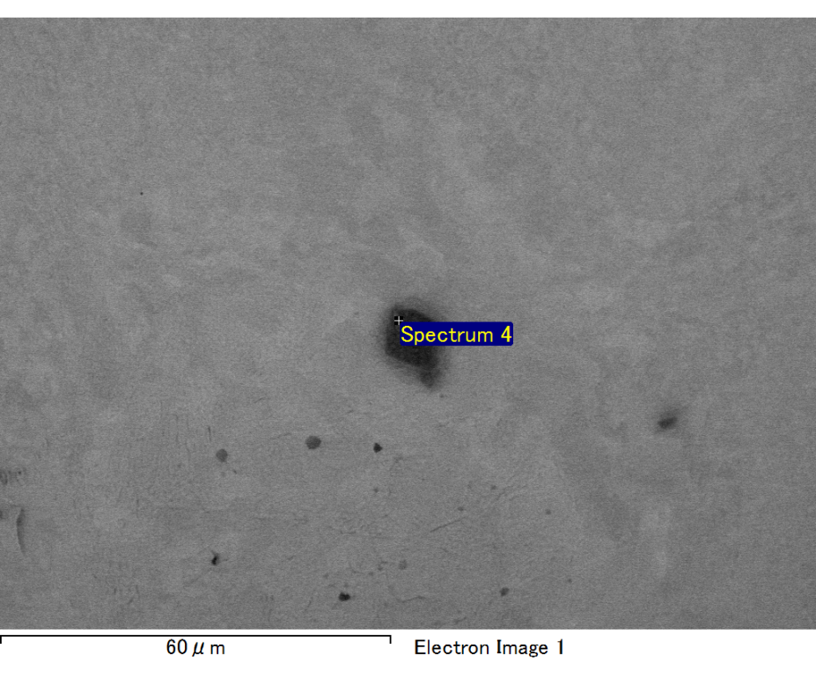

Spectrum processing :

No peaks omitted

Processing option : All elements analyzed (Normalised)

Number of iterations = 2

Standard :

C CaCO3 1-Jun-1999 12:00 AM

O SiO2 1-Jun-1999 12:00 AM

Mg MgO 1-Jun-1999 12:00 AM

Si SiO2 1-Jun-1999 12:00 AM

Fe Fe 1-Jun-1999 12:00 AM

Au Au 1-Jun-1999 12:00 AM

|  |  |  |  |
| --- | --- | --- | --- |
| Element | Weight% | Atomic% |  |
|  |  |  |  |
| C K | 2.98 | 11.67 |  |
| O K | 16.88 | 49.74 |  |
| Mg K | 5.31 | 10.29 |  |
| Si K | 4.20 | 7.05 |  |
| Fe L | 7.19 | 6.07 |  |
| Au M | 63.44 | 15.18 |  |
|  |  |  |  |
| Totals | 100.00 |  |  |

Spectrum Label: Spectrum 4

Livetime 60.0 s

Acquisition geometry ( degrees ):

Tilt = 15.0

Azimuth = 0.0

Elevation = 30.0

Accelerating voltage = 10.00 kV

Total spectrum counts = 49536

|  |  |  |  |
| --- | --- | --- | --- |
| Sample data : | Energy (eV) | Resn. (eV) | Area |
| Strobe : | 3.8 | 47.49 | 1000440 |
|  |  |  |  |

No quant optimization performed

Sample: Sample 1

Type: Default

ID:

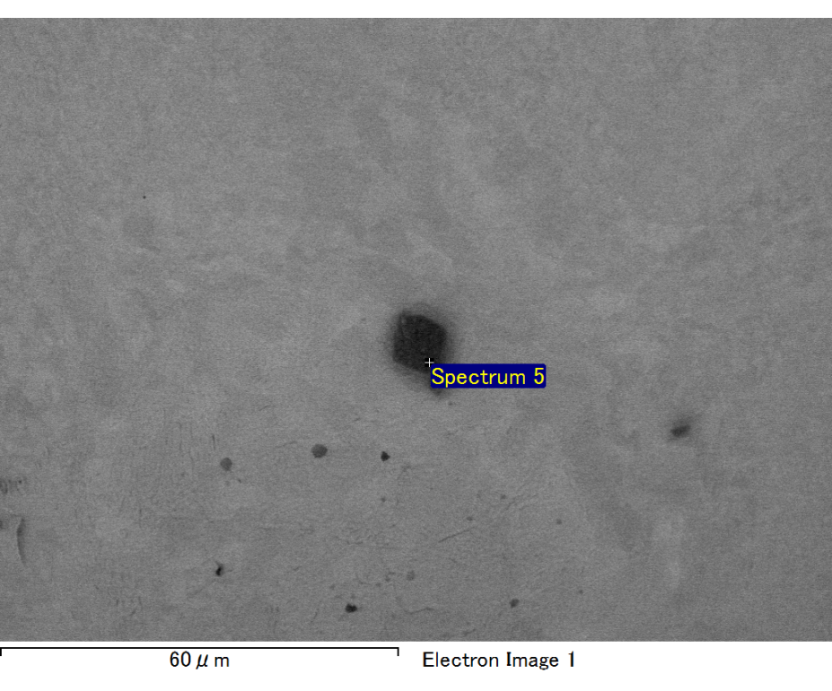

Spectrum processing :

Peak possibly omitted : 0.700 keV

Processing option : All elements analyzed (Normalised)

Number of iterations = 2

Standard :

C CaCO3 1-Jun-1999 12:00 AM

O SiO2 1-Jun-1999 12:00 AM

Mg MgO 1-Jun-1999 12:00 AM

Si SiO2 1-Jun-1999 12:00 AM

Au Au 1-Jun-1999 12:00 AM

|  |  |  |  |
| --- | --- | --- | --- |
| Element | Weight% | Atomic% |  |
|  |  |  |  |
| C K | 3.17 | 12.23 |  |
| O K | 19.18 | 55.64 |  |
| Mg K | 5.16 | 9.85 |  |
| Si K | 3.68 | 6.08 |  |
| Au M | 68.81 | 16.21 |  |
|  |  |  |  |
| Totals | 100.00 |  |  |

Spectrum Label: Spectrum 5

Livetime 60.0 s

Acquisition geometry ( degrees ):

Tilt = 15.0

Azimuth = 0.0

Elevation = 30.0

Accelerating voltage = 10.00 kV

Total spectrum counts = 49160

|  |  |  |  |
| --- | --- | --- | --- |
| Sample data : | Energy (eV) | Resn. (eV) | Area |
| Strobe : | 3.8 | 47.37 | 1000280 |
|  |  |  |  |

No quant optimization performed

Sample: Sample 1

Type: Default

ID: