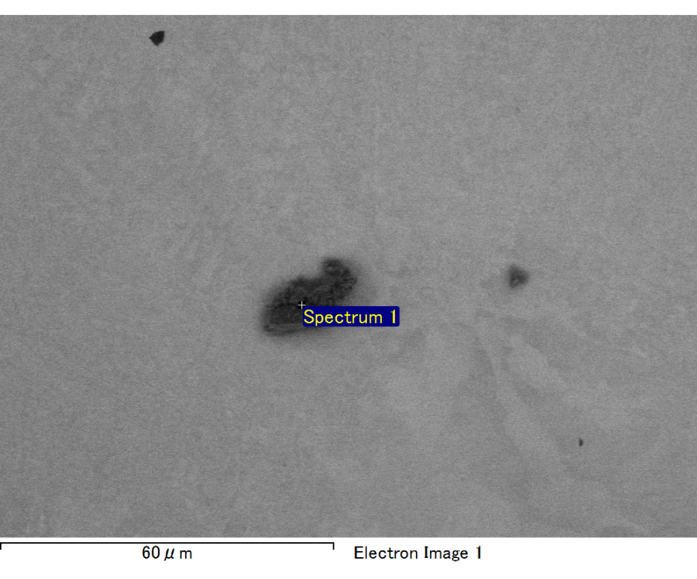

Spectrum processing :

No peaks omitted

Processing option : All elements analyzed (Normalised)

Number of iterations = 2

Standard :

C CaCO3 1-Jun-1999 12:00 AM

O SiO2 1-Jun-1999 12:00 AM

Mg MgO 1-Jun-1999 12:00 AM

Si SiO2 1-Jun-1999 12:00 AM

Au Au 1-Jun-1999 12:00 AM

|  |  |  |  |
| --- | --- | --- | --- |
| Element | Weight% | Atomic% |  |
|  |  |  |  |
| C K | 3.60 | 17.86 |  |
| O K | 11.34 | 42.29 |  |
| Mg K | 3.62 | 8.87 |  |
| Si K | 3.46 | 7.35 |  |
| Au M | 77.98 | 23.62 |  |
|  |  |  |  |
| Totals | 100.00 |  |  |

Spectrum Label: Spectrum 1

Livetime 60.0 s

Acquisition geometry ( degrees ):

Tilt = 15.0

Azimuth = 0.0

Elevation = 30.0

Accelerating voltage = 10.00 kV

Total spectrum counts = 45111

|  |  |  |  |
| --- | --- | --- | --- |
| Sample data : | Energy (eV) | Resn. (eV) | Area |
| Strobe : | 3.8 | 47.42 | 1000552 |
|  |  |  |  |

No quant optimization performed

Sample: Sample 1

Type: Default

ID:

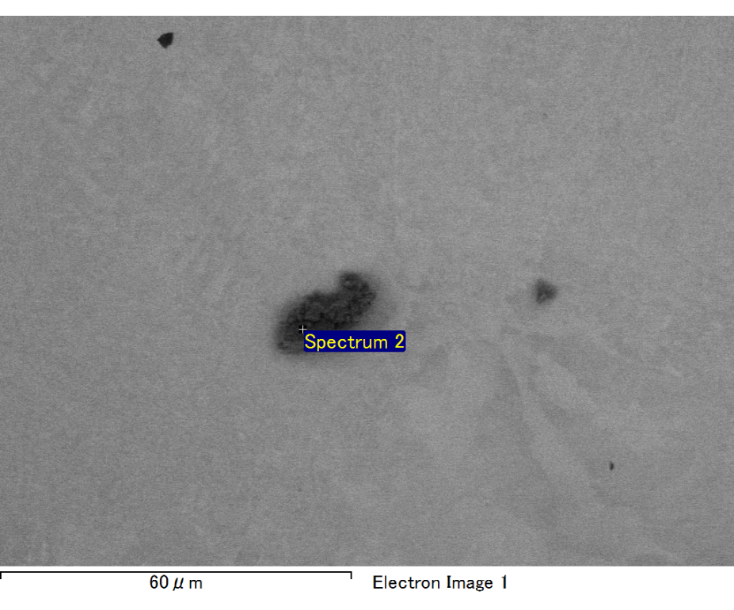

Spectrum processing :

No peaks omitted

Processing option : All elements analyzed (Normalised)

Number of iterations = 2

Standard :

C CaCO3 1-Jun-1999 12:00 AM

O SiO2 1-Jun-1999 12:00 AM

Mg MgO 1-Jun-1999 12:00 AM

Si SiO2 1-Jun-1999 12:00 AM

Fe Fe 1-Jun-1999 12:00 AM

Au Au 1-Jun-1999 12:00 AM

|  |  |  |  |
| --- | --- | --- | --- |
| Element | Weight% | Atomic% |  |
|  |  |  |  |
| C K | 2.97 | 10.17 |  |
| O K | 21.00 | 53.94 |  |
| Mg K | 6.04 | 10.21 |  |
| Si K | 4.18 | 6.12 |  |
| Fe L | 11.04 | 8.13 |  |
| Au M | 54.77 | 11.43 |  |
|  |  |  |  |
| Totals | 100.00 |  |  |

Spectrum Label: Spectrum 2

Livetime 60.0 s

Acquisition geometry ( degrees ):

Tilt = 15.0

Azimuth = 0.0

Elevation = 30.0

Accelerating voltage = 10.00 kV

Total spectrum counts = 52221

|  |  |  |  |
| --- | --- | --- | --- |
| Sample data : | Energy (eV) | Resn. (eV) | Area |
| Strobe : | 3.8 | 47.44 | 1000063 |
|  |  |  |  |

No quant optimization performed

Sample: Sample 1

Type: Default

ID:

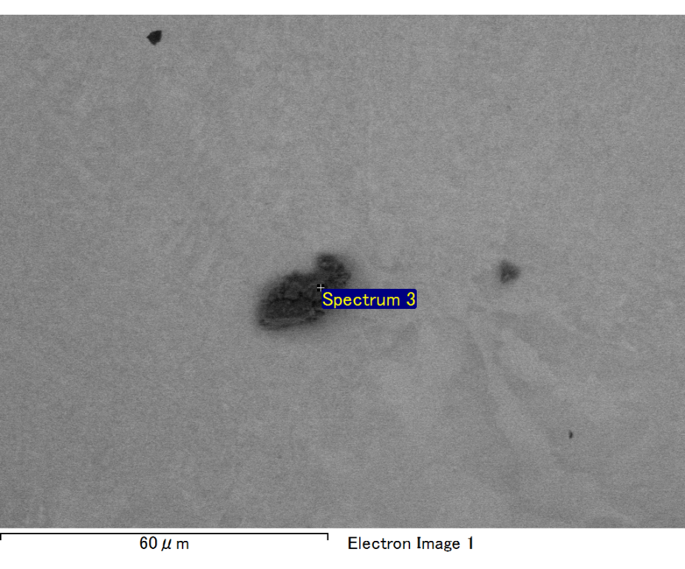

Spectrum processing :

No peaks omitted

Processing option : All elements analyzed (Normalised)

Number of iterations = 2

Standard :

C CaCO3 1-Jun-1999 12:00 AM

O SiO2 1-Jun-1999 12:00 AM

Mg MgO 1-Jun-1999 12:00 AM

Si SiO2 1-Jun-1999 12:00 AM

Fe Fe 1-Jun-1999 12:00 AM

Au Au 1-Jun-1999 12:00 AM

|  |  |  |  |
| --- | --- | --- | --- |
| Element | Weight% | Atomic% |  |
|  |  |  |  |
| C K | 2.81 | 9.54 |  |
| O K | 22.05 | 56.16 |  |
| Mg K | 6.07 | 10.17 |  |
| Si K | 4.73 | 6.86 |  |
| Fe L | 7.60 | 5.54 |  |
| Au M | 56.74 | 11.74 |  |
|  |  |  |  |
| Totals | 100.00 |  |  |

Spectrum Label: Spectrum 3

Livetime 60.0 s

Acquisition geometry ( degrees ):

Tilt = 15.0

Azimuth = 0.0

Elevation = 30.0

Accelerating voltage = 10.00 kV

Total spectrum counts = 51206

|  |  |  |  |
| --- | --- | --- | --- |
| Sample data : | Energy (eV) | Resn. (eV) | Area |
| Strobe : | 3.8 | 47.42 | 1001246 |
|  |  |  |  |

No quant optimization performed

Sample: Sample 1

Type: Default

ID:

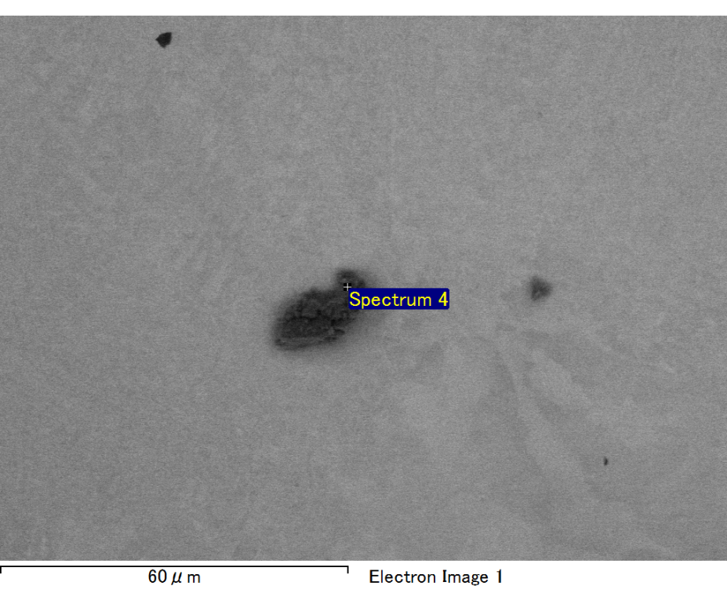

Spectrum processing :

No peaks omitted

Processing option : All elements analyzed (Normalised)

Number of iterations = 2

Standard :

C CaCO3 1-Jun-1999 12:00 AM

O SiO2 1-Jun-1999 12:00 AM

Mg MgO 1-Jun-1999 12:00 AM

Si SiO2 1-Jun-1999 12:00 AM

Fe Fe 1-Jun-1999 12:00 AM

Au Au 1-Jun-1999 12:00 AM

|  |  |  |  |
| --- | --- | --- | --- |
| Element | Weight% | Atomic% |  |
|  |  |  |  |
| C K | 3.03 | 10.66 |  |
| O K | 20.28 | 53.62 |  |
| Mg K | 5.75 | 10.00 |  |
| Si K | 4.24 | 6.38 |  |
| Fe L | 9.24 | 6.99 |  |
| Au M | 57.47 | 12.34 |  |
|  |  |  |  |
| Totals | 100.00 |  |  |

Spectrum Label: Spectrum 4

Livetime 60.0 s

Acquisition geometry ( degrees ):

Tilt = 15.0

Azimuth = 0.0

Elevation = 30.0

Accelerating voltage = 10.00 kV

Total spectrum counts = 51056

|  |  |  |  |
| --- | --- | --- | --- |
| Sample data : | Energy (eV) | Resn. (eV) | Area |
| Strobe : | 3.8 | 47.40 | 1000295 |
|  |  |  |  |

No quant optimization performed

Sample: Sample 1

Type: Default

ID:

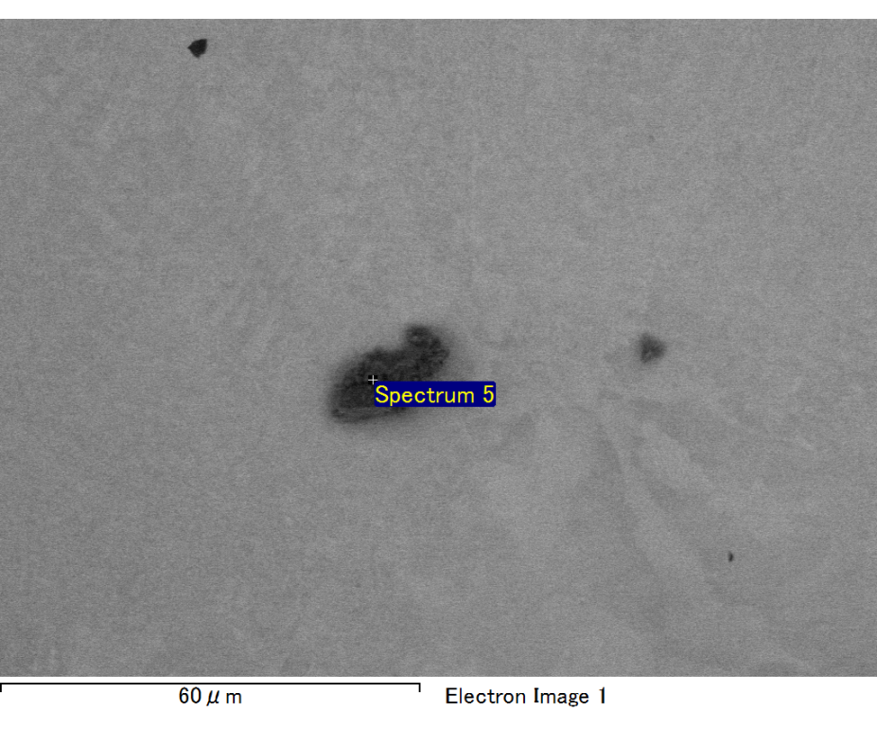

Spectrum processing :

No peaks omitted

Processing option : All elements analyzed (Normalised)

Number of iterations = 2

Standard :

C CaCO3 1-Jun-1999 12:00 AM

O SiO2 1-Jun-1999 12:00 AM

Mg MgO 1-Jun-1999 12:00 AM

Si SiO2 1-Jun-1999 12:00 AM

Fe Fe 1-Jun-1999 12:00 AM

Au Au 1-Jun-1999 12:00 AM

|  |  |  |  |
| --- | --- | --- | --- |
| Element | Weight% | Atomic% |  |
|  |  |  |  |
| C K | 2.83 | 9.90 |  |
| O K | 20.50 | 53.83 |  |
| Mg K | 6.00 | 10.38 |  |
| Si K | 4.27 | 6.39 |  |
| Fe L | 9.92 | 7.46 |  |
| Au M | 56.48 | 12.05 |  |
|  |  |  |  |
| Totals | 100.00 |  |  |

Spectrum Label: Spectrum 5

Livetime 60.0 s

Acquisition geometry ( degrees ):

Tilt = 15.0

Azimuth = 0.0

Elevation = 30.0

Accelerating voltage = 10.00 kV

Total spectrum counts = 51645

|  |  |  |  |
| --- | --- | --- | --- |
| Sample data : | Energy (eV) | Resn. (eV) | Area |
| Strobe : | 3.8 | 47.36 | 1000231 |
|  |  |  |  |

No quant optimization performed

Sample: Sample 1

Type: Default

ID: