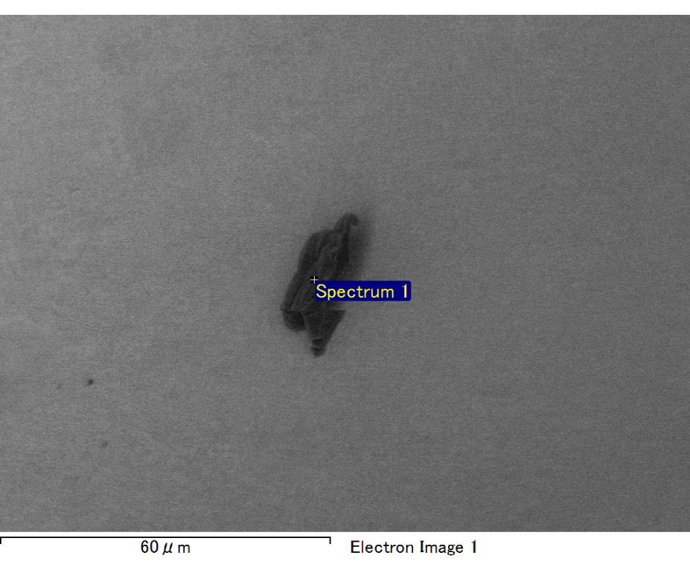

Spectrum processing :

No peaks omitted

Processing option : All elements analyzed (Normalised)

Number of iterations = 2

Standard :

C CaCO3 1-Jun-1999 12:00 AM

O SiO2 1-Jun-1999 12:00 AM

Na Albite 1-Jun-1999 12:00 AM

Al Al2O3 1-Jun-1999 12:00 AM

Si SiO2 1-Jun-1999 12:00 AM

Au Au 1-Jun-1999 12:00 AM

|  |  |  |  |
| --- | --- | --- | --- |
| Element | Weight% | Atomic% |  |
|  |  |  |  |
| C K | 2.33 | 7.90 |  |
| O K | 23.10 | 58.88 |  |
| Na K | 2.33 | 4.13 |  |
| Al K | 3.08 | 4.66 |  |
| Si K | 8.12 | 11.79 |  |
| Au M | 61.04 | 12.64 |  |
|  |  |  |  |
| Totals | 100.00 |  |  |

Spectrum Label: Spectrum 1

Livetime 60.0 s

Acquisition geometry ( degrees ):

Tilt = 15.0

Azimuth = 0.0

Elevation = 30.0

Accelerating voltage = 10.00 kV

Total spectrum counts = 52297

|  |  |  |  |
| --- | --- | --- | --- |
| Sample data : | Energy (eV) | Resn. (eV) | Area |
| Strobe : | 3.8 | 47.43 | 1000295 |
|  |  |  |  |

No quant optimization performed

Sample: Sample 1

Type: Default

ID:

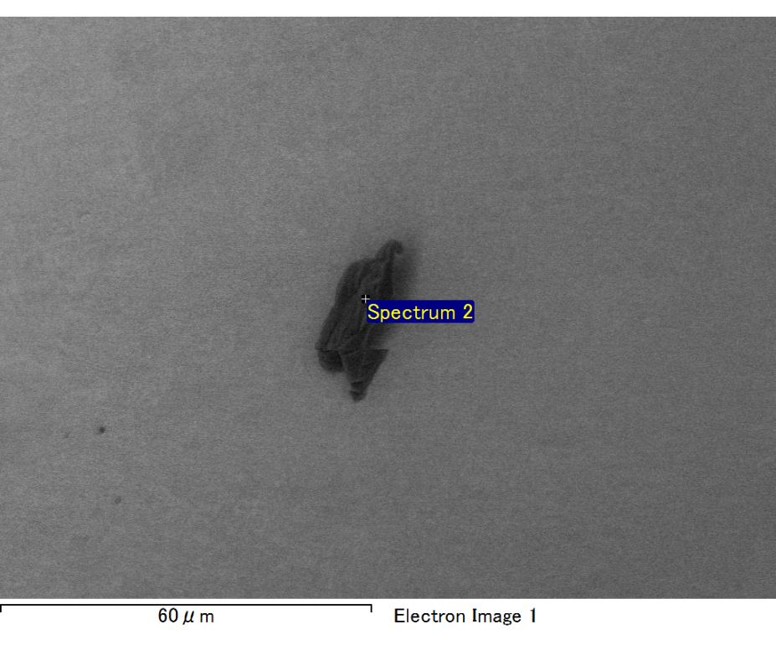

Spectrum processing :

No peaks omitted

Processing option : All elements analyzed (Normalised)

Number of iterations = 2

Standard :

C CaCO3 1-Jun-1999 12:00 AM

O SiO2 1-Jun-1999 12:00 AM

Na Albite 1-Jun-1999 12:00 AM

Al Al2O3 1-Jun-1999 12:00 AM

Si SiO2 1-Jun-1999 12:00 AM

Au Au 1-Jun-1999 12:00 AM

|  |  |  |  |
| --- | --- | --- | --- |
| Element | Weight% | Atomic% |  |
|  |  |  |  |
| C K | 3.18 | 10.67 |  |
| O K | 23.08 | 58.06 |  |
| Na K | 2.01 | 3.53 |  |
| Al K | 3.13 | 4.67 |  |
| Si K | 7.38 | 10.57 |  |
| Au M | 61.22 | 12.51 |  |
|  |  |  |  |
| Totals | 100.00 |  |  |

Spectrum Label: Spectrum 2

Livetime 60.0 s

Acquisition geometry ( degrees ):

Tilt = 15.0

Azimuth = 0.0

Elevation = 30.0

Accelerating voltage = 10.00 kV

Total spectrum counts = 52765

|  |  |  |  |
| --- | --- | --- | --- |
| Sample data : | Energy (eV) | Resn. (eV) | Area |
| Strobe : | 3.8 | 47.43 | 1001517 |
|  |  |  |  |

No quant optimization performed

Sample: Sample 1

Type: Default

ID:

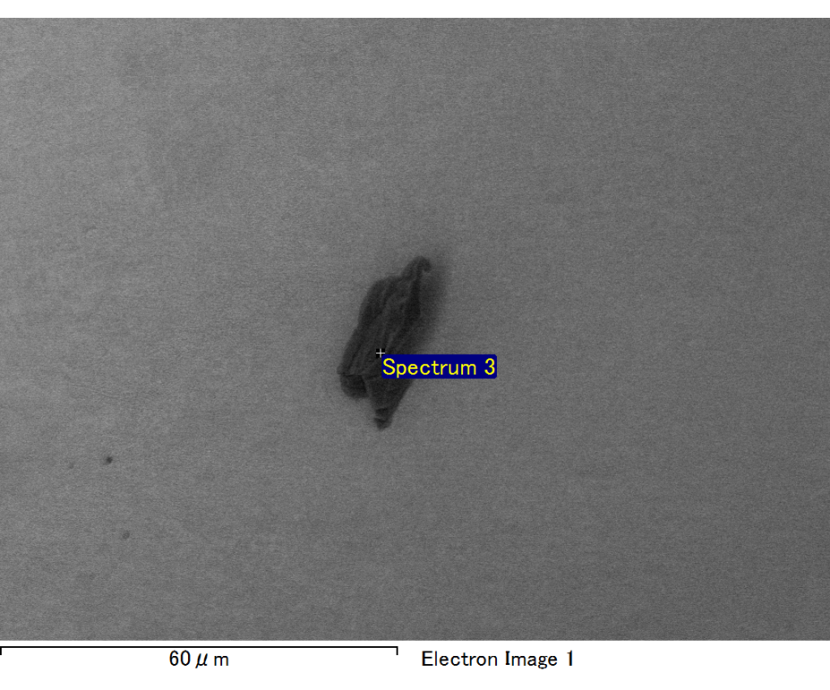

Spectrum processing :

No peaks omitted

Processing option : All elements analyzed (Normalised)

Number of iterations = 2

Standard :

C CaCO3 1-Jun-1999 12:00 AM

O SiO2 1-Jun-1999 12:00 AM

Na Albite 1-Jun-1999 12:00 AM

Al Al2O3 1-Jun-1999 12:00 AM

Si SiO2 1-Jun-1999 12:00 AM

Au Au 1-Jun-1999 12:00 AM

|  |  |  |  |
| --- | --- | --- | --- |
| Element | Weight% | Atomic% |  |
|  |  |  |  |
| C K | 2.62 | 8.59 |  |
| O K | 24.55 | 60.34 |  |
| Na K | 2.28 | 3.90 |  |
| Al K | 3.23 | 4.71 |  |
| Si K | 7.50 | 10.51 |  |
| Au M | 59.81 | 11.94 |  |
|  |  |  |  |
| Totals | 100.00 |  |  |

Spectrum Label: Spectrum 3

Livetime 60.0 s

Acquisition geometry ( degrees ):

Tilt = 15.0

Azimuth = 0.0

Elevation = 30.0

Accelerating voltage = 10.00 kV

Total spectrum counts = 52768

|  |  |  |  |
| --- | --- | --- | --- |
| Sample data : | Energy (eV) | Resn. (eV) | Area |
| Strobe : | 3.8 | 47.43 | 1000482 |
|  |  |  |  |

No quant optimization performed

Sample: Sample 1

Type: Default

ID:

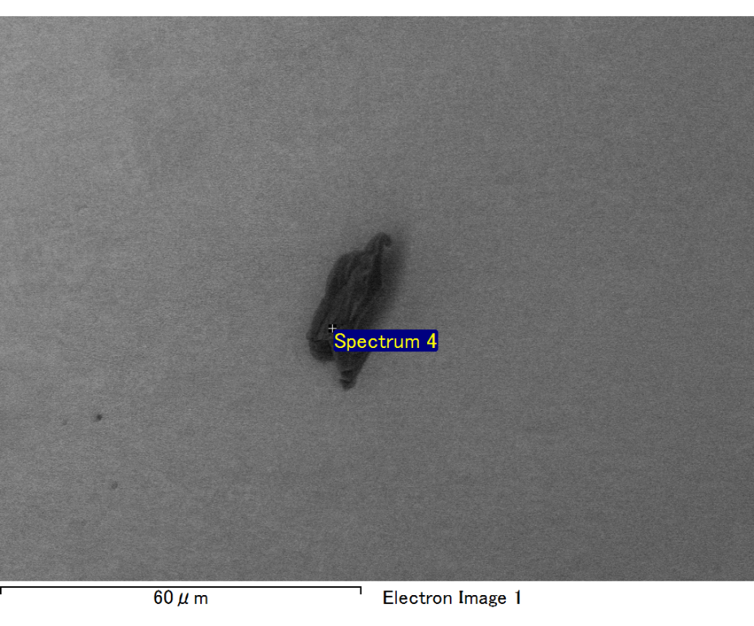

Spectrum processing :

No peaks omitted

Processing option : All elements analyzed (Normalised)

Number of iterations = 2

Standard :

C CaCO3 1-Jun-1999 12:00 AM

O SiO2 1-Jun-1999 12:00 AM

Na Albite 1-Jun-1999 12:00 AM

Al Al2O3 1-Jun-1999 12:00 AM

Si SiO2 1-Jun-1999 12:00 AM

Au Au 1-Jun-1999 12:00 AM

|  |  |  |  |
| --- | --- | --- | --- |
| Element | Weight% | Atomic% |  |
|  |  |  |  |
| C K | 2.72 | 9.17 |  |
| O K | 23.42 | 59.26 |  |
| Na K | 2.00 | 3.52 |  |
| Al K | 3.15 | 4.72 |  |
| Si K | 7.45 | 10.73 |  |
| Au M | 61.26 | 12.59 |  |
|  |  |  |  |
| Totals | 100.00 |  |  |

Spectrum Label: Spectrum 4

Livetime 60.0 s

Acquisition geometry ( degrees ):

Tilt = 15.0

Azimuth = 0.0

Elevation = 30.0

Accelerating voltage = 10.00 kV

Total spectrum counts = 52627

|  |  |  |  |
| --- | --- | --- | --- |
| Sample data : | Energy (eV) | Resn. (eV) | Area |
| Strobe : | 3.8 | 47.42 | 1000271 |
|  |  |  |  |

No quant optimization performed

Sample: Sample 1

Type: Default

ID:

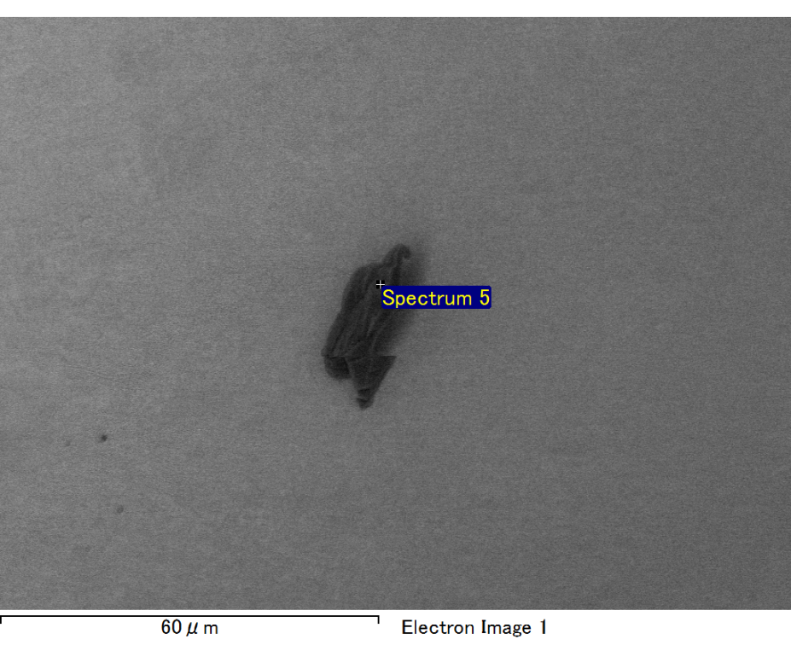

Spectrum processing :

No peaks omitted

Processing option : All elements analyzed (Normalised)

Number of iterations = 2

Standard :

C CaCO3 1-Jun-1999 12:00 AM

O SiO2 1-Jun-1999 12:00 AM

Na Albite 1-Jun-1999 12:00 AM

Al Al2O3 1-Jun-1999 12:00 AM

Si SiO2 1-Jun-1999 12:00 AM

Au Au 1-Jun-1999 12:00 AM

|  |  |  |  |
| --- | --- | --- | --- |
| Element | Weight% | Atomic% |  |
|  |  |  |  |
| C K | 2.90 | 10.21 |  |
| O K | 21.88 | 57.83 |  |
| Na K | 1.96 | 3.60 |  |
| Al K | 2.73 | 4.28 |  |
| Si K | 6.93 | 10.43 |  |
| Au M | 63.61 | 13.66 |  |
|  |  |  |  |
| Totals | 100.00 |  |  |

Spectrum Label: Spectrum 5

Livetime 60.0 s

Acquisition geometry ( degrees ):

Tilt = 15.0

Azimuth = 0.0

Elevation = 30.0

Accelerating voltage = 10.00 kV

Total spectrum counts = 52507

|  |  |  |  |
| --- | --- | --- | --- |
| Sample data : | Energy (eV) | Resn. (eV) | Area |
| Strobe : | 3.8 | 47.45 | 1000363 |
|  |  |  |  |

No quant optimization performed

Sample: Sample 1

Type: Default

ID: