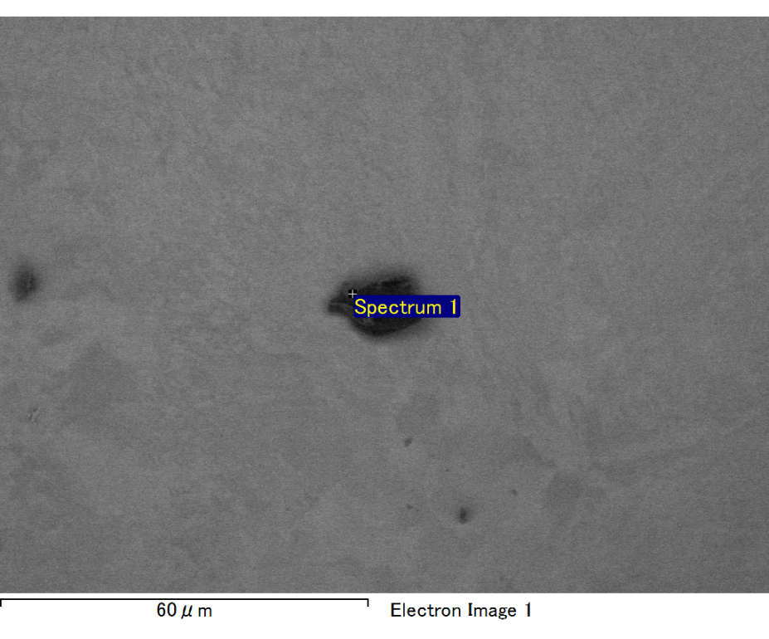

Spectrum processing :

No peaks omitted

Processing option : All elements analyzed (Normalised)

Number of iterations = 2

Standard :

C CaCO3 1-Jun-1999 12:00 AM

O SiO2 1-Jun-1999 12:00 AM

Mg MgO 1-Jun-1999 12:00 AM

Si SiO2 1-Jun-1999 12:00 AM

Fe Fe 1-Jun-1999 12:00 AM

Au Au 1-Jun-1999 12:00 AM

|  |  |  |  |
| --- | --- | --- | --- |
| Element | Weight% | Atomic% |  |
|  |  |  |  |
| C K | 2.49 | 8.96 |  |
| O K | 19.81 | 53.58 |  |
| Mg K | 6.01 | 10.70 |  |
| Si K | 4.25 | 6.55 |  |
| Fe L | 9.73 | 7.54 |  |
| Au M | 57.70 | 12.67 |  |
|  |  |  |  |
| Totals | 100.00 |  |  |

Spectrum Label: Spectrum 1

Livetime 60.0 s

Acquisition geometry ( degrees ):

Tilt = 15.0

Azimuth = 0.0

Elevation = 30.0

Accelerating voltage = 10.00 kV

Total spectrum counts = 50554

|  |  |  |  |
| --- | --- | --- | --- |
| Sample data : | Energy (eV) | Resn. (eV) | Area |
| Strobe : | 3.8 | 47.42 | 1001502 |
|  |  |  |  |

No quant optimization performed

Sample: Sample 1

Type: Default

ID:

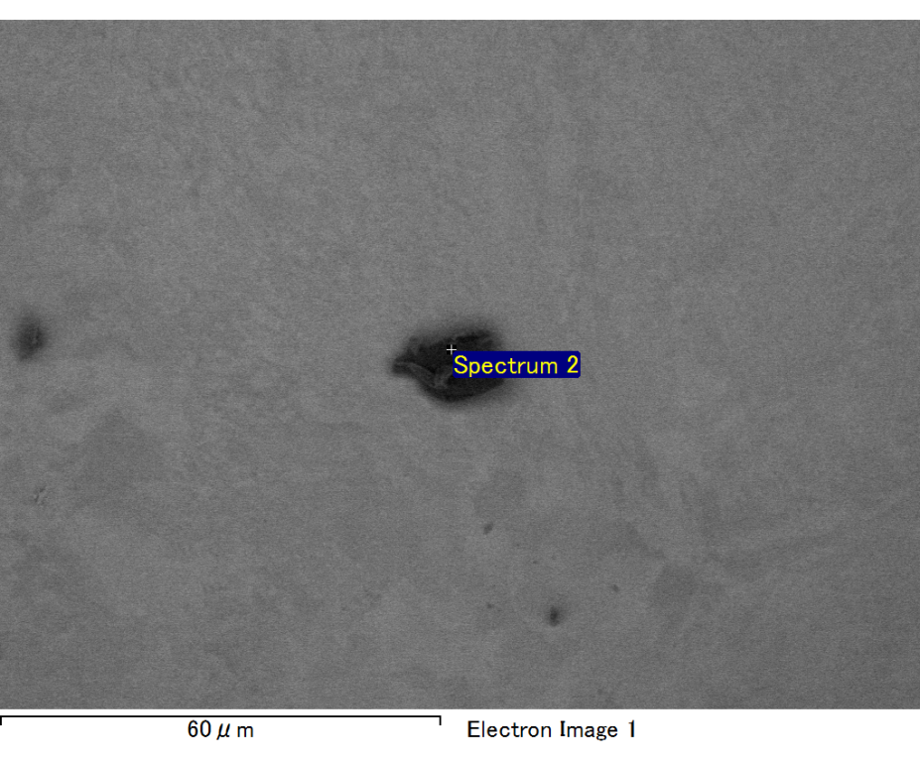

Spectrum processing :

Peaks possibly omitted : 0.710, 6.369 keV

Processing option : All elements analyzed (Normalised)

Number of iterations = 2

Standard :

C CaCO3 1-Jun-1999 12:00 AM

O SiO2 1-Jun-1999 12:00 AM

Mg MgO 1-Jun-1999 12:00 AM

Si SiO2 1-Jun-1999 12:00 AM

Au Au 1-Jun-1999 12:00 AM

|  |  |  |  |
| --- | --- | --- | --- |
| Element | Weight% | Atomic% |  |
|  |  |  |  |
| C K | 3.69 | 16.16 |  |
| O K | 13.69 | 45.00 |  |
| Mg K | 5.45 | 11.79 |  |
| Si K | 4.02 | 7.53 |  |
| Au M | 73.14 | 19.52 |  |
|  |  |  |  |
| Totals | 100.00 |  |  |

Spectrum Label: Spectrum 2

Livetime 60.0 s

Acquisition geometry ( degrees ):

Tilt = 15.0

Azimuth = 0.0

Elevation = 30.0

Accelerating voltage = 10.00 kV

Total spectrum counts = 47624

|  |  |  |  |
| --- | --- | --- | --- |
| Sample data : | Energy (eV) | Resn. (eV) | Area |
| Strobe : | 3.8 | 47.44 | 1000424 |
|  |  |  |  |

No quant optimization performed

Sample: Sample 1

Type: Default

ID:

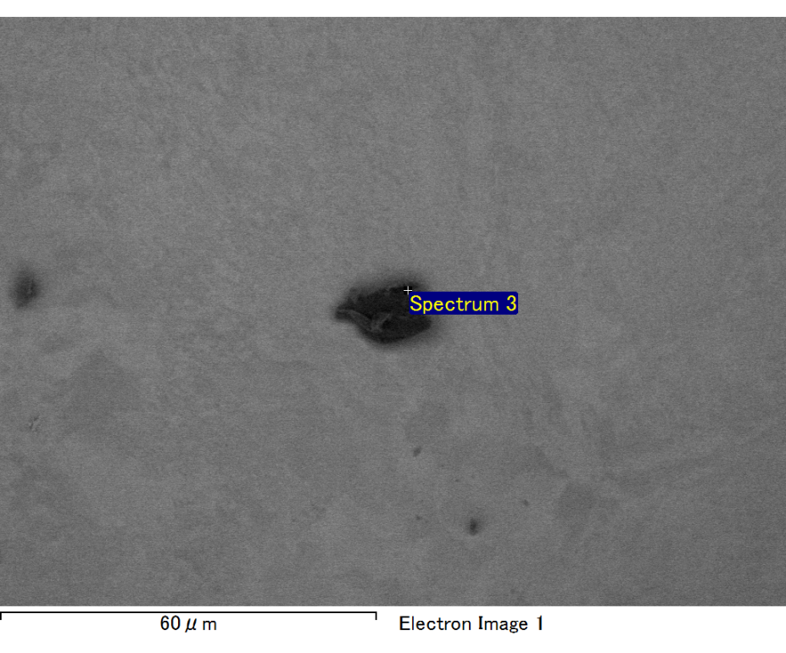

Spectrum processing :

No peaks omitted

Processing option : All elements analyzed (Normalised)

Number of iterations = 2

Standard :

C CaCO3 1-Jun-1999 12:00 AM

O SiO2 1-Jun-1999 12:00 AM

Mg MgO 1-Jun-1999 12:00 AM

Si SiO2 1-Jun-1999 12:00 AM

Fe Fe 1-Jun-1999 12:00 AM

Au Au 1-Jun-1999 12:00 AM

|  |  |  |  |
| --- | --- | --- | --- |
| Element | Weight% | Atomic% |  |
|  |  |  |  |
| C K | 2.10 | 7.70 |  |
| O K | 19.39 | 53.22 |  |
| Mg K | 6.02 | 10.87 |  |
| Si K | 4.47 | 7.00 |  |
| Fe L | 10.75 | 8.46 |  |
| Au M | 57.26 | 12.77 |  |
|  |  |  |  |
| Totals | 100.00 |  |  |

Spectrum Label: Spectrum 3

Livetime 60.0 s

Acquisition geometry ( degrees ):

Tilt = 15.0

Azimuth = 0.0

Elevation = 30.0

Accelerating voltage = 10.00 kV

Total spectrum counts = 52016

|  |  |  |  |
| --- | --- | --- | --- |
| Sample data : | Energy (eV) | Resn. (eV) | Area |
| Strobe : | 3.8 | 47.44 | 1001293 |
|  |  |  |  |

No quant optimization performed

Sample: Sample 1

Type: Default

ID:

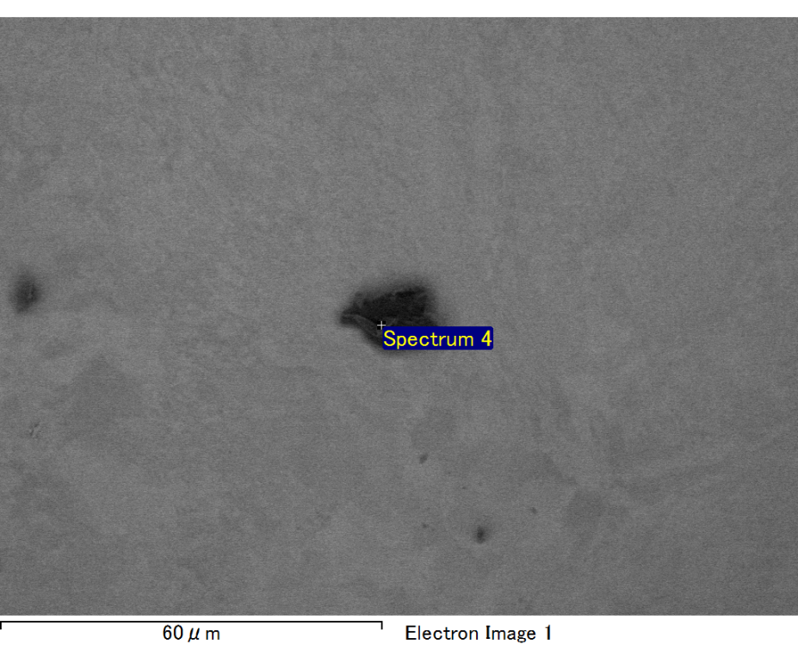

Spectrum processing :

No peaks omitted

Processing option : All elements analyzed (Normalised)

Number of iterations = 2

Standard :

C CaCO3 1-Jun-1999 12:00 AM

O SiO2 1-Jun-1999 12:00 AM

Mg MgO 1-Jun-1999 12:00 AM

Si SiO2 1-Jun-1999 12:00 AM

Fe Fe 1-Jun-1999 12:00 AM

Au Au 1-Jun-1999 12:00 AM

|  |  |  |  |
| --- | --- | --- | --- |
| Element | Weight% | Atomic% |  |
|  |  |  |  |
| C K | 3.07 | 11.55 |  |
| O K | 17.88 | 50.56 |  |
| Mg K | 5.32 | 9.91 |  |
| Si K | 3.53 | 5.68 |  |
| Fe L | 10.65 | 8.63 |  |
| Au M | 59.56 | 13.68 |  |
|  |  |  |  |
| Totals | 100.00 |  |  |

Spectrum Label: Spectrum 4

Livetime 60.0 s

Acquisition geometry ( degrees ):

Tilt = 15.0

Azimuth = 0.0

Elevation = 30.0

Accelerating voltage = 10.00 kV

Total spectrum counts = 52833

|  |  |  |  |
| --- | --- | --- | --- |
| Sample data : | Energy (eV) | Resn. (eV) | Area |
| Strobe : | 3.8 | 47.39 | 1000144 |
|  |  |  |  |

No quant optimization performed

Sample: Sample 1

Type: Default

ID:

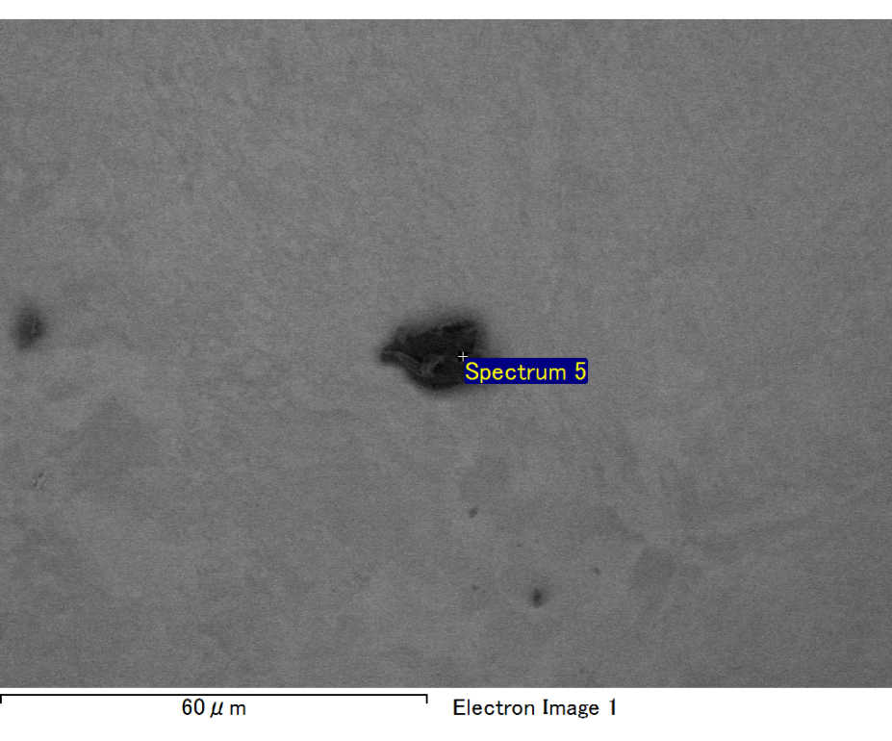

Spectrum processing :

No peaks omitted

Processing option : All elements analyzed (Normalised)

Number of iterations = 2

Standard :

C CaCO3 1-Jun-1999 12:00 AM

O SiO2 1-Jun-1999 12:00 AM

Mg MgO 1-Jun-1999 12:00 AM

Si SiO2 1-Jun-1999 12:00 AM

Fe Fe 1-Jun-1999 12:00 AM

Au Au 1-Jun-1999 12:00 AM

|  |  |  |  |
| --- | --- | --- | --- |
| Element | Weight% | Atomic% |  |
|  |  |  |  |
| C K | 2.11 | 7.74 |  |
| O K | 19.21 | 52.95 |  |
| Mg K | 6.24 | 11.32 |  |
| Si K | 4.64 | 7.29 |  |
| Fe L | 9.75 | 7.70 |  |
| Au M | 58.05 | 13.00 |  |
|  |  |  |  |
| Totals | 100.00 |  |  |

Spectrum Label: Spectrum 5

Livetime 60.0 s

Acquisition geometry ( degrees ):

Tilt = 15.0

Azimuth = 0.0

Elevation = 30.0

Accelerating voltage = 10.00 kV

Total spectrum counts = 50375

|  |  |  |  |
| --- | --- | --- | --- |
| Sample data : | Energy (eV) | Resn. (eV) | Area |
| Strobe : | 3.8 | 47.39 | 1000081 |
|  |  |  |  |

No quant optimization performed

Sample: Sample 1

Type: Default

ID: