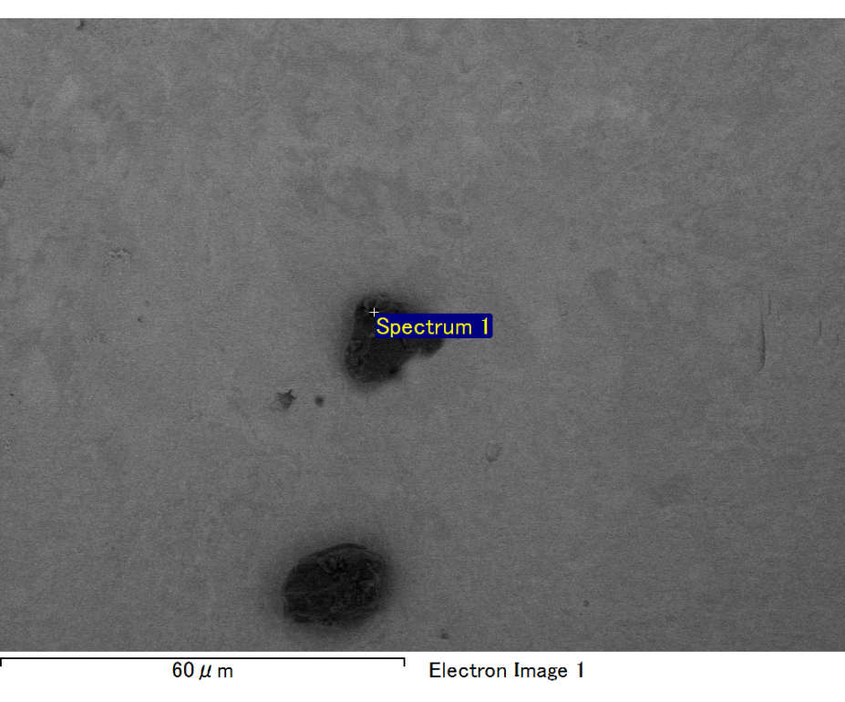

Spectrum processing :

Peaks possibly omitted : 0.700, 6.415 keV

Processing option : All elements analyzed (Normalised)

Number of iterations = 2

Standard :

C CaCO3 1-Jun-1999 12:00 AM

O SiO2 1-Jun-1999 12:00 AM

Mg MgO 1-Jun-1999 12:00 AM

Si SiO2 1-Jun-1999 12:00 AM

Au Au 1-Jun-1999 12:00 AM

|  |  |  |  |
| --- | --- | --- | --- |
| Element | Weight% | Atomic% |  |
|  |  |  |  |
| C K | 2.78 | 11.08 |  |
| O K | 17.95 | 53.80 |  |
| Mg K | 5.61 | 11.07 |  |
| Si K | 4.18 | 7.14 |  |
| Au M | 69.47 | 16.91 |  |
|  |  |  |  |
| Totals | 100.00 |  |  |

Spectrum Label: Spectrum 1

Livetime 60.0 s

Acquisition geometry ( degrees ):

Tilt = 15.0

Azimuth = 0.0

Elevation = 30.0

Accelerating voltage = 10.00 kV

Total spectrum counts = 48782

|  |  |  |  |
| --- | --- | --- | --- |
| Sample data : | Energy (eV) | Resn. (eV) | Area |
| Strobe : | 3.8 | 47.43 | 1000167 |
|  |  |  |  |

No quant optimization performed

Sample: Sample 1

Type: Default

ID:

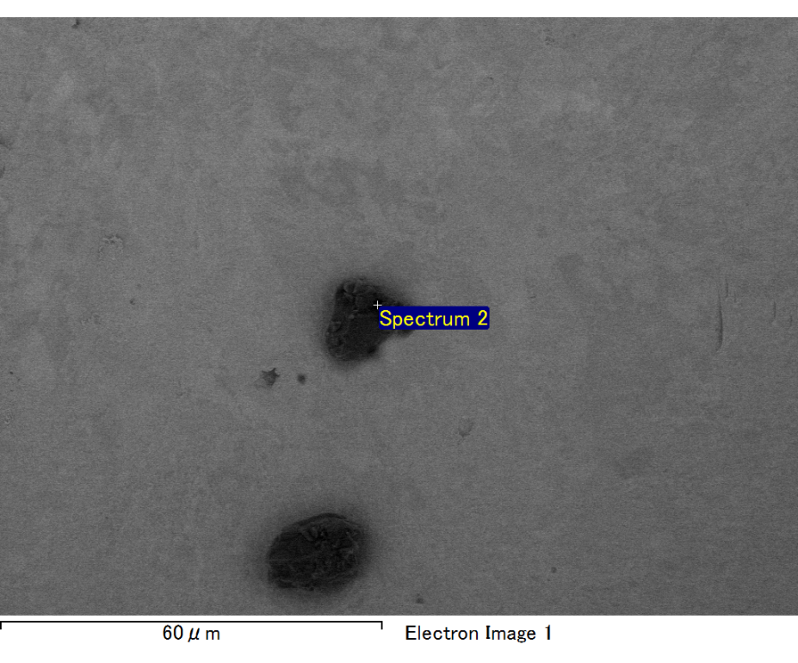

Spectrum processing :

Peak possibly omitted : 4.580 keV

Processing option : All elements analyzed (Normalised)

Number of iterations = 2

Standard :

C CaCO3 1-Jun-1999 12:00 AM

O SiO2 1-Jun-1999 12:00 AM

Mg MgO 1-Jun-1999 12:00 AM

Si SiO2 1-Jun-1999 12:00 AM

Fe Fe 1-Jun-1999 12:00 AM

Au Au 1-Jun-1999 12:00 AM

|  |  |  |  |
| --- | --- | --- | --- |
| Element | Weight% | Atomic% |  |
|  |  |  |  |
| C K | 2.53 | 8.76 |  |
| O K | 20.59 | 53.56 |  |
| Mg K | 6.24 | 10.69 |  |
| Si K | 4.29 | 6.36 |  |
| Fe L | 12.36 | 9.21 |  |
| Au M | 53.98 | 11.41 |  |
|  |  |  |  |
| Totals | 100.00 |  |  |

Spectrum Label: Spectrum 2

Livetime 60.0 s

Acquisition geometry ( degrees ):

Tilt = 15.0

Azimuth = 0.0

Elevation = 30.0

Accelerating voltage = 10.00 kV

Total spectrum counts = 52664

|  |  |  |  |
| --- | --- | --- | --- |
| Sample data : | Energy (eV) | Resn. (eV) | Area |
| Strobe : | 3.8 | 47.49 | 1000069 |
|  |  |  |  |

No quant optimization performed

Sample: Sample 1

Type: Default

ID:

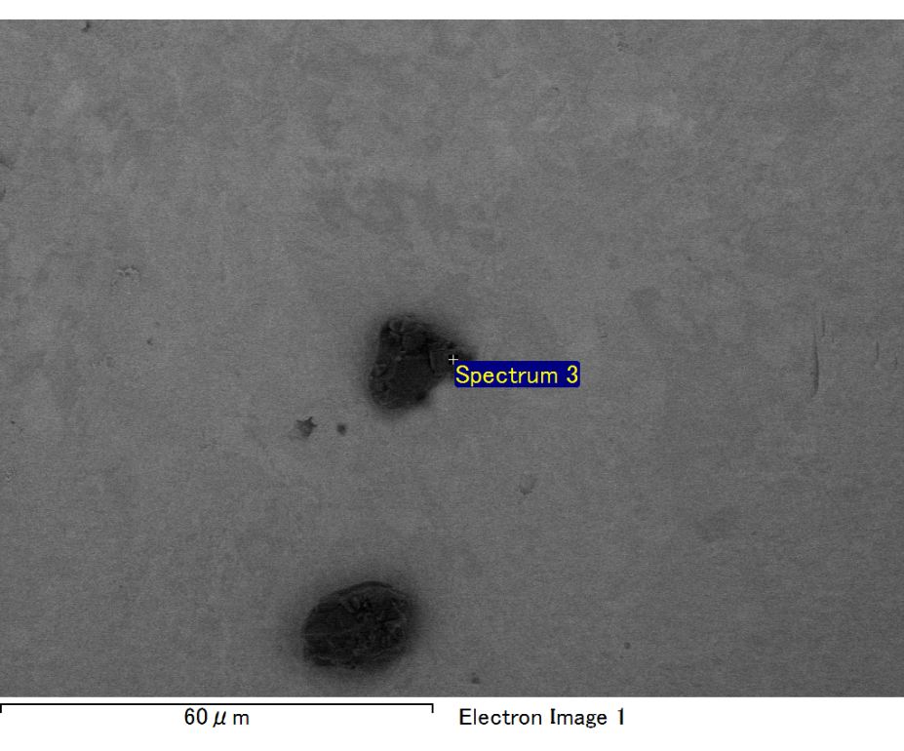

Spectrum processing :

No peaks omitted

Processing option : All elements analyzed (Normalised)

Number of iterations = 2

Standard :

C CaCO3 1-Jun-1999 12:00 AM

O SiO2 1-Jun-1999 12:00 AM

Mg MgO 1-Jun-1999 12:00 AM

Si SiO2 1-Jun-1999 12:00 AM

Au Au 1-Jun-1999 12:00 AM

|  |  |  |  |
| --- | --- | --- | --- |
| Element | Weight% | Atomic% |  |
|  |  |  |  |
| C K | 3.95 | 22.60 |  |
| O K | 7.88 | 33.87 |  |
| Mg K | 2.91 | 8.24 |  |
| Si K | 2.62 | 6.42 |  |
| Au M | 82.65 | 28.87 |  |
|  |  |  |  |
| Totals | 100.00 |  |  |

Spectrum Label: Spectrum 3

Livetime 60.0 s

Acquisition geometry ( degrees ):

Tilt = 15.0

Azimuth = 0.0

Elevation = 30.0

Accelerating voltage = 10.00 kV

Total spectrum counts = 46729

|  |  |  |  |
| --- | --- | --- | --- |
| Sample data : | Energy (eV) | Resn. (eV) | Area |
| Strobe : | 3.8 | 47.41 | 999803 |
|  |  |  |  |

No quant optimization performed

Sample: Sample 1

Type: Default

ID:

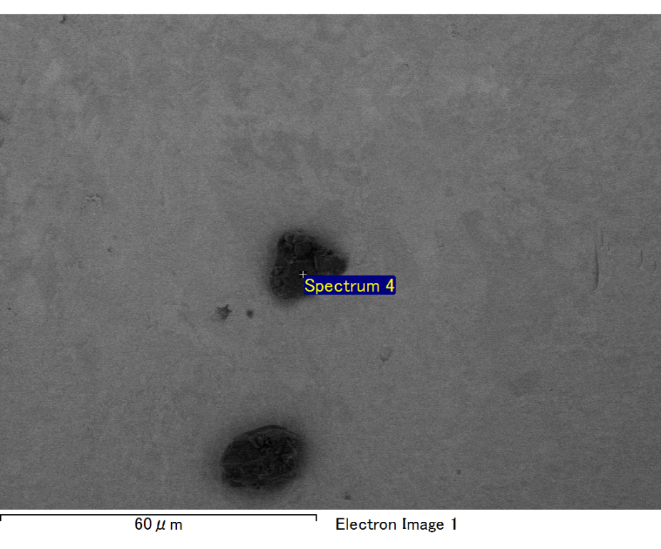

Spectrum processing :

No peaks omitted

Processing option : All elements analyzed (Normalised)

Number of iterations = 2

Standard :

C CaCO3 1-Jun-1999 12:00 AM

O SiO2 1-Jun-1999 12:00 AM

Mg MgO 1-Jun-1999 12:00 AM

Si SiO2 1-Jun-1999 12:00 AM

Au Au 1-Jun-1999 12:00 AM

|  |  |  |  |
| --- | --- | --- | --- |
| Element | Weight% | Atomic% |  |
|  |  |  |  |
| C K | 3.35 | 14.37 |  |
| O K | 15.72 | 50.59 |  |
| Mg K | 4.66 | 9.86 |  |
| Si K | 3.33 | 6.11 |  |
| Au M | 72.94 | 19.07 |  |
|  |  |  |  |
| Totals | 100.00 |  |  |

Spectrum Label: Spectrum 4

Livetime 60.0 s

Acquisition geometry ( degrees ):

Tilt = 15.0

Azimuth = 0.0

Elevation = 30.0

Accelerating voltage = 10.00 kV

Total spectrum counts = 48538

|  |  |  |  |
| --- | --- | --- | --- |
| Sample data : | Energy (eV) | Resn. (eV) | Area |
| Strobe : | 3.8 | 47.48 | 1000523 |
|  |  |  |  |

No quant optimization performed

Sample: Sample 1

Type: Default

ID:

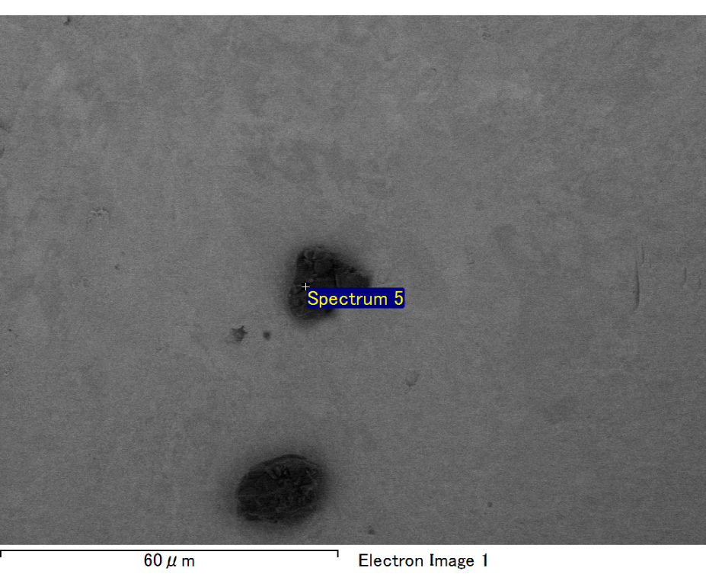

Spectrum processing :

No peaks omitted

Processing option : All elements analyzed (Normalised)

Number of iterations = 2

Standard :

C CaCO3 1-Jun-1999 12:00 AM

O SiO2 1-Jun-1999 12:00 AM

Mg MgO 1-Jun-1999 12:00 AM

Si SiO2 1-Jun-1999 12:00 AM

Fe Fe 1-Jun-1999 12:00 AM

Au Au 1-Jun-1999 12:00 AM

|  |  |  |  |
| --- | --- | --- | --- |
| Element | Weight% | Atomic% |  |
|  |  |  |  |
| C K | 2.35 | 8.68 |  |
| O K | 19.51 | 54.17 |  |
| Mg K | 5.35 | 9.77 |  |
| Si K | 4.00 | 6.33 |  |
| Fe L | 9.71 | 7.73 |  |
| Au M | 59.08 | 13.32 |  |
|  |  |  |  |
| Totals | 100.00 |  |  |

Spectrum Label: Spectrum 5

Livetime 60.0 s

Acquisition geometry ( degrees ):

Tilt = 15.0

Azimuth = 0.0

Elevation = 30.0

Accelerating voltage = 10.00 kV

Total spectrum counts = 51665

|  |  |  |  |
| --- | --- | --- | --- |
| Sample data : | Energy (eV) | Resn. (eV) | Area |
| Strobe : | 3.8 | 47.46 | 1000090 |
|  |  |  |  |

No quant optimization performed

Sample: Sample 1

Type: Default

ID: