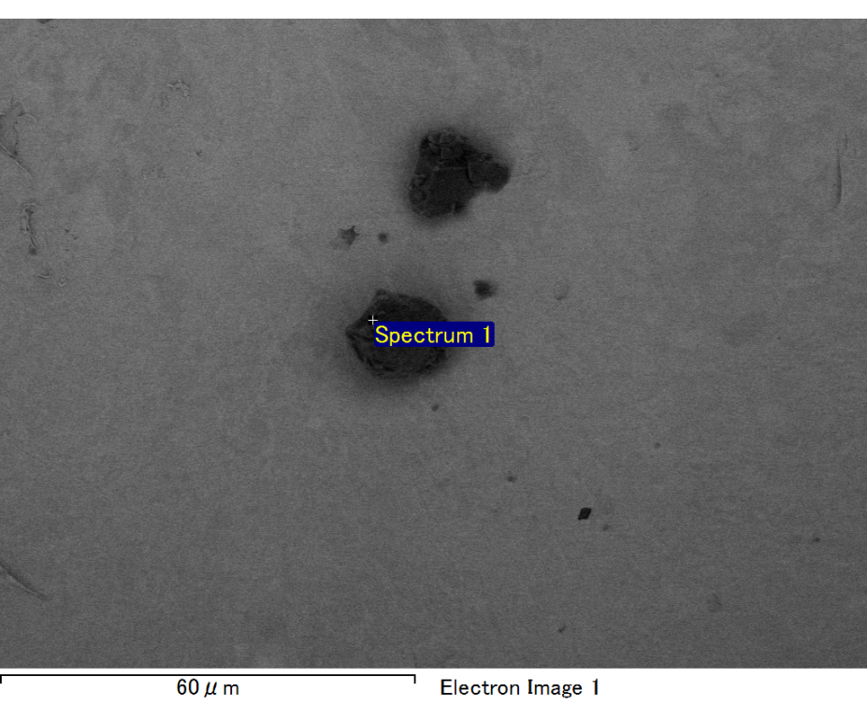

Spectrum processing :

No peaks omitted

Processing option : All elements analyzed (Normalised)

Number of iterations = 2

Standard :

C CaCO3 1-Jun-1999 12:00 AM

O SiO2 1-Jun-1999 12:00 AM

Mg MgO 1-Jun-1999 12:00 AM

Si SiO2 1-Jun-1999 12:00 AM

Fe Fe 1-Jun-1999 12:00 AM

Au Au 1-Jun-1999 12:00 AM

|  |  |  |  |
| --- | --- | --- | --- |
| Element | Weight% | Atomic% |  |
|  |  |  |  |
| C K | 2.42 | 8.85 |  |
| O K | 19.46 | 53.36 |  |
| Mg K | 5.44 | 9.81 |  |
| Si K | 3.90 | 6.09 |  |
| Fe L | 11.69 | 9.18 |  |
| Au M | 57.09 | 12.71 |  |
|  |  |  |  |
| Totals | 100.00 |  |  |

Spectrum Label: Spectrum 1

Livetime 60.0 s

Acquisition geometry ( degrees ):

Tilt = 15.0

Azimuth = 0.0

Elevation = 30.0

Accelerating voltage = 10.00 kV

Total spectrum counts = 53533

|  |  |  |  |
| --- | --- | --- | --- |
| Sample data : | Energy (eV) | Resn. (eV) | Area |
| Strobe : | 3.8 | 47.49 | 999892 |
|  |  |  |  |

No quant optimization performed

Sample: Sample 1

Type: Default

ID:

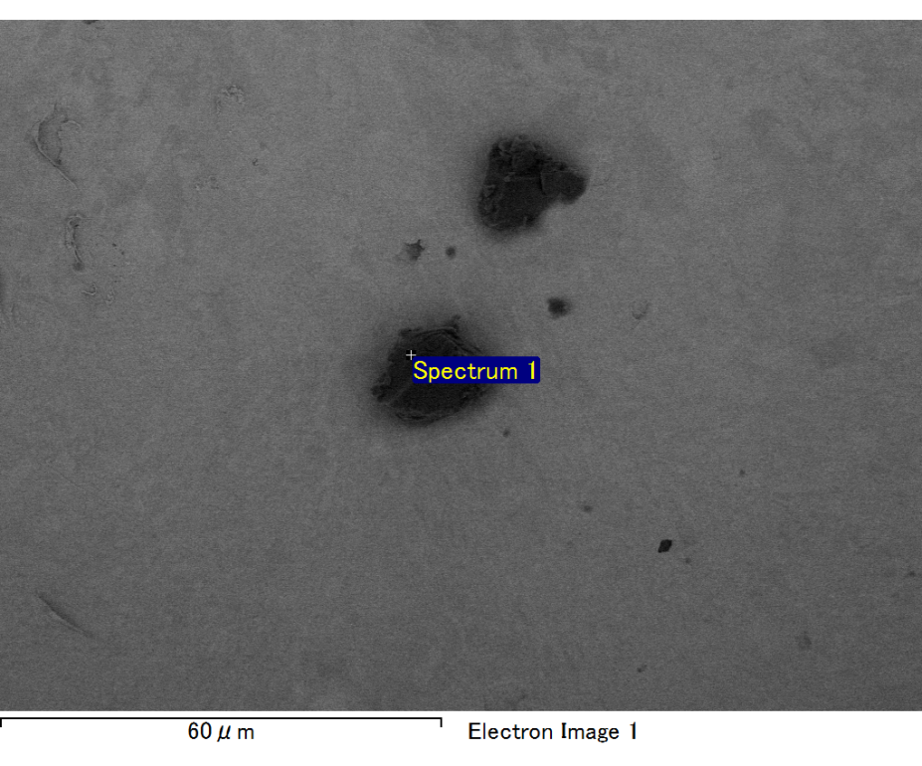

Spectrum processing :

No peaks omitted

Processing option : All elements analyzed (Normalised)

Number of iterations = 2

Standard :

C CaCO3 1-Jun-1999 12:00 AM

O SiO2 1-Jun-1999 12:00 AM

Mg MgO 1-Jun-1999 12:00 AM

Si SiO2 1-Jun-1999 12:00 AM

Fe Fe 1-Jun-1999 12:00 AM

Au Au 1-Jun-1999 12:00 AM

|  |  |  |  |
| --- | --- | --- | --- |
| Element | Weight% | Atomic% |  |
|  |  |  |  |
| C K | 2.80 | 10.59 |  |
| O K | 18.52 | 52.70 |  |
| Mg K | 5.24 | 9.82 |  |
| Si K | 3.75 | 6.08 |  |
| Fe L | 8.07 | 6.57 |  |
| Au M | 61.62 | 14.24 |  |
|  |  |  |  |
| Totals | 100.00 |  |  |

Spectrum Label: Spectrum 1

Livetime 60.0 s

Acquisition geometry ( degrees ):

Tilt = 15.0

Azimuth = 0.0

Elevation = 30.0

Accelerating voltage = 10.00 kV

Total spectrum counts = 49385

|  |  |  |  |
| --- | --- | --- | --- |
| Sample data : | Energy (eV) | Resn. (eV) | Area |
| Strobe : | 3.8 | 47.43 | 1000776 |
|  |  |  |  |

No quant optimization performed

Sample: Sample 1

Type: Default

ID:

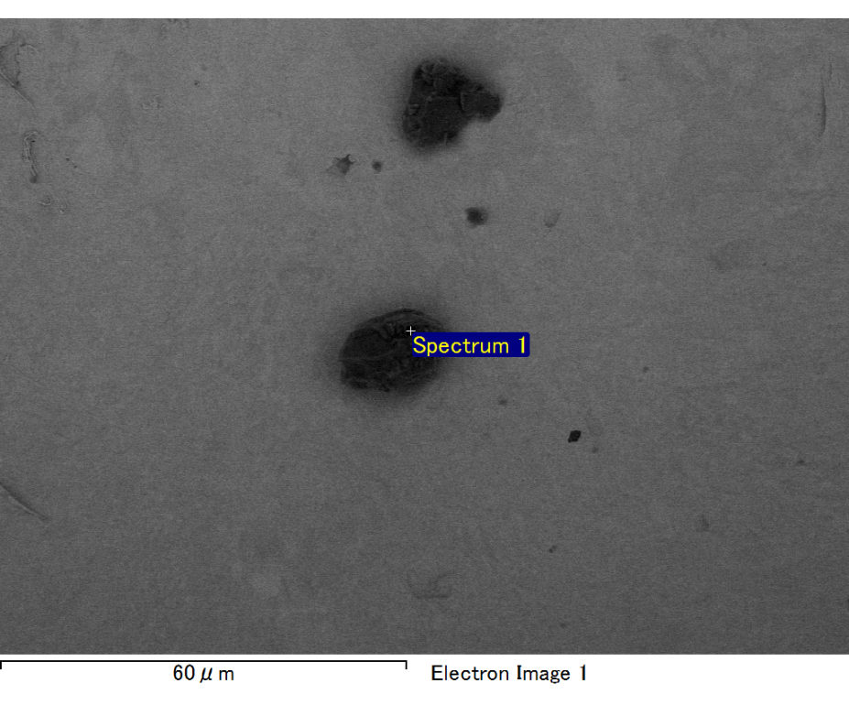

Spectrum processing :

No peaks omitted

Processing option : All elements analyzed (Normalised)

Number of iterations = 2

Standard :

C CaCO3 1-Jun-1999 12:00 AM

O SiO2 1-Jun-1999 12:00 AM

Mg MgO 1-Jun-1999 12:00 AM

Si SiO2 1-Jun-1999 12:00 AM

Fe Fe 1-Jun-1999 12:00 AM

Au Au 1-Jun-1999 12:00 AM

|  |  |  |  |
| --- | --- | --- | --- |
| Element | Weight% | Atomic% |  |
|  |  |  |  |
| C K | 2.81 | 9.72 |  |
| O K | 20.71 | 53.78 |  |
| Mg K | 5.41 | 9.24 |  |
| Si K | 4.03 | 5.97 |  |
| Fe L | 13.42 | 9.98 |  |
| Au M | 53.62 | 11.31 |  |
|  |  |  |  |
| Totals | 100.00 |  |  |

Spectrum Label: Spectrum 1

Livetime 60.0 s

Acquisition geometry ( degrees ):

Tilt = 15.0

Azimuth = 0.0

Elevation = 30.0

Accelerating voltage = 10.00 kV

Total spectrum counts = 53212

|  |  |  |  |
| --- | --- | --- | --- |
| Sample data : | Energy (eV) | Resn. (eV) | Area |
| Strobe : | 3.8 | 47.48 | 1000404 |
|  |  |  |  |

No quant optimization performed

Sample: Sample 1

Type: Default

ID:

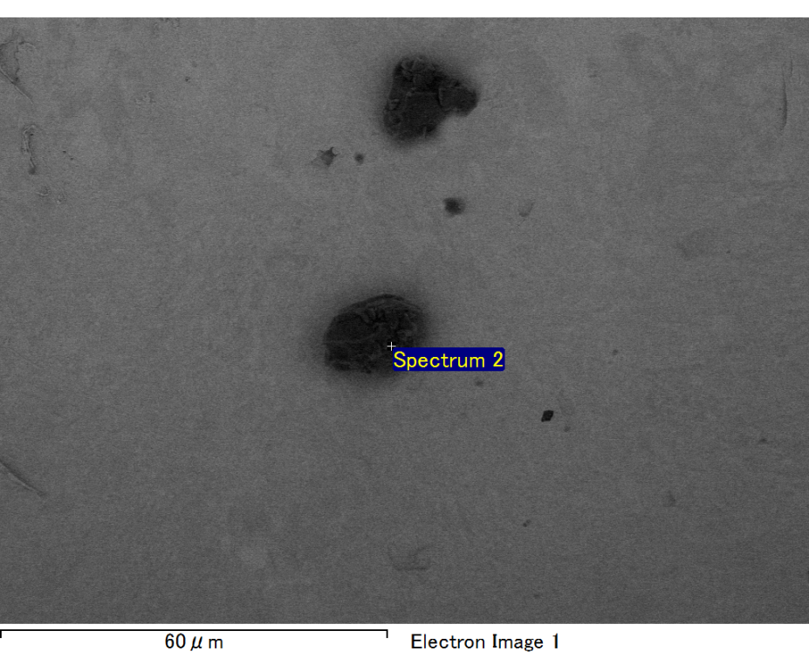

Spectrum processing :

No peaks omitted

Processing option : All elements analyzed (Normalised)

Number of iterations = 2

Standard :

C CaCO3 1-Jun-1999 12:00 AM

O SiO2 1-Jun-1999 12:00 AM

Mg MgO 1-Jun-1999 12:00 AM

Si SiO2 1-Jun-1999 12:00 AM

Fe Fe 1-Jun-1999 12:00 AM

Au Au 1-Jun-1999 12:00 AM

|  |  |  |  |
| --- | --- | --- | --- |
| Element | Weight% | Atomic% |  |
|  |  |  |  |
| C K | 3.51 | 19.60 |  |
| O K | 7.89 | 33.03 |  |
| Mg K | 3.11 | 8.58 |  |
| Si K | 3.09 | 7.38 |  |
| Fe L | 3.92 | 4.70 |  |
| Au M | 78.48 | 26.71 |  |
|  |  |  |  |
| Totals | 100.00 |  |  |

Spectrum Label: Spectrum 2

Livetime 60.0 s

Acquisition geometry ( degrees ):

Tilt = 15.0

Azimuth = 0.0

Elevation = 30.0

Accelerating voltage = 10.00 kV

Total spectrum counts = 46846

|  |  |  |  |
| --- | --- | --- | --- |
| Sample data : | Energy (eV) | Resn. (eV) | Area |
| Strobe : | 3.8 | 47.46 | 1001334 |
|  |  |  |  |

No quant optimization performed

Sample: Sample 1

Type: Default

ID:

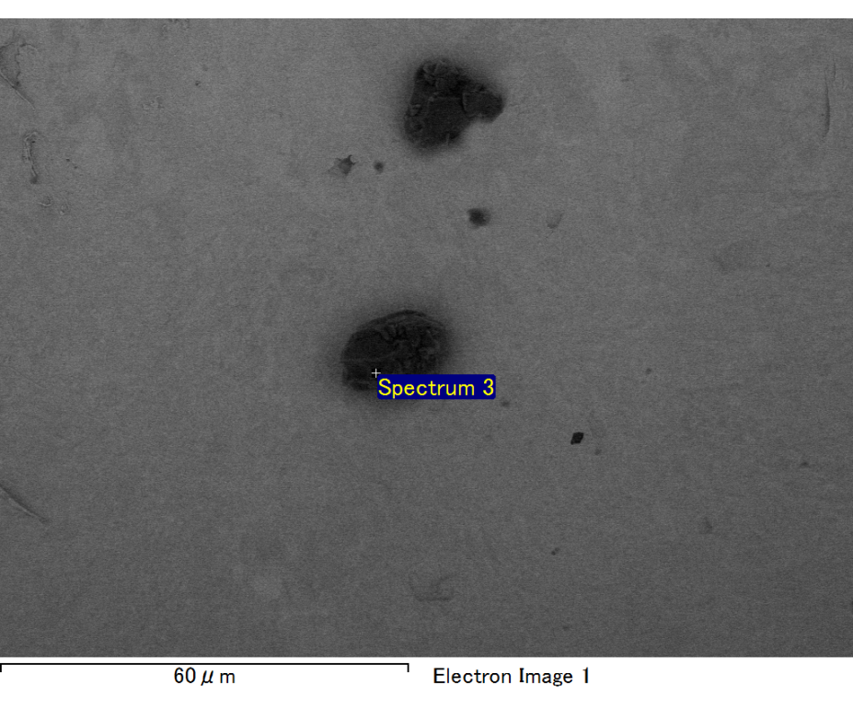

Spectrum processing :

No peaks omitted

Processing option : All elements analyzed (Normalised)

Number of iterations = 2

Standard :

C CaCO3 1-Jun-1999 12:00 AM

O SiO2 1-Jun-1999 12:00 AM

Mg MgO 1-Jun-1999 12:00 AM

Si SiO2 1-Jun-1999 12:00 AM

Fe Fe 1-Jun-1999 12:00 AM

Au Au 1-Jun-1999 12:00 AM

|  |  |  |  |
| --- | --- | --- | --- |
| Element | Weight% | Atomic% |  |
|  |  |  |  |
| C K | 3.30 | 12.48 |  |
| O K | 17.94 | 50.96 |  |
| Mg K | 5.02 | 9.38 |  |
| Si K | 3.73 | 6.03 |  |
| Fe L | 8.55 | 6.96 |  |
| Au M | 61.47 | 14.19 |  |
|  |  |  |  |
| Totals | 100.00 |  |  |

Spectrum Label: Spectrum 3

Livetime 60.0 s

Acquisition geometry ( degrees ):

Tilt = 15.0

Azimuth = 0.0

Elevation = 30.0

Accelerating voltage = 10.00 kV

Total spectrum counts = 50931

|  |  |  |  |
| --- | --- | --- | --- |
| Sample data : | Energy (eV) | Resn. (eV) | Area |
| Strobe : | 3.8 | 47.35 | 999818 |
|  |  |  |  |

No quant optimization performed

Sample: Sample 1

Type: Default

ID: